Freight Mode Choice: A Regret Minimization and Utility Maximization Based Hybrid Model

Nowreen Keya
Graduate Student
Department of Civil, Environmental & Construction Engineering, University of Central Florida
4000 Central Florida Blvd., Orlando, FL 32816
Tel: 1-321-352-9263; Email: nowreen.keya@Knights.ucf.edu

Sabreena Anowar
Post-Doctoral Associate
Department of Civil, Environmental & Construction Engineering, University of Central Florida
4000 Central Florida Blvd., Orlando, FL 32816
Tel: 407-718-3444; Email: sabreena.anowar@ucf.edu

Naveen Eluru*
Associate Professor
Department of Civil, Environmental & Construction Engineering, University of Central Florida
4000 Central Florida Blvd., Orlando, FL 32816
Tel: 1-407-823-4815; Fax: 1-407-823-3315 ; Email: naveen.eluru@ucf.edu

Submission Date: November 15, 2017

*Corresponding author

97th Annual Meeting of the Transportation Research Board, 2018, Washington DC

Submitted to: AT015 (Freight Transportation and Logistics Analysis and Modeling) committee for presentation and publication

Word count: 237 abstract + 5,046 text + 903 references + 3 figure + 3 tables = 7,686 equivalent words

ABSTRACT
With the introduction of automated vehicles, the performance of trucking industry is expected to be improved. In fact, this may impact the entire freight transportation system as trucks possesses the highest mode share in freight transportation. Therefore, to investigate this impact, an advanced discrete freight mode choice model has been proposed in this study. A hybrid utility-regret based model system has been estimated while accommodating for shipper level unobserved heterogeneity. The proposed model framework recognizes that not all attributes impacting freight mode choice are evaluated following a homogenous decision rule (either solely random utility maximization or solely random regret minimization). In our model building effort, we use the 2012 Commodity Flow Survey data augmented with a host of origin-destination attributes from a host of secondary sources. To demonstrate the applicability of the proposed model system, a detailed policy analysis is conducted considering several futuristic scenarios such as implementation of automation and rerouting of freight movements away from a region. The results offer some interesting insights. We found that introduction of automation in the freight industry would be more beneficial for long-haul hire truck mode than short-haul private truck mode. An increase in travel time by truck due to re-routing of truck flows away from urban region clearly indicates a modal shift from truck to parcel or “other” mode which includes rail, water or multiple modes.

Keywords: Freight Mode Choice, Random Regret Minimization, Hybrid Model, Latent Class

INTRODUCTION

Motivation
An efficient and cost-effective freight transportation system is the prerequisite for a region’s economic growth and prosperity. About 122.5 million households, 7.5 million businesses and 90 thousand government units, daily depend on the efficient movement of about 55 million tons of freight valued at around $49 billion (1). In the US, the demand for goods has grown steadily over the past half century and is expected to increase with the growth in population. The percentage share of freight transported in 2013 by weight and value by mode are as follows: truck (70 and 64), rail (9 and 3), water (4 and 1.5), air (0.1 and 6.5), and pipeline (7.7 and 6.0) (1). The remainder of the freight is transported by multiple modes, mail and unknown modes. This percentage clearly indicates that, road based freight transportation is an important component of supply chain in the U.S and trucks are the preferred mode of shipping for most manufacturers and distributors in the country. Higher percentage of truck mode share is associated with negative externalities including, air pollution, traffic congestion, increase in accident severity and expeditious deterioration of road and bridge infrastructure. Though heavy trucks consist only 3 percent of the total registered vehicles in USA and comprise 7 percent of total vehicle miles driven, yet they are involved in 11 percent of total road fatalities (2). Usually multiple axle trucks produce rutting damage and single and tandem axles cause cracking on road surface (3).
There is growing recognition among transportation researchers that addressing the freight industry associated challenges needs us to examine several dimensions including freight mode choice, freight infrastructure, pricing strategies across modes, and wages. In our research, we focus our attention on identifying and quantifying the influence of factors affecting mode choice for freight shipments. With the emerging advances in vehicle technology – connected and autonomous vehicles – there is likely to be a seismic shift in the freight industry in the near future. While level 4 adoption which is a fully self-driving vehicle in all conditions, (as defined by NHTSA, 4) is likely to take time, several intermediate levels of vehicle technologies are already being introduced by private and public companies. These vehicular advances offer significant advantages to the trucking industry in terms of fuel, time, and labor cost savings. For instance, a platoon of connected trucks in a formation can reduce the impact of wind resistance by maintaining a shorter distance between them (15m instead of 50m) thus saving fuel and reducing CO₂ emission by around 7 percent for a platoon of three trucks (5). Further, adoption of fully autonomous vehicles will allow the trucking industry to circumvent the need for federally mandated driver breaks for long-haul trips. These are instances of how vehicle technology can offer environmental and financial benefits. While these changes are likely to improve the performance of the trucking industry, their impact on the overall freight mode choice is less straight forward.
The proposed research effort contributes to our understanding of the impact of these technological adoptions, by developing advanced discrete choice models for freight mode choice analysis. Toward that end, we adopt a three-pronged research approach. First, we contribute to the existing literature by examining freight mode choice from the perspectives of alternative behavioral paradigms including classical random utility (RU) framework, newly emerging random regret (RR) framework, and hybrid framework (that builds on both utility and regret). Two kinds of hybrid models are considered: (1) hybrid framework with single utility equation accommodating regret and utility terms, and (2) latent class model with one segment following random utility structure and another following random regret structure. The applicability of these behavioral paradigms and the corresponding changes predicted to freight modal share under future vehicle technology adoption are evaluated. Second, a national level dataset drawn from Commodity Flow Survey (CFS) 2012 is augmented with a host of exogenous variables generated at origin and destination CFS areas including major industry type, area type (urban/rural), mean income, average annual temperature, roadway density by functional classification, density of employees and establishment by industry type, number of freight transportation establishment, number of intermodal facility, number of seaports and airports and density of toll roads, truck routes and intermodal facilities for model building exercise. Finally, based on these variable effects, a host of policy scenarios are identified and evaluated employing the various model structures; based on the policy scenario outcomes, recommendations for freight planning process are given.

Earlier Work and Current Study Context
A detailed review of literature on freight mode choice models is available in our previous study (6). From our review, we observed that in terms of contributing factors affecting freight mode choice, earlier studies have found the following variables to be of significance: (1) LOS measures (such as shipping time, shipping cost, speed, delay, fuel cost); (2) freight characteristics (such as commodity group, commodity size, commodity density, commodity value, commodity weight, product state, temperature controlled or not, perishability, trade type, quantity); (3) transportation network and origin-destination (O-D) attributes (such as shipment O-D, distance, ratio of highway and railway miles in origin and in destination); and (4) others (service reliability, service frequency, loss and damage, shipper’s characteristics).
On the methodological front, the majority of earlier studies have employed traditional random utility based multinomial logit (RUMNL) model (7, 8, 9, 10 and 11) and its several extensions such as nested logit model (10, 12 and 13), mixed logit model (6, 8), or heteroscedastic extreme value model (14 and 15), latent class multinomial logit model (8 and 16), and a copula based joint model embedded with a multinomial logit (MNL) model (17). Alternative approaches such as artificial neural network (18 and 19), neuro-fuzzy model (19) have also been developed. The most commonly employed approach, the random utility framework is mainly a compensatory behavioral framework that might not be optimal in determining choice behavior with alternative specific attributes. An alternative random regret framework that allows for pairwise alternative attribute comparison has been successfully applied in several fields including transportation (for travel mode choice (20) or route choice (21), road pricing (22), departure time (23), automobile fuel choice (24), online dating (25), healthcare (26), and recreational site choice (27). Recently, Boeri and Masiero (28) used random regret based multinomial logit (RRMNL) model to study mode choice based on a stated preference survey conducted on some Swiss medium to large industries. In their study, the authors found that the RRMNL model performed slightly better than its utility counterpart.
While comparison between random utility maximization and random regret minimization based approaches is beneficial, it is also possible that attribute impact on choice behavior could follow either approach. Towards accommodating such flexibility, a hybrid approach that allows attribute impacts to follow both random utility and random regret is employed in our analysis. While behavioral paradigm is quite important, the presence of unobserved heterogeneity is also likely to affect choice behavior. To accommodate for alternative behavioral paradigms and potential presence of unobserved heterogeneity we develop the following models structures: (1) random utility based mixed MNL (RUMMNL), (2) random regret based mixed MNL (RRMMNL), (3) a hybrid utility-regret mixed MNL (HUMMNL) model combining both RU and RR based attribute processing, and (4) latent class models with hybrid segments (LSRURR). These models are estimated using data from the 2012 US Commodity Flow Survey (CFS).

EMPIRICAL DATA

Data Source
The main data source for this study is the 2012 CFS data. The survey is conducted every 5 years since 1993 and is the only publicly available source of commodity flow information at a national level. The Public Use Microdata (PUM) file of CFS 2012 contains a total of 4,547,661 shipment records from approximately 60,000 responding industries. A sample of 5,565 records is drawn from the original CFS dataset to manage the burden of generating level of service variables (shipping cost and shipping time), ensuring that the weighted mode share in the random sample is the same as the weighted mode share in the original dataset. Of this, 4,000 records were randomly chosen for estimation purpose and 1,565 records were set aside for validation exercise.

Dependent Variable Generation
A total of twenty-one shipping modes are reported in CFS 2012. In our study, based on sample share, the reported modes were categorized into five classes: (1) hire truck (including truck and hire truck), (2) private truck, (3) air, (4) parcel or courier service, and (5) other mode (includes predominantly rail mode and the rest of the modes). Hire truck refers to those trucks operated by a non-governmental business units to provide transport services to customers for a payment. On the other hand, private truck is not available to public and is owned and used by individual business unit for shipping its own freight. Parcel or courier service mainly refers to multiple modes. The air mode consists of both air and truck, as truck is needed to pick up and supply the commodity from or to a particular place which cannot be accessed by air mode. The “other” mode refers to rail, water, pipeline or combination of non-parcel multiple modes. The distribution of the weighted mode share in the sample is as follows: hire truck (16.57%), private truck (25.97%), parcel (55.73%), air (1.42%), and other (0.31%). We also created alternative availability following a heuristic approach based on shipment weight and routed distance (see 6).

Independent Variable Generation
The CFS data was augmented with information from a host of secondary GIS and Census data sources. First, we generated level of service variables employing information from several sources for all available modes. For instance, shipping cost by hire truck and private truck was estimated using the 2007 revenue per ton-mile from National Transportation Statistics (NTS) with appropriate regional and temporal correction factors. For parcel mode, using FedEx, pricing functions were generated with distance and weight as variables for the seven zones in the US. The pricing functions also accommodated for shipping speed - express overnight (1day), express deferred (3 days) and ground service (5days) - based on observed shares of these shipping options from FedEx 2015 annual report. For shipping time by hire and private truck, three different travel speed bands were considered based on trip distance while considering the required break times according to the service regulations provided by Federal Motor Carrier Safety Administration (FMCSA) (see (6) for a detailed discussion on how mode shipping time and cost variables were generated for each mode). Second, using GIS layers from different sources, we generated a number of origin-destination attributes. For example, from National Transportation Atlas Database 2012 (NTAD 2012) and Highway Performance Monitoring System (HPMS) we collected roadway and railway network files and generated the roadway (including length of tolled road and length of truck route) and railway lengths. Other information collected from the same source are: urban and rural population in each county, number of airports, number of seaports and number of intermodal facilities. Number of bridges in each county was generated using GIS shape file from National Bridge Inventory. Truck AADT was collected from National Highway Freight Transportation (NHFN). Third, from census, the following data were collected: population count, number of employees and number of establishment by NAICS industry type, mean household income, number of warehouse and super center, number of warehouse and storage, number of freight transportation establishments and percentage of population below poverty level for each county in 2012. The industry types considered were manufacturing, mining, retail trade, warehouse and storage, company and enterprise, wholesale and information. The origin and destination area type (urban or rural) was classified based on the percentage of population residing in each area. If more than 50 percent population lives in urban area then the area is classified as urban; rural otherwise. The CFS area was categorized into low, medium and high income category groups based on annual average household income (< $50,000, $50,000-$80,000 and > $80,000 respectively). A state is recognized as cold state if the average annual temperature is below or equal to 60ºF; warm otherwise. The state wise temperature data has been collected from the website of Current Result-weather and science facts (30). Also based on the highest number of industries located in an area, the area is classified as manufacturing, mining, wholesale, information, retail trade, warehouse and storage and company and enterprise major area.

Descriptive Statistics
Figure 1 illustrates the shipment weight distribution by mode. It shows that private trucks carry increased tonnage in the California, Piedmont Atlantic and Gulf Coast regions. Air and Parcel modes mainly carry loads less than or equal to 30 lbs in the majority of the CFS areas. In Figure 2, the shipping cost by different modes across the CFS areas are presented. It can be observed from the figure that the shipping cost is comparatively higher in California and Great Lake mega regions for hire and private truck (more than $370 and $100 respectively). The shipping cost by air mode is relatively higher in Northern states (> $450). The reason might be the cold weather in these states. Shipping cost by parcel mode is lower than other modes across whole USA with very few CFS areas with shipping cost more than $80. The shipping cost by parcel mode in most of the areas is less than $80. Figure 3 demonstrates the shipping time distribution by mode across entire USA. In most of the regions the shipping time varies between 12 to 63 hours for hire truck and 1 to 3 hours for private truck. Very few regions have shipping time as high as 100 hours by hire truck. Shipping time by private truck is more than 6 hours in very few areas, because private truck usually travels shorter distance compared to hire truck. The shipping time by air mode in most CFS areas is less than 3 hours by air mode. For parcel mode, shipping time is greater than 94 hours in majority of the CFS areas, as typically parcel mode takes 3 to 5 days to deliver a product (except express delivery option which usually takes 1 or 2 days). Barely some areas can be found in the figure where shipping time is 1 to 3 days.

ECONOMETRIC FRAMEWORK
In this section, we discuss the econometric frameworks employed in the study.

Mixed Hybrid Model-Combination of RUM and RRM
Let $s (s=1,2,……, S)$ be the index for shippers, and $i (n=1,2,……, I)$ be the index for freight mode alternatives characterized by $m (m=1,2,…N,…,M)$ attributes. Let us also consider, $N$ are evaluated following utility maximization principle while the rest $(M-N)$ are evaluated following random regret minimization principle. With these notations, the systematic part of the hybrid (or modified) utility/regret equation would take the following form:
$${HU}_{i}=\sum_{m=1}^{N}{β_{m}^{'}}x_{i}-\sum_{j≠i}{\sum_{m=N+1}^{M}{\ln\left[1+exp\left\{β_{m}^{'}\left(x_{jm}-x_{im}\right)\right\}\right]}}$$ | (1)
In the above formula, the linear in parameter portion represents random utility maximization and the non-linear part represents random regret minimization attribute processing. Considering, the error term to be standard type-1 extreme value distributed, the mathematical expression for the unconditional probability of the hybrid utility/regret model could be written (accommodating for unobserved heterogeneity) as:
$$P_{i}^{HU}=\int{\left({\left[\frac{exp\left({HU}_{i}\right)}{\sum_{i=1}^{I}{exp \left({HU}_{i}\right)}}\right]}^{d_{i}}\right)}f\left(β\right)dβ$$ | (2)
where $f\left(β\right)$ is a density function specified to be normally distributed with mean 0 and variance $σ^{2}$ and $d_{i}$ is a binary variable which is equal to 1 if shipper $s$ choose mode $i$ or 0 otherwise. There is no a priori expectation regarding which attributes are likely to be processed in utility theoretic fashion and which are likely to be processed by random regret approach. If all parameters are evaluated based on utility maximization principle, then the model collapses to traditional random utility based mixed MNL model and if all parameters are evaluated based on regret minimization principle, then hybrid model collapses to regret based mixed MNL model. To estimate parameters, maximum simulated likelihood (MSL) estimation technique is employed. For this particular study, we use a quasi-Monte Carlo (QMC) approach (Scrambled Halton draws) with 200 draws for the MSL estimation (see 31 for more details).

Latent Class Two Segment Model with RUM and RRM
In the two class latent segment model, Segment 1 follows random utility principle and segment 2 follows a regret based decision rule. The latent segmentation based models assign shipments probabilistically into k (k = 1, 2) segments based on a host of explanatory variables (for example, freight characteristics). The mathematical expression for the probability of a shipment s belonging to segment k can be expressed as follows:
$$P_{sk }= \frac{\exp{(γ_{k}^{'}z_{s})}}{\sum_{k=1}^{2}{\exp{(γ_{k}^{'}z_{s})}}}$$ | (3)
where, $z_{s}$ is a vector of shipment attributes that influences the propensity of belonging to segment k, $γ_{k}^{'}$ is a vector of estimable coefficients.

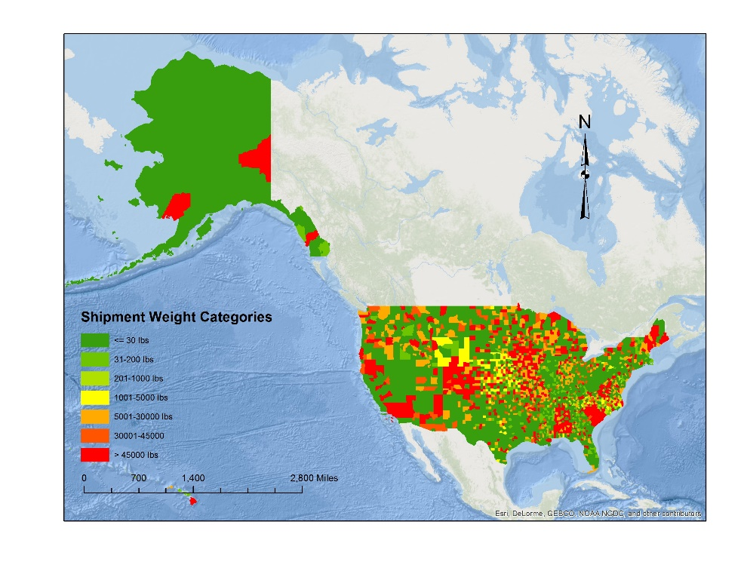 | 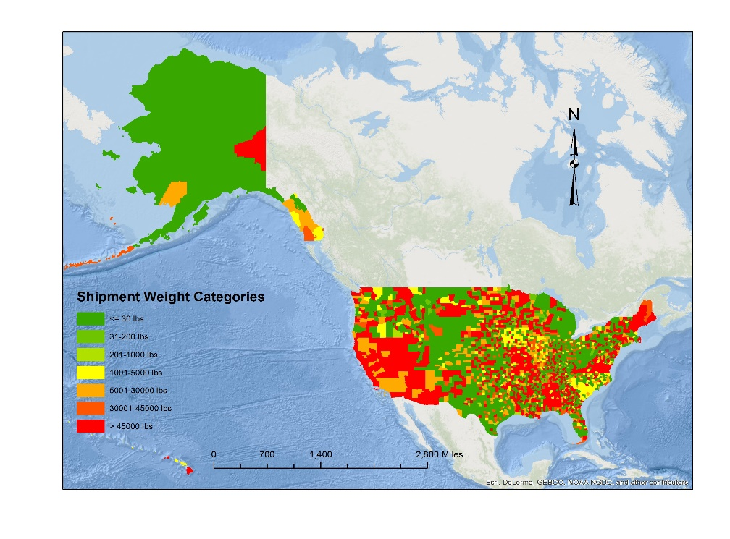
(1a) | (1b)
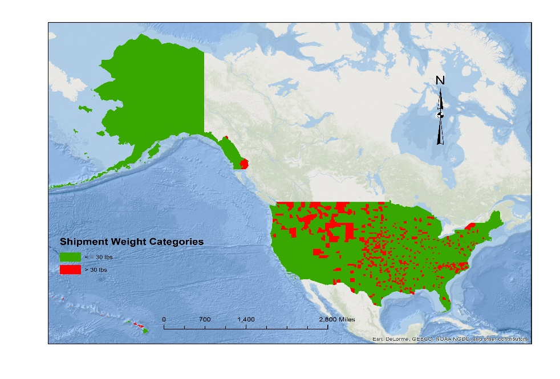 | 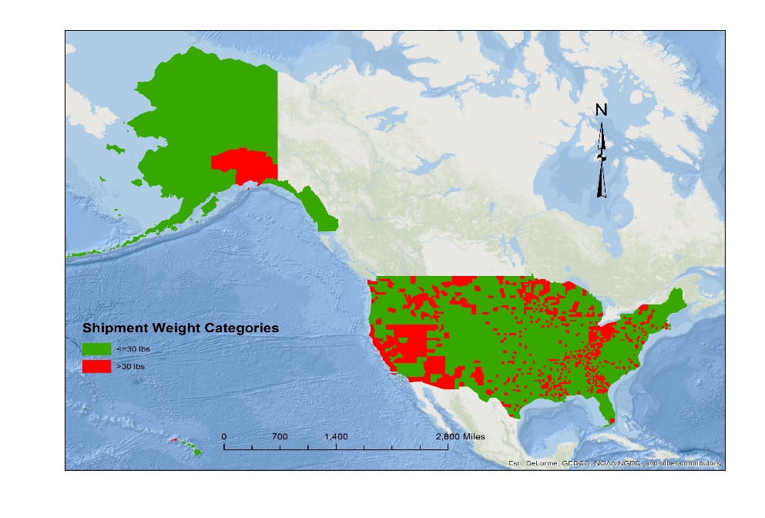
(1c) | (1d)

FIGURE 1 Shipment Weight Distribution in CFS Areas (1a) Hire Truck; (1b) Private Truck; (1c) Air; (1d) Parcel.
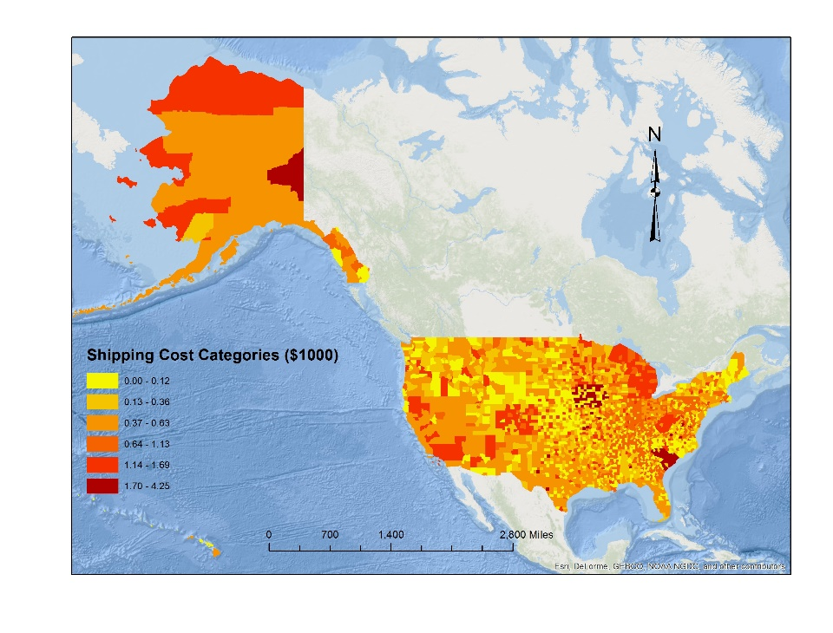 | 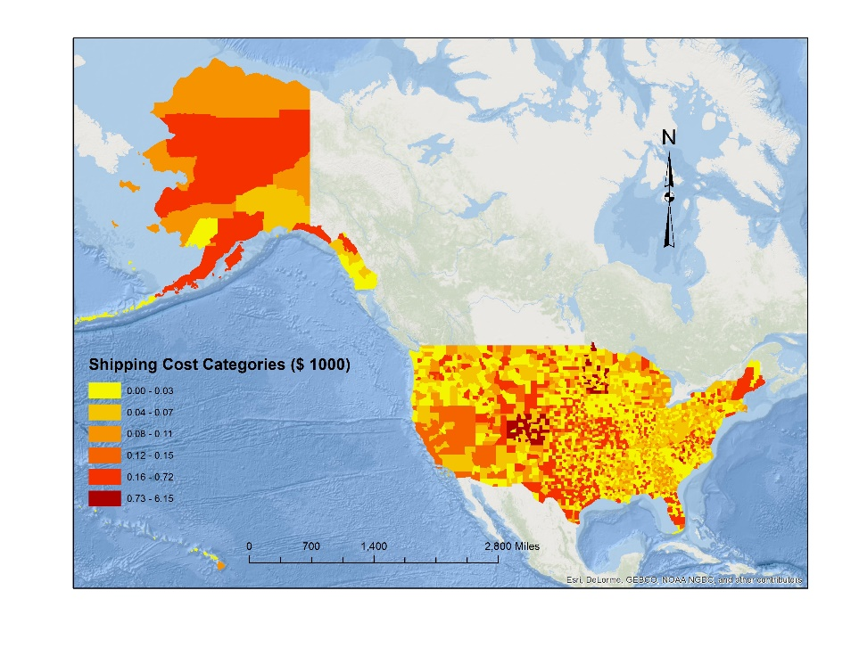
(2a) | (2b)
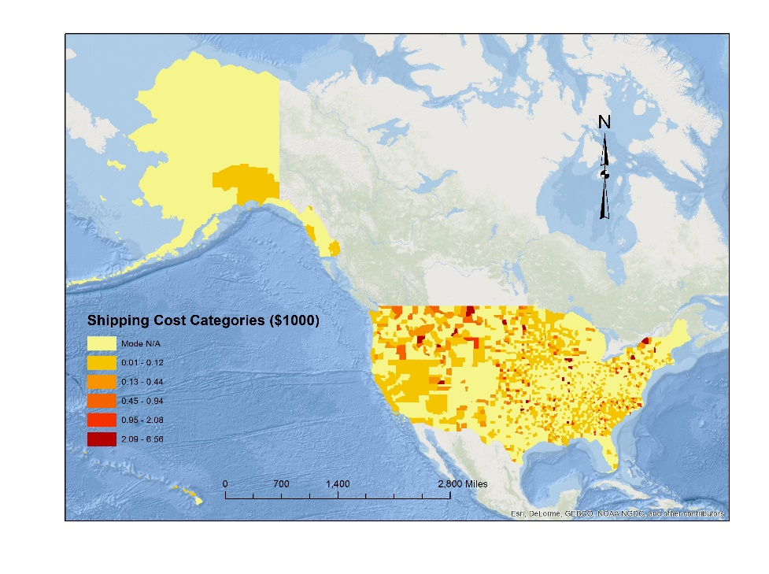 | 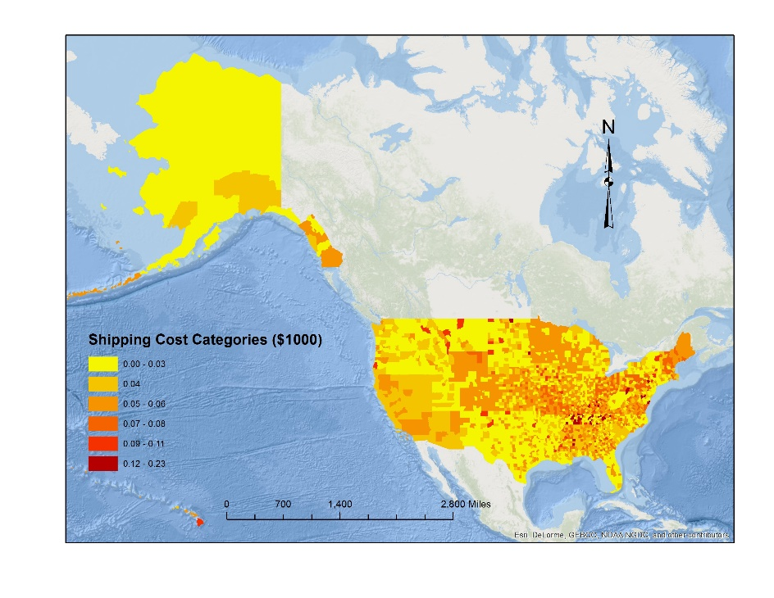
(2c) | (2d)

FIGURE 2 Shipping Cost ($1,000) Distribution in CFS Areas (2a) Hire Truck; (2b) Private Truck; (2c) Air; (2d) Parcel.
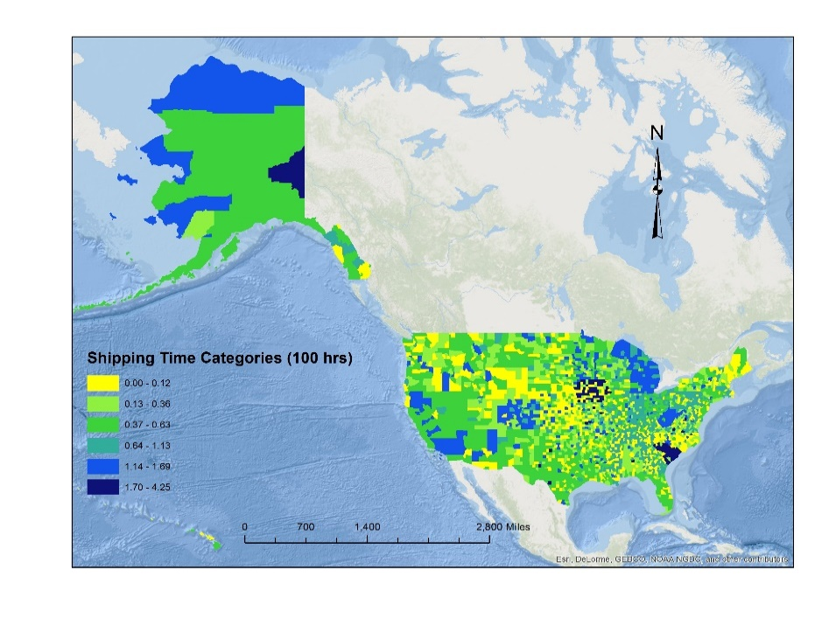 | 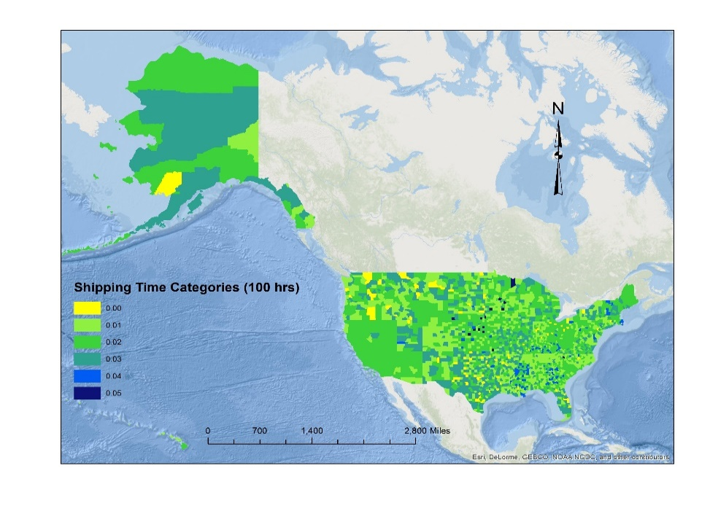
(3a) | (3b)
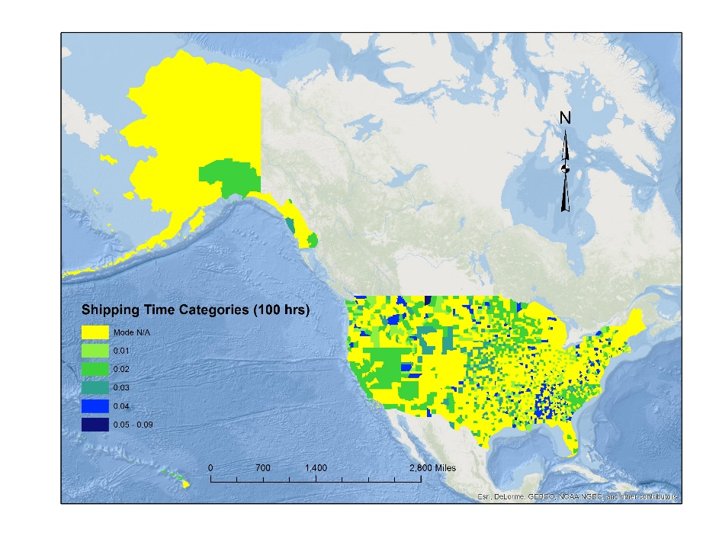 | 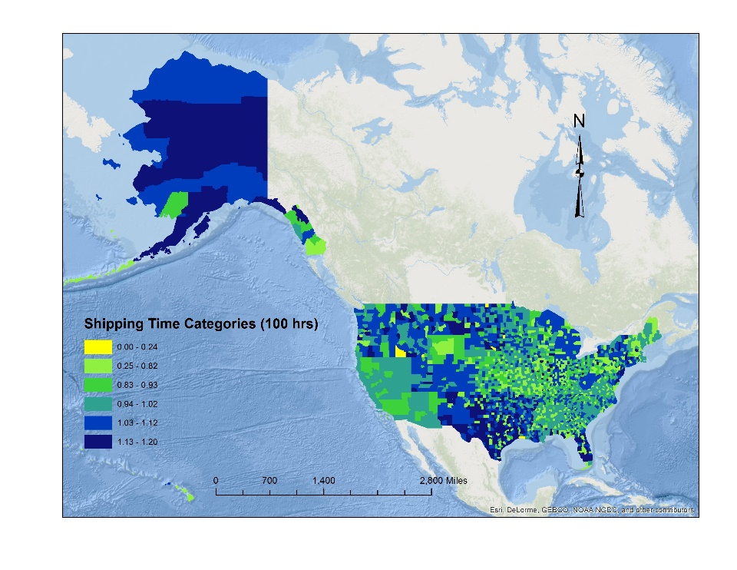
(3c) | (3d)

FIGURE 3 Shipping Time (100 hrs) in CFS Areas (3a) Hire Truck; (3b) Private Truck; (3c) Air; (3d) Parcel.

Within the latent class approach, the unconditional probability of a shipment $s$ being shipped by mode $i$ is given as:
$$P_{s}\left(i\right)=\sum_{k=1}^{2}{(}P_{s}\left(i\right) \left| k\right)(P_{sk})$$ | (4)
where $P_{s}(i)|k$ represents the conditional probability of shipment $s$ being shipped by mode $i$ within the segment $k$. Using the notations mentioned above, the conditional probability for segment 1 (considering random utility maximization principle) would be as follows:
$$P_{s}\left(i\right) | 1= \frac{\exp{(α_{k}^{'}x_{si})}}{\sum_{i=1}^{I}{\exp{(α_{k}^{'}x_{si})}})}$$ | (5)
Here, $α_{s}^{'}$ represents a vector of coefficients, and $x_{si}$ is a vector of attributes influencing mode choice. On the other hand, for segment 2 (considering random regret based decision), the conditional probability would be given as:
$$P_{s}\left(i\right)| 2= \frac{\exp{(-R_{si })}}{\sum_{i=1}^{I}{\exp{(-R_{si })}}}$$ | (6)
here, $R_{si}=\sum_{j≠i}{\sum_{m=1}^{M}{\ln\left[1+exp⁡\left\{δ_{m}\left(x_{sjm}-x_{sim}\right)\right\}\right]}}$; $δ_{m}$ is (Lx1) column vector of estimable coefficients associated with attribute $x_{m}$; $x_{im}$ and $x_{jm}$ are (Lx1) column vector of mode attributes for the considered alternative $i$ and another alternative $j$, respectively. The log-likelihood function for the entire dataset with appropriate $P_{s}\left(i\right)|k$ is as follows:
$$LL= \sum_{s=1}^{S}{log⁡(P_{s}(i}))$$ | (7)

EMPIRICAL ANALYSIS

Model Fit
In this study a series of models have been estimated including traditional random utility maximization based MNL (RUMNL), random regret minimization based MNL (RRMNL), random utility based mixed MNL (RUMMNL), random regret based mixed MNL (RRMNL), hybrid utility-regret based MNL (HUMNL), hybrid utility-regret based mixed MNL (HUMMNL) and latent class two segment model with RU and RR (LSRURR). To compare these models, Bayesian Information Criterion (BIC) values have been computed which are presented in Table 1. The BIC value for a given empirical model can be calculated using [– 2 (LL) + K ln (Q)], where (LL) is the log-likelihood value at convergence, K is the number of parameters and Q is the number of observations. The lowest BIC value was found for HUMMNL (3840.49). Therefore, we present and discuss the results obtained from this model only (Table 2). Please note that we considered a 90 percent significance level. The last column of Table identifies whether the variable was considered following random utility structure (RUM) or random regret structure (RRM). We discuss the results for RUM variables followed by RRM variables.
TABLE 1 Comparison of Different Models

Model | Log-likelihood at Convergence | No. of Parameters | No. of Observation | BIC Values
RUMNL | -1782.95 | 41 | 4000 | 3905.96
RRMNL | -1769.30 | 40 | 4000 | 3870.36
HUMNL | -1769.69 | 38 | 4000 | 3854.55
RUMMNL | -1772.06 | 42 | 4000 | 3892.75
RRMMNL | -1759.83 | 41 | 4000 | 3859.72
HUMMNL | -1758.52 | 39 | 4000 | 3840.52
LSRURR | -1857.98 | 36 | 4000 | 4014.55

Exogenous Variable Effects (RU)
The level of service variables (shipping cost and shipping time) negatively influence mode share. This is expected as shippers naturally would prefer modes offering faster shipping time and lower carrying cost. We also allowed for the presence of the unobserved heterogeneity across shipping cost and time. From analysis result, it was found that shipping cost has a statistically significant standard deviation. The coefficient of cost follows a normal distribution with mean value of -0.8097 and standard deviation off 0.4639. The distribution infers that shipping cost impact most of the observation negatively with a very small proportion (4.09%) of cases having the positive impact of cost. In addition to an overall travel time coefficient, travel time interactions with different commodity types were examined (observed and unobserved). Of the various commodity types, only the raw food and prepared products presented a statistically significant result for observed effects. The estimated parameter implied that the raw and prepared foods are more sensitive to travel time compared to other commodity types. The result is reasonable because these products are usually perishable and require timely delivery. For export freight, air is more likely to be preferred alternative compared to hire truck (see 32 for similar result). Private truck is more likely to be chosen when the shipment value is less than $5000.
The transportation network and demographic attributes offer intuitive results as well. With increasing highway density at origin, the propensity to choose parcel mode increases. The result indicates that increasing roadway connectivity increases the accessibility associated with parcel mode. Densely populated area attracts more freights flows, hence the probability of choosing private truck, air and parcel mode also increases with increasing population density at destination. Private trucks are unlikely to be the preferred option at inter-modal facilities relative to other alternatives. The reason may be private trucks typically runs in a comparatively shorter distance and hence change of modes may not be necessary for private truck. The result also shows that probability of choosing private truck decreases when density of warehouse and super center increases at origin. Air mode is less likely to be chosen for destinations with population below poverty level presumably since shipping through air mode is expensive. Also the impoverished destinations may not have necessary provisions for air mode as well (airports or freight air strips). Also with increasing number of employee density in manufacturing industries at origin, the probability of choosing private truck decreases.

Exogenous Variable Effects (RR)
The constants do not possesses any substantive interpretation after introducing other exogenous variables. The coefficients of freight characteristics treated with RRM approach bears intuitive results. The probability of choosing parcel decreases when the commodity is non-flammable liquid or other hazardous material. It is expected because this type of commodity needs special cares for handling and advanced safety precautions. The result for temperature control variable indicates that probability of choosing private truck increases when the commodity needs temperature control as desired temperature control facilities can be provided by private truck providers. Hence, regret would be lesser compared to any other mode when private truck is chosen for temperature controlled products. In addition, the probability of choosing private truck increases when the commodity is prepared products, petroleum and coals or furniture and other commodities. On the other hand, private truck is not preferred when the commodity is stone and non-metallic minerals, chemicals or electronics. Our findings are in line with the results reported in previous studies (17 and 32). Eelectronics products are comparatively light weight, expensive and need special care while transporting (see 17 for the same finding) and hence, there would be lesser regret associated with choosing air mode for transporting these commodity type. Parcel mode is less likely to be chosen when the shipment is expensive in terms of its value (more than $5000) (see (16, 19 and 33) for similar results).
When the origin mega region is Florida, private truck is more likely to be chosen. Again when destination is North-East region parcel mode is less likely to be chosen. The probability of choosing private truck increases when the origin is urban area. In cold areas with average temperature below or equal to 60⁰ F, parcel mode is more likely to be chosen. The reason may be in colder areas people are more dependent on purchasing products online than going out by themselves to purchase that commodity. Hence, the regret would be lesser for this case. The probability of choosing private truck increases when the major industry type at origin is whole sale, but probability of choosing private truck decreases when the major industry type at destination is wholesale. One plausible explanation might be that wholesale dominating origins produce bulk amount of products which are required to ship by truck than air or parcel mode. When the density of interstate highways and freeways at destination increases, the probability of choosing air mode decreases which is expected. With increasing density of warehouse and super center at destination probability of choosing parcel mode decreases. Also if there are more number of seaports at destination, it less likely to choose private truck as freight transportation mode.

Validation
We performed a validation exercise using the 1,565 records to examine the performance of the model. We generated the mean absolute error (MAE) and root mean square error (RMSE) metrics based on predicted mode share at the aggregate level. The MAE and RMSE values obtained were 0.34 and 0.44 respectively. The results highlight the reasonable performance of the proposed model.

POLICY ANALYSIS
To illustrate the applicability of the proposed model, a policy analysis has been conducted. The policy scenarios considered include:
(1) a carbon tax on truck mode increasing the shipping cost by 25%, 35% and 50%,
(2) a reduction in truck shipping time due to introduction of automated truck fleets in trucking industry (by eliminating the heavy vehicle driver’s resting time),
(3) re-routing of trucks away from the urban region resulting an increased travel time by 15%, 25% and 50%,
(4) a carbon tax measure of 50% increase in truck shipping cost and reduction of travel time from scenario 2, and
(5) a carbon tax on air mode of 25% and 50%.
Table 3 illustrates the changes in predicted mode share from base share for different policy scenarios. In the table, a positive (negative) sign specifies an increase (decrease) from the base mode share. When the shipping cost increases due to carbon tax measure, as expected, the mode share of hire truck and private truck decreases. This reduction ranges from 1.93 percent to 2.96 percent for hire truck and 1.08 percent to 1.77 percent for private truck. It is interesting to observe from the table that percentage share of “other” mode increases significantly under this policy scenario. This is not surprising, because truck usually carry larger loads which can only be substituted by rail. In the second scenario, the shipping time by hire and private truck is reduced by not considering rest and break time associated with long haul drivers. As expected, the results illustrate a potential increase in hire truck mode share (by 4.83%). But there is a slight increment in private truck because private trucks usually runs shorter distance compared to hire truck and hence, rest or break time is not usually associated with this mode. This essentially signifies that vehicle automation might be more beneficial for long-haul modes. On the other hand, reduction in truck shipping time decreases the share of air and parcel mode substantially. Also under the third scenario, the travel time by trucks is increased by 15%, 25% and 50%. To reduce congestion, to reduce conflicts between heavy vehicle and automobiles and pedestrians/cyclists on the roadways within cities, and to reduce air pollution, city officials might decide to reroute truck flows to by-pass roadways located at the periphery of the cities. This will apparently benefit passenger traffic but will lead to increased travel time for trucks. As expected, we observed that increase in travel time leads to a substantial decrease in truck share. From the table, it can also be observed that hire truck share decreases between the range of 2.35 percent to 7.85 percent. In contrast, share of private truck does not decrease remarkably. Under this scenario, the share of parcel and “other” modes increases. More interestingly, when a 50% carbon tax is implied and at the same time shipping time is reduced for truck mode, the share of hire truck increases indicating that shippers are usually more sensitive to shipping time than shipping cost. At the same time share of “other” mode increases by almost 72 percent under this policy scenario. Finally, a carbon tax measure of 25% and 50% on air mode reduces the air mode share by 7.71 percent and 11.92 percent, respectively, simultaneously increasing parcel and “other” mode share.

CONCLUSION
An efficient and cost-effective freight transportation system is the prerequisite for a region’s economic growth and prosperity. The advanced technology adoption and implementation in trucking industry benefits the industry both financially and environmentally. Hence, this change may influence overall freight industry in a complex way. The proposed research effort contributes to our understanding of the impact of these technological adoptions, by developing advanced discrete choice models for freight mode choice analysis.
We contribute to the existing literature by examining freight mode choice from alternative behavioral paradigms-random utility maximization and random regret minimization. To capture unobserved heterogeneity of level of service variables, a mixed hybrid model was estimated. The applicability of these behavioral paradigms and the corresponding changes predicted to freight mode choice under future vehicle technology adoption are evaluated. In our empirical analysis, the hybrid utility-regret mixed MNL model performed better compared to all other models. Our finding lends credence to the growing recognition that attributes impacting choice behavior could be treated either by heterogeneously – using either utility theoretic manner or regret minimization orientation. Overall, the estimated results offer plausible interpretation of the choice behavior. The evaluation of policy scenarios offers reasonable and intuitive results in terms of modal shifts. We found that introduction of automation in the freight industry would be more beneficial for long-haul hire truck mode than short-haul private truck mode. An increase in travel time by truck due to re-routing of truck flows away from urban region clearly indicates a modal shift from truck to parcel or “other” mode which includes rail, water or multiple modes. Also, implementation of carbon tax should be accompanied by travel time penalty, if modal shift from road based transportation to rail or water vessel based transportation is to be achieved. These policy insights can be helpful for transportation planner and urban policy makers to provide adequate physical facilities and services for truck transportation. Designated truck route, controlled access to urban area and selected parking and loading-unloading infrastructural facilities can improve truck transportation significantly. Also adopting automated truck fleets can cut off the economic and environmental impacts associated with trucking industry to a greater extent.
To be sure, the study is not without limitations. CFS data does not provide exact geo-coded origin and destination locations. Several approaches that randomize geo-coded locations to protect privacy are available. CFS data could implement these approaches and provide the geo-coded location for modeling analysis. The availability of such geo-coded data will improve shipping time computation as well as alternative availability matrices. While our model structures accommodate for the impact of unobserved factors, additional information on shipment frequency, shipper reliability, vehicle fleet ownership of the shipping firm, travel time delays would enhance the model developed. Additional work on improving the approaches for LOS computation is beneficial. In future work, analysis of mode choice decisions at regional or state level will enhance the model findings as well as provide policy makers with more customized insights.
TABLE 2 Estimation Result of Mixed Hybrid Model-Combination of RUM and RRM Based Approaches

Explanatory Variables | Hire Truck |  | Private Truck |  | Air |  | Parcel/Courier |  | Other |  | Type
 | Parameter | t-stat | Parameter | t-stat | Parameter | t-stat | Parameter | t-stat | Parameter | t-stat
Constant | 0 | − ¹ | 0.2222 | 2.680 | -0.3997 | -1.021 | 1.3049 | 7.959 | -1.7770 | -3.532 | RRM²
Level of Service variables
Shipping Cost  (1000 $) | -0.8097 | -2.239 | -0.8097 | -2.239 | -0.8097 | -2.239 | -0.8097 | -2.239 | -0.8097 | -2.239 | RUM³
Std. Dev. | 0.4639 | 1.751 | 0.4639 | 1.751 | 0.4639 | 1.751 | 0.4639 | 1.751 | 0.4639 | 1.751 | RUM
Shipping Time (hrs) | -0.0059 | -3.648 | -0.0059 | -3.648 | -0.0059 | -3.648 | -0.0059 | -3.648 | -0.0059 | -3.648 | RUM
Interaction Variables
Interaction of Travel Time with Raw Food (hrs) | -0.0169 | -2.625 | -0.0169 | -2.625 | -0.0169 | -2.625 | -0.0169 | -2.625 | -0.0169 | -2.625 | RUM
Interaction of Travel Time with Prepared Products (hrs) | -0.0086 | -2.129 | -0.0086 | -2.129 | -0.0086 | -2.129 | -0.0086 | -2.129 | -0.0086 | -2.129 | RUM
Freight Characteristics
Hazardous Material (Base: Not Hazardous)
Non-flammable Liquid and Other Hazardous Material | − | − | − | − | − | − | -0.6022 | -3.557 | − | − | RRM
Temperature Controlled
(Base: No)
Yes | − | − | 0.2743 | 2.366 | − | − | − | − | − | − | RRM
Export (Base: No)
Yes | − | − | − | − | 2.4275 | 5.664 | − | − | − | − | RUM
SCTG Commodity Type (Base: Wood, Papers and Textile)
Prepared Products | − | − | 0.5488 | 4.064 | − | − | − | − | − | − | RRM
Stone & Non-Metallic Minerals | − | − | -0.3178 | -3.381 | − | − | − | − | − | − | RRM
Petroleum and Coals | − | − | 0.5279 | 3.220 | − | − | − | − | − | − | RRM
Chemicals | − | − | -0.1538 | -2.300 | − | − | − | − | − | − | RRM
Electronics | − | − | -0.1552 | -2.354 | 0.6292 | 3.146 | − | − | − | − | RRM
Furniture and Others | − | − | 0.1544 | 2.394 | − | − | − | − | − | − | RRM
Shipment Value ($) (Base: Value >5000) | − | − |  |  | − | − | − | − | − | −
Value ≤ 1000 | − | − | 1.6217 | 10.484 | − | − | − | − | − | − | RUM
1000 < Value ≤ 5000 | − | − | 0.9355 | 5.254 | − | − | − | − | − | − | RUM
Value > 5000 | − | − | − | − | − | − | -0.3176 | -2.787 | − | − | RRM
Transportation Network and Demographic Variables
Origin Mega Region (Base: Non Mega Region)
Florida | − | − | 0.2998 | 2.198 | − | − | − | − | − | − | RRM
Destination Mega Region (Base: Non Mega Region)
North-East | − | − | − | − | − | − | -0.1356 | -1.653 | − | − | RRM
Origin Area Type (Base: Rural)
Urban | − | − | 0.2787 | 2.593 | − | − | − | − | − | − | RRM
Avg. Temperature at Origin
(Base: Warm;
>60⁰ F)
Cold ( ≤ 60⁰ F) | − | − | − | − | − | − | 0.1850 | 2.826 | − | − | RRM
Major Industry at Origin
(Base: Manufacturing)
Wholesale | − | − | 0.1209 | 1.850 | − | − | − | − | − | − | RRM
Major Industry at Destination
(Base: Manufacturing)
Wholesale | − | − | -0.1093 | -1.788 | − | − | − | − | − | − | RRM
Origin Highway Density (mi/mi²) | − | − | − | − | − | − | 2.2970 | 1.974 | − | − | RUM
Density Interstate Highways and Freeways at Destination (mi/mi²) | − | − | − | − | -0.0283 | -1.785 | - | - | − | − | RRM
Destination Population Density (pop/mi²) | − | − | 0.0011 | 3.500 | 0.0011 | 3.500 | 0.0007 | 3.733 | − | − | RUM
No. of Inter Modal Facility at Destination | − | − | -0.0067 | -2.869 | − | − | − | − | − | − | RUM
Density of Warehouse and Super Center at Origin (per mi²) | − | − | -0.4361 | -2.356 | − | − | − | − | − | − | RUM
 | − | − | - | - | − | − | -0.1903 | -2.210 | − | − | RRM
Density of Wholesale Industry at Destination  (per mi²) | − | − | -0.2117 | -2.978 | − | − | − | − | − | − | RRM
Percentage of Population below Poverty Level at Destination | − | − | − | − | -10.7827 | -1.744 | − | − | − | − | RUM
Density of Employees in Manufacturing Industry at Origin (per mi²) | − | − | -0.4453 | -7.936 | − | − | − | − | − | − | RUM
No. of Seaports at Destination | − | − | -0.0003 | -2.924 | − | − | − | − | − | − | RRM
Number of cases | 4000
Log Likelihood for Constant only Model | -2063.51
Log Likelihood at Convergence | -1758.52
No. of Parameter | 39
Adjusted rho-square | 0.1313

¹ - = Variable insignificant at 90 percent confidence level
² RRM = Random Regret Minimization
³ RUM = Random Utility Maximization

TABLE 3 Percentage Changes of Mode Share from Base Prediction under Different Policy Scenarios

Mode | Truck Shipping Cost 25% Increase | Truck Shipping Cost 35% Increase | Truck Shipping Cost 50% Increase | Truck Shipping Time Under Automated Vehicles | Truck Shipping Time 15% Increase | Truck Shipping Time 25% Increase | Truck Shipping Time 50 % Increase | Truck Shipping Cost 50% Increase and Truck Shipping Time Reduction | Air Shipping Cost 25% Increase | Air Shipping Cost 50% Increase
Hire Truck | -1.93 | -2.41 | -2.96 | 6.91 | -2.35 | -3.68 | -7.85 | 4.83 | 0.42 | 0.48
Private Truck | -1.08 | -1.54 | -1.77 | 0.27 | -1.09 | -1.13 | -1.21 | 0.08 | -1.16 | -1.14
Air | -4.39 | -4.29 | -4.15 | -7.16 | -2.70 | -2.04 | -0.33 | -6.22 | -7.71 | -11.92
Parcel | 1.01 | 1.29 | 1.42 | -2.20 | 1.22 | 1.60 | 2.82 | -1.69 | 0.72 | 0.75
Other | 35.75 | 51.55 | 76.23 | 0.68 | 12.74 | 13.82 | 16.63 | 72.12 | 3.45 | 3.45

REFERENCES
- “Freight Facts and Figures, 2015”, Bureau of Transportation statistics, 2015. http://www.rita.dot.gov/bts/programs/freight_transportation. Accessed July 29, 2017.
- Bezwada, N. N. K. Characteristics and contributory causes associated with fatal large truck crashes. In Kansas State University, 2010.
- Salama, H. K., K. Chatti, and R. W. Lyles. Effect of heavy multiple axle trucks on flexible pavement damage using in-service pavement performance data. Journal of Transportation Engineering, Vol. 132, No. 10, 2006, pp. 763-770.
- Administration, N. H. T. S. Preliminary statement of policy concerning automated vehicles. Washington, DC, 2013, pp. 1-14.
- Connected Trucks Freight transport of the future by using the internet. Daimler Blog. https://www.daimler.com/innovation/digitalization/connectivity/connected-trucks.html. Accessed on July 29, 2017.
- Keya, N., S. Anowar, and N. Eluru. Estimating a Freight Mode Choice Model: A Case Study of Commodity Flow Survey 2012. In Transportation Research Board 97th Annual Meeting, Washington, D.C., 2017.
- Arencibia, A. I., M. Feo-Valero, L. García-Menéndez, and C. Román. Modelling mode choice for freight transport using advanced choice experiments. Transportation Research Part A: Policy and Practice, Vol. 75, 2015, pp. 252-267.
- Brooks, M. R., S. M. Puckett, D. A. Hensher, and A. Sammons. Understanding mode choice decisions: A study of Australian freight shippers. Maritime Economics & Logistics, Vol. 14, No. 3, 2012, pp. 274-299.
- Mitra, S., and S. M. Leon. Discrete choice model for air-cargo mode selection. The International Journal of Logistics Management, Vol. 25, No. 3, 2014, pp. 656-672.
- Nugroho, M. T., A. Whiteing, and G. de Jong. Port and inland mode choice from the exporters' and forwarders' perspectives: Case study—Java, Indonesia. Research in Transportation Business & Management, 2016.
- Yang, D., G. P. Ong, and A. T. H. Chin. An exploratory study on the effect of trade data aggregation on international freight mode choice. Maritime Policy & Management, Vol. 41, No. 3, 2014, pp. 212-223.
- Jiang, F., P. Johnson, and C. Calzada. Freight demand characteristics and mode choice: an analysis of the results of modeling with disaggregate revealed preference data. Journal of transportation and statistics, Vol. 2, No. 2, 1999, pp. 149-158.
- Rich, J., P. M. Holmblad, and C. Hansen. A weighted logit freight mode-choice model. Transportation Research Part E: Logistics and Transportation Review, Vol. 45, No. 6, 2009, pp. 1006-1019.
- Holguín-Veras, J. Revealed preference analysis of commercial vehicle choice process. Journal of Transportation Engineering, Vol. 128, No. 4, 2002, pp. 336-346.
- Norojono, O., and W. Young. A stated preference freight mode choice model. Transportation Planning and Technology, Vol. 26, No. 2, 2003, pp. 1-1.
- Arunotayanun, K., and J. W. Polak. Taste heterogeneity and market segmentation in freight shippers’ mode choice behaviour. Transportation Research Part E: Logistics and Transportation Review, Vol. 47, No. 2, 2011, pp. 138-148.
- Pourabdollahi, Z., B. Karimi, and A. Mohammadian. Joint Model of Freight Mode and Shipment Size Choice. Transportation Research Record: Journal of the Transportation Research Board, No. 2378, 2013, pp. 84-91.
- Abdel Wahab, W., and T. SAYED. Freight mode choice models using artificial neural networks. Civil Engineering Systems, Vol. 16, No. 4, 1999, pp. 267-286.
- Sayed, T., and A. Razavi. Comparison of neural and conventional approaches to mode choice analysis. Journal of Computing in Civil Engineering, Vol. 14, No. 1, 2000, pp. 23-30.
- Chorus, C. G. A new model of random regret minimization. Ejtir, Vol. 2, No. 10, 2010, pp. 181-196.
- Chorus, C. G. A generalized random regret minimization model. Transportation Research Part B: Methodological, Vol. 68, 2014, pp. 224-238.
- Chorus, C. G., J. A. Annema, N. Mouter, and B. van Wee. Modeling politicians' preferences for road pricing policies: A regret-based and utilitarian perspective. Transport Policy, Vol. 18, No. 6, 2011, pp. 856-861.
- Chorus, C. G., and G. C. De Jong. Modeling experienced accessibility for utility-maximizers and regret-minimizers. Journal of Transport Geography, Vol. 19, No. 6, 2011, pp. 1155-1162.
- Hensher, D. A., W. H. Greene, and C. G. Chorus. Random regret minimization or random utility maximization: an exploratory analysis in the context of automobile fuel choice. Journal of Advanced Transportation, Vol. 47, No. 7, 2013, pp. 667-678.
- Chorus, C. G., and J. M. Rose. 11. Selecting a date: a matter of regret and compromises. Choice modelling: The state of the art and the state of practice, 2013, p. 229.
- de Bekker-Grob, E. W., and C. G. Chorus. Random regret-based discrete-choice modelling: an application to healthcare. PharmacoEconomics, Vol. 31, No. 7, 2013, pp. 623-634.
- Boeri, M., A. Longo, E. Doherty, and S. Hynes. Site choices in recreational demand: a matter of utility maximization or regret minimization? Journal of Environmental Economics and Policy, Vol. 1, No. 1, 2012, pp. 32-47.
- Boeri, M., and L. Masiero. Regret minimisation and utility maximisation in a freight transport context. Transportmetrica A: Transport Science, Vol. 10, No. 6, 2014, pp. 548-560.
- Current Results. Weather and Science facts. Average Annual Temperature for Each US State. https://www.currentresults.com/Weather/US/average-annual-state-temperatures.php . Accessed July 29, 2017.
- Bhat, C. R. Quasi-random maximum simulated likelihood estimation of the mixed multinomial logit model. Transportation Research Part B: Methodological, Vol. 35, No. 7, 2001, pp. 677-693.
- Wang, Y., C. Ding, C. Liu, and B. Xie. An analysis of Interstate freight mode choice between truck and rail: A case study of Maryland, United States. Procedia-Social and Behavioral Sciences, Vol. 96, 2013, pp. 1239-1249.
- Moschovou, T., and G. Giannopoulos. Modeling Freight Mode Choice in Greece. Procedia-Social and Behavioral Sciences, Vol. 48, 2012, pp. 597-611.

