**A Multivariate Approach For Modeling Driver Injury Severity By Body Region**

**Ahmed Kabli**

Ph.D. Student

Department of Civil, Environmental & Construction Engineering

University of Central Florida

Tel: 1-407-406-1699, Fax: 1-407-823-3315

Email: [ahmedkabli@knights.ucf.edu](mailto:ahmedkabli@knights.ucf.edu)

Faculty member

Department of Urban and Engineering Research

Umm Al-Qura University

Email: [amkabli@uqu.edu.sa](mailto:amkabli@uqu.edu.sa)

ORCiD number: 0000-0001-8694-0308

**Tanmoy Bhowmik\***

Ph.D.

Department of Civil, Environmental & Construction Engineering

University of Central Florida

Tel: 1-407-927-6574, Fax: 1-407-823-3315

Email: [tanmoy78@knights.ucf.edu](mailto:tanmoy78@knights.ucf.edu)

ORCiD number: 0000-0002-0258-1692

**Naveen Eluru**

Associate Professor

Department of Civil, Environmental & Construction Engineering

University of Central Florida

Tel: 407-823-4815, Fax: 407-823-3315

Email: [naveen.eluru@ucf.edu](mailto:naveen.eluru@ucf.edu)

ORCiD number: 0000-0003-1221-4113

*Corresponding author

**ABSTRACT**

Road traffic crashes remain a major concern globally resulting in loss of life and worsening the quality of life and productivity of the crash survivors. The current study contributes to road safety literature by focusing on developing high resolution crash severity models based on driver injury severity reported using Abbreviated Injury Scale (AIS) by body region. For this purpose, the research develops a joint random parameters multivariate model structure with as many dimensions as severity by body location. The proposed model system is developed using Crash Injury Research Engineering Network (CIREN) data, which includes patients admitted to trauma centers due to a crash from 2005-2015. The dataset contained information about a comprehensive set of exogenous variables including driver characteristics, vehicle characteristics, crash characteristics, roadway characteristics, and environmental characteristics. The empirical analysis involves the estimation of Random Parameters Multivariate Generalized Ordered Probit Model that allows for the influence of common unobserved factors affecting the vehicle occupant severity across body locations. The model estimation results are further augmented by conducting elasticity analysis to highlight the differential impact of various factors on severity across body regions.

*Keywords:*Driver Injury Severity; Body Region; CIREN Data; Abbreviated Injury Scale (AIS); Random Parameters Multivariate Generalized Ordered Probit Model; Elasticity Effects.

# MOTIVATION

Road traffic crashes remain a major concern globally resulting in loss of life and worsening the quality of life and productivity of the crash survivors. In the United States, a staggering 6.5 million traffic crashes are reported in 2017 accounting for about 37,000 fatalities, and 2.75 million injuries (National Highway Traffic Safety Administration, 2019). More worryingly, these numbers represent substantial increases for fatalities (12.5%) and injuries (22.6%) from 2010. Given the significant challenges associated with the consequences of motor vehicle crashes, the issue has received significant attention from researchers and practitioners. Earlier research examining traffic crashes can very broadly be classified into two areas: (a) studies focusing on crash occurrence using crash frequency models (see Yasmin et al., 2016 for a review) and (b) studies analyzing crash consequences (conditional on the occurrence of the crash) using crash severity models (see Yasmin and Eluru, 2013 for a review). The current study contributes to road safety literature by focusing on developing high resolution crash severity models of driver injury severity reported using Abbreviated Injury Scale (AIS) by body region.

Crash severity models are typically developed using police reported injury severity databases that adopt the KABCO scale with five severity levels: fatal (K), incapacitating (A), non-incapacitating (B), possible injury (C), and property damage only (O). As evident from the substantial amount of research in the safety field (see for example Eluru et al., 2010; Farid et al., 2017; Marcoux et al., 2018; Rezapour et al., 2019; Wang et al., 2019; Yasmin et al., 2016; Yasmin and Eluru, 2013), police reported crash data based analysis efforts have contributed immensely to developing empirical data driven approaches for ameliorating the consequences of road traffic crashes. However, several research studies have identified various challenges associated with police reported data (Farmer, 2003; Imprialou and Quddus, 2017; Janstrup et al., 2016; Mannering and Bhat, 2014; Watson et al., 2013). For instance, there is evidence to indicate that minor crashes are more likely to go unreported to police to avoid insurance claims thus affecting the overall crash severity distribution (Amoros et al., 2006; Watson et al., 2015; Yamamoto et al., 2008; Ye and Lord, 2011). Further, police officers are not medical professionals and are not trained to accurately discern the vehicle occupant crash injury severity. In fact, comparison of policer officer generated injury assessment, with the assessment of medical professionals during hospital admission, has found several discrepancies (Burdett et al., 2015; Compton, 2005; McDonald et al., 2009; Tsui et al., 2009). Hence, it might be beneficial to consider medical professional reported severity representation for severity model development.

# ALTERNATIVE INJURY SEVERITY REPRESENTATIONS AND THEIR ADOPTION IN LITERATURE

To be sure, given the well documented challenges associated with police reported data several studies have advocated for the adoption of improved data for developing severity models. Specifically, there is a concerted effort from transportation and safety researchers to incorporate severity data reporting adopted by medical professionals. The medical data is compiled, usually at Trauma centers, when road traffic crash patients are admitted for triage and treatment (see Burdett et al., 2015; Imprialou and Quddus, 2017; Janstrup et al., 2016; Watson et al., 2015)). In the medical field, injury severity is typically reported using the Abbreviated Injury Scale (AIS) – a coding system developed by the Association for the Advancement of Automotive Medicine – employing a six point ordinal scale (Gennarelli TA, Wodzin E., 2008). AIS classifies an individual’s injury by body region according to its relative severity from minor (AIS 1), moderate (AIS 2), serious (AIS 3), severe (AIS 4), critical (AIS 5) to maximum (AIS 6) severity. Two other severity scores Injury Severity Score (ISS) and Maximum Abbreviated Injury Scale (MAIS) are derived from AIS. ISS is calculated as the sum of squared AIS scores based on the three most severe AIS scores for the individual. MAIS is computed as the maximum of all the AIS scores for the individual.

National Highway Traffic Safety Administration (NHTSA) coordinated the development of multiple datasets to improve the databases available for crash severity. NHTSA worked closely with several states to enhance linkage between police reported crash data and medical data thus enhancing the quality of severity data. The program referred to as the crash outcome data evaluation system (CODES) provides information on injury location and associated costs (Cook et al., 2015; Johnson and Walker, 1996). NHTSA developed the National Automotive Sampling System (NASS) Crashworthiness Data System (CDS) that employs police reported crash records focused on generating detailed vehicle damage reports. The NASS-CDS data also compiles AIS, ISS and MAIS scores by following up with passengers and retrieving medical reports. Finally, NHTSA developed the Crash Injury Research Engineering Network (CIREN) dataset from 2005 to 2015 by compiling occupant injury severity based on body region for patients admitted to trauma centers. There is an important distinction to note between NASS-CDS and CIREN data. The former provides a more representative sample of the general population while the latter dataset represents a severely injured population with additional details on severity. Surprisingly, while several states have developed CODES data, their applicability for research has been very limited (see Cook et al., 2015; Shen and Neyens, 2015 for examples). On the contrary, NASS-CDS and CIREN data have been more widely adopted.

A comprehensive summary of earlier research employing alternative injury severity representations including AIS, ISS, and MAIS are presented in Table 1 with information on study and Country, dataset adopted, injury severity representation adopted, body regions considered, modeling methodology adopted, and the exogenous factors considered. Several observations can be made based on the summary provided. *First*, a large number of studies have adopted alternative injury severity representation in severity modeling. The most commonly adopted representation include AIS categorized as a binary variable (such as AIS ≥3). *Second*, researchers considered either a single body region or examined all body regions in their analysis. However, only descriptive analysis was conducted in studies examining all body regions separately. The researchers either focused on AIS for a particular body region or adopted MAIS or ISS to develop statistical models for severity analysis. *Third*, the most commonly adopted methodologies include descriptive analysis, linear regression, logistic regression and ordered logit regression. *Finally*, in safety analysis, researchers traditionally considered independent variables from driver characteristics; vehicle characteristics, crash characteristics, roadway characteristics, and environmental characteristics (see for example Yasmin and Eluru, 2013)). However, using alternative severity representation such a comprehensive set of variables was not considered. Specifically, from our review we find that roadway and environmental characteristics were never considered.

In earlier research, independent variables significantly affecting severity include body weight (Mock et al., 2002; Ryb and Dischinger, 2008), age (Farmer et al., 1997; Ridella et al., 2012; Welsh et al., 2006), type of crash (Edmond and James, 2003; Pintar et al., 2008; Gabriel E Ryb et al., 2009; Stigson et al., 2015) and vehicle age. Among these factors, increasing body weight is positively associated with higher severity; this is particularly observed in the case of steering airbag deployment that increase chest injury risk for obese patients (Matthes et al., 2006; Mock et al., 2002). Regarding the occupant age, elderly occupants are more likely to sustain serious injury. Specifically, in frontal and near side impacts older occupants are likely to sustain thorax, head, and lower extremity injuries (Ridella et al., 2012). In terms of various crash types, rollover is associated with the increasing the risk of head, neck, thorax and spine injury (Riden and Eigen, 2008). Side impacts lead to chest, pelvis/hip injury, and head injury for cases where side airbag is absent (Brumbelow et al., 2015; Farmer et al., 1997; Pintar et al., 2007). Frontal impacts are linked with increasing the risk of lower extremity region (Pintar et al., 2008). Additionally, in frontal car crashes, as vehicle age increases the injury severity sustained is higher (Pintar et al., 2012).

# STUDY CONTEXT

It is evident from the review that substantial research has been conducted for adopting alternative injury representation for severity analysis. However, earlier research efforts have many limitations. *First*, while several efforts have been made to consider medical reported severity scores, modeling approaches developed focus on a single score for severity such as MAIS or ISS. These scores inherently suffer from aggregation bias (similar to police reported severity score) as different combinations of AIS score can result in the same MAIS or ISS score thus potentially conflating the impact of independent variables. *Second*, even in studies that considered AIS score by body location, only descriptive studies or simple univariate models were developed in earlier literature. These studies do not explicitly accommodate for the repetition of severity scores for the same individual in the modeling framework.

The current research effort is motivated from aforementioned challenges to enhance crash injury severity modeling. The research examines driver injury severity by body location (such as head, neck, upper extremities, and lower extremities) to develop a disaggregate injury severity modeling framework that can enhance the estimation accuracy of independent variable impacts on severity. The consideration of injury severity by body location adds complexity to the modeling exercise. Specifically, as opposed to modeling a single injury severity variable for a vehicle occupant, our proposed approach models multiple severity variables for each individual. We accommodate for the influence of common unobserved factors related to the crash, roadway conditions and the vehicle occupant in modeling severity. For this purpose, the research develops a random parameters multivariate model structure with as many dimensions as severity by body location. The proposed model system is developed using CIREN data which includes patients admitted to trauma centers, with detailed AIS scores by body region. The study recognizes that the CIREN data is a biased sample with over representation of severely injured vehicle occupants. Considering an unbiased sample (as available in NASS-CDS), would result in very low percentages of injury severity spectrum towards severe injury and thus result in a very restrictive injury severity classification. As this is the first multivariate severity model by body location, to the best of the authors’ knowledge, analysis adopting CIREN is likely to be informative. In future efforts, more emphasis can be placed on building a representative model for the population. The model estimation exercise is augmented with an exhaustive elasticity computation exercise to illustrate the value of our proposed approach.

# METHODOLOGY

In the current research effort, the modeling of injury severity levels for different body regions is undertaken using the Random Parameters Multivariate Generalized Ordered Probit model. In this section, we provide a description of our proposed model structure.

Let us assume $i (i=1,2,3,…,N, N=1,495)$ be an index to represent the drivers (observation unit); $r\left(r=1,2,…,R, R=8\right)$ be an index for different body regions and $k$ $(k=1,2,3,…,K)$ be the index to represent injury categories at observation unit $i$ for body regions $r$. In this empirical study, $k$ take the values of ‘no injury’ $(k=1)$, ‘minor injury’ $(k=2)$, ‘moderate injury’ $(k=3)$, ‘serious injury’ $(k=4)$, ‘severe injury’ $(k=5)$ and ‘critical injury’ $(k=6)$. However, the reader would note that based on sample size, we consider different number of injury categories across different body regions. In the ordered outcome framework, the actual injury $\left(y_{i,rk}\right)$ are assumed to be associated with an underlying continuous latent variable $\left(y_{i,r}^{*}\right)$. The latent propensity equation is typically specified using the following linear function:

|  |  |
| --- | --- |
| $y_{i,r}^{*}=\left(α_{r}+γ_{i, r}\right)z_{ir}+η_{ir}+ ξ_{i, r}$ |  |

This latent propensity $y_{i,r}^{*}$ is mapped to the actual injury categories $γ_{i, rk}$ by the $ψ_{r,k}$ thresholds ( $ψ_{r,0}$ =-∞ and $ψ_{r,K}$ = ∞). $z_{ir}$ is a vector of attributes that influences the propensity associated with injuries across different body regions. $α_{r}$ is a corresponding vector of mean effects, and $γ_{i, r}$ is a vector of unobserved factors on injury propensity for driver $i$ for body region $r$ and its associated zonal characteristics assumed to be a realization from standard normal distribution: $γ\sim N(0, σ^{2})$. $ξ_{i, r}$ is an idiosyncratic random error term assumed to be identically and independently standard normal distributed across driver $i$*. $η_{ir}$*  captures unobserved factors that simultaneously impact injury severities across different body regions for driver $i$. Here, it is important to note that the unobserved heterogeneity between severities across different body regions can vary across drivers. Therefore, in the current study, the correlation parameter $η_{ri}$ is parameterized as a function of observed attributes as follows:

|  |  |
| --- | --- |
| $$η_{ir}=δ_{r}x_{ir}$$ |  |

where, $x_{ir}$ is a vector of exogenous variables, $δ_{r}$ is a vector of unknown parameters to be estimated (including a constant).

The GOP (generalized ordered probit) model relaxes the constant threshold across observation to provide a flexible form of the OP (Ordered Probit) model. The thresholds are expressed as:

|  |  |
| --- | --- |
| $$ψ_{r,k}=fn(s_{irk})$$ |  |

where, $s_{ik}$ is a set of exogenous variables (including a constant) associated with $k th$ threshold. Further, to ensure the accepted ordering of observed injury severity $\left(-∞<ψ_{r,1}<ψ_{r,2}< ………<ψ_{r, K-1}<+∞\right)$, we employ the following parametric form as employed by (Eluru et al., 2008):

|  |  |
| --- | --- |
| $$ψ_{r,k}=ψ_{r,k-1}+exp(({β_{r,k}+θ_{i,rk})s}_{irk})$$ |  |

where, $β_{r,k}$ is a vector of parameters to be estimated. $θ_{i,rk}$ is another vector of unobserved factors moderating the influence of attributes in $s_{irk}$ on the injury severity $k$ for analysis unit $i$ and body region $r$.

Given these relationships across different parameters, the resulting probability for the GOP model takes the following form:

|  |  |
| --- | --- |
| $P_{i, rk}=G [{(ψ}_{r,k}-\{\left(α_{r}^{'}+γ_{i,r}'\right)z_{ir}+η_{ir}\} ]$ $-$ $G [{(ψ}_{r,k-1}-\left\{\left(α_{r}+γ_{i,r}\right)z_{ir}+η_{ir}\right\}]$ |  |

where, $G(∙)$ is the standard normal cumulative distribution function (Eluru et al., 2013; Papke and Wooldridge, 1996).

In estimating the model, it is necessary to specify the structure for the unobserved vectors $γ, δ, θ and η$ represented by Ω. In this paper, it is assumed that these elements are drawn from independent normal distribution: Ω $\sim N(0, (σ^{2} , π^{2}, ϱ^{2}, { ρ}^{2}))$. Thus, conditional on Ω, the likelihood function for the joint probability can be expressed as:

|  |  |
| --- | --- |
| $$L_{i}=\int_{Ω}{\prod_{r=1}^{R}{\prod_{k=1}^{K}{{\left(P_{i, rk}\right)}^{d_{i, rk}}}})f(Ω)}dΩ$$ |  |

where, $d_{i, rk}$ is a dummy variable taking the value 1 if the driver $i$ sustain an injury level $k$ for body region $r$ and 0 otherwise. Finally, the log-likelihood function is:

|  |  |
| --- | --- |
| $$LL=\sum_{i}{{Ln(L}_{i})}$$ |  |

All the parameters in the model are estimated by maximizing the logarithmic function $LL$ presented in equation 7. The parameters to be estimated in the model are: $α$, $β$, $ψ$, $σ$, $π$ and $ρ$. To estimate the proposed model, we apply Quasi-Monte Carlo simulation techniques based on the scrambled Halton sequence to approximate this integral in the likelihood function and maximize the logarithm of the resulting simulated likelihood function across individuals (see Bhat, 2001; Eluru et al., 2008) for examples of Quasi-Monte Carlo approaches in literature). The model estimation routine is coded in GAUSS Matrix Programming software (Aptech, 2015).

# DATA PREPARATION

Data for our empirical analysis is sourced from the Crash Injury Research and Engineering Network (CIREN) database. The CIREN data are drawn from occupants that are admitted in a trauma center due to a crash from 2005-2015. The dataset includes information on 1,869 accidents involving 2,104 individuals and 1,888 vehicles. In our analysis, we confined our attention to drivers only and excluded all other occupants. The final sample prepared for modeling has 1,495 drivers. The dataset includes detailed information about the injury severity level for each individual across different body regions. The AIS severity score is reported using the ordinal reporting scale as follows: 1) no injury, 2) minor injury, 3) moderate injury, 4) serious injury, 5) severe injury and 6) critical injury. For the current study, we consider 8 body regions including: head, face, neck, abdomen, thorax, spine, lower and upper extremity. The reader would note that for some body regions, upper injury severity categories are combined together in one category because of the extremely low number of observations.

Figure 1 shows the categories of the injury severity levels by body region. For most of the body region, we can observe from Figure 1 that as we move to the right, the percentage of individuals within an injury level drops. The numbers also highlight how head and thorax body regions are the most vulnerable regions with a large share of critical injury severity level (across all body locations). Neck, on the other hand, has the lowest injury severity level categories with all levels above moderate injury level collapsed into one category. Further, neck region has the most no injury cases. Moreover, from the total 1,495 cases, we find that lower extremity regions are most likely to sustain an injury (i.e. minor and higher) across all body regions.

## Variables Considered

In addition to the injury data for different body regions, the dataset contained information about a comprehensive set of exogenous variables including driver characteristics, vehicle characteristics, crash characteristics, roadway characteristics, and environmental characteristics. Figure 2 and 3 summarize the sample characteristics of the explanatory variables with the appropriate description for final model estimation along with the share. In terms of the crash characteristics, a total of 13 collision types are considered including head-on, forward impact in the same direction or forward impact in the opposite direction and turn into a path or turn across a path. However, this classification approach does not provide adequate information on the driver position at the time of a crash. For example, in the rear-impact crash category, it is preferred to divide the crash type to rear-end crash and rear-ender crash because the first driver who experiences rear impact may have different body injury than the second driver who experiences frontal crash type (Yasmin et al., 2014). Therefore, a new definition of crash type was deduced. The current study categorizes the crash type as follows: off-road left side, off-road right side, forward impact, backward impact, driver side-impact, and passenger side-impact. Further, the forward impact crashes encompass head on, rear-end, and fixed object. Therefore, to capture the distinct impacts, two interaction terms are considered in the study (forward impact crash * head-on and forward impact crash * rear-end).

# EMPIRICAL ANALYSIS

## Model Specification and Overall Measure of Fit

The empirical analysis involves the estimation of three different model systems for driver severity for the eight body locations: 1) a set of Independent Ordered Probit models (IOP), 2) a set of Independent Generalized Ordered Probit Models (IGOP) and 3) Random Parameters Multivariate Generalized Ordered Probit Model (RPMGOP) model. The log-likelihood values (Bayesian Information Criterion) at convergence for the different models are as follows: 1) IOP (101 parameters) is -13395.26 (27804.40), 2) IGOP (107 parameters) is -13369.79 (27621.98) and 3) RPMGOP (110 parameters) is-13260.69 (27428.52). The log-likelihood and BIC values clearly indicate that RPMGOP model outperforms both IOP and IGOP. For the sake of brevity, we only present the results of the RPMGOP model.

## **Model Estimation Results**

The estimation results of the RPMGOP are presented in Table 2. For the ease of presentation, we provide a discussion of model results by variable groups.

### *Threshold Variables*

The threshold parameters serve as delineators between alternatives in the ordered outcome model. The number of thresholds vary based on the number of severity levels modeled for each body region. These parameters do not have any substantive interpretation.

### *Driver Characteristics*

In this current study, it was found that younger drivers have a greater risk of head and abdomen injury risk. Senior drivers are likely to experience higher thorax and spine injury risk while their risk for being severely injured in face, abdomen and lower extremity regions is lower. These findings are in agreement with earlier research that identifies age as an important factor affecting severity. From the results, it is interesting to note the differential impact of age across body regions. These findings support the development of body region specific severity models (as opposed to a single injury severity level model). The model estimates offer interesting results for the ethnicity variable. The results show that Caucasian drivers are consistently associated with higher injury risk propensity across face, abdomen, thorax, and upper extremity regions.

The parameter estimates for gender variable offer interesting results. The injury risk for male drivers (relative to female drivers) is higher for head, face, and thorax while the corresponding risk is lower for neck and lower extremity regions. The result is in contrast to findings from several severity studies (3) that indicate that male occupants injured in crashes are likely to sustain less severe injuries. The difference in these results could be attributed to the difference in CIREN data sampling and/or the difference in how injury severity is modeled. The variable representing alcohol consumption highlights additional injury risk for face and spine regions.

The finding associated with driver Body Mass Index (BMI) indicates increased risk for abdomen and lower extremity region and reduced risk for face region. Further, for the BMI variable, the positive sign of threshold demarcating the moderate and serious injury indicates lower likelihood of serious injury for abdomen for an obese driver.

### *Vehicle Characteristics*

With respect to vehicle characteristics, our results show that drivers in newer vehicles (2011 and later) have additional safety, particularly for head, lower and upper extremity regions. Further, the positive impact of the vehicle age variable on the threshold value indicates that the likelihood of serious injury in the upper extremity region is lower for a driver in a newer vehicle. It can be seen from Table 2 that drivers in an automobile have higher injury risk propensity for the thorax while light truck provides increased protection to drivers from severe injury in the abdomen region.

Consistent with previous findings (Howson et al., 2012), the study found that drivers involved in a rollover crash have a higher risk to injure their head, neck, and spine. Interestingly, abdomen and lower extremity are less likely to be injured in rollover crashes. The result associated with rollover indicates that the variable does not have any effect on the injury severity propensity for thorax region. However, we found a positive impact of rollover crash on the threshold value demarcating the minor and moderate injury for the thorax which indicates a higher likelihood of moderate injury in the thorax region in the event of a rollover crash.

Crashes in which drivers are ejected from a vehicle are associated with higher injury risk propensity across head and upper extremity region while a reduced risk propensity is found for the lower extremity region. This result is reasonable because CIREN dataset has larger proportion of partial ejection, resulting in a higher risk of injury for the upper body region. Steering wheel airbag is a crucial safety feature. In our study, we found that a deployed steering airbag can reduce risk for head region while increasing the injury risk for lower and upper extremity regions.

### Crash Characteristics

Crash type plays a significant role in the driver injury severity model. The current study finds that drivers involved in off-road left side collision type face a higher risk of serious injury for head and spine. Further, we found that the impact of this crash type (off-road left side) has significant variability on the injury propensity for spine as indicated by the significant standard deviation. The result implies that the overall impact is likely to be positive (increased risk of injury) for about 81% of the drivers. The parameter for forward impact shows that drivers involved in a forward impact collision have higher chance of being severely injured in the abdomen region while reducing the risk of getting injury in the head and face regions. To further examine the influence of forward impact, the impact of the interaction of the variable with head-on and rear-end crash types is explored. The parameter estimates indicate that head-on collisions increase the injury severity propensity for head, face, lower and upper extremity regions. Further, the positive effect of head-on crashes on the threshold value for lower extremity region indicates that a driver involved in a head on crash has a higher likelihood of serious injury in the lower extremity region. Similarly, the negative coefficient of head-on collision on the threshold value for thorax indicates the increased propensity of critical injury in the thorax for a driver involved in a head-on collision. For read-end collision, the estimated results highlight an increased propensity for injury for face region while decreasing the injury risk for the spine. Further the effect of rear-end on the threshold value indicates that driver involved in a rear end crash has higher injury risk propensity in the face. The reader would note that the parameters for face in the propensity and threshold parameters jointly influence the actual risk profile and it is not straight forward to isolate the exact impact on all severity levels.

Consistent with expectation, the results found that when struck by other vehicles on the driver side, the likelihood of a severe injury substantially rises for abdomen, thorax and lower extremity region whereas a reduced risk propensity is observed for the face and spine region. On the other hand, when the vehicle is being hit on the passenger side, drivers are less likely to be severely injured in the face, thorax and lower extremity regions.

### Roadway Characteristics

Neck and thorax regions are less likely to have a serious injury when driving in a straight road while driving on a level road increases the risk of thorax injury. Crashes that occur in the absence of traffic control face a higher injury risk propensity for spine while being involved in an accident at a stop sign increases the likelihood of head and spine injuries. Posted speed limit serves as a surrogate measure of actual vehicle speed at the point of impact and the results show that the likelihood of being severely injured in most of the body regions (except neck and abdomen) are higher for drivers involved in a crash on high speed roads (≥ 50mph).

### Environmental Characteristics

Many environment variables were examined in this study. However, only two variables are found to exert significant impact on injury severity level across different body regions. Driving in snow/ ice road surface increases the risk of face and spine injury. However, drivers involved in a crash during clear weather are likely to have a reduced injury risk in the lower extremity region.

### Correlations

The final set of variables in Tables 2 correspond to the correlation matrix (unobserved heterogeneity) in the joint model. Three common unobserved factors were found to be significant.

The first parameter represents the common unobserved factors affecting head, face and neck injury propensity simultaneously. The second parameter represents the common correlation between the abdomen and thorax severity propensity. Finally, in terms of exogenous variables, we find that the correlation between neck and spine is moderated by the rollover crash providing support to our hypothesis that the unobserved correlation is not necessarily constant across the entire database.

# Elasticity Effects

The parameters on the exogenous variables in Table 2 do not directly provide the magnitude of the effects of variables on the probability of each level of driver injury severity across different body regions. Hence, we undertake an elasticity computation exercise with the following procedure (see Eluru and Bhat 2007 for a similar procedure). *First*, we compute the base predicted probability for all severity levels using the unconditional probability expression from Equation 6. *Second*, using the same probability expressions, one can compute the revised probability estimates for any indicator exogenous variable (all exogenous variables in our model are indicator variables) by changing the value of the variable to one for the subsample of observations for which the variable takes a value of zero and to zero for the subsample of observations for which the variable takes a value of one. *Third*, a difference in probability across each record is aggregated across the population. In this aggregation, the difference in probability for records with a value of zero are used directly while for the other sample the sign of the probability shift is reversed. *Fourth*, an aggregate level percentage elasticity is computed based on the aggregated change and the overall shares of the sample. *Finally*, this process is repeated 50 times for the IGOP and RPMGOP models by using a different estimation parameter realization drawn from a normal distribution based on the parameter and its standard deviation from the corresponding model. The results presented in Table 3 represent the confidence bands generated based on the results from 50 realizations.

Several important observations can be made from the results presented in Table 3. *First*, the results at a global level are reasonably compatible across the two frameworks i.e. elasticities are usually of the same sign for different independent variables. *Second*, based on the confidence bands generated, the elasticity effects are usually significant at the 90% confidence level (i.e. 0 is not part of the confidence band). To be sure, multiple elasticity effects do not present a significant elasticity effect for a particular injury category (such as Rollover, Driver Ejected for Head body region). The finding is expected since in the GOP model system we usually estimate a single propensity variable (and/or a subset of threshold parameters) to capture the impact of the variable. Thus, it is not necessary that the variable affects severity probability for all alternatives significantly. *Third*, we observe that several independent variable elasticities for the severe injury and critical injury alternatives vary between the two models. Further, in these variables the IGOP model is likely to underpredict the elasticity impact. For example, for the head body region, gender variable exhibits significant difference. *Finally*, given the data fit measures presented in Section 6.1, RPMGOP model elasticity results are to be considered more accurate (compared to the elasticity results from the IGOP model.

To further illustrate the value of the proposed model system, we present the elasticity effects for a subset of independent variables including driver ejection (whether the driver ejected from the vehicle or not), speed limit (≥50mph), driver age (senior drivers), driver gender (male), rollover and driver side impact crash in Figures 4 through 6. From these figures, we observe that the proposed approach provides a mechanism to estimate severity levels by body region. Of the variables considered, driver ejected from a vehicle increases the severity level for head and upper extremity regions. For the face region, driver gender and high-speed roads are associated with higher severity injury while driver age (senior drivers) and driver side impact crash contributes to reducing the injury propensity. With respect to neck region, drivers involved in a rollover crash are likely to sustain severe injury. In terms of injury reduction (for neck), driver gender is found to be an important factor. Drivers are likely to sustain severe thorax injury if they are involved in a crash with driver side impact. The injury propensity in the spine region is higher if the driver is elderly (senior driver). We find that only driver side impact and high-speed roads are found to be responsible for increasing the injury propensity in the lower extremity region. Finally, the impacts on injury severity, in magnitude, are substantially different for several variables across different body regions.

# CONCLUSIONS

Earlier crash severity models are typically developed using police reported injury severity databases that adopt the KABCO scale despite number of limitations associated with these data. The current study contributes to road safety literature by focusing on developing high resolution crash severity models based on driver severity reported by medical professional using Abbreviated Injury Scale (AIS) by body region. Specifically, the research examines injury severity by body location (such as head, neck, upper extremities, and lower extremities) to develop a disaggregate injury severity modeling framework that can enhance the estimation accuracy of independent variable impacts on severity. For this purpose, the research develops a Random Parameters Multivariate Generalized Ordered Probit model with as many dimensions as the severity by body location.

The proposed model system is developed using CIREN data, which includes patients admitted to trauma centers due to a crash from 2005-2015. The dataset contained information about a comprehensive set of exogenous variables including driver characteristics, vehicle characteristics, crash characteristics, roadway characteristics, and environmental characteristics. The empirical analysis involves a series of model estimation including: 1) a set of Independent Ordered Probit models (IOP), 2) a set of Independent Generalized Ordered Probit Models (IGOP) and 3) Random Parameters Multivariate Generalized Ordered Probit Model (RPMGOP) model. The RPMGOP model offered superior fit compared to the other models. The model exercise clearly illustrates that several variables yield different impacts (both in sign and magnitude) on the injury severity level across body regions. Further, we also find evidence that common unobserved factors affect the severity levels across body regions. The model estimation results are further augmented by conducting elasticity analysis to highlight the important factors affecting the level of driver injury severity across different body regions.

To be sure, the paper is not without limitations. *First*, the sample employed for model estimation has been collected over several years (2005-2015). Hence, it is plausible to assume that the model estimation results might be influenced by observed and unobserved factors. For example, the impact of variable such as “Ejected” might be substantially different in 2005 relative to 2015. Similarly, the unobserved variance of the severity model could vary across years. With data from multiple years, attempts to estimating the relative differences are possible. To be sure, multiple research studies in recent years have discussed and/or estimated models to accommodate for these temporal observed and unobserved effects (see Mannering, 2018; Marcoux et al., 2018; Behnood and Mannering, 2019; Islam and Mannering 2020). The approach suggested in Marcoux et al., (2018) can be extended to the current dataset. However, given the small sample size of 1495 records with even smaller number of records across the years – ranging from 77 through 206 per year - it might be computationally challenging to estimate these models – particularly for six correlated dependent variables. However, with a larger dataset the enhancement of our proposed model framework with temporal factors is a feasible future research direction.

*Second*, in our study we focused on injury severity for drivers. Any attempt to consider multiple occupants will increase the order of the dependent variables at the rate of six per additional occupant. For example, for a vehicle with three occupants, the dimensions of interest will increase to eighteen increasing the complexity of the simulation platform extensively. In fact, with larger size of dependent variables it is possible to argue simulation is no longer viable. Approaches such as composite maximum likelihood might be more appropriate for future research (see Bhat et al., 2010; Chakour and Eluru, 2016).

*Finally*, in our study, we considered CIREN data which includes patients admitted to trauma centers and excludes no injury crashes or death at the scene, on arrival, or in the emergency department, creating the potential for selection bias. Thus, our results are not representative for the general population. In the future, it might be fruitful to consider data fusion approaches to combine CIREN and NASS CDS data to provide findings representative of the general population (see Yasmin et al., 2015).

# ACKNOWLEDGMENTS

The authors would like to gratefully acknowledge the National Highway Traffic Safety Administration for providing access to Crash Injury Research and Engineering Network (CIREN).

# REFERENCES

Amoros, E., Martin, J.L., Laumon, B., 2006. Under-reporting of road crash casualties in France. Accident Analysis and Prevention, 38(4), 627-635.

Aptech 2015, Aptech Systems Inc, URL <http://www.aptech.com/> (accessed 9.19.15).

Augenstein, J., Perdeck, E., Stratton, J., Digges, K., Bahouth, G., 2003. Characteristics of crashes that increase the risk of serious injuries. Annual proceedings. Association for the Advancement of Automotive Medicine, 47, 561-576.

Behnood, A. and Mannering, F., 2019. Time-of-day variations and temporal instability of factors affecting injury severities in large-truck crashes. Analytic Methods in Accident Research, 23, 100102, 1-17.

Bhat, C.R., 2001. Quasi-random maximum simulated likelihood estimation of the mixed multinomial logit model. Transportation Research Part B, 35 (7), 677-693.

Bhat, C.R., Sener, I.N. and Eluru, N., 2010. A flexible spatially dependent discrete choice model: formulation and application to teenagers' weekday recreational activity participation. Transportation Research Part B, 44(8-9), 903-921.

Brumbelow, M.L., Mueller, B.C., Arbelaez, R.A., 2015. Occurrence of serious injury in real-world side impacts of vehicles with good side-impact protection ratings. Traffic Injury Prevention, 16(sup1), S125-S132.

Burdett, B., Li, Z., Bill, A.R., Noyce, D.A., 2015. Accuracy of injury severity ratings on police crash reports. Transportation Research Record: Journal of the Transportation Research Board, 2516, 58-67.

Carter, P.M., Flannagan, C.A.C., Reed, M.P., Cunningham, R.M., Rupp, J.D., 2014. Comparing the effects of age, BMI and gender on severe injury (AIS 3+) in motor-vehicle crashes. Accident Analysis and Prevention, 72, 146-160.

Chakour V., and Eluru, N., 2016. Examining the influence of stop level infrastructure and built environment on bus ridership in Montreal. Journal of Transport Geography, 51, 205-217.

Compton, C.P., 2005. Injury severity codes: a comparison of police injury codes and medical outcomes as determined by NASS CDS Investigators. Journal of Safety Research, 36(5), 483-484.

Conroy, C., Tominaga, G.T., Erwin, S., Pacyna, S., Velky, T., Kennedy, F., Sise, M., Coimbra, R., 2008. The influence of vehicle damage on injury severity of drivers in head-on motor vehicle crashes. Accident Analysis and Prevention, 40(4), 1589-1594.

Cook, L.J., Thomas, A.M., Olson, C., Funai, T., Simmons, T., 2015. Crash Outcome Data Evaluation System (CODES): an examination of methodologies and multi-state traffic safety applications. U.S. Department of Transportation, National Highway Traffic Safety Administration, Report No. DOT HS 812 179.

Edmond, L.T., and James, K.H., 2003. Safety impacts of SUVs, vans, and pickup trucks in two-vehicle crashes. Risk Analysis, 23(4), 641-650.

Elliott, M.R., Resler, A., Flannagan, C.A., Rupp, J.D., 2010. Appropriate analysis of CIREN data: using NASS-CDS to reduce bias in estimation of injury risk factors in passenger vehicle crashes. Accident Analysis and Prevention, 42(2), 530-539.

Eluru, N., and Bhat, C.R., 2007. A joint econometric analysis of seat belt use and crash-related injury severity. Accident Analysis and Prevention, 39 (5), 1037-1049.

Eluru, N., Bhat, C.R., Hensher, D.A., 2008. A mixed generalized ordered response model for examining pedestrian and bicyclist injury severity level in traffic crashes. Accident Analysis and Prevention, 40 (3), 1033-1054.

Eluru, N., Chakour, V., Chamberlain, M., Miranda-Moreno, L.F., 2013. Modeling vehicle operating speed on urban roads in Montreal: a panel mixed ordered probit fractional split model. Accident Analysis and Prevention, 59, 125-134.

Eluru, N., Paleti, R., Pendyala, R.M., Bhat, C.R., 2010. Modeling multiple vehicle occupant injury severity: a copula-based multivariate approach. Transportation Research Record, 2165, 1-11.

Farid, A., Abdel-Aty, M., Lee, J., Eluru, N., 2017. Application of Bayesian informative priors to enhance the transferability of safety performance functions. Journal of Safety Research, 62, 155-161.

Farmer, C.M., 2003. Reliability of police-reported information for determining crash and injury severity. Traffic Injury Prevention, 4(1), 38-44.

Farmer, C.M., Braver, E.R., Mitter, E.L., 1997. Two-vehicle side impact crashes: the relationship of vehicle and crash characteristics to injury severity. Accident Analysis and Prevention, 29(3), 399-406.

Gennarelli TA, Wodzin E., 2008. The abbreviated injury scale 2005, update 2008. American Association for Automotive Medicine.

Griffin, R., Huisingh, C., McGwin, G., Reiff, D., 2012. Association between side-impact airbag deployment and risk of injury: a matched cohort study using the CIREN and the NASS-CDS. Journal of Trauma and Acute Care Surgery, 73(4), 914-918.

Hartka, T., Glass, G., Kao, C., Mcmurry, T., 2018. Development of injury risk models to guide CT evaluation in the emergency department after motor vehicle collisions. Traffic Injury Prevention, 19(sup2), S114-S120.

Howson, J. E., Lord, D., and Bullard, D.L., 2012. The effect of driver height on the death rate in single-vehicle rollover accidents. Transportation Research Board 91st Annual Meeting.

Huber, C.D., Lee, J.B., Yang, K.H., King, A.I., 2005. Head injuries in airbag-equipped motor vehicles with special emphasis on AIS 1 and 2 facial and loss of consciousness injuries. Traffic Injury Prevention, 6(2), 170-174.

Imprialou, M., and Quddus, M., 2017. Crash data quality for road safety research: current state and future directions. Accident Analysis and Prevention, 130, 84-90.

Islam, M. and Mannering, F., 2020. A temporal analysis of driver-injury severities in crashes involving aggressive and non-aggressive driving. Analytic Methods in Accident Research, 27, 100128.

Janstrup, K.H., Kaplan, S., Hels, T., Lauritsen, J., Prato, C.G., 2016. Understanding traffic crash under-reporting: linking police and medical records to individual and crash characteristics. Traffic Injury Prevention, 17(6), 580-584.

Johnson, S., Walker, J., 1996. The Crash Outcome Data Evaluation System (CODES). National Highway Traffic Safety Administration. Report No: DOT HS 808 338.

Joseph, B., Hadeed, S., Haider, A.A., Ditillo, M., Joseph, A., Pandit, V., Kulvatunyou, N., Tang, A., Latifi, R., Rhee, P., 2017. Obesity and trauma mortality: sizing up the risks in motor vehicle crashes. Obesity Research and Clinical Practice, 11(1), 72-78.

Kelley, M.E., Talton, J.W., Weaver, A.A., Usoro, A.O., Barnard, E.R., Miller, A.N., 2019. Associations between upper extremity injury patterns in side impact motor vehicle collisions with occupant and crash characteristics. Accident Analysis and Prevention, 122, 1-7.

Mannering, F. (2018). Temporal instability and the analysis of highway accident data. Analytic Methods in Accident Research, 17, 1-13.

Mannering, F.L. and Bhat, C.R., 2014. Analytic methods in accident research: methodological frontier and future directions. Analytic Methods in Accident Research, 1, 1-22.

Marcoux, R., Yasmin, S., Eluru, N., and Rahman, M., 2018. Evaluating temporal variability of exogenous variable impacts over 25 years: an application of scaled generalized ordered logit model for driver injury severity. Analytic Methods in Accident Research, 20, 15-29.

Matthes, G., Schmucker, U., Lignitz, E., Huth, M., Ekkernkamp, A., Seifert, J., 2006. Does the frontal airbag avoid thoracic injury? Archives of Orthopaedic and Trauma Surgery, 126(8), 541-544.

McDonald, G., Davie, G., Langley, J., 2009. Validity of police-reported information on injury severity for those hospitalized from motor vehicle traffic crashes. Traffic Injury Prevention, 10(2), 184-190.

Mock, C.N., Grossman, D.C., Kaufman, R.P., MacK, C.D., Rivara, F.P., 2002. The relationship between body weight and risk of death and serious injury in motor vehicle crashes. Accident Analysis and Prevention, 34(2), 221-228.

National Highway Traffic Safety Administration (NHTSA), 2019. Traffic Safety Facts Annual Report 2019. URL <https://cdan.nhtsa.gov/tsftables/National%20Statistics.pdf>.

Nirula, R., Pintar, F.A., 2008. Identification of vehicle components associated with severe thoracic injury in motor vehicle crashes: a CIREN and NASS analysis. Accident Analysis and Prevention, 40(1), 137-141.

Papke, L.E., and Wooldridge, J.M., 1996. Econometric methods for fractional response variables with an application to 401 (k) plan participation rates. Journal of Applied Econometrics, 11(6), 619-632.

Parenteau, C.S., and Viano, D.C., 2018. Driver injury in near- and far-side impacts: update on the effect of front passenger belt use. Traffic Injury Prevention, 19(3), 264-269.

Pintar, F.A., Maiman, D.J., Yoganandan, N., 2007. Injury patterns in side pole crashes. Annual proceedings. Association for the Advancement of Automotive Medicine, 51, 419-433.

Pintar, F.A., Yoganandan, N., Maiman, D.J., 2008. Injury mechanisms and severity in narrow offset frontal impacts. Annals of advances in automotive medicine. Association for the Advancement of Automotive Medicine. Annual Scientific Conference, 52, 185-192.

Pintar, F.A., Yoganandan, N., Maiman, D.J., Scarboro, M., Rudd, R.W., 2012. Thoracolumbar spine fractures in frontal impact crashes. Annals of advances in automotive medicine. Association for the Advancement of Automotive Medicine. Annual Scientific Conference, 56, 277-283.

Rezapour, M., Moomen, M., Ksaibati, K., 2019. Ordered logistic models of influencing factors on crash injury severity of single and multiple-vehicle downgrade crashes: a case study in Wyoming. Journal of Safety Research, 68, 107-118.

Ridella, S.A., Rupp, J.D., Poland, K., 2012. Age‐related differences in AIS 3+ crash injury risk, types, causation and mechanisms. Proceedings of the 2012 International Research Council on the Biomechanics of Injury Conference, 43-60.

Riden, S. a, Eigen, A.M., 2008. Biomechanical investigation of injury mechanisms in rollover crashes from the CIREN database. Proceedings of the 2008 International Research Council on the Biomechanics of Injury Conference, 33-47.

Rupp, J.D., Carol, C.A., Leslie, A.J., Hoff, C.N., Reed, M.P., Cunningham, R.M., 2013. Effects of BMI on the risk and frequency of AIS 3+ injuries in motor-vehicle crashes. Obesity, 21(1), 88-97.

Ryb, G.E., Dischinger, P.C., 2008. Injury severity and outcome of overweight and obese patients after vehicular trauma: a crash injury research and engineering network (CIREN) study. Journal of Trauma and Acute Care Surgery, 64(2), 406-411.

Ryb, G. E., Dischinger, P. C., Braver, E. R., Burch, C. A., Ho, S. M., and Kufera, J. A 2009a. Expected differences and unexpected commonalities in mortality, injury severity, and injury patterns between near versus far occupants of side impact crashes. Journal of Trauma and Acute Care Surgery, 66(2), 499-503.

Ryb, G. E., Dischinger, P. C., and Ho, S., 2009b. Vehicle model year and crash outcomes: a CIREN study. Traffic Injury Prevention, 10(6), 560-566.

Shen, S., Neyens, D.M., 2015. The effects of age, gender, and crash types on drivers’ injury-related health care costs. Accident Analysis and Prevention, 77, 82-90.

Stigson, H., Gustafsson, M., Sunnevång, C., Krafft, M., and Kullgren, A., 2015. Differences in long-term medical consequences depending on impact direction involving passenger cars. Traffic Injury Prevention, 16(sup1), S133-S139.

Tencer, A.F., Kaufman, R., MacK, C., Mock, C., 2005. Factors affecting pelvic and thoracic forces in near-side impact crashes: a study of US-NCAP, NASS, and CIREN data. Accident Analysis and Prevention, 37(2), 287-293.

Tsui, K.L., So, F.L., Sze, N.N., Wong, S.C., Leung, T.F., 2009. Misclassification of injury severity among road casualties in police reports. Accident Analysis and Prevention, 41(1), 84-89.

Viano, D.C., and Parenteau, C.S., 2018. Belted driver fatalities: time of death and risk by injury severity. Traffic Injury Prevention, 19(2), 153-158.

Wang, K., Bhowmik, T., Yasmin, S., Zhao, S., Eluru, N., Jackson, E., 2019. Multivariate copula temporal modeling of intersection crash consequence metrics: a joint estimation of injury severity, crash type, vehicle damage and driver error. Accident Analysis and Prevention, 125, 188-197.

Watson, A., Watson, B., Vallmuur, K., 2015. Estimating under-reporting of road crash injuries to police using multiple linked data collections. Accident Analysis and Prevention, 83, 18-25.

Watson, A., Watson, B.C., Vallmuur, K., 2013. How accurate is the identification of serious traffic injuries by Police? The concordance between Police and hospital reported traffic injuries. Proceedings of the 2013 Australasian Road Safety Research, Policing & Education Conference, Australasian College of Road Safety (ACRS).

Welsh, R., Morris, A., Hassan, A., Charlton, J., 2006. Crash characteristics and injury outcomes for older passenger car occupants. Transportation Research Part F: Traffic Psychology and Behaviour, 9(5), 322-334.

Yamamoto, T., Hashiji, J., Shankar, V.N., 2008. Underreporting in traffic accident data, bias in parameters and the structure of injury severity models. Accident Analysis and Prevention, 40(4), 1320-1329.

Yasmin. S., Eluru, N., and Pinjari, A. R., 2015. Pooling data from fatality analysis reporting system (FARS) and generalized estimates system (GES) to explore the continuum of injury severity spectrum. Accident Analysis and Prevention, 84, 112-127.

Yasmin, S., Eluru, N., Pinjari, A. R., and Tay, R., 2014. Examining driver injury severity in two vehicle crashes – a copula based approach. Accident Analysis and Prevention, 66, 120-135.

Yasmin, S., Eluru, N., 2013. Evaluating alternate discrete outcome frameworks for modeling crash injury severity. Accident Analysis and Prevention, 59, 506-521.

Yasmin, S., Eluru, N., Lee, J., Abdel-Aty, M., 2016. Ordered fractional split approach for aggregate injury severity modeling. Transportation Research Record: Journal of the Transportation Research Board, 2583, 119-126.

Ye, F., Lord, D., 2011. Investigation of effects of underreporting crash data on three commonly used traffic crash severity models. Transportation Research Record: Journal of the Transportation Research Board, 2241, 51-58.

**LIST OF FIGURES**

FIGURE 1 Frequencies of Each Body Region with The Level of Injury Severity

FIGURE 2 Sample Characteristics (Driver and Vehicle Related Factors)

FIGURE 3 Sample Characteristics (Crash, Roadway and Environment Related Factors)

FIGURE 4 Elasticity Effects for The Three Highest Injury Severity Level for Driver Ejected and Posted Speed Limit

FIGURE 5 Elasticity Effects for The Three Highest Injury Severity Level by Gender and Age of The Driver

FIGURE 6 Elasticity Effects for The Three Highest Injury Severity Level by Crash Types

**LIST OF TABLES**

TABLE 1: Summary of Earlier Research Employing Alternative Injury Severity Representations

TABLE 2: Random Parameters Multivariate Generalized Ordered Probit Model Results

TABLE 3: Elasticity Effects Analysis for all Injury Severity Levels (IGOP and RPMGOP Models)

**Figure 1 Frequencies of Each Body Region with The Level of Injury Severity**

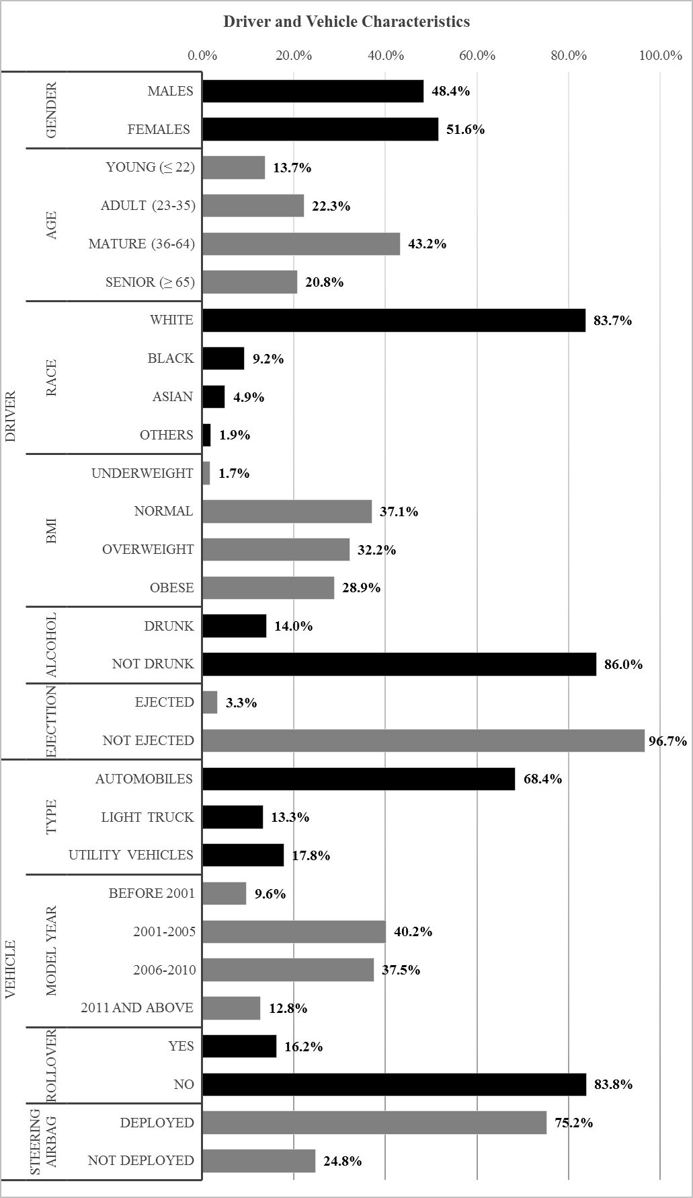

**Figure 2: Sample Characteristics (Driver and Vehicle Related Factors)**

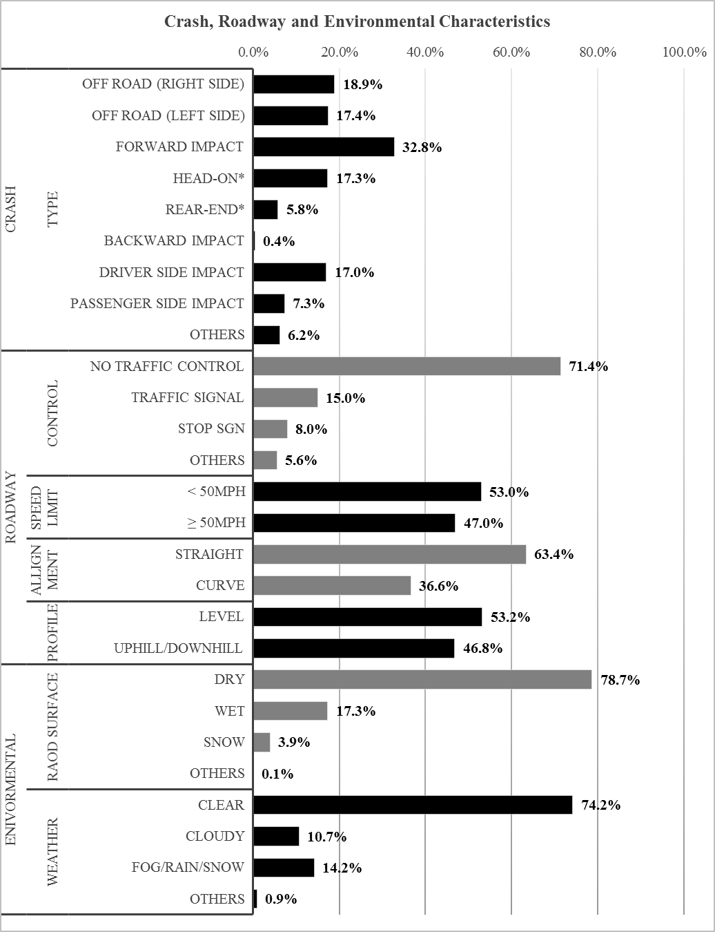

**Figure 3: Sample Characteristics (Crash, Roadway and Environment Related Factors)**

* Head on and Rear-end crashes are part of the Forward Impact crash (interaction terms).

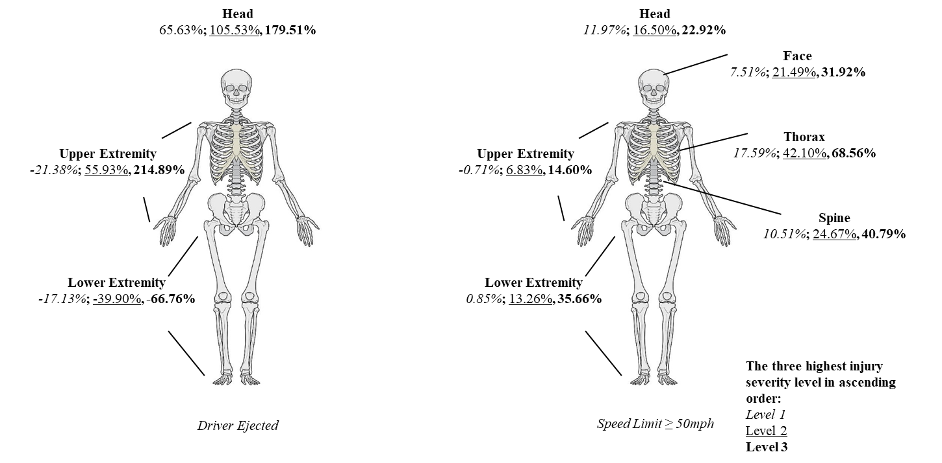

**Figure 4 Elasticity Effects for The Three Highest Injury Severity Level for Driver Ejected and Posted Speed Limit**

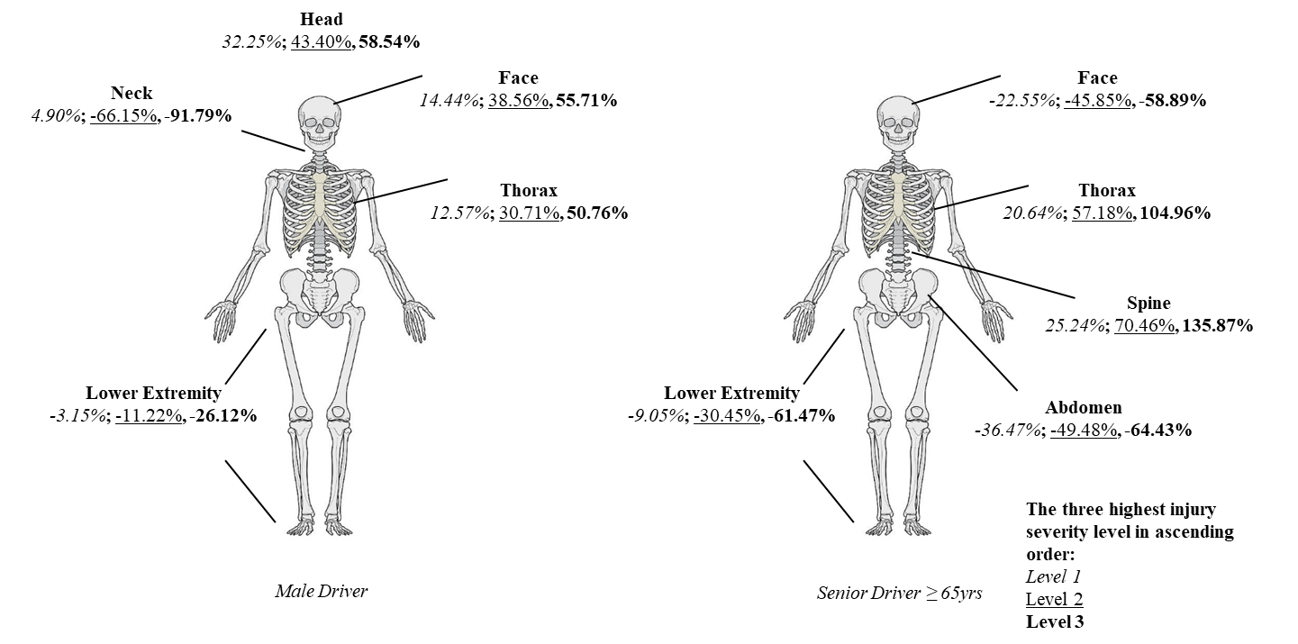

**Figure 5 Elasticity Effects for The Three Highest Injury Severity Level by Gender and Age of The Driver**

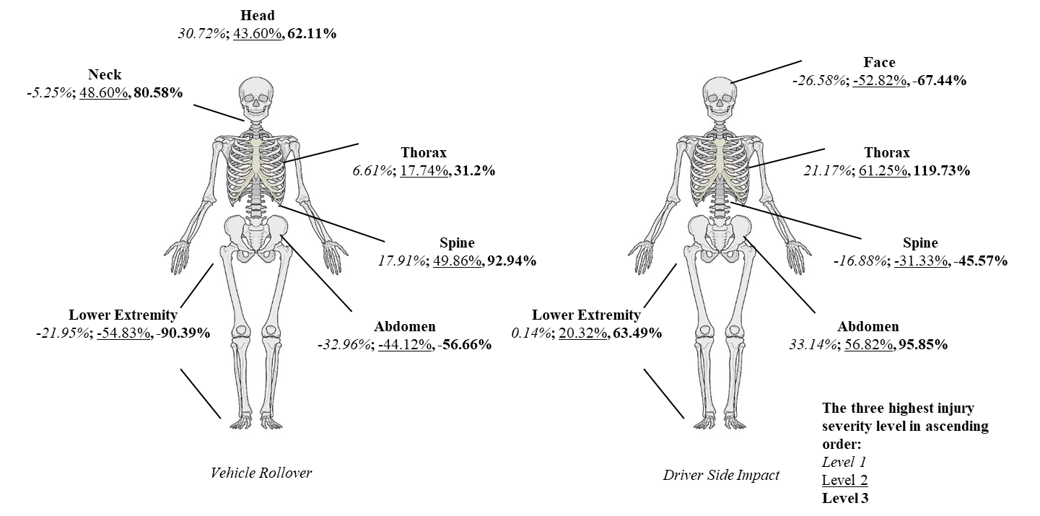

**Figure 6 Elasticity Effects for The Three Highest Injury Severity Level by Crash Types**

**TABLE 1 Summary of Earlier Research Employing Alternative Injury Severity Representations**

|  |  |  |  |  |  |  |  |  |  |
| --- | --- | --- | --- | --- | --- | --- | --- | --- | --- |
| **Exogenous Factors** | | | | | **Modeling Methodology Adopted** | **Body Regions Considered** | **Injury Severity Representation Adopted** | **Dataset Adopted** | **Study and Country** |
| **EC\*** | **RC\*** | **CC\*** | **VC\*** | **DC\*** |
| --- | ---2 | Y | Y | Y1 | Chi-square analysis  Logistic regression | Head/skull/face, neck, chest, pelvic/hip, other | AIS | NASS‐CDS | (Farmer et al., 1997), USA |
| --- | --- | --- | --- | Y | Descriptive analysis and logistic regression | All body regions | AIS and ISS | NASS‐CDS | (Mock et al., 2002), USA |
| --- | --- | Y | Y | Y | Regression models and logistic regression | No specific body region | MAIS | NASS‐CDS, CIREN | (Augenstein et al., 2003), USA |
| --- | --- | --- | Y | Y | Logistic regression | No specific body region | MAIS and AIS | NASS‐CDS | (Edmond and James, 2003), USA |
| --- | --- | --- | Y | --- | Descriptive study | Head, face | AIS | NASS‐CDS | (Huber et al., 2005), USA |
| --- | --- | Y | Y | --- | Multiple linear regression/  Ordered logistic regression | Pelvic and thoracic | AIS and MAIS | NASS‐CDS, CIREN | (Tencer et al., 2005), USA |
| --- | --- | --- | Y | --- | Correlation and frequencies test | Thoracic Injury | ISS, AIS | Drivers involved in crashes | (Matthes et al., 2006), Germany |
| --- | --- | Y | --- | Y | Chi-square analysis | Head and chest | MAIS, AIS,  Fatal/Serious/  Slight/No injury | National accident data | (Welsh et al., 2006), UK |
| --- | --- | --- | Y | --- | Descriptive study | All body regions | AIS | CIREN | (Pintar et al., 2007), USA |
| --- | --- | Y | Y | Y | Logistic regression models | All body regions | AIS and ISS | CIREN | (Conroy et al., 2008), USA |
| --- | --- | Y | Y | Y | Univariate and multivariate logistic regression | Thoracic Injury | AIS | NASS‐CDS, CIREN | (Nirula and Pintar, 2008), USA |
| --- | --- | Y | Y | Y | Descriptive study | All body regions | MAIS and ISS | NASS‐CDS, CIREN | (Pintar et al., 2008), USA |
| --- | --- | Y | Y | Y | Descriptive study | All body regions | AIS | CIREN | (Riden and Eigen, 2008), USA |
| --- | --- | Y | --- | Y | Multiple linear and logistic regression | All body regions | AIS and ISS | CIREN | (Ryb and Dischinger, 2008), USA |
| --- | --- | Y | Y | Y | Logistic regression models | All body regions | MAIS | CIREN | (Ryb et al., 2009a), USA |
| --- | --- | Y | Y | Y | Multiple logistic regression models | Head, face, neck, thorax, abdomen, spine, lower extremity | ISS, AIS and MAIS | CIREN | (Ryb et al., 2009b), USA |
| --- | --- | Y | Y | Y | Logistic regression | Head, thorax, lower extremity | AIS | NASS‐CDS, CIREN | (Elliott et al., 2010), USA |
| --- | --- | Y | Y | Y | Cox proportional hazards regression | Head, neck, thorax | AIS | NASS‐CDS, CIREN | (Griffin et al., 2012), USA |
| --- | --- | Y | Y | Y | Linear regression | Thoracolumbar spine (thoracic and lumbar vertebral body) | AIS | NASS‐CDS, CIREN | (Pintar et al., 2012), USA |
| --- | --- | Y | Y | Y | Logistic regression | All body regions | AIS and MAIS | NASS‐CDS, CIREN | (Ridella et al., 2012), USA |
| --- | --- | Y | Y | Y | Multivariate logistic regression | All body regions | AIS | NASS‐CDS, CIREN | (Rupp et al., 2013), USA |
| --- | --- | Y | Y | Y | Multivariate logistic regression | Head, spine, thorax, abdomen, upper extremity, lower extremity | AIS | NASS‐CDS | (Carter et al., 2014), USA |
| --- | --- | Y | Y | Y | Descriptive study | Head, neck/ spine, thorax, abdomen, extremities, pelvis/hip | AIS | NASS‐CDS, CIREN | (Brumbelow et al., 2015), USA |
| --- | --- | Y | --- | Y | Descriptive study | Head, face, abdomen, upper extremity, lower extremity thorax, cervical spine, thoracic spine lumbar spine, external | AIS | Folksam,(insurance company) | (Stigson et al., 2015), Sweden |
| --- | --- | --- | Y | Y | Multivariate logistic regression | No specific body region | ISS | National Trauma Data Bank | (Joseph et al., 2017), USA |
| --- | --- | Y | Y | Y | Forward stepwise logistic regression | Head, neck, chest abdomen/pelvis, c-spine,  T-spine, l-spine | AIS, and ISS | NASS‐CDS | (Hartka et al., 2018), USA |
| --- | --- | Y | --- | --- | Weighted values.  standard errors | Head, thorax, abdomen, spine, lower extremity, unspecified | MAIS | NASS‐CDS | (Parenteau et al., 2018), USA |
| --- | --- | --- | --- | Y | Descriptive study | Head, neck, thorax, abdomen, spine, lower extremity, unspecified | MAIS | NASS‐CDS | (Viano et al., 2018), USA |
| --- | --- | Y | Y | Y | Linear and logistic regression analyses | Upper extremity | AIS | CIREN | (Kelley et al.,2019), USA |

*DC= Driver characteristics; VC= vehicle characteristics, CC= crash characteristics, RC= roadway characteristics, EC= environmental characteristics

1 Y= attribute is considered

2 ---= attribute is not considered

**TABLE 2 Random Parameters Multivariate Generalized Ordered Probit Model Results**

|  |  |  |  |  |  |  |  |  |
| --- | --- | --- | --- | --- | --- | --- | --- | --- |
| **Variables Name** | **BODY REGIONS** | | | | | | | |
| ***Head*** | ***Face*** | ***Neck*** | ***Abdomen*** | ***Thorax*** | ***Spine*** | ***Lower extremity*** | ***Upper extremity*** |
| Coefficient  (T-stat) | Coefficient (T-stat) | Coefficient  (T-stat) | Coefficient  (T-stat) | Coefficient  (T-stat) | Coefficient (T-stat) | Coefficient (T-stat) | Coefficient (T-stat) |
| ***Threshold Parameters*** | | | | | | | | |
| Thresh01 | 0.396  (3.939) | 0.198  (1.719) | 1.218  (11.557) | 0.586  (4.974) | 0.161  (1.338) | 0.673  (8.045) | -0.760  (-6.994) | -0.012  (-0.14) |
| Thresh02 | -0.951  (-12.696) | 0.378  (9.422) | -0.195  (-2.141) | -0.628  (-9.932) | -0.903  (-11.972) | -0.098  (-2.115) | -0.306  (-6.273) | 0.055  (1.564) |
| Thresh03 | -0.771  (-10.333) | -0.148  (-1.601) | ---3 | -0.773  (-8.543) | -1.036  (-13.74) | 0.100  (1.291) | -0.549  (-10.502) | -0.191  (-3.57) |
| Thresh04 | -0.698  (-8.178) | --- | --- | -0.504  (-6.001) | 0.066  (1.389) | --- | 0.429  (8.26) | --- |
| Thresh05 | -0.566  (-5.269) | --- | --- | --- | 0.289  (3.645) | --- | --- | --- |
| ***Driver Characteristics*** | | | | | | | | |
| Younger driver (adult and mature driver are base) | 0.338  (3.448) | --- | --- | 0.238  (2.168) | --- | --- | --- | --- |
| Senior diver (adult and mature driver are base) | --- | -0.265  (-3.05) | --- | -0.336  (-3.75) | 0.346  (4.335) | 0.452  (5.877) | -0.310  (-4.584) | --- |
| Caucasian (Others are base | --- | 0.168  (1.762) | --- | 0.368  (3.366) | 0.297  (3.217) | --- | --- | 0.348  (4.4) |
| Male (Female is base) | 0.280  (3.85) | 0.246  (3.441) | -0.363  (-3.293) | --- | 0.213  (3.247) | --- | -0.093  (-1.639) | --- |
| Drunk (Not drunk is base) | --- | 0.186  (1.871) | --- | --- | --- | 0.162  (1.731) | --- | --- |
| BMI index ≥30 (Others are base) | --- | -0.306  (-3.868) | --- | 0.184  (2.382) | --- | --- | 0.123  (2.002) | --- |
| Between moderate and serious injury | --- | --- | --- | 0.360  (2.473) | --- | --- | --- | --- |
| ***Vehicle Characteristics*** | | | | | | | | |
| Vehicle model 2011 and later (others are base) | -0.296  (-2.484) | --- | --- | --- | --- | --- | -0.231  (-2.82) | -0.155  (-1.66) |
| Between moderate and serious injury | --- | --- | --- | --- | --- | --- | --- | 0.493  (3.483) |
| Automobiles car (Utility vehicles is base) | --- | --- | --- | --- | 0.175  (2.471) | --- | --- | --- |
| Light truck (Utility vehicles is base) | --- | --- | --- | -0.296  (-2.699) | --- | --- | --- | --- |
| Rollover | 0.265  (3.112) | --- | 0.314  (2.183) | -0.295  (-2.831) | --- | 0.342  (3.542) | -0.617  (-7.562) | --- |
| Between minor  and moderate injury | --- | --- | --- | --- | -0.396  (-1.897) | --- | --- | --- |
| Driver ejected | 0.563  (2.939) | --- | --- | --- | --- | --- | -0.418  (-2.638) | 0.846  (5.566) |
| Steering air bag deployed | -0.242  (-2.908) | --- | --- | --- | --- | --- | 0.353  (4.511) | 0.189  (2.918) |
| ***Crash Characteristics*** | | | | | | | | |
| Off road left side | 0.140  (1.558) | --- | --- | --- | --- | 0.182  (2.109) | --- | --- |
| Standard deviation | --- | --- | --- | --- | --- | 0.205  (3.264) | --- | --- |
| Forward impact | -0.338  (-3.115) | -0.422  (-3.095) | --- | 0.164  (2.038) | --- | --- | --- | --- |
| Forward Impact*Head On | 0.226  (1.696) | 0.342  (2.257) | --- | --- | --- | --- | 0.547  (6.853) | 0.297  (3.883) |
| Between serious and severe injury | --- | --- | --- | --- | --- | --- | 0.416  (4.273) | --- |
| Between severe and critical injury | --- | --- | --- | --- | -0.516  (-2.59) | --- | --- | --- |
| Forward impact*rear end | --- | 0.357  (1.964) | --- | --- | --- | -0.245  (-1.624) | --- | --- |
| Between moderate and serious injury | --- | 1.688  (11.273) | --- | --- | --- | --- | --- | --- |
| Driver side impact | --- | -0.315  (-3.111) | --- | 0.394  (3.756) | 0.370  (3.908) | -0.193  (-2.022) | 0.272  (3.083) | --- |
| Passenger side impact | --- | -0.235  (-1.631) | --- | --- | -0.415  (-3.411) | --- | -0.274  (-2.288) | --- |
| ***Roadway Characteristics*** | | | | | | | | |
| Straight road (curved road is base) | --- | --- | -0.188  (-1.756) | --- | -0.172  (-2.452) | --- | --- | --- |
| Road level (uphill/downhill is base) | --- | --- | --- | --- | 0.124  (1.897) | --- | --- | --- |
| No traffic control | --- | --- | --- | --- | --- | 0.183  (2.202) | --- | --- |
| Stop sign | 0.300  (2.232) | --- | --- | --- | --- | 0.31  (2.291) | --- | --- |
| Speed limit ≥ 50mph (< 50mph is base) | 0.126  (1.703) | 0.151  (2.066) | --- | --- | 0.280  (4.222) | 0.189  (2.874) | 0.175  (3.003) | 0.102  (1.831) |
| ***Environmental Characteristics*** | | | | | | | | |
| Snow/ Ice road surface (Others are base) | --- | 0.357  (2.106) | --- | --- | --- | 0.305  (2.123) | --- | --- |
| Clear weather (Others are base) | --- | --- | --- | --- | --- | --- | -0.126  (-1.968) | --- |
| ***Correlation*** | | | | | | | | |
| Correlation 1 (Head, Face, and Neck) | 0.612  (14.243) | | | | | | | |
| Correlation 2 (Abdomen, and Thorax | 0.685  (13.989) | | | | | | | |
| Rollover (Neck and Spine) | 0.658  (4.830) | | | | | | | |

3 ---= attribute insignificant at 90% significance level

**TABLE 3 Elasticity Effects Analysis for all Injury Severity Levels (IGOP and RPMGOP Models)**

|  |  |  |  |  |  |  |  |  |
| --- | --- | --- | --- | --- | --- | --- | --- | --- |
| **BODY REGION** | **VARIABLE** | **MODEL** | **THE ELASTICITY** | | | | | |
| ***No injury*** | ***Minor injury*** | ***Moderate injury*** | ***Serious injury*** | ***Severe injury*** | ***Critical injury*** |
| Mean (90% C.I.) | Mean (90% C.I.) | Mean (90% C.I.) | Mean (90% C.I.) | Mean (90% C.I.) | Mean (90% C.I.) |
| **Head** | Male | IGOP | -13.12 (-24.7, -1.54) | 8.87 (1.55, 16.19) | 15.73 (10.06, 21.41) | 23.43 (19.03, 27.84) | 31.8 (27.65, 35.95) | 44.65 (37.97, 51.32) |
| RPMGOP | -15.07 (-29.21, -0.92) | 12.31 (2.62, 22) | 21.76 (14.29, 29.24) | 32.25 (26.45, 38.04) | 43.4 (38.07, 48.72) | 58.54 (51.44, 65.64) |
| Rollover | IGOP | -13.11 (-25.5, -0.73) | 7.11 (-1.49, 15.72) | 14.3 (7.4, 21.2) | 22.76 (16.84, 28.67) | 32.4 (25.55, 39.25) | 48.24 (34.97, 61.5) |
| RPMGOP | -14.43 (-28.6, -0.25) | 9.61 (-1.29, 20.51) | 19.3 (10.46, 28.14) | 30.72 (23.02, 38.43) | 43.6 (34.63, 52.56) | 62.11 (46.59, 77.63) |
| Driver ejected | IGOP | -29.48 (-52.98, -5.98) | 9.96 (-15.18, 35.09) | 27.68 (4.04, 51.32) | 51.06 (28.88, 73.24) | 81.48 (58.64, 104.33) | 143.94 (105.74, 182.15) |
| RPMGOP | -29.96 (-56.02, -3.9) | 13.16 (-15.76, 42.09) | 35.47 (8.01, 62.93) | 65.63 (38.81, 92.44) | 105.53 (74.63, 136.43) | 179.51 (123.72, 235.3) |
| Speed limit ≥ 50mph | IGOP | -6.44 (-15.4, 2.51) | 3.23 (-0.34, 6.8) | 6.3 (2.65, 9.95) | 9.76 (4.33, 15.18) | 13.51 (5.51, 21.52) | 19.52 (6.27, 32.78) |
| RPMGOP | -6.82 (-17.14, 3.51) | 3.93 (-0.49, 8.34) | 7.73 (2.78, 12.68) | 11.97 (4.39, 19.54) | 16.5 (5.48, 27.51) | 22.92 (6.08, 39.76) |
| **Face** | Senior diver | IGOP | 13.84 (10.53, 17.14) | -16.93 (-32.62, -1.24) | -34.66 (-57.89, -11.43) | -46.12 (-72.78, -19.46) | ---1 | --- |
| RPMGOP | 16.67 (13.26, 20.08) | -22.55 (-42.37, -2.73) | -45.85 (-73.68, -18.01) | -58.89 (-89.18, -28.61) | --- | --- |
| Male | IGOP | -14.17 (-27.86, -0.48) | 11.11 (4.71, 17.5) | 29.13 (24.38, 33.89) | 43.15 (34.38, 51.91) | --- | --- |
| RPMGOP | -16.37 (-33.13, 0.39) | 14.44 (6.43, 22.45) | 38.56 (32.26, 44.87) | 55.71 (45.31, 66.1) | --- | --- |
| Driver side impact | IGOP | 16.73 (13.18, 20.27) | -20.35 (-38.51, -2.19) | -40.8 (-67.06, -14.53) | -54.12 (-84.26, -23.98) | --- | --- |
| RPMGOP | 19.75 (15.7, 23.8) | -26.58 (-49.14, -4.02) | -52.82 (-84.1, -21.53) | -67.44 (-101.56, -33.32) | --- | --- |
| Speed limit ≥ 50mph | IGOP | -8.95 (-20.4, 2.5) | 6.01 (2.05, 9.98) | 16.79 (9.48, 24.1) | 25.46 (12.23, 38.7) | --- | --- |
| RPMGOP | -10.1 (-23.83, 3.64) | 7.51 (2.62, 12.41) | 21.49 (11.62, 31.36) | 31.92 (15.11, 48.73) | --- | --- |
| **Neck** | Male | IGOP | 5.37 (4.32, 6.43) | -41.2 (-65.43, -16.98) | -60.34 (-92.63, -28.06) | --- | --- | --- |
| RPMGOP | 4.9 (4.15, 5.64) | -66.15 (-101.45, -30.85) | -91.79 (-135.04, -48.53) | --- | --- | --- |
| Rollover | IGOP | -10.49 (-19.37, -1.61) | 63.06 (53.11, 73.02) | 109.86 (80.81, 138.9) | --- | --- | --- |
| RPMGOP | -5.25 (-13.3, 2.79) | 48.6 (19.34, 77.87) | 80.58 (22.74, 138.43) | --- | --- | --- |
| **Abdomen** | Senior diver | IGOP | 17.73 (15.66, 19.81) | -16.49 (-32.35, -0.62) | -27.31 (-47.32, -7.29) | -37.88 (-61.26, -14.49) | -52.12 (-77.33, -26.91) | --- |
| RPMGOP | 19.44 (16.73, 22.16) | -22.29 (-43.36, -1.22) | -36.47 (-62.39, -10.54) | -49.48 (-78.8, -20.17) | -64.43 (-94.83, -34.03) | --- |
| Driver side impact | IGOP | -19.81 (-35.26, -4.37) | 8.65 (-3.49, 20.8) | 21.61 (11.19, 32.04) | 36.74 (27.88, 45.61) | 64.33 (52.69, 75.97) | --- |
| RPMGOP | -23.67 (-42.87, -4.48) | 13.09 (-4.49, 30.66) | 33.14 (17.26, 49.03) | 56.82 (42.64, 70.99) | 95.85 (80.67, 111.03) | --- |
| Rollover | IGOP | 16.62 (13.18, 20.06) | -16.33 (-32.54, -0.12) | -26.37 (-46.94, -5.8) | -36.01 (-60.11, -11.91) | -48.64 (-75, -22.27) | --- |
| RPMGOP | 16.98 (13.25, 20.71) | -20.61 (-40.95, -0.27) | -32.96 (-58.37, -7.56) | -44.12 (-73.18, -15.07) | -56.66 (-87.59, -25.72) | --- |
| **Thorax** | Senior diver | IGOP | -26.52 (-43.65, -9.39) | -7.43 (-24.72, 9.87) | 0.05 (-16.81, 16.91) | 14.57 (0.5, 28.63) | 39.86 (29.54, 50.18) | 72.88 (66.85, 78.91) |
| RPMGOP | -32.41 (-53.65, -11.18) | -10.21 (-33.19, 12.77) | 0.26 (-22.68, 23.21) | 20.64 (1.1, 40.17) | 57.18 (41.94, 72.42) | 104.96 (94.21, 115.71) |
| Male | IGOP | -16.83 (-31.53, -2.14) | -3.95 (-15.35, 7.45) | 0.59 (-9.51, 10.68) | 8.86 (2.05, 15.67) | 21.89 (17.65, 26.12) | 36.84 (29.93, 43.75) |
| RPMGOP | -21.27 (-40.16, -2.39) | -5.52 (-21.13, 10.09) | 0.99 (-13, 14.97) | 12.57 (3.12, 22.03) | 30.71 (24.89, 36.53) | 50.76 (43.31, 58.21) |
| Driver side impact | IGOP | -27.92 (-46.74, -9.09) | -8.32 (-27.04, 10.4) | -0.53 (-18.69, 17.64) | 14.81 (-0.23, 29.85) | 42.12 (31.27, 52.97) | 80.08 (71.45, 88.72) |
| RPMGOP | -34.14 (-57.18, -11.09) | -11.37 (-36.06, 13.32) | -0.45 (-25.05, 24.14) | 21.17 (0.19, 42.15) | 61.25 (44.81, 77.7) | 119.73 (105.57, 133.89) |
| Rollover | IGOP | --- | -31.02 (-56.25, -5.8) | -0.11 (-5.88, 5.66) | 4.82 (0.56, 9.08) | 12.91 (7.62, 18.21) | 22.83 (13.24, 32.43) |
| RPMGOP | --- | -30.82 (-56.69, -4.94) | -0.11 (-7.85, 7.62) | 6.61 (0.86, 12.36) | 17.74 (10.28, 25.2) | 31.2 (18.07, 44.32) |
| Speed limit ≥ 50mph | IGOP | -22.71 (-39.42, -6.01) | -4.99 (-19.43, 9.45) | 1.32 (-12.03, 14.68) | 12.76 (2.83, 22.68) | 30.83 (24.69, 36.97) | 51.3 (47.23, 55.37) |
| RPMGOP | -27.93 (-49.08, -6.78) | -6.83 (-26.2, 12.53) | 1.99 (-16.13, 20.12) | 17.59 (4.13, 31.06) | 42.1 (33.43, 50.76) | 68.56 (63.51, 73.62) |
| **Spine** | Senior diver | IGOP | -24.95 (-39.09, -10.8) | 23.18 (9.75, 36.61) | 62.96 (52.16, 73.76) | 119.56 (112.43, 126.69) | --- | --- |
| RPMGOP | -26.73 (-41.71, -11.75) | 25.24 (10.01, 40.47) | 70.46 (57.63, 83.29) | 135.87 (127.03, 144.72) | --- | --- |
| Driver side impact | IGOP | 11.13 (5.86, 16.4) | -16.47 (-31.99, -0.96) | -30.36 (-53.93, -6.78) | -43.98 (-74.69, -13.26) | --- | --- |
| RPMGOP | 11.2 (5.85, 16.54) | -16.88 (-32.88, -0.89) | -31.33 (-55.72, -6.95) | -45.57 (-77.54, -13.6) | --- | --- |
| Rollover | IGOP | -23.96 (-38.89, -9.03) | 21.51 (8.59, 34.42) | 60.13 (51.74, 68.53) | 112.55 (102.28, 122.82) | --- | --- |
| RPMGOP | -20.07 (-35.36, -4.77) | 17.91 (8.12, 27.7) | 49.86 (42.2, 57.53) | 92.94 (73.53, 112.35) | --- | --- |
| Speed limit ≥ 50mph | IGOP | -9.55 (-19.06, -0.04) | 8.82 (5.9, 11.74) | 20.61 (14.31, 26.92) | 34.04 (21.3, 46.78) | --- | --- |
| RPMGOP | -10.95 (-21.17, -0.73) | 10.51 (7.11, 13.92) | 24.67 (18.83, 30.52) | 40.79 (28.78, 52.8) | --- | --- |
| **Lower extremity** | Senior diver | IGOP | 40.25 (36.7, 43.8) | 8.57 (-2.78, 19.92) | -9.04 (-25.74, 7.66) | -30.45 (-50.6, -10.29) | -61.48 (-87.47, -35.49) | --- |
| RPMGOP | 40.23 (36.63, 43.84) | 8.55 (-2.8, 19.91) | -9.05 (-25.78, 7.68) | -30.45 (-50.66, -10.24) | -61.47 (-87.55, -35.4) | --- |
| Male | IGOP | 11.71 (3.65, 19.77) | 2.64 (-0.33, 5.61) | -3.14 (-8.92, 2.65) | -11.21 (-22.67, 0.25) | -26.11 (-49.65, -2.57) | --- |
| RPMGOP | 11.7 (3.56, 19.84) | 2.62 (-0.37, 5.62) | -3.15 (-8.95, 2.65) | -11.22 (-22.73, 0.29) | -26.12 (-49.78, -2.45) | --- |
| Driver side impact | IGOP | -29.25 (-51.33, -7.17) | -12.08 (-30.04, 5.88) | 0.14 (-14.38, 14.66) | 20.31 (12.33, 28.3) | 63.45 (46.56, 80.35) | --- |
| RPMGOP | -29.26 (-51.35, -7.18) | -12.09 (-30.07, 5.89) | 0.14 (-14.41, 14.69) | 20.32 (12.31, 28.33) | 63.49 (46.65, 80.33) | --- |
| Rollover | IGOP | 86.43 (74.03, 98.84) | 12.17 (-17.77, 42.1) | -21.93 (-54, 10.13) | -54.82 (-81.66, -27.97) | -90.38 (-112.25, -68.52) | --- |
| RPMGOP | 86.44 (74.07, 98.81) | 12.15 (-17.83, 42.13) | -21.95 (-54.08, 10.17) | -54.83 (-81.74, -27.92) | -90.39 (-112.31, -68.47) | --- |
| Driver ejected | IGOP | 57.9 (39.17, 76.63) | 5.35 (-12.22, 22.93) | -17.12 (-41.8, 7.57) | -39.91 (-68.35, -11.46) | -66.77 (-98.66, -34.89) | --- |
| RPMGOP | 57.86 (39.06, 76.66) | 5.34 (-12.26, 22.93) | -17.13 (-41.84, 7.58) | -39.9 (-68.38, -11.42) | -66.76 (-98.71, -34.8) | --- |
| Speed limit ≥ 50mph | IGOP | -20.29 (-37.72, -2.87) | -7.45 (-19.78, 4.88) | 0.85 (-8.17, 9.87) | 13.25 (9.2, 17.29) | 35.65 (26.64, 44.66) | --- |
| RPMGOP | -20.29 (-37.7, -2.89) | -7.45 (-19.78, 4.89) | 0.85 (-8.18, 9.89) | 13.26 (9.2, 17.31) | 35.66 (26.73, 44.6) | --- |
| **Upper extremity** | Driver ejected | IGOP | -67.91 (-86.16, -49.66) | -21.6 (-52.61, 9.4) | 55.58 (11.04, 100.11) | 214.48 (189.73, 239.22) | --- | --- |
| RPMGOP | -67.81 (-86.42, -49.21) | -21.38 (-53.35, 10.59) | 55.93 (9.54, 102.32) | 214.89 (187.72, 242.07) | --- | --- |
| Speed limit ≥ 50mph | IGOP | -10.42 (-22.23, 1.39) | -0.68 (-5.06, 3.71) | 6.89 (3.28, 10.5) | 14.66 (4.61, 24.71) | --- | --- |
| RPMGOP | -10.43 (-22.45, 1.6) | -0.71 (-5.32, 3.9) | 6.83 (3.21, 10.46) | 14.6 (4.57, 24.63) | --- | --- |

1 ---= attribute is not considered