EVALUATING VEHICULAR EMISSIONS WITH AN INTEGRATED MESOSCOPIC AND MICROSCOPIC TRAFFIC SIMULATION

**Timothy M.N. Sider -** Graduate Student

Civil Engineering & Applied Mechanics, McGill University

817 Sherbrooke St. W., Room 492

Montreal, Quebec H3A 2K6, Canada

Tel.: 514-398-6935; Fax: 514-398-7361; [timothy.sider@mcgill.ca](mailto:timothy.sider@mcgill.ca)

**Ahsan Alam -** Doctoral Candidate

Civil Engineering & Applied Mechanics, McGill University

817 Sherbrooke St. W., Room 492

Montreal, Quebec H3A 2K6, Canada

Tel.: 514-398-6935; Fax: 514-398-7361; [ahsan.alam2@mail.mcgill.ca](mailto:ahsan.alam2@mail.mcgill.ca)

**William Farrell -** Graduate Student

Civil Engineering & Applied Mechanics, McGill University

817 Sherbrooke St. W., Room 492

Montreal, Quebec H3A 2K6, Canada

Tel.: 514-398-6935; Fax: 514-398-7361; [william.farrell@mcgill.ca](mailto:william.farrell@mcgill.ca)

**Marianne Hatzopoulou** - Assistant Professor

Civil Engineering & Applied Mechanics, McGill University

817 Sherbrooke St. W., Room 492

Montreal, Quebec H3A 2K6, Canada

Tel.: 514-398-6935; Fax: 514-398-7361; [marianne.hatzopoulou@mcgill.ca](mailto:marianne.hatzopoulou@mcgill.ca)

**Naveen Eluru -** Associate Professor (Corresponding Author)

Civil, Environmental and Construction Engineering, University of Central Florida

12800 Pegasus Drive, Room 301D

Orlando, Florida 32816, USA

Tel.: 407-823-4815; Fax: 407-823-3315; [naveen.eluru@ucf.edu](mailto:naveen.eluru@ucf.edu)

ABSTRACT

This paper demonstrates the implementation of a traffic simulation linked with instantaneous emissions modelling and is used to evaluate the effects of street closures and area-wide pedestrianization on vehicle-induced greenhouse gas emissions. The study is set in Montreal, Canada where traffic in a dense borough (8,656 links) is simulated in a dynamic traffic assignment (DTA) mode to generate second-by-second speed profiles along every link in the 7-8 AM period. Instantaneous speeds are then used to estimate link-level and intersection-level emissions. The traffic demand at the borough boundaries is simulated using a mesoscopic traffic assignment model developed for the Montreal metropolitan region (127,217 links). Street closures and area-wide pedestrianization schemes are modelled within the microscopic as well as the mesoscopic models in order to evaluate their effects on greenhouse gas emissions, both while accounting for changes in demand and under constant demand. In all cases, we observe an increase in borough-level greenhouse gas emissions compared to the base-case scenario indicating that such schemes do not lead to a reduction in emissions even when accounting for changes in demand. We also compare emissions calculated using the microscopic models (traffic and emissions) and those obtained from the mesoscopic assignment (traffic and average-speed emissions) and observe that the regional model is much less sensitive to local-level changes mostly due to the incapacity of simulating accelerations and decelerations and therefore underestimating the changes in borough-level emissions compared to the base-case scenario. This indicates the importance of adopting instantaneous emissions models for the evaluation of changes to street configuration.

**Keywords:** Mesoscopic traffic simulation, microscopic traffic simulation, emissions modelling, transportation environmental impacts, greenhouse gases

# Introduction

Traffic congestion levels have risen substantially in Canadian and American urban areas over the past decade. The negative externalities of traffic congestion include travel time delays, financial losses (excess fuel usage and lost work time), and rising air pollution and greenhouse gas (GHG) emissions (Transport Canada 2006, Schrank, and Lomax, 2009). Of particular concern from a societal point of view is the impact of traffic-related air pollution on the health of urban populations. In fact, there are sufficient data to conclude that chronic exposure to traffic pollutants is associated with the incidence and mortality from cardiovascular disease, especially ischemic heart disease, and from lung cancer (Gan et al., 2012, Chen et al., 2008; Brook et al., 2004). As well, there are overwhelming data implicating acute exposures to air pollution with a variety of immediate health effects (Pope at al., 2006; Dockery, 2001; Pope, 2000). Further, given that traffic emissions of air pollutants are highest at low speeds (especially during idling) reducing traffic congestion in urban regions is important.

In this context, it is not surprising that metropolitan agencies in urban regions are reviewing strategies to reduce the impact of traffic congestion. With increasing environmental concerns, local municipalities and boroughs are also considering the implementation of road network and infrastructure changes within their jurisdictions. These local agencies are particularly interested in managing traffic volumes on the lower level transportation networks (minor arterials, collectors and local roads) (see Wang et al., 2013). Within the transportation planning paradigm, it is nearly impossible to represent the transportation network at a fine resolution (Lopez and Monzon, 2010). The inadequate prediction of traffic volumes on smaller roads (minor arterials, collectors and local roads) - where most people reside ‑ is important from an environmental and public health perspective. The lack of an accurate prediction framework is of a particular concern for local agencies considering traffic calming measures. Moreover, knowledge of traffic volumes (including second-by-second vehicle speed information) is essential for estimating air pollutants and GHG emissions from vehicular traffic.

## Motivation

This study is motivated by the need to evaluate the effects of street closures and area-wide pedestrianization as means to reduce GHG emissions in a dense borough located in Montreal, Canada. The Montreal Metropolitan Region covers an area of approximately 7,000 km2 and has a population of about 3.8 million (Statistics Canada, 2011); the region is dominated by the island of Montreal, with approximately 47% of the region’s population and 67% of the region’s 1.7 million employment opportunities (Agence métropolitaine de Transport, 2010). Within the metropolitan region, we particularly focus on the Plateau-Mont-Royal borough, more often referred to as “the Plateau”. The Plateau is a dense and lively area, characterized by its environmentally conscious population and a local council that is faced with the challenge of reducing its GHG emissions from traffic[1]. It currently experiences many elements of an unsustainable transportation system: (1) Large volumes of “through” traffic generates significant amounts of pollution and causes increased safety risks and (2) Narrow local streets experience heavy traffic volumes limiting space for cyclists and pedestrians. The Plateau borough in the context of the Montreal Metropolitan Region is provided in Figure 1. The Plateau recorded a population of 101,054 individuals in an area of only 8.1 km2, according to the most recent Canadian census report. This equates to a population density of 12,476 individuals per square kilometer, or conversely, 80 m2 for every person. In the Plateau region the trip modal split is as follows: 34% by Automobile, 28% by Public Transit and 34% by Active Transport (walking or cycling). Recent statistics clearly highlight the environmental friendly attitude among the Plateau residents. At the same time, the Plateau residents are exposed to some of the highest levels of pollution because of its strategic location, attracting “through” traffic destined to Montreal’s central business district.

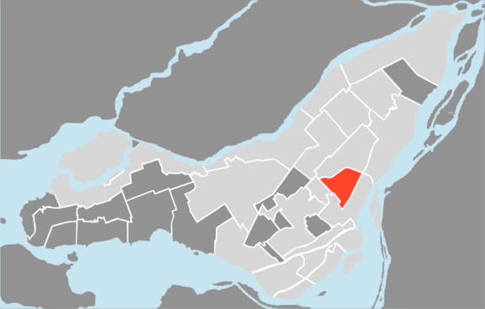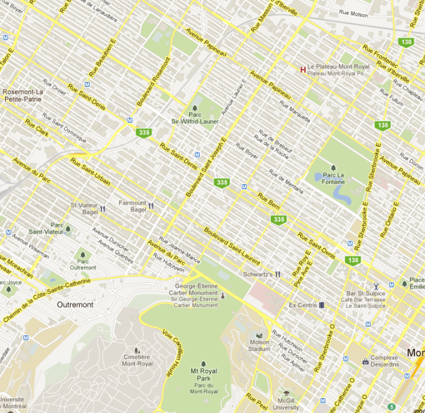

Figure 1. The Plateau borough in the context of the Montreal region

**1.2 Study objectives**

Traditional approaches have considered micro-simulation for either an intersection or a small set of intersections. For larger neighborhood level studies, mesoscopic models are typically employed for traffic and emissions modeling. In our study, we employ a micro-simulation based traffic and emissions modeling for a neighborhood with about 600 intersections. In this study, we develop a large-scale integrated model employing a combination of mesoscopic and microscopic traffic modelling and instantaneous speed-based vehicle emissions modelling to examine traffic flow and GHG emissions on Montreal urban streets. Specifically, we employ the PTV mesoscopic model (VISUM) to determine the traffic flow assignment for the Montreal urban region (network of 127,217 links) and microscopic model (VISSIM) to examine the Plateau borough in Montreal, a network consisting of 8,656 links and 576 intersections (PTVAG, 2012). Second-by-second vehicle speed information is processed through the USEPA’s Motor Vehicle Emissions Simulator (MOVES) to generate link-level GHG emissions. The analysis tools developed will allow us to compare the performance of traffic and emission modeling in the context of the proposed integrated framework and the traditional aggregate approaches. Within this broad paradigm, the current study has the following objectives: (1) Examine traffic flow patterns and GHG emissions at a link level for a reasonably large borough in a microscopic framework, and (2) Develop a policy tool that evaluates the impacts of regional and local transportation infrastructure changes at a neighbourhood level. To illustrate potential applicability of the model, we examine traffic and emissions for two pedestrianization scenarios: (1) corridor level pedestrianization and (2) area-wide pedestrianization while accounting for changes in traffic demand as well as under constant demand. The main contribution of this work is a demonstration of the potential of micro-simulation at a neighbourhood scale for the evaluation of traffic emissions under various policies affecting the road network. The proposed framework is contrasted with a traditional aggregate-level analysis in order to highlight possible weaknesses of the latter.

# Recent Advances in Traffic and Emission Modelling

This paper presents an integrative process whereby traffic simulation and emission estimation are incorporated simultaneously. The literature review section discusses advances in both streams of research.

## Traffic flow models

The distinction between the three forms of traffic flow modeling – macroscopic, mesoscopic, and microscopic – is well documented in the literature (Burghout et al., 2006). Macroscopic models consider traffic flow through traffic flow relationships involving measures such as flow, density, and speed. Microscopic models simulate individual vehicles at a fine resolution considering vehicle speed, acceleration, and lane changing behaviour (Burghout et al., 2006; Burghout, and Wahlstedt, 2007). Mesoscopic models are positioned in between the macroscopic and microscopic models. The exact structure of the mesoscopic model can take several forms. In one of the approaches, vehicles grouped as platoons are routed through the network. Alternatively, vehicles are allocated on possible paths between an origin destination pair based on perceived route travel times (Sheffi, 1985). In another approach, aggregate sets of vehicles employing speed-density relationships coupled with queuing theory concepts are applied (see page 10 Burghout, 2005 for a detailed discussion of various approaches).

Microscopic level models are more adept at allowing us to study incident detection while mesoscopic level models are more suited for larger networks. The different scales of these models offer distinct advantages and limitations; an increase in the resolution and detail is compensated by an enormous increase in computational burden. The contemporary challenge of simulating traffic flow lies within the scale of the modelling framework and the size of the network under consideration. When the size of the network is reasonably large, it is prohibitively expensive to develop a micro-scale traffic model.

Towards addressing this challenge, various transportation researchers have developed integrated models of different resolutions. For instance, mesoscopic models are integrated with microscopic models (Burghout et al., 2006). Researchers have also explored the traffic flow properties at the boundary transfer point for different scales (Leclercq, 2006). However, the theoretical research on this topic is still in its infancy (Burghout et al., 2006, Shelton et al., 2009). Burghout et al. (2006) discuss the empirical implications of connecting models at different scales by highlighting the important conditions that need to be considered. The authors conclude that the locations of boundaries are particularly important because these demarcate traffic flow at different scales. The authors suggest that boundaries should be located along a link where traffic flow properties are expected to be homogeneous, as opposed to locating them on intersections. The authors implemented their framework for an artificial network using Mezzo for mesoscopic simulation and MITSIMLab for the microscopic simulation. In another study, Burghout, and Wahlstedt (2007) examined the integration between Mezzo and VISSIM*.* In this application, the authors considered a large section of Stockholm, Sweden for the mesoscopic component and a three intersection network for the microscopic component. In the study, the authors validated outputs from the microscopic model and found that traffic volumes were more accurate with the microscopic model compared to the volumes from mesoscopic models.

## Emission models

A considerable number of vehicle emission models have been developed to estimate and predict the amount of pollutants at macroscopic, mesoscopic, and microscopic levels. Analyses of the efficacy of each degree of resolution are evaluated in several studies (Abo-Qudais and Abu Qdais, 2005, Rakha et al., 2003, Ahn et al., 2002). Macroscopic models provide emission estimates based on an average network speed by facility type. These models are often used to generate region-wide or state-wide emission inventories. For example, Qian and Zhang (2013) implemented a macroscopic level emissions model to study the impact of highway closures using NetZone. On the other hand, mesoscopic models employ average link speeds for emission estimation. These models are sensitive to spatial variability across the network. Microscopic emission models consider instantaneous vehicle speeds thus accounting for second-by-second speed profiles including acceleration, deceleration, idling and cruising i.e. they are sensitive to the variation in drive cycles that might occur within the same average speed. Such increases in resolution have been made possible by the recent shift in research from static assignment models to dynamic models, where the latter disaggregates data into individual trips, sensitive to minor changes in the road network (Lin et al., 2011; Hao et al., 2010). The analysis employs a macroscopic model to determine demand changes due to highway closure.

For long-range transportation planning the macro and meso-scale emission models are adequate; however for examining the influence of traffic volumes on air pollution and related public health impacts, micro-scale models are essential. Recently, a number of studies have focused on incorporating emission measures within a mesoscopic model (Aziz and Ukkusuri 2012) or within network design problems (Ferguson et al., 2012). However, these studies are primarily focused on incorporating emissions with traffic signal and/or network designs. Yang et al. (2011) propose an approach to estimate emissions at a microscopic level for arterial corridors. The approach is designed to estimate emissions for observed traffic flows by generating vehicle trajectories. However, this approach is not suited to undertake an evaluation of the impact of regional and local level changes on the system performance in terms of traffic volumes and resulting emissions.

# Methodology

This study involves the implementation of a mesoscopic regional level model, microscopic neighbourhood level model and instantaneous emissions simulator. In this section, we provide detail on each of these modules.

## Regional model

The Montreal regional model (MRM) was created in VISUM to generate input traffic flows for the Plateau neighbourhood model (PNM). The former takes as input the 2008 Origin-Destination (O-D) trip data for the Montreal region provided by the Agence Métropolitaine de Transport(AMT); it consists of 127,217 links. From this model we were able to extract the proportions of trips on the network entering and leaving the Plateau borough. The MRM output was used to generate a multi-dimensional matrix containing the numbers of trips between every two traffic analysis zones for the following trips: (1) generated outside the Plateau and destined to the borough, (2) generated in the borough and destined to an outside zone, (3) generated and destined within the Plateau, and (4) generated outside the borough and destined outside the borough (through traffic). This matrix is the main driver for the PNM which is run in Dynamic Traffic Assignment (DTA) mode available in VISSIM.

MRM is run under the stochastic user equilibrium(SUE) traffic assignment for the 6 AM to 7 AM period and again for the 7 AM to 8 AM period. One file containing all of the origin and destination traffic analysis zones (TAZ) path information is then extracted for each time period. These files are processed using a Visual Basics Application (VBA) in order to extract the O-D matrix at the boundary of the microsimulated region. Following this, a 5 AM to 6 AM O-D matrix is created by taking 10% of the volume from the 6 AM to 7 AM matrix. These matrices were then fed into the PNM, with the 5 AM to 6 AM period serving as the “warm-up” hour.

## Microscopic simulation

In order to evaluate the effects of various policy interventions on traffic flow, speed, and emissions, we developed a microscopic model for the road network of the Plateau neighbourhood (PNM). The first step in the development of the traffic simulation involved the creation of a database of all intersections in the study area. For every intersection, traffic light signal phases, and turning restrictions were compiled. Turning restrictions were gathered using Google Maps StreetView and then confirmed through field visits. Traffic counts were obtained from the City of Montreal’s automatic counters as well as through manual counts. The PNM network was developed using a combination of orthophotographs, topographic maps, cartographic maps, and field visits. Bicycle lanes were added to the network, as well as any crosswalks where pedestrians would conflict with turning vehicles. In total, the PNM network has 8,656 links and connectors and 576 intersections. Conflict areas were assigned to any segment where the three travel modes could overlap; 5,987 in all. All stop signs and traffic lights were included, as well as the changes in speed limit between arteries, local roads and school zones. The 43 public transit bus lines running through the borough were then incorporated, along with the 361 bus stops. Reduced speed areas were allocated to every turn to account for changes in speed. The PNM network can be seen highlighted within the MRM network in Figure 2.

Based on the input from the MRM, the PNM microscopic simulation was used to assign vehicles on the very detailed road network within the borough. Dynamic traffic assignment (DTA) available in VISSIM was used, and so each link on the periphery acted as an abstract parking lot whereby vehicles were generated onto and removed from the network. Vehicles that originated from or were destined to the Plateau were included by adding an origin link and a destination link for each TAZ centroid. The Plateau region consisted of 125 origin destination pairs in 50 TAZs. The following parameters were used for the DTA[2]:

* Evaluation Interval: 1,800s,
* Costs were stored using the *method of successive averages* (MSA),
* The number of paths was limited to 999 per O-D pair,
* Paths with a total cost higher than 75% of the best path were rejected,
* Paths and volumes were stored using a Kirchhoff exponent of 3.5, logit scaling factor of 1.5, and a logit lower limit of 0.001,
* Overlapping paths were corrected for,
* Detours greater than 2.5 times the length of the best path were avoided,
* The convergence criteria was set for travel time on edges so that that the variance of the travel time on any given edge was not greater than 2.

We then ran PNM in *multirun* mode with the volume initially set at 10% of the total, increasing by 10% for the next nine iterations, until it eventually reached the convergence criterion. In the base case, convergence was reached after 23 iterations. One final iteration was run in order to generate the results for the instantaneous link speeds to be evaluated in the vehicle emission model. Data were recorded for the 7-8 AM period.

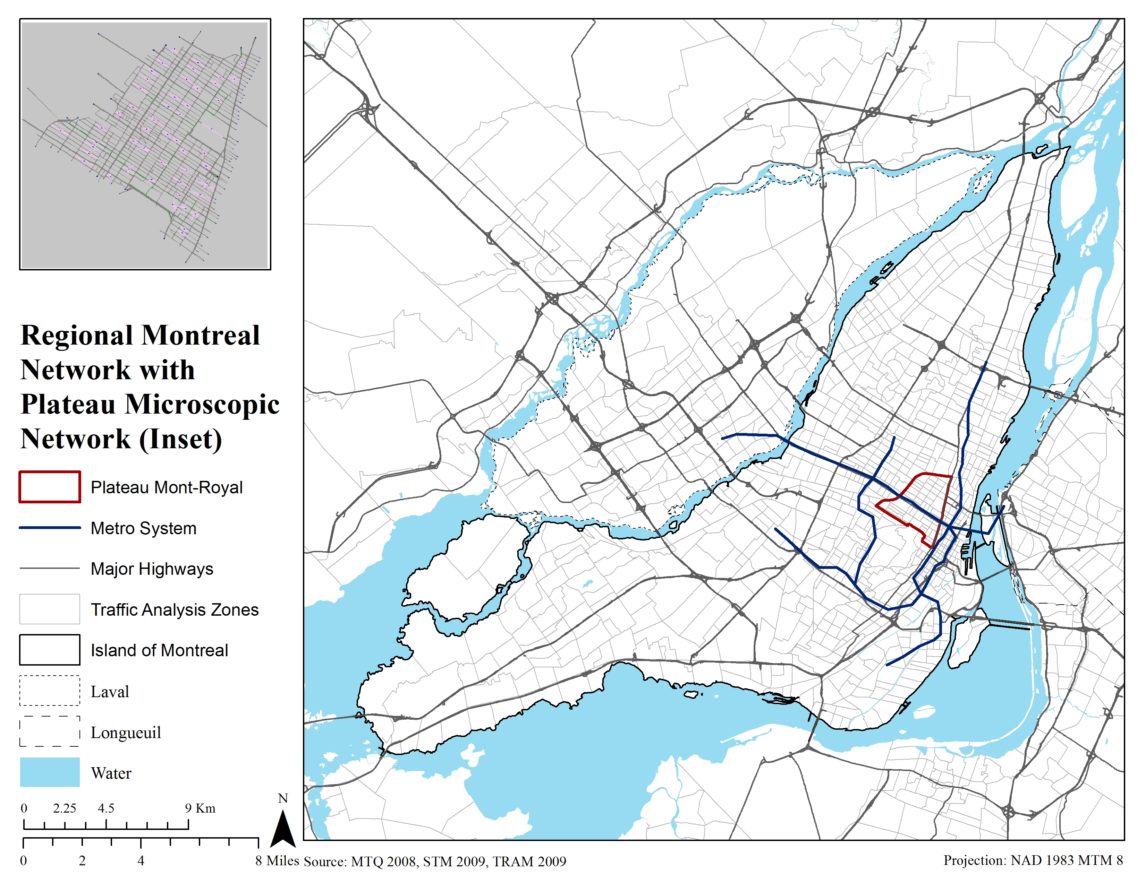

Figure 2. Plateau microscopic network within the regional Montreal network

## Simulating emissions

The Motor Vehicle Emission Simulator, more commonly known as MOVES, was developed by the USEPA in order to estimate link-based emissions. MOVES requires information about the link length, traffic volume, traffic composition, road grade, and speed. Speed can be input as an average “per link” speed or second-by-second speed that captures acceleration, deceleration, cruising, and idling, also known as the drive-cycle. By including the drive-cycle in emissions calculations, the model becomes much more representative of actual driving conditions.

Before simulating emissions for the 8,656 links; 200 links were randomly selected and employed to determine the minimum number of seconds (or signal cycles) required for the emission level to represent the entire 7 AM to 8 AM period. The link-based emissions began to stabilize at 210 seconds, meaning that traffic patterns stabilize after about 3 signal cycles. We chose to simulate every link’s emissions for 360 seconds and scale them back to the hourly emissions assuming that the next 9 intervals of 360 seconds would look the same in terms of link drive-cycles. This stabilization effect is illustrated in Figure 3. Such an assumption allows us to reduce computational time significantly (4.5hr per scenario vs. more than 2 days if 3600 seconds were used).

To reflect local conditions, a customized MOVES model was developed by replacing the MOVES default distributions with Montreal-specific data. Traffic volume and link information were obtained from the PNM model. Vehicle type and model year information were obtained from the motor vehicle registry, Société de l'assurance automobile du Québec (SAAQ), from which the age distribution of the fleet was developed. Meteorological data were collected for October 2011, which was aligned with the period for traffic counts. Fuel composition reflecting Montreal conditions was also provided. GHG emissions were expressed in carbon dioxide equivalent (CO2e).

Figure 3. Effective drive cycle for CO2 emission factors

# SCENARIO aNALYSIS APPRoach

## Scenarios considered

To evaluate the potential for reducing GHG emissions through pedestrianization policies, we simulated two pedestrianization scenarios. The first scenario, *corridor level pedestrianization*, involves completely closing down three corridors within the Plateau borough for vehicular traffic. The streets that were converted into pedestrian/bicyclist only corridors are all adjacent to parks and schools and are strong hubs for pedestrian activity. Figure 4 shows the three pedestrianized streets in green; from top-left to bottom-right they are (1) Avenue Laurier, (2) Avenue du Mont-Royal, and (3) Rue Milton. The second scenario, *area-wide pedestrianization*, involves pedestrianization of a small neighbourhood within the Plateau borough. The pedestrianized neighbourhood is also indicated in Figure 4.

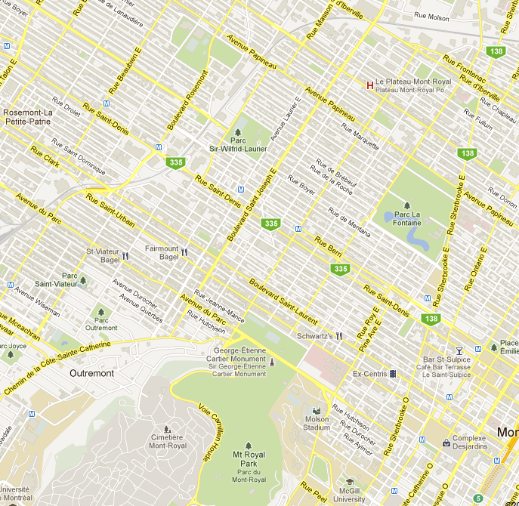

**(1)**

**(2)**

**(3)**

Figure 4. Illustrating the streets closed to vehicular traffic in green and area-wide pedestrianization in black

## Comparison strategy

The two scenarios considered along with the base network provide three scenarios for comparison. The closure of roadways is bound to affect the vehicular volume passing through the Plateau. Hence, the MRM model needs to be run again with updated network configuration. However, it is also important to recognize that the change to the traffic volumes destined to the PNM region might occur gradually depending on the information flow to drivers i.e. the traffic destined to the PNM region might not be updated on day 1 of the policy considered. Hence, we consider additional scenarios for each of the pedestrianization cases with no change to the traffic volumes destined to the PNM region i.e. assuming only the network changes without change in traffic volumes. With the inclusion of these additional scenarios, we have five comparison scenarios: (1) base scenario, (2) corridor pedestrianization with no change to traffic volumes in the PNM, (3) corridor pedestrianization with change to traffic volumes in the PNM, (4) neighborhood pedestrianization with no change to traffic volumes in the PNM, and (5) neighborhood pedestrianization with change to traffic volumes in the PNM.

The scenarios that ignore changes in traffic volumes (2 and 4) require re-running of the PNM model only with the updated network configuration. The scenarios that consider traffic volume change (3 and 5) require re-running of the MRM model followed by a re-run of the PNM model with updated network configurations.

# Results

## Base case validation of traffic models

Prior to discussing the results from the scenarios we presents a validation of our MRM and PNM base models using automatic and manual traffic counts conducted by the city of Montreal between the years 2008 and 2012.

The MRM was validated using traffic counts (integrated over a week) at 35 major intersections within the region as well as five bridges linking the Island of Montreal with the rest of the region. The comparison between actual counts versus predicted counts provides an R2 value for the 6AM - 7AM period of 0.78 (Figure 5) and a R2 value for the 7AM - 8AM period of 0.65 (Figure 6). Currently, traffic counts on highways are unavailable to the research team and hence validation was confined to arterial roads and bridges. We recognize this as a significant limitation that will be addressed once highway traffic counts are obtained. For the purpose of the current study, we are more interested in highlighting how the MRM is used to generate PNM inputs and how these inputs vary across policies.

As mentioned earlier, a large portion of the Montreal region includes the Montreal Island which is heavily dependent on its bridges. To validate our MRM model we also examine simulated traffic volumes across the day on Montreal bridges (Figure 7). The traffic patterns observed match with expected traffic flows in a typical urban region in North America.

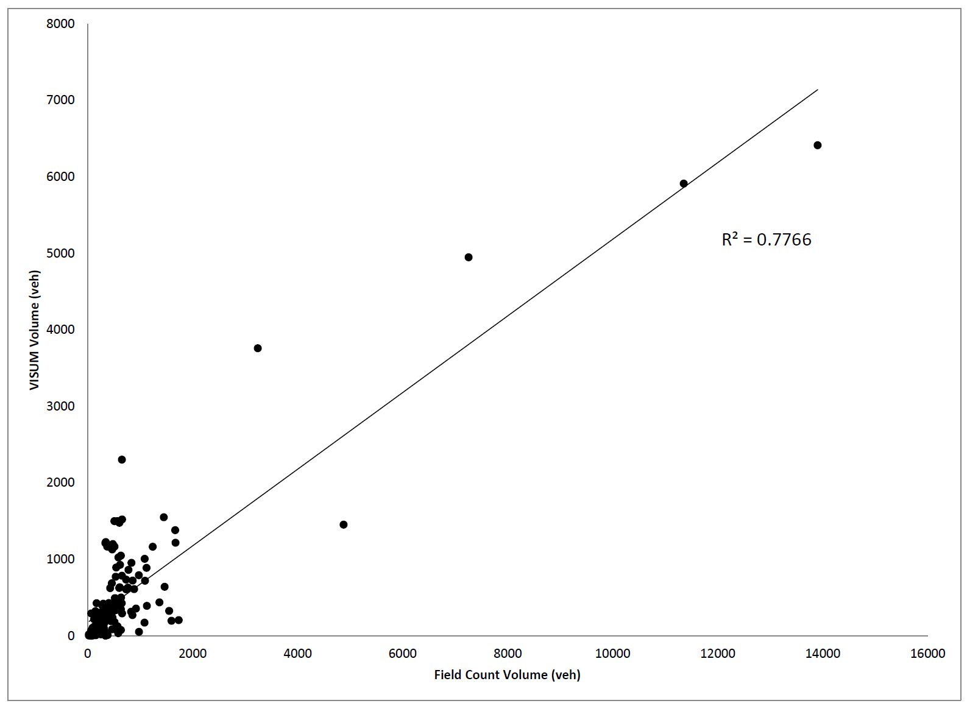

Figure 5. Comparison between measured and modelled traffic volumes using MRM (6 - 7 AM)

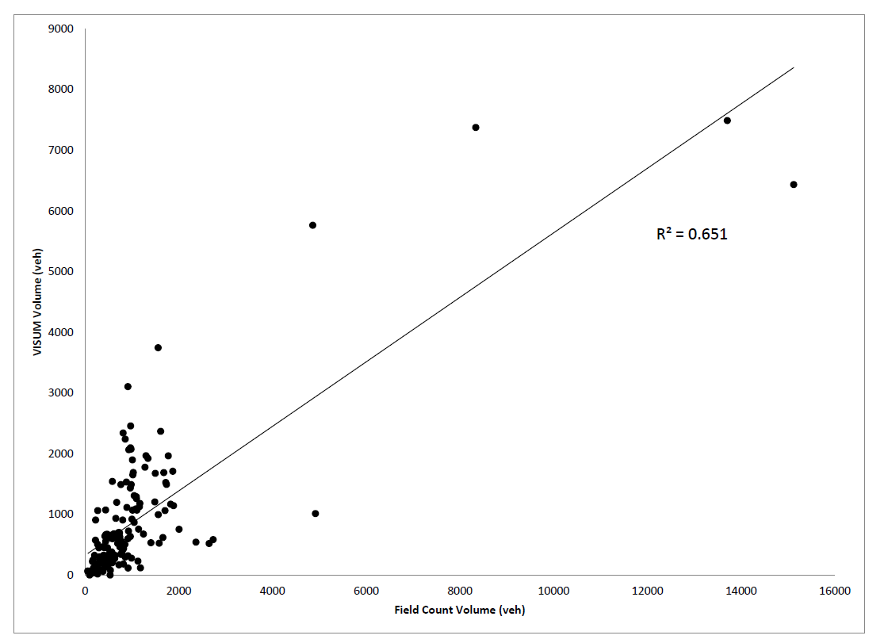

Figure 6. Comparison between measured and modelled traffic volumes using MRM (7 - 8 AM)

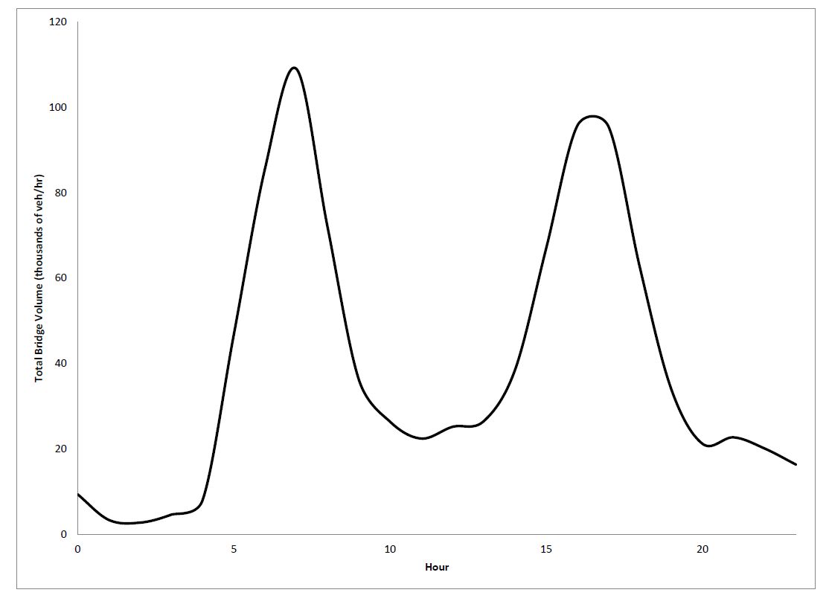

**Figure 7. Hourly traffic volume profile on the bridges**

Within the microscopic simulation model (PNM), counts from 162 intersections were used in order to validate the model. The scatter plots in Figure 8 and Figure 9 show that the R2 values for the 6AM - 7AM period and the 7AM - 8AM period are 0.58 and 0.72, respectively.

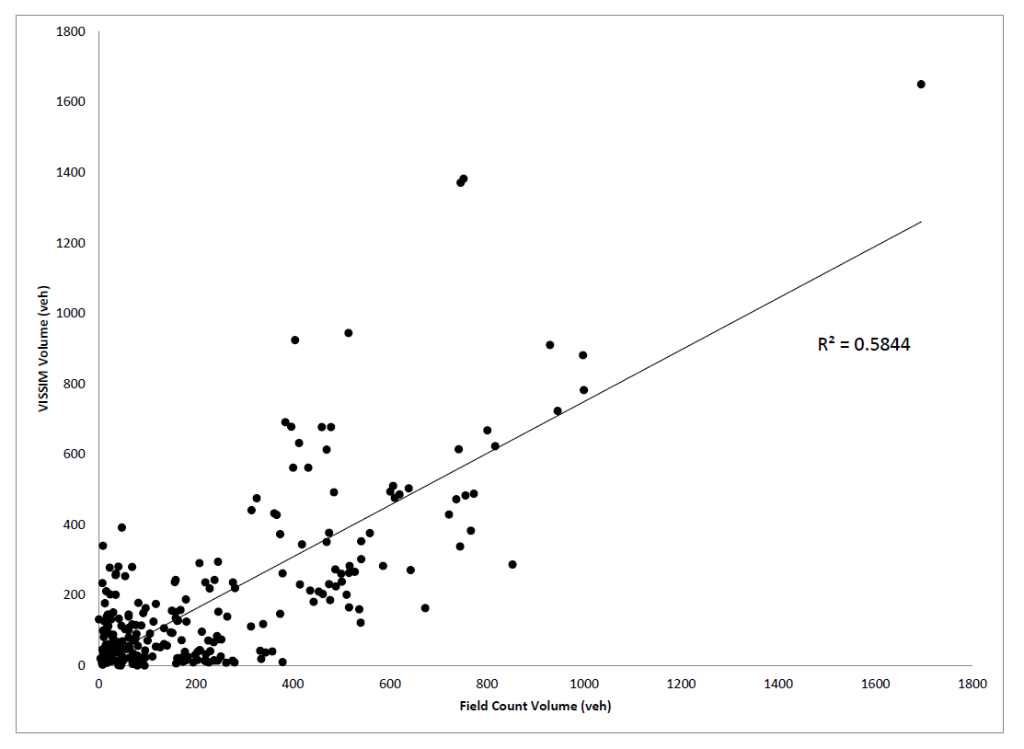

Figure 8. Comparison between measured and modelled traffic volumes using PNM (6 - 7 AM)

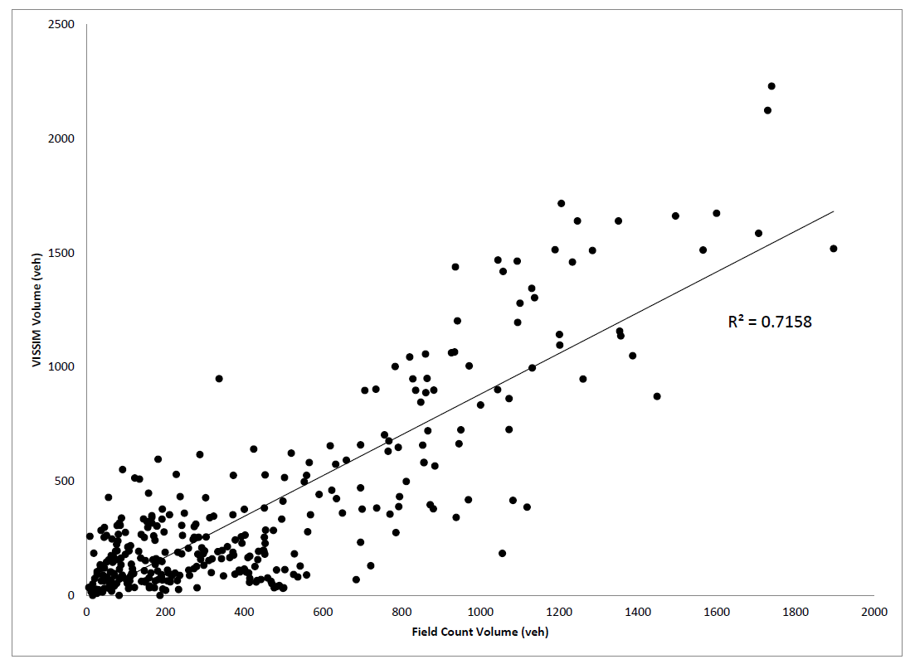

Figure 9. Comparison between measured and modelled traffic volumes using PNM (7 - 8 AM)

The figures illustrate that in the microscopic simulation case a large share of the error is contributed by roads with small volumes. The differences between observed traffic counts and predicted traffic counts indicate that the accuracy for streets with heavy traffic is better than for smaller streets (Table 1). Overall, the validation results for the MRM and PNM models provide reasonable confidence in the outputs generated by these models.

Table 1. PNM predictions Percent Error by Volume

|  |  |
| --- | --- |
| Volume (veh/hr) | Percent Error |
| 0 – 500 | 104.9% |
| 500 – 1,000 | 34.8% |
| > 1,000 | 24.6% |

## Traffic and emissions in base-case and pedestrianization scenarios

The five scenarios were evaluated in terms of network-wide GHG emissions (Table 2) as well as the spatial distribution of GHG emissions across the network in the Plateau neighbourhood. In the base case scenario, total GHG emissions amount to about 12.45 tons (in CO2e) with an average emission factor of 446 grams per vehicle mile travelled (VMT). When the three corridors undergo closure to traffic and assuming the same traffic demand at the network boundary (Scenario 2), total emissions increase to about 16.22 tons. This increase is associated with an increase in total VMT despite a decrease in the total number of vehicles that crossed the network within the hour (due to lower speeds). In addition, the average emission factor has increased to 492 grams per VMT, indicating that vehicles are running with more accelerations, decelerations, and idling due to the disruptions caused by the closures of the three corridors. Under the same street closures but accounting for a change in traffic demand at the network boundary (Scenario 3), we observe an improvement compared to Scenario 2. Total GHG emissions are 13.62 tons, almost 1.2 tons higher than the base case. However, the average emission factor is 430 grams per vehicle kilometer travelled which is lower than the base case, indicating that vehicles are running “smoother”. The increase in emissions compared to the base case is mostly associated with an increase in VMT due to the re-routing imposed by street closures. As such, despite a reduced demand, higher mileage is imposed on every vehicle in the network therefore increasing network emissions compared to the base case. In Scenario 4 where an area-wide pedestrianization is applied to a small neighbourhood within the Plateau borough and assuming the same traffic demand as in the base-case, we observe an increase in GHG emissions of about 2 tons compared to the base-case. This brings total emissions to 14.48 tons, which is lower than the 16.22 tons estimated under the corridor pedestrianization scheme. This is due to the vital nature of the corridors that were pedestrianized compared to the neighbourhood converted to a pedestrian zone. Under the same scheme and taking into account a change in traffic demand (Scenario 5), total emissions are almost the same at 14.56 tons even though the average emission factor is lower which indicates smoother driving. The insignificant change in emissions is due to the increased total VMT associated with longer (albeit faster) alternative routes.

Looking at the spatial distribution of emissions across the network, we plotted link-based changes in emissions compared to the base-case scenario for Scenarios 2 and 4 (which entail corridor pedestrianization and area-wide pedestrianization respectively, without accounting for changes in traffic demand at the boundary). Figure 10 illustrates the spatial distribution of emissions under Scenario 2 clearly highlighting that the links that incur the highest increase in emissions are those that serve as alternatives to the three pedestrianized corridors. They are parallel to the pedestrianized corridors running east-west. In addition, cross-streets serving as “feeders” to these links, also incurred significant increases in emissions. Figure 11 illustrates the effect of area-wide pedestrianization showing that the most visible increases occur to streets neighbouring the pedestrianized area in the south-west corner of the borough.

Table 2. Network-level emissions and other statistics based on microscopic models

|  |  |  |  |  |  |
| --- | --- | --- | --- | --- | --- |
|  | Scenario 1 | Scenario 2 | Scenario 3 | Scenario 4 | Scenario 5 |
| Average network speed (mph) | 16.19 | 16.03 | 16.25 | 16.01 | 16.15 |
| Total hourly network volume | 437,744 | 420,375 | 407,420 | 425,718 | 436,270 |
| Total emissions (Kg) | 12,450.7 | 16,216.8 | 13,622.3 | 14,477.8 | 14,560.5 |
| Total VMT | 27,918 | 32,979 | 31,657 | 32,458 | 33,942 |
| Emission factor (g/VMT) | 445.97 | 491.73 | 430.31 | 446.05 | 428.98 |

(1) base scenario, (2) corridor pedestrianization with no change to traffic volumes in the PNM, (3) corridor pedestrianization with change to traffic volumes in the PNM, (4) neighbourhood pedestrianization with no change to traffic volumes in the PNM, (5) neighbourhood pedestrianization with change to traffic volumes in the PNM.

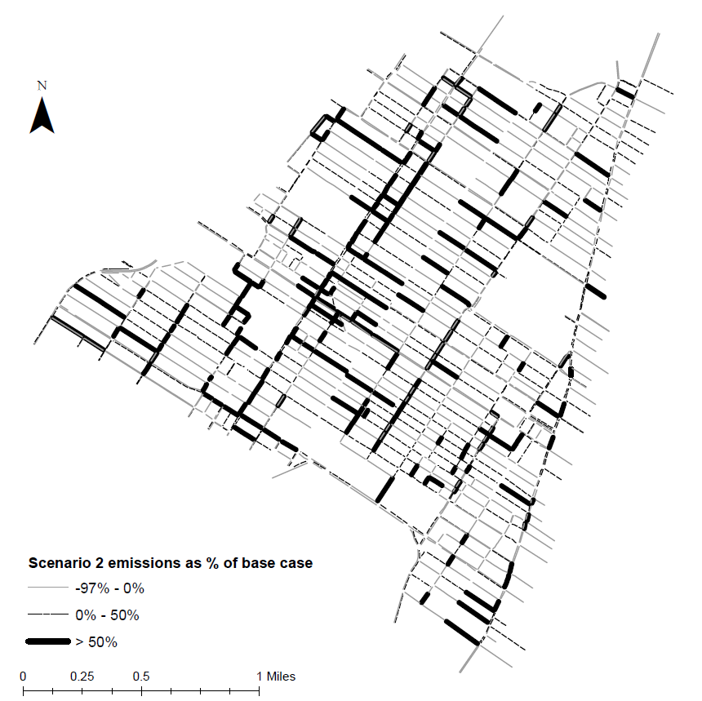

Figure 10. Changes in link-based emissions as modelled in VISSIM-MOVES for Scenario 2

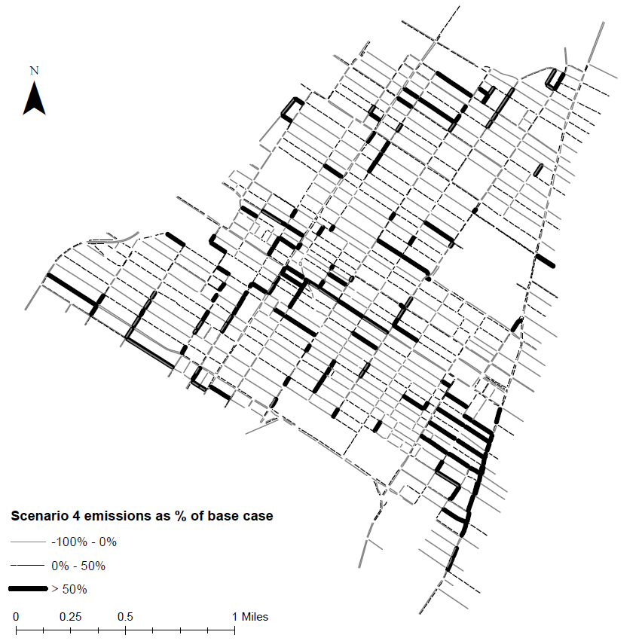

Figure 11. Changes in link-based emissions as modelled in VISSIM-MOVES for Scenario 4

## Comparison between mesoscopic and microscopic emissions

As an additional dimension to the estimation of borough-level emissions under the different scenarios, we investigated the effect of using the regional model (developed in VISUM) to estimate emissions within the borough. Since the MRM only provides an average speed per link, a look-up table was developed using MOVES in order to associate vehicle emission factors with a range of average speeds. The look-up table was developed for different speed bins and for 30 vehicle ages. In order to infer the age distribution of vehicles on every link, a path file was extracted for every O-D pair. The path file was employed to determine the link volume contributions of each O-D pair. Based on the vehicle age distributions at the TAZ level (Origin) obtained from motor-vehicle registry data, we inferred the vehicle age distribution for the links. For example, consider that there are two OD pairs which contribute to flow on a link as follows: O1 60% and O2 40%. The vehicle age distributions in both origins are appropriately weighted based on the contribution i.e. 60% of the vehicle age distribution is based on origin 1 and the rest is based on origin 2. The approach is appropriately extended for multiple OD pairs. It is important to note that due to the aggregate nature of the vehicle age data obtained by the motor vehicle registry, we do not allocate a specific car to a specific trip but rather apply an age distribution on a link basis based on the origins of trips on every link.

Table 3 summarizes the changes in borough-level emissions compared to the base-case scenario using the MRM coupled with the average speed method. Emissions estimated using instantaneous speeds obtained from the PNM and discussed in the previous section are also summarized in terms of change with respect to the base-case scenario. In both models, the changes are summarized for Scenarios 3 and 5 which entail corridor pedestrianization and area-wide pedestrianization while accounting for changes in demand. We observe that the regional model is less sensitive to the effects of the two schemes on GHG emissions. This is due to different factors: 1) the mesoscopic model does not account for changes in drive-cycles and therefore cannot incorporate the effects of added accelerations and decelerations, 2) since increases in emissions are not linear with increases in average speed, small changes in link-speeds can induce either massive increases in emissions or insignificant changes depending on the position of the initial speed on the speed-emission curve; as such, any uncertainty associated with average speed in the mesoscopic model can entail a large error in terms of emissions, 3) since the mesoscopic model assigns paths from origin to destination in a static way, any small network changes can entail significant changes in the paths chosen upstream of the segment that has incurred closure which is not necessarily realistic; the result would be overall unchanged network emissions.

In order to better understand the differences between emissions estimated using the MRM (using average-speed emission factors) and the PNM (by simulating emissions instantaneously), we generated a histogram illustrating the frequency of links that have undergone changes in emissions in different emission categories. Figure 12 illustrates the histogram derived from the MRM. We observe that while a large portion of links have incurred no changes in emissions (in scenarios 3 and 5) compared to the base case, more than 20% of links incur more than 100% change in emissions under scenario 3 and more than 12% of links incur that drastic change under scenario 5. This indicates that the mesoscopic model has made drastic changes to certain paths whereby links which carried a small amount of vehicles in the base-case scenario, suddenly experienced more than double the traffic load. In contrast, Figure 13 illustrates that the PNM model associated with instantaenous emissions has predicted a “smoother” distribution of link changes whereby the majority of links experience between -10% and +10% change from the base case. No links epxerience more than 70% increase or decrease in emissions.

This analysis points to the fact that mesoscopic models tend to be myopic to local-changes in network configuration therefore underestimating the increases in emissions at a network level compared to microscopic models. In addition, microscopic models estimate a more even distribution of increases and decreases in link-level emissions which tends to be closer to the effects expected intuitively than the drastic link-level changes predicted by the mesoscopic model.

Table 3. Comparison between emissions obtained using microscopic and mesoscopic modelling

|  |  |  |  |  |
| --- | --- | --- | --- | --- |
|  | | | Scenario 3 | Scenario 5 |
| VISUM-MOVES average speeds | % Change from Base | Total emissions (g) | 1.21% | -4.27% |
| Emission Factor (g/Km) | -0.31% | -0.38% |
| VISSIM-MOVES instantaneous speeds | % Change from Base | Total emissions (g) | 9.41% | 16.95% |
| Emission Factor (g/Km) | -3.51% | -3.81% |



Figure 12. Frequency distribution of changes in link-based emissions under Scenarios 3 and 5 compared to base-case modelled in VISUM



Figure 13. Frequency distribution of changes in link-based emissions under Scenarios 3 and 5 compared to base-case modelled in VISSIM

# Conclusion

The current study demonstrates an effective framework utilizing the strengths of both the mesoscopic and microscopic traffic and emission simulation scales. Specifically, we employ a mesoscopic model to determine the traffic flow assignment for the Montreal urban region (network of 127,217 links) and a microscopic model to examine the Plateau neighbourhood in Montreal, a network consisting of 8,656 links and 576 intersections. The second-by-second vehicle speed information is processed through a customized version of the USEPA Motor Vehicle Emissions Simulator (MOVES) to generate GHG emissions. By adopting the mesoscopic model to generate a boundary O-D matrix for a microscopic simulation region, we are able to capture the effects of changes in the network on traffic demand at the boundary of the borough. The microscopic simulation provides a far superior level of detail by incorporating second-by-second drive cycles into the emissions calculator. This detail allows for more informed policy decisions.

The applicability of the integrated tool to analyze transportation infrastructure changes is illustrated through two different pedestrianization schemes. The simulation results suggest that in all scenarios considered, GHG emissions in the borough are actually higher than in the base case as a result of increased VMT (due to re-routing) as well as increased accelerations and decelerations especially on alternative routes which become more congested. In fact, despite taking into account demand changes into the borough (mostly by diverting a portion of “through” traffic onto other boroughs), no single scenario is able to achieve the borough’s objective of reducing GHG emissions. It is important to note that this framework does not account for mode shift, which presumably would lead to further decreases in demand. However, the strategic location of the borough between major highway interchanges to the north and Montreal’s central business district to the south, continues to make it attractive for “through” traffic despite the street closures and re-routing that they entail. In this particular case, pedestrianization is not a viable option for the reduction of GHG emissions from traffic unless combined with aggressive mode shift.

In this context, it is important to note the importance of simulating potential interventions within the context where they are meant to occur, in order to gain meaningful information of their possible impact on GHG emissions. Different policies will work differently depending on the location where they are applied. While regional-level policies such as transit improvements and fleet renewal are often associated with positive effects on traffic emissions, local-level interventions can perform differently in various contexts. This becomes a challenge for local-level governments, which only exert authority over their local road network, when they are faced with the challenge of reducing traffic-induced GHG emissions. It is only with a microscopic model associated with a regional model that can account for changes in demand that one can achieve a deep understanding of the impacts of potential network changes both at a link-level and neighbourhood level.

**ACKNOWLEDGEMENTS**

The authors would like to acknowledge financial support from Natural Sciences and Engineering Research Council (NSERC) of Canada under the Discovery Grants program. The authors would also like to acknowledge the critical input of two anonymous reviewers.

**REFERENCES**

Abo-Qudais, S., & Abu Qdais, H. (2005). Performance Evaluation of Vehicles Emissions Prediction Models. Clean Technologies and Environmental Policy, 7: 279-284.

Ahn, K., Rakha, H., Trani, A., and Van Aerde, M. (2002). "Estimating Vehicle Fuel Consumption and Emissions based on Instantaneous Speed and Acceleration Levels." Journal of Transportation Engineering, 128 (2), 182-190

Agence métropolitaine de transport (2010), The future of Public Transit for the Greater Montreal Area – Vision 2020, accessed on 5th May 2013, online at http://plan2020.amt.qc.ca/tiki-download_file.php?fileId=217

Aziz, H.M. A & Ukkusuri, S.V. (2012), “Integration of Environmental Objectives in a System Optimal Dynamic Traffic Assignment Model,” Computer-Aided Civil and Infrastructure Engineering, 27:7, pp.

Brook R.D., Franklin B., Cascio W., Hong Y., Howard G., Lipsett M., Luepker R., Mittleman M., Samet J., Smith S.C., Jr., Tager I. (2004). Air pollution and cardiovascular disease: a statement for healthcare professionals from the Expert Panel on Population and Prevention Science of the American Heart Association. Circulation 109 (21), 2655-2671

Burghout, W., (2005.) Mesoscopic simulation models for short-term prediction. PREDIKT project report CTR2005 3 (accessed at <http://www.ctr.kth.se/publications/ctr2005_03.pdf>)

Burghout, W., Wahlstedt, J. (2007). Hybrid Traffic Simulation with Adaptive Signal Control. Transportation Research Record Journal of the Transportation Research Board , 1999 (1) 191-197.

Burghout, W., Koutsopoulos, H., & Andréasson, I. (2006). Hybrid Mesoscopic-Microscopic Traffic Simulation. Transportation Research Record Journal of the Transportation Research Board , 1934 (1) 218-255.

Chen H, Goldberg MS, Villeneuve PJ (2008). A systematic review of the relation between long-term exposure to ambient air pollution and chronic diseases. Reviews on Environmental Health, 23(4), 243-297.

Dockery D.W. (2001). Epidemiologic evidence of cardiovascular effects of particulate air pollution. Environmental Health Perspectives, 109 (4), 483-486.

Ferguson, E.M., Duthie, J.,and Waller, S.T. (2012), “Comparing Delay Minimization and Emissions Minimization in the Network Design Problem,” Computer-Aided Civil and Infrastructure Engineering, 27 (4), 288-302.

Gan, W.Q., Davies, H.W., Koehoorn, M., Brauer, M. (2012). Association of long-term exposure to community noise and traffic-related air pollution with coronary heart disease mortality. American Journal of Epidemiology, 175, 898-906.

Hao, J.Y., Hatzopoulou, M., Miller, E.J. (2010). Integrating an activity-based travel demand model with dynamic traffic assignment and emission models. Transportation Research Record: Journal of the Transportation Research Board 2176 (1), 1-13.

Helbing, D., Treiber, M., Kesting, A., Schönhof, M. (2009). Theoretical vs. Empirical classification and prediction of congested traffic states. The European Physical Journal B-Condensed Matter and Complex Systems 69 (4), 583-598.

Leclercq, L. (2007). Hybrid approaches to the solutions of the “Lighthill–Whitham–Richards” model. Transportation Research Part B: Methodological 41 (7), 701-709.

Lin, J., Yi-Chang, C., Vallamsundar, S. & Song, B. (2011), Integration of MOVES and dynamic traffic assignment models for fine-grained transportation and air quality analyses, IEEE Forum on Integrated and Sustainable Transportation System (FISTS), Vienna, 176–81.

López, E. and Monzón, A. (2010), “Integration of Sustainability issues in Strategic Transportation Planning: A Multi-Criteria Model for the Assessment of Transport Infrastructure Plans,” Computer-Aided Civil and Infrastructure Engineering, 25 (6), 440-451.

Ministère des Transports Québec (MTQ) (2008). Major Highways of the Montreal Region. Shapefile data accessed from the Transportation Research at McGill GIS database. http://tramarchive.mcgill.ca/tram/index.php?page=catalog

Patriquin, M. (2010), One Montreal burough’s war on the car. Accessed on April 24th 2013, at <http://www2.macleans.ca/2010/06/30/one-montreal-boroughs-war-on-the-car/>

Pope III, C.A. (2000) Epidemiology of fine particulate air pollution and human health: biologic mechanisms and who's at risk? Environmental Health Perspectives,108 (Suppl 4), 713-723.

Pope III, C.A., Dockery D.W. (2006) Health effects of fine particulate air pollution: lines that connect. Journal of Air Waste Management Association, 56 (6), 709-742.

PTVAG 2012, PTV website <http://www.ptvag.com/software/transportation-planning-traffic-engineering/software-system-solutions/> (accessed on April 30, 2012)

Qian, Z. and Michael Zhang, H. (2013). Full Closure or Partial Closure? Evaluation of Construction Plans for the I-5 Closure in Downtown Sacramento. Journal of Transportation Engineering, 139 (3), 273–286.

Rakha, H., Kyoungho, A., & Trani, A. (2003). Comparison of MOBILE5A, MOBILE6, VT-MICRO, and CMEM Models for Estimating Hot-Stabilized Light-Duty Gasoline Vehicle Emissions. Canadian Journal of Civil Engineering, 30, 1010-1021.

Schrank, D., and T. Lomax (2009) The 2009 Urban Mobility Report. Texas Transportation Institute, The Texas A&M University System. July 2009

Sheffi, Y. (1985) Urban Transportation Networks: Equilibrium Analysis with Mathematical Programming Methods. Prentice-Hall Inc, Englewood Cliffs, NJ 07632

Shelton J., Chiu Y.C. and Samant S. (2009) Modeling for flexibility and consistency: an integration capability for mesoscopic dta and microscopic traffic simulation models. Report submitted to Center for International Intelligent Transportation Research, Texas Transportation Institute, 1-18.

Société de Transport de Montréal (STM) (2009). Metro Lines for the City of Montreal. Shapefile data accessed from the Transportation Research at McGill GIS database. http://tramarchive.mcgill.ca/tram/index.php?page=catalog

Statistics Canada. (2011). 2011 Census of Population. Ottawa: Statistics Canada.

Transport Canada (2006), The cost of urban congestion in Canada, Transport Canada, Environmental Affairs

Transportation Research at McGill (TRAM) (2009). Municipality Boundaries for the Montreal Region. Shapefile data accessed from the Transportation Research at McGill GIS database. http://tramarchive.mcgill.ca/tram/index.php?page=catalog

Turcotte, M., (2008). Dependence on cars in urban neighbourhoods. Canadian Social Trends 85, 20-30.

Wang, T., Gan, A., Alluri, P. (2013), Year. Estimating annual average daily traffic for local roads for highway safety analysis. In: Proceedings of the Transportation Research Board 92nd Annual Meeting.

Yang, Q., Boriboonsomsin, K., Barth, M., Year (2011). Arterial roadway energy/emissions estimation using modal-based trajectory reconstruction, 14th IEEE Conference on Intelligent Transportation Systems, 809-814.

1. The borough council is represented by Projet Montreal, a party created by environmental activists. The party is established on the platform of reducing vehiclular traffic, encouraging pedestrian and bicyclist activity among other priorities.
2. Parameters such as total number of paths per O-D pair, paths with total cost higher than 75% of the best path, and detours greater than 2.5 times the length of the best path assist in eliminating circular paths in the PNM model. Other parameters were arrived at after a series of iterative steps based on the calibration of the PNM model.