**Modelling the Spatio-Temporal Distribution of Ambient Nitrogen Dioxide and**

**Investigating the Effects of Public Transit Policies on Population Exposure**

Maryam Shekarrizfard1, Ahmadreza Faghih-Imani1, Louis-Francois Tetreault2, Shamsunnahar Yasmin3, Frederic Reynaud4, Patrick Morency5, Celine Plante5, Louis Drouin5, Audrey Smargiassi2, Naveen Eluru3, Marianne Hatzopoulou6

1- Civil Engineering, McGill University

2- Département de Santé Environnementale et Santé au Travail, Université de Montréal

3- Civil, Environmental and Construction Engineering, University of Central Florida

4 – Oliver Wyman Consulting, Montreal

5- Direction régionale de santé publique du CIUSS du Centre-Sud-de-l’Île de Montréal

6- Corresponding Author: Associate Professor, Civil Engineering, University of Toronto,   
35 St George Street, Toronto, ON M5S 1A4, Tel: 1- 416-978-0864, Fax: 1-416-978-6813,   
Email: [marianne.hatzopoulou@utoronto.ca](file:///C:\Users\Maryam\Desktop\marianne.hatzopoulou@utoronto.ca)

**Modelling the Spatio-Temporal Distribution of Ambient Nitrogen Dioxide and**

**Investigating the Effects of Public Transit Policies on Population Exposure**

**Abstract**

Estimating the future state of air quality associated with transport policies and infrastructure investments is key to the development of meaningful transportation and planning decisions. This paper describes the design of an integrated transportation and air quality modelling framework capable of simulating traffic emissions and air pollution at a refined spatio-temporal scale. For this purpose, emissions of Nitrogen Oxides (NOx) were estimated in the Greater Montreal Region at the level of individual trips and vehicles. In turn, hourly Nitrogen Dioxide (NO2) concentrations were simulated across different seasons and validated against observations. Our validation results reveal a reasonable performance of the modelling chain. The modelling system was used to evaluate the impact of an extensive regional transit improvement strategy revealing reductions in NO2 concentrations across the territory by about 3.6% compared to the base case in addition to a decrease in the frequency and severity of NO2 hot spots. This is associated with a reduction in total NOx emissions of 1.9% compared to the base case; some roads experienced reductions by more than half. Finally, a methodology for assessing individuals’ daily exposure is developed (by tracking activity locations and trajectories) and we observed a reduction of 20.8% in daily exposures compared to the base case. The large difference between reductions in the mean NO2 concentration across the study domain and the mean NO2 exposure across the sample population results from the fact that NO2 concentrations dropped largely in the areas which attract the most individuals. This exercise illustrates that evaluating the air quality impacts of transportation scenarios by solely quantifying reductions in air pollution concentrations across the study domain would lead to an underestimation of the potential health gains.

Keywords**:** Air quality; Dispersion modelling; Traffic emissions; Nitrogen dioxide (NO2); CALMET; CALPUFF; Public Transit; Policy Scenario

**Highlights:**

► An integrated transportation, emissions, air quality modelling chain is developed

► Our modelling framework is able to account for the spatio-temporal distribution of NO2

► The modelling framework was used to test the effect of transit investments

► Increased transit service was associated with reductions in population exposure to NO2

**Information on funding sources supporting the work**

This study was funded by a collaborative grant from the Canadian Institutes of Health Research and the Natural Sciences and Engineering Research Council of Canada. Special thanks are extended to Joseph Scire, David Strimaitis and the entire CALPUFF development team for their immense assistance throughout this study.

1. **Introduction**

Heavily trafficked urban streets are major sources of Nitrogen Oxide (NOx) emissions and exposure to nitrogen dioxide (NO2) has been associated with a range of health effects (Clark et al., 2012; Crouse et al., 2010; Parent et al., 2013). In metropolitan areas around the world, urban air pollution modelling has been conducted for a variety of road and network configurations (Batterman et al., 2010; Hatzopoulou and Miller, 2010) using a range of methods such as, dispersion models (Cheng and Li, 2010; Den Boeft et al., 1996; Hertel et al., 1989; Vardoulakis et al., 2007), box and Neural Networks models (Shekarrizfard et al., 2012), and Land use regression models (LUR) (Johnson et al. 2010; Crouse et al. 2009; Hoek et al. 2008). Among these methods, dispersion models have the advantage of capturing the influence of many factors such as the topology of the street and local wind turbulence.

Modelling traffic-related air pollution using an integrated approach, starting from travel demand, captures the interactions between individual mobility, on-road traffic, meteorology, emissions, atmospheric transport, and chemical transformations. Furthermore, this integration between traffic, emission, and dispersion modelling enables the investigation of the effects of transportation plans and policies on air pollution and public health thus adding an important dimension to decision-making in transportation.

A number of interdisciplinary research initiatives have developed modelling frameworks that account for vehicle emissions whereby activity-based models were used to calculate person- and trip-level emissions for varieties of pollutants such as PM10 (McCreddin et al., 2015) and NOx (Int Panis et al., 2011). Among these, most analyses of exposure took into account variations of the emission source, but assumed fixed receptor conditions (Bae et al., 2007). Based on this approach, individuals are considered to remain at home and, therefore, only exposed to air pollution at their home address. The attempts at dynamic exposure assessments are uncommon and often focus on long time scales (De Ridder et al., 2008).

Several recent studies have addressed the impacts of transport policies on health and well-being (Hosking et al., 2011; Grabow et al., 2012; Dhondt et al., 2013; Braubach et al., 2015; Perez et al., 2015). Among the early studies that show the importance of dynamic population modelling over the traditional static modelling, we note the work of Dons et al. (2011) and Beckx et al. (2009). These studies demonstrated significant exposure differences (ranging from 12% to 20% depending on pollutant) between the static approach where people are assumed to be at a fixed residential location and dynamic micro-simulation approach. Hatzopoulou and Miller (2010) and Hao et al. (2010) also developed integrated modelling frameworks to estimate exposures in Canada. Dhondt et al. (2012) applied an integrated modelling framework consisting of an activity based model and dispersion models and found a large difference between static and dynamic approaches (12%). Lefebvre et al. (2013) incorporated a land use modelling component to the integrated modeling framework to account for regional concentration patterns. Additionally, Vallamsundar et al. (2016) developed an integrated modelling framework to estimate the population exposure of PM2.5 in Arizona. Rowangould (2015) calculated exposure levels across Los Angeles County, California using a multi-modal platform combining concentration data from trip-based regional travel demand models with population information from census.

A variety of other studies demonstrated how these model capabilities are useful for planning applications, and how they can be used to evaluate the effects of various transport policy scenarios on air pollution and exposure. Nieuwenhuijsen et al. (2016) observed that policies that emphasize changes in travel behaviour, including the increased use of public transit, are essential in reducing transport emissions and the adverse health effects of traffic-related air pollution. Recently, a number of studies have attempted to quantify the overall health co-benefits of replacing car travel with alternative transport modes (Woodcock et al. 2009; Maizlish et al., 2013; Macmillan et al., 2014; Xia et al. 2015; Tobollik et al. 2016; Gariazzo et al., 2016). Woodcock et al. (2009) quantified the environmental and health benefits of various alternative transport scenarios for 2030 in London. The authors estimated that over 500 premature deaths could be saved under alternative transport scenarios. Tobollik et al. (2016) estimated the greenhouse gas reduction potential of various policies in Rotterdam using a base year of 2010 and projecting to 2020. The authors estimated reductions in PM2.5 and elemental carbon of around 40% and 60% respectively.

This paper describes the development and validation of an integrated transportation, emission, and dispersion model system for the Montreal metropolitan area taking into account population mobility. The developed framework has the ability to estimate population exposures during travel and at activity locations, an element that has not been emphasized in the literature. One of the novel aspects of this model is its ability to identify the contribution of travelling/commuting to daily exposure, in addition to its capability for predicting travel demand and the travel mode, analyzing vehicle movements, estimating traffic emissions, and modelling the dispersion of air pollutants. This means that, in addition to being policy sensitive, our model system is refined in terms of spatio-temporal variability in air pollution levels thus making it relevant for exposure analysis. Beyond the description of our modelling system, we present an evaluation of proposed transit expansions in Montreal in terms of their effects on urban air quality and population exposure. Our scenario analysis demonstrates the strength of our modelling system in terms of its ability to unveil a different dimension to policy performance. Rather than simply analyzing policies based on their effects on ambient air quality, we also quantify their effects on exposure, illustrating a different angle.

Beyond this introduction, the paper is divided into four sections: Section 2.1 explains the general overview of modelling system and the components of the integrated model for the study area. Then in section 2.2 and 2.3 integrated model components are described in detail. Following model development, validation efforts are described in section 2.4. A scenario is introduced in section 2.5 and the method of finding population exposure to traffic related pollution is defined in section 2.6. Section 3 discusses the results and section 4 concludes the paper.

1. **Model development**
   1. **General overview**

Our modelling system consists of two main components: 1) the travel demand and emission module and 2) the atmospheric dispersion module that simulates air quality based on road segment emissions. Fig. 1 presents the components of the integrated model. The output of the transportation and emission model includes spatially refined emissions of NOx generated at the level of every road segment and varying by time of day. The dispersion model is driven by a meteorological processor and is capable of dispersing emissions of every individual road segment in our modelling domain (127,217 road segments).

Our study is set in Montreal, Canada and includes the city of Montreal as well as the larger metropolitan region. The Montreal Metropolitan area with a surface of 4258 km2 and population of 4.1 million is the second largest city in Canada and located in south west of the province Quebec. The city of Montreal covers most of the island of Montreal at the confluence of the St. Lawrence and Ottawa river. The island is crossed north-south and east-west by major highways causing high congestion during rush hours. The city center is relatively dense with busy arterials and tall buildings. The west of the island also known as the “West Island Region” is composed of relatively affluent suburbs while the east of the island includes a large number of industries. A high-activity port is located near the city center on the St. Lawrence River.

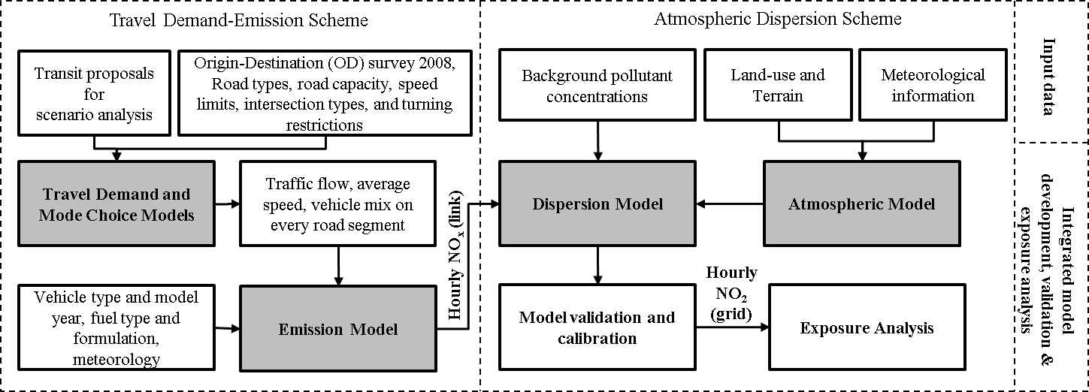

**Fig. 1.** Schematic flowchart of the integrated transportation-emission-dispersion model system.

* 1. **Travel demand and emissions model**

Our travel demand model is intended to generate trips including their respective modes as a response to various changes in population patterns, demographics, the built environment, and transportation. For example, new transit infrastructure would improve the travel times of individuals previously driving and potentially induce mode shift towards public transit. Briefly, we used 2008 origin-destination survey data for the Montreal metropolitan area to develop trip level mode choice models (Eluru et al., 2012). The 2008 origin-destination data includes information for a 5% sample of the Montreal population, encompassing a total of 66,000 households and approximately 157,000 individuals conducting a total of 355,000 daily trips across the metropolitan region. We categorized trips based on their origin and purpose into four groups: home-based-work (origin is home, purpose is work), home-based-other (origin is home and purpose is non-work), work-based (origin is work and purpose is any) and non-home based (origin is any location other than trip maker’s home, purpose is any). For each category, we estimated a mode choice model separately. Our mode choice models consider various travel modes including drive, passenger, transit, walk, bike, and combinations of these modes. The models were calibrated on a 7.5% sample of the origin-destination data. The drive mode trips obtained from our mode choice models and scaled up to the total population were used as input to generate traffic flows on the network using a traffic assignment model.

A regional traffic assignment model was developed for the Montreal metropolitan area. The traffic assignment model allocates vehicle flows on the road network using the road types ranging from expressways to local roads. The model includes road capacities, speed limits, number of lanes, type and length of roads, intersection types, and turning restrictions. Output of the traffic assignment model includes traffic volume, average speed, and vehicle mix on every road segment in the region. Our regional network consists of 127,217 road segments and 90,467 nodes associated with 1,552 traffic analysis zones (TAZs). The trips made by driving were aggregated into 24 hourly origin-destination (OD) matrices based on trip departure times. The OD matrices were generated at the TAZ level. In order to get the total number of trips (expand to the total population), we applied weighting factors available in the 2008 OD survey. The simulated traffic was assigned to the network employing the Stochastic User Equilibrium approach (SUE) using the VISUM platform (developed by PTV Group, PTV Vision, 2009). This ensures a probabilistic distribution of path choices between any OD pair. It is important to note that we only simulated household travel and therefore truck movements were not included in our model. This is a limitation that we fully recognize considering that diesel trucks are significant emitters of NOx. In Montreal, on average the proportion of heavy and medium trucks on the road is 4% responsible for about 30% of the emissions. Through ongoing research, we are extending our model to incorporate truck movements.

Using the model output, emissions of NOx (in gram) at the level of every individual vehicle were estimated based on its type, age, speed, and type of road. Emissions were based on emission factors that we generated using the Mobile Vehicle Emissions Simulator (MOVES) platform developed by the United States Environmental Protection Agency (USEPA) and calibrated with Montreal-specific data. To estimate emissions, MOVES requires various inputs such as link information; vehicle type and composition; vehicle model year; fuel type and formulation; and meteorology. Data on vehicle ownership were purchased from the vehicle registry database for Montreal, provided by the Societe de l’Assurance Automobile du Quebec (SAAQ). The SAAQ database includes vehicle ownership information for the Montreal region at the level of the Forward Sorting Area (FSA), indicated by the first three characters of the postal code. Within each FSA, the total number of vehicles by type (e.g. passenger car, sports utility vehicle, minivan, small truck, large truck) and model year was provided. Hourly emissions of NOx were estimated for each road by summing the contributions of all vehicles on every segment. Details on the development of the transportation and emission model are presented in Sider et al. (2013). The resulting segment-level NOx emission rates (in grams/km) are presented in Fig. 2 which illustrates total daily NOx for each road link in the Montreal metropolitan area (Fig. 2a) and the frequency distribution of NOx across the 127,217 road links (Fig. 2b). It is important to note that we do estimate traffic and emissions for each hour of the day but we only simulate a single day which is considered to be representative of an average weekday in terms of travel patterns. This is a limitation of the origin-destination survey which covers a single day in the travel patterns of each household.

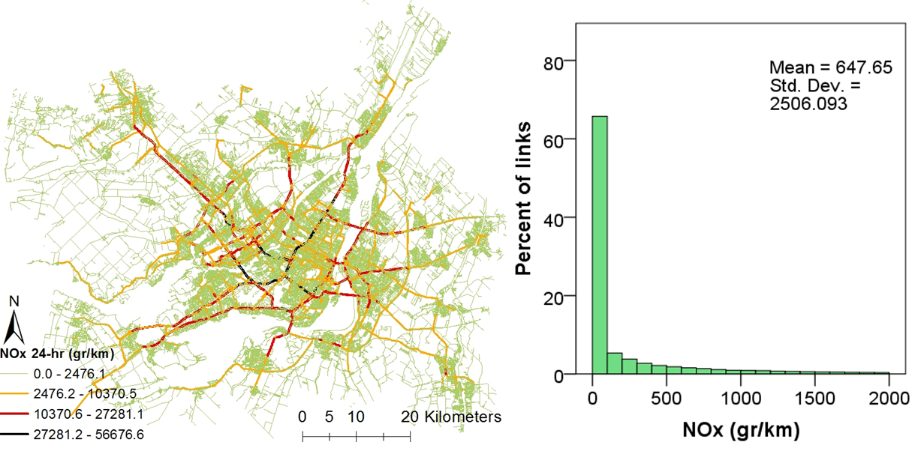

(a) (b)

**Fig. 2.** Total daily NOx emissions for each road link in the Montreal metropolitan area   
(a) and frequency distribution of NOx across the 127,217 road links (b).

* 1. **Dispersion model**

In recent years, various dispersion models that address a variety of source emissions (road, point and area) have been developed. Among these, the multi-layer, multi-species non-steady state model CALPUFF is becoming more commonly applied for the dispersion of traffic emissions because of its capability for handling complex terrain and land use interaction effects (Scire et al., 2000a; Cohen et al., 2005). Several researchers who used such advanced tools reported appropriate simulation performance (Carper and Ottersburg, 2003; Radonjic et al., 2013). In this study, NO2 concentrations were modeled using the CALMET/CALPUFF modelling system (Scire et al., 2000a; Scire et al., 2000b).

CALMET is a meteorological pre-processor to CALPUFF and it was used to interpolate winds and temperatures using higher-resolution terrain elevation and land-use data and create detailed hourly meteorological fields as well as predict boundary layer parameters such as mixing height. Since the data interpolation process accounts for land slopes, blocking effects of terrain, and preserves the air-mass continuity, it must be driven either by observations or by three-dimensional data from prognostic models (e.g. MM5, WRF, RAMS). We obtained land use and land-cover data from the Montréal DMTI Spatial Inc. database 2009. The resolution of the data is 1 x 1 Km; using a land-use processor, we computed the fractional land-use/land cover for each grid cell in the modelling domain. Terrain elevation data was obtained from the Shuttle Radar Topography Mission (SRTM) conducted by the National Aeronautics and Space Administration (NASA) and the National Geospatial-Intelligence Agency (NGA). The data for the modelling domain is in SRTM3 (spacing for individual data points is 3 arc-seconds), which corresponds to 90 meters in resolution. SRTM3 data were allocated to the modelling grid. Fig. 3 presents land-use and topography for the entire modelling domain. Note that our modelling domain is significantly larger than our study area, which is the Montreal metropolitan area. This is done in order to ensure that the meteorology and dispersion account for the full land-use and topography effects. Three dimensional hourly wind speed and direction for the 1 x 1 Km resolution were obtained from the Pennsylvania State University/National Center for Atmospheric Research (PSU/NCAR) mesoscale model MM5 (Grell et al., 1994). Surface meteorological data were obtained from the National Oceanic and Atmospheric Administration (NOAA) database, 2008 (NOAA, 2012). In total, data for 12 surface stations were used in model development.

The development of accurate wind speeds and directions across the modelling domain is crucial for dispersion modelling. We first used the meteorological model to produce initial guess wind fields by adjusting MM5 winds for terrain effects. In a next step, these adjusted values were refined through the introduction and processing of surface observations. In order to force the simulated winds to follow the wind vectors at each surface station included in the model and to account for terrain effects using MM5 data, weights were assigned to surface stations. A high weight given to a surface station would force winds to follow the wind vector recorded at the station thereby wiping out terrain effects. In this study, 10 different combinations of weights and terrain effects were tested. The resulting wind fields were validated against observed values at two monitoring stations, which were not included in the model. We conducted this exercise for different months of the year (January, April, March and July) in order to find the weights that would achieve the best fit across all seasons. The meteorological data were simulated at a resolution of 1 x 1 Km which were then used to drive the dispersion model.

CALPUFF is based on the Lagrangian puff equation, which estimates the growth diffusion and transport of released puffs in the modelling domain. Besides inputting spatially resolved meteorology, emissions from each of the 127,217 road links in Greater Montreal were input. The road links were broken down into smaller segments (less than 0.5 km) of one-directional links to increase the accuracy of road source modelling (in total 370,000 segments); in turn, the corresponding coordinates of start and end points of each link were generated using ArcGIS v10.2. Then, the base elevation for each point was found using the SRTM maps in order to account for road elevation. In CALPUFF, each link is treated as a road source separately whether it is a one-way link or one half of a two-way link. The road input file for simulation must include the start and end coordinates, initial vertical and horizontal dispersion coefficients; sigma z (σz) and sigma y (σy), base elevation, and emissions in gram/sec.meter. Values of 3.5 and 3 meters were considered (iterations) for sigma z and sigma y, therefore representing traffic-induced mixing near the roadway.

Background NO2 concentrations were also included in the simulation using data observed at station 99, located west of the Montreal Island. CALPUFF incorporates a set of chemical and physical processes. During the chemical reactions, NOx transforms to NO2. Chemical reactions reduce NOx concentrations in the presence of O3, solar radiation UV, and VOCs. There is a non-linear relation in the response of O3 concentrations to reductions in NOx and VOC (Wu et al., 2009). Since the conversion rate of NOx to NO2 is a non-linear function of O3, solar radiation, and NOx concentrations, and since solar radiation and O3 vary between different seasons, the simulated concentrations for each season are expected to be different. We used O3 as an input to model chemistry of NOx to NO3 and HNO3. A RIVAD chemistry scheme in CALPUFF was used. In this scheme, NOx was transformed to NO3 and HNO3. However since part of NOx is transferred to smog using VOC, we have to account for the transformation of NO2 in the presence of hydrocarbons producing PAN, aldehyde, smog, etc. This means we have to account for further reactions that vary with the NO2/NOx ratio which is not always constant. As a result, the NO2/NOx ratio curve/equation is an additional input to the model. For this purpose, we used data for observed NO2 and NOx values to estimate and validate the regression parameters. Data were extracted from 9 stations across the city of Montreal to account for spatial variability. We put together all 69,400 data available from all stations to account for both temporal and spatial variability and estimated the regression parameters. Then, simulated NOx emissions were transformed to NO2 concentrations using a regression relation between NOx (dependent variable) and NO2/NOx ratio (independent variable) in CALPUFF.

The simulation started at 4:00 LST on the 7th and ended at 4:00 LST on the 14th of the following 4 months: January, April, August and October 2008. CALMET and CALPUFF share the same modelling domain. The domain is divided into 200 grid cells in the X direction (Easting) and 140 grid cells in the Y direction (Northing) centered around the Montreal Island; the size of every grid cell is 1 x 1 Km. In terms of vertical model resolution, the domain consists of 10 levels (the elevations of level 1 to level 10 are: 20m, 40m, 80m, 160m, 320m, 700m, 1300m, 1700m, 2300m, and 3000m).

**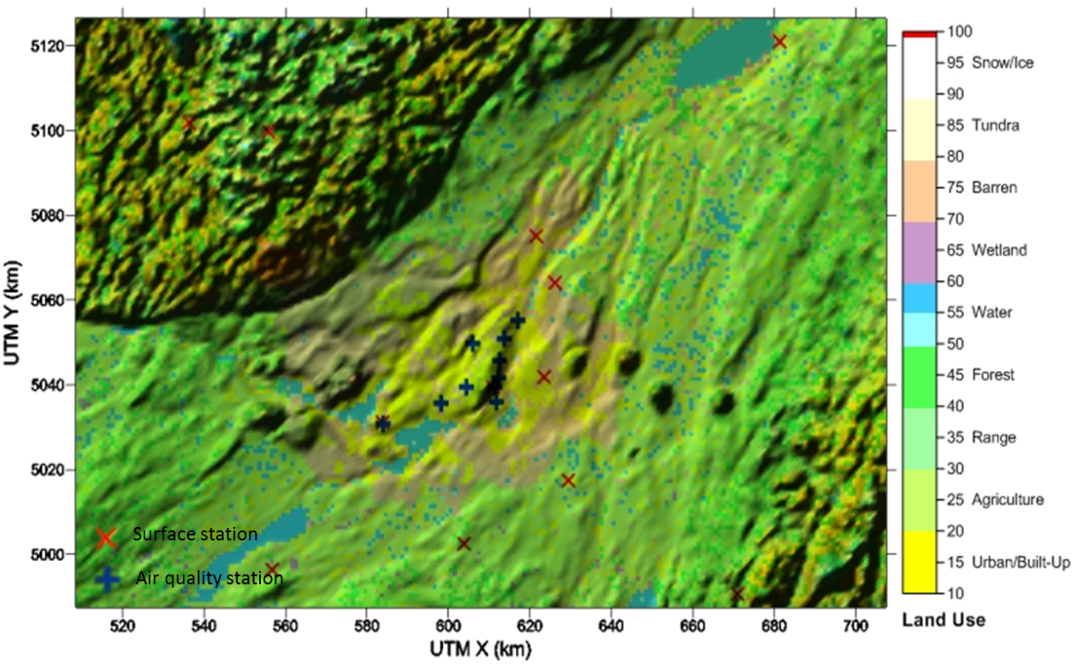**

**Fig. 3.** Land-use and topography across the study domain. The locations of meteorological surface stations (×) and air quality stations (+) are presented on the map. The air quality stations were used for model validation.

**2.4 Validation of meteorology and dispersion model**

Comparison of model predictions with data measured at monitoring stations is a core element of dispersion model evaluation. Examining wind roses generated from the available meteorological data provides a better understanding of the complex wind flows within the modelling domain. To calibrate our meteorological model, as mentioned in section 2.3, different weights were assigned to surface stations to force winds to follow the wind vector recorded at the station and accounting for terrain effects using MM5 data. The resulting wind speeds and directions were validated against observations. We generated and compared daily, monthly, and seasonal wind roses form CALMET with observed data at two airport stations (Mirabel and Dorval stations). We also estimated the correlation between observed and predicted wind speeds and wind directions.

To validate the dispersion model, the predicted NO2 concentrations were validated against NO2 data collected at a total of 9 fixed-site air quality monitoring stations managed and operated by the City of Montreal through the Reseau de Surveillance de la Qualite de l’Air (RSQA). These monitors are located on the Montreal Island. After pairing simulated and measured NO2 concentrations in both space and time, we used a number of performance measures proposed by Chang and Hanna (2004) as presented in Table 1.

**Table 1.** Performance measures for urban dispersion model validation  
(adapted from (Chang and Hanna, 2004).

|  |  |  |  |
| --- | --- | --- | --- |
| Performance measures | Equation | Ideal Value | Acceptable Value |
| Normalized absolute difference (*NAD*) |  | 0 | <0.5 |
| Fractional mean bias (*FB*) | $$FB=\frac{2(\overline{C_{0}-C_{P}})}{\overline{C_{0}}+\overline{C_{P}}}$$ | 0 | -0.67 to 0.67 |
| Normalized mean-square error (*NMSE*) |  | 0 | <6 |

C0 and Cp represent the observed and predicted concentrations, respectively.

The overbar represents the average over the hourly values.

**2.5 Scenario analysis**

The need for air quality prediction associated with transportation policies is important for health impact assessment (Bhalla et al., 2014; De Nazelle et al., 2011). We estimated the current NO2 concentrations linked to driving trips using travel data for the year 2008 as the base year. Then, a transit scenario was introduced which evaluates the effects of major public transit expansions throughout the region. We assumed that all of these expansions would occur in 2008 without projecting a future business as usual scenario. The reason for assessing a policy scenario in the current base year rather than in a future year is to control for all other factors such as population growth as well changes in land-use and socio-demographics. Since the thrust of this paper is to test the robustness of our modelling tool rather than to explore feasible policies and timelines, we are interested in an extreme scenario that helps us assess the response of the model. For this purpose, we have obtained information on all of the public transit projects that are currently planned or are under construction. These include subway extensions, light rail, and regional rail proposals included within Montreal region’s land-use and sustainable transportation plan for 2031. The plan is entitled Plan Métropolitain d’Aménagement et de Développement (PMAD) and includes three main dimensions: transportation, land-use, and environmental protection.

Using the travel demand and mode choice models, we re-estimated trip decisions and modes. With the new transit proposals, our transit travel times for the trips originating or with destinations in areas within 1km of new stations were reduced by about 60 to 100% of the original transit travel times. This reduction in travel time by transit is expected to lead to an increased ridership.

**2.6 Evaluating population exposure to air pollution**

Traditional epidemiologic studies often rely on average air pollutant concentrations at the residential location as a potential predictor for the odds of air pollution-related health effects. In this study, we estimated a daily NO2 exposure based on individuals’ trajectories and activity locations. To demonstrate our methodology, we used data from the origin-destination survey. We extracted all 29,272 individuals who underwent single mode trips which started and ended at home as drivers or passengers (90,000 trips). Based on the traffic assignment model, we assigned a path to each trip. Then, hourly NO2 surfaces were used to assign NO2 to the path. The NO2 exposure over a selected path was calculated as the weighted average NO2 concentration at every individual road segment throughout the trip. Concentrations of NO2 were also extracted for each activity location based on the duration of the individual’s activity at each location and the NO2 concentration at each time period. Then, for every individual, daily exposure was calculated as the average NO2 concentration resulting from the NO2 concentrations at all activity locations and trips (Eq. 1).

$C_{NO2}^{i}$*= $\frac{\sum_{t=1}^{n}{{\left(\sum_{k=1}^{m}{\left[C_{NO2-t}^{k}\left(t\right)× t_{trip}^{k}\left(t\right)+C_{NO2-s}^{k}\left(t\right)× t_{stop}^{k}\left(t\right)\right]}\right)}_{t} }}{N}$* (1)

*i is individual,*

*n is the total number of time steps per day (for hourly time steps n=24),*

*t is indicator for time step,*

*m is the total number of locations per individual trip,*

*k is indicator for location number,*

*N is the sum of trip and stop durations (N=24 since the exposure is computed for the entire day),*

$t_{trip}^{k}(t)$*is the time an individual spent in every trip,*

$t_{stop}^{k}\left(t\right)$*is the time an individual spent at every stop or activity location,*

$C_{NO2-s}^{k}\left(t\right)$*is the NO2 concentration during the stop at the end of trip k at time t,*

$C_{NO2-t}^{k}\left(t\right)$*is the NO2 concentration for part of trip k at time t.*

1. **Results and discussion**

**3.1 Meteorology**

The CALMET simulated wind fields were compared with observed data at Mirabel airport. Fig. 4 presents side-by-side, two windroses plotted based on CALMET output and observed data for one week in April. In general, CALMET captures reasonably well the most frequent winds observed at the station (spearman correlations for wind speed and wind direction are 0.64 and 0.82 respectively). Northwestern winds were somehow under-represented by the model. Moreover, CALMET predicted lower wind speeds. Similar results were reported in other studies whereby overall wind directions and speeds were well captured by the model but the frequency of high wind speeds is lower in simulated data (Hatzopoulou and Miller, 2010; Klausmann A.M, 2005).

**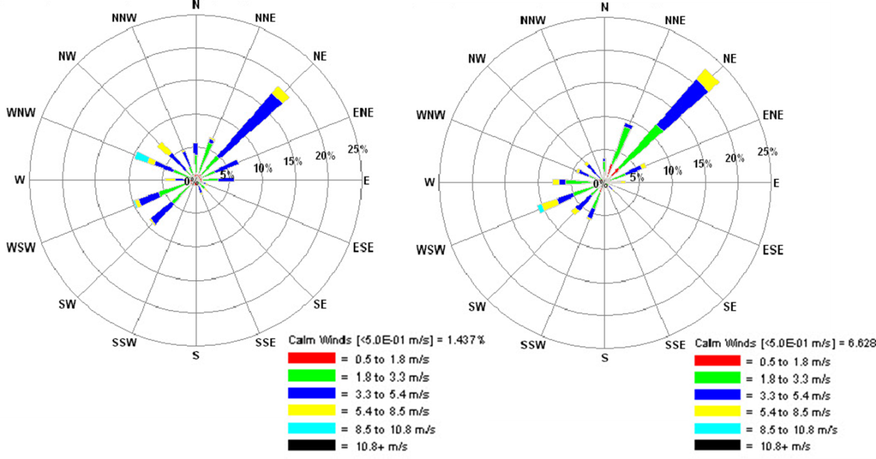**

**Fig. 4.** Simulated winds using CALMET (left) and observed winds at Mirabel airport (right)   
for April 7-14, 2008.

**3.2. Dispersion**

Fig. 5 presents the simulated NO2 concentrations over 24 hours. The hourly data in this map represent the average NO2 in each hour across the four weeks of simulation (in January, April, August, and October). This represents a long-term average concentration in each hour.

The simulated weekly averages for NO2 in January, April, August, and October are presented in Fig 6. NO2 concentrations for January, April, August and October range between 6.5-23.0 ppb, 4.4-25.1 ppb, 1.06-29.6 ppb and 3.7-31.7 ppb, respectively. The minimum value for NO2 is higher in January and April while the maximum value is higher in August and October. Also, Fig. 6 illustrates that the four-week average NO2 concentration for the study region ranges between 4 ppb and 17 ppb. Note that these concentrations reflect the contribution of traffic only, without the contribution of other sources (industrial, residential). In addition, the contribution of traffic does not include truck movements.

|  |  |  |  |  |  |
| --- | --- | --- | --- | --- | --- |
| ***I:\CAL_rd_1_6_2015\2008_Fred\Analysis\figs\24.png***  12-1 AM | ***I:\CAL_rd_1_6_2015\2008_Fred\Analysis\figs\1.png***  1-2 AM | ***I:\CAL_rd_1_6_2015\2008_Fred\Analysis\figs\2.png***  2-3 AM | ***I:\CAL_rd_1_6_2015\2008_Fred\Analysis\figs\3.png***  3-4AM | ***I:\CAL_rd_1_6_2015\2008_Fred\Analysis\figs\4.png***  4-5AM | ***I:\CAL_rd_1_6_2015\2008_Fred\Analysis\figs\5.png***  5-6AM |
| ***I:\CAL_rd_1_6_2015\2008_Fred\Analysis\figs\6.png***  6-7AM | ***I:\CAL_rd_1_6_2015\2008_Fred\Analysis\figs\7.png***  7-8AM | ***I:\CAL_rd_1_6_2015\2008_Fred\Analysis\figs\8.png***  8-9AM  2-3PM | ***I:\CAL_rd_1_6_2015\2008_Fred\Analysis\figs\9.png***  9-10AM  3-4PM  4-5PM  5-6PM | ***I:\CAL_rd_1_6_2015\2008_Fred\Analysis\figs\10.png***  10-11AM | ***I:\CAL_rd_1_6_2015\2008_Fred\Analysis\figs\11.png***  11AM-12PM |
| ***I:\CAL_rd_1_6_2015\2008_Fred\Analysis\figs\12.png***  6-7PM  12-1PM | ***I:\CAL_rd_1_6_2015\2008_Fred\Analysis\figs\13.png***  1-2PM  7-8PM | ***I:\CAL_rd_1_6_2015\2008_Fred\Analysis\figs\14.png***  8-9PM | ***I:\CAL_rd_1_6_2015\2008_Fred\Analysis\figs\15.png***  9-10PM | ***I:\CAL_rd_1_6_2015\2008_Fred\Analysis\figs\16.png***  10-11PM | ***I:\CAL_rd_1_6_2015\2008_Fred\Analysis\figs\17.png***  11PM-12AM |
| ***I:\CAL_rd_1_6_2015\2008_Fred\Analysis\figs\18.png*** | ***I:\CAL_rd_1_6_2015\2008_Fred\Analysis\figs\19.png*** | ***I:\CAL_rd_1_6_2015\2008_Fred\Analysis\figs\20.png*** | ***I:\CAL_rd_1_6_2015\2008_Fred\Analysis\figs\21.png*** | ***I:\CAL_rd_1_6_2015\2008_Fred\Analysis\figs\22.png*** | ***I:\CAL_rd_1_6_2015\2008_Fred\Analysis\figs\23.png*** |

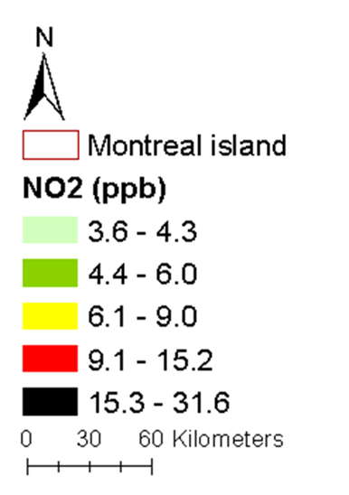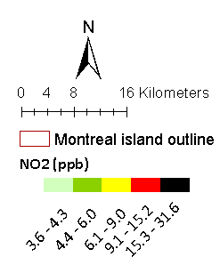

**Fig. 5.** Hourly simulated NO2 concentrations (ppb), starts form 12 am (top left image) to 11 pm (downright image).   
The red and green areas show the highest and lowest concentrations, respectively.

|  |  |
| --- | --- |
| **C:\Users\LocalAdmin\Desktop\jan.jpg**  **(a)** | **C:\Users\LocalAdmin\Desktop\April.jpg**  **(b)** |
| **C:\Users\LocalAdmin\Desktop\aug.jpg**  **(c)** | **C:\Users\LocalAdmin\Desktop\october.jpg**  **(d)** |
| **C:\Users\LocalAdmin\Desktop\all24hourly_3.jpg**  **(e)** | |

**Fig. 6.** Weekly (a, b, c, d) and long-term (four-weeks, e) average simulated NO2 concentrations.

The validation of simulated concentrations was conducted along various dimensions. Our validation against observed concentrations entailed matching our simulated concentrations against data from nine fixed monitoring stations in Montreal for 168 hours of each week in January, April, August and October. We then calculated the Spearman correlations between the hourly observed and simulated NO2 concentrations at the 9 stations. As presented in Table 2, the correlations vary among weeks and stations: Spearman correlation coefficients range from 0.55 -0.78 for January, 0.45 - 0.83 for April, 0.02 - 0.70 for August, and 0.24 - 0.69 for October. The lower correlations noted in the month of August are predominantly due to the meteorology and generally lower wind speeds observed during this period, with days of extremely low wind speeds. Tables I to IV in the supplementary material present frequency distributions of observed and simulated concentrations. We also estimated correlations for each station based on pooled data for the four weeks and observed a range of correlations between 0.39 and 0.74. Finally, we computed the correlation between the averages for the four weeks of simulation with the averages of the measured concentrations at each station. This leads to 10 simulated vs 10 measured values, we obtain a spearman correlation coefficient of 0.78, significant at the 0.05 level (2-tailed), picking up the robustness of our model at capturing the spatial variability in ambient NO2.

In addition, a set of performance measures were estimated for all selected stations as shown in Table 3. The fractional mean bias (*FB*) indicates that the model performance is acceptable for the selected simulation periods (less than 0.65). We also observe a high variability in FB across the seasons and stations, ranging from a minimum of -0.38 (which indicates an overprediction at a single station in October) to a maximum of 1.13 (which indicates underprediction at a single station in April). The *FB* measures the mean relative bias and indicates only systematic errors. In contrast, *NMSE* and *NAD* are measures of mean relative scatter and reflect both systematic and random errors. If a model systematically overpredicts or underpredicts, but still has the same scatter as the observations, the values for NMSE and NAD would equal 0, an ideal result. As indicated in Table 1, the model performance is also acceptable in terms of the Normalised Mean-Square Error (*NMSE*<6) and Normalized Absolute Difference (*NAD<0.5*).

Finally, we compared our simulated NO2 surface (for the four weeks in 2008) with two land-use regression (LUR) surfaces developed previously for Montreal (Crouse et al., 2009; Deville-Cavellin et al., 2015). The surface developed by Crouse et al. (2009) reflects an annual mean for 2005/2006 while the surface developed by Deville-Cavellin et al. (2015) reflects an annual mean for 2014. Between 2005 and 2015, Montreal did not witness significant changes in land-use therefore it is expceted that the spatial variability in NO2 remains relatively stable. The correlation between our dispersion surface and the LUR developed by Crouse et al. (2009) is 0.78 while that with the LUR developed by Deville-Cavellin et al. (2015) is 0.76, indicating reasonably strong correlation between the three surfaces.

**Table 2.** Correlations between simulated and observed NO2 concentrations at air quality stations in Montreal.

|  |  |  |  |  |  |  |  |  |  |
| --- | --- | --- | --- | --- | --- | --- | --- | --- | --- |
| Spearman Correlation | Station Number | | | | | | | | |
| 1 | 3 | 7 | 12 | 28 | 29 | 61 | 66 | 68 |
| January | 0.71 | 0.55 | na | 0.78 | 0.65 | 0.78 | 0.71 | 0.76 | 0.66 |
| April | 0.55 | 0.55 | 0.53 | na | 0.45 | 0.59 | 0.59 | 0.83 | 0.70 |
| August | 0.70 | 0.56 | 0.63 | 0.48 | 0.02 | 0.46 | 0.10 | na | 0.37 |
| October | 0.63 | 0.56 | 0.53 | na | 0.24 | 0.69 | 0.30 | 0.43 | 0.56 |
| Pooled data | 0.62 | 0.55 | 0.62 | 0.65 | 0.40 | 0.74 | 0.39 | 0.65 | 0.47 |

NA indicates that no observations were recorded by The City of Montreal for that pollutant

**Table 3.** Model performance across the four seasons.

|  |  |  |  |  |
| --- | --- | --- | --- | --- |
| Performance measures | January | April | October | August |
| Normalized absolute difference (*NAD*) | 0.39 | 0.34 | 0.28 | 0.40 |
| Fractional mean bias (*FB*) | 0.23 | 0.67 | 0.46 | 0.56 |
| Normalized mean-square error (*NMSE*) | 1.23 | 1.45 | 1.01 | 6.92 |

**3.3 Scenario analysis**

We observed a modal shift towards transit especially for the trips that are affected by the new public transit alternatives (this increase is 1.86% for the total population and 16.65% for the population with high access to the new transit stations). Subsequently, we observed a decrease in traffic volumes on the road network and increases in speed. The 2008 transit scenario resulted in a reduction in total NOx emissions of 1.9% compared to the base case; some roads experienced reductions by more than half. Recall that by applying the transit policies in 2008 rather than in a future year, we do not face the confounding effects of lower emissions due to improved vehicle technology. Fig. 7 illustrates the difference in hourly NOx emission rates between the 2008 scenario and the base scenario, highlighting that the larger reductions occur during peak periods where traffic congestion is highest.

Fig. 8 compares the simulated NO2 concentrations for 2008 base case and transit scenario. These maps represent the average NO2 concentrations across the four weeks of simulation (in January, April, August and October). Beyond the overall decrease in NO2 concentrations, we observe that people living near major roads enjoy the highest decrease. The mean NO2 concentration was reduced by 3.6%. This decrease is more than twice the reduction in mean NOx emissions (1.9% compared to the base case) illustrating the importance of dispersion modelling when evaluating the air quality effects of various policies.

**Fig. 7.** Hourly difference between baseline and scenario NOx emissions   
in gram per unit of length (g/km) for Montreal.

|  |  |
| --- | --- |
| **I:\Papers\Env Model &soft\1st revision\fig\attachments\jan.pngJanuary** | **I:\Papers\Env Model &soft\1st revision\fig\attachments\scale diff.pngI:\Papers\Env Model &soft\1st revision\fig\attachments\april.pngApril** |
| **I:\Papers\Env Model &soft\1st revision\fig\attachments\aug.png**  **August** | **I:\Papers\Env Model &soft\1st revision\fig\attachments\oct.png**  **October** |

**Fig. 8.** Difference between base case and transit scenario for weekly average simulated NO2 concentrations

**3.4 Exposure analysis**

After simulating NO2 concentrations across the study domain, we estimated a 24-hour average exposure for a sample of the population based on individual trajectories and daily activities. Individual exposures were estimated in the base and transit scenarios. Fig. 9 illustrates the frequency distributions of individual exposures under the base case and the transit scenario for the average of four weeks. Compared to the baseline, the transit scenario resulted in substantially lower daily NO2 exposures. For example, in the base case, the percentage of individuals with a daily exposure exceeding 8ppb is 14% while this percentage decreases to 1.7% in the transit scenario. In the base case, around half of the sample (53%) is exposed to NO2 concentrations above 6 ppb while this percentage drops to less than 13% in the transit scenario. Fig. 10 presents the frequency distributions of NO2 concentrations at the home locations of individuals in our sample under the base case and the transit scenario. Compared to the base case, the transit scenario resulted in a mean reduction of 26.4% in NO2 concentrations at the home locations of individuals in the sample.

In summary, we observe that the percentage reduction in NOx emissions (1.9%) across the road segments and NO2 concentrations across the grid-cells in the study domain (3.6%) are far from proportional to the decrease in average NO2 concentrations at the home locations of participants (26.4%), or to the decrease in daily exposures based on mobility patterns (20.8%). We also observe a difference in the daily exposures based on trips and activity locations compared to the daily mean concentration at the home location indicating that the latter slightly overestimate the improvements associated with transit investments. The difference between the expected decreases in NO2 concentrations and daily NO2 exposures illustrates the power of our integrated emission dispersion and exposure model in policy analysis. This is particularly true when these models are further used for health impact assessments therefore translating exposures to health effects. The large discrepancy between NO2 daily concentrations across the study area and NO2 daily exposures clearly indicates that the evaluation of the effects of transportation policies on air quality should include an analysis of population exposure.

In order to better understand the spatial variability in ambient NO2 reductions as a result of the transit scenario and compare them with reductions in NO2 exposures across individuals’ home locations, we developed two maps illustrated in Fig. 11. Fig. 11a presents the reductions in NO2 exposures computed as (NO2 exposure in Base - NO2 exposure in Scenario)/ NO2 exposure in Base. Fig. 11b presents the reductions in ambient NO2 concentrations computed as (NO2 in Base - NO2 in Scenario)/ NO2 in Base. Starting with Fig. 11b, we clearly observe higher reductions in NO2 concentrations in downtown areas due to the presence of transit and active transportation facilities affecting mode choice. However, reductions in exposure (Fig. 11a) turned out to be higher for individuals living in peripheral areas in light of their mobility patterns, visiting the areas with highest reductions in NO2 concentrations and therefore significantly reducing their daily exposure. In fact, Fig. 11a illustrates what we have already quantified at a region-level, that reductions in exposures are higher than reductions in ambient air quality. Reductions in exposures are also more expansive as seen by the large area in the warmer colours (Fig. 11a).

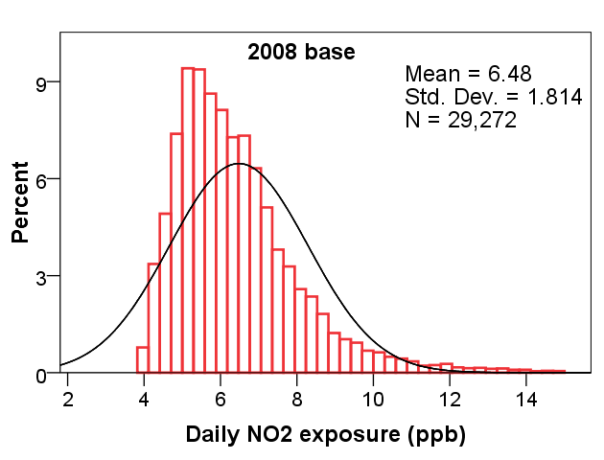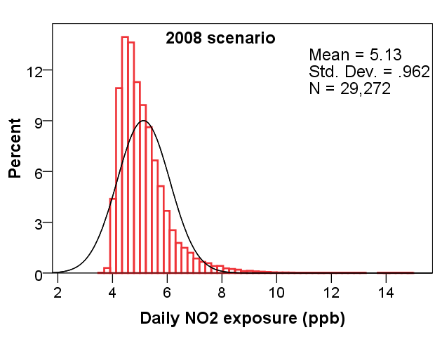

**Fig. 9.** Frequency distributions for daily NO2 exposures for 2008 base (left) and scenario (right).

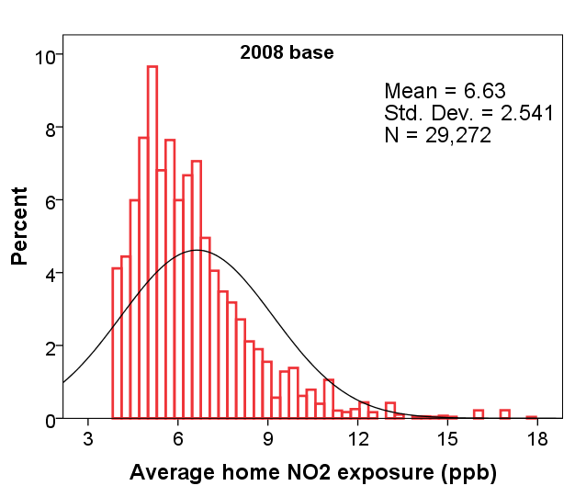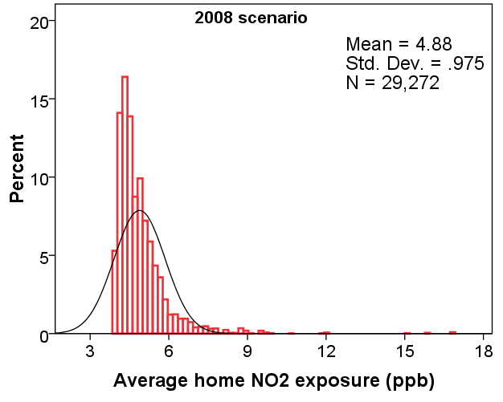

**Fig. 10.** Frequency distributions for daily NO2 concentrations at home locations of individuals in the sample for 2008 base (left) and scenario (right).

|  |  |  |
| --- | --- | --- |
| **I:\CAL_rd_1_6_2015\scenario analysis_DSP\Latest result Without point\Fig\8mobredcu.png** | **I:\CAL_rd_1_6_2015\scenario analysis_DSP\Latest result Without point\Fig\8NO2redcu.png** | **I:\CAL_rd_1_6_2015\scenario analysis_DSP\Latest result Without point\Fig\8-scale.png** |

(a) (b)

**Fig. 11.** Reduction in NO2 concentrations (b) and daily NO2 exposure (a) mapped across traffic analysis zones (the white zones represent the places with no individuals in our sample). Traffic analysis zones were chosen for better visualisation

1. **Conclusion**

This paper describes the development and validation of a travel demand, emission, and dispersion model for the Montreal Metropolitan Area. The simulated meteorological variables and NO2 concentrations were compared with the corresponding observed values at different stations within the study area. In general, the meteorological model captures reasonably well the most frequent winds observed at the meteorological stations. This study also showed that simulated concentrations can be reasonably correlated with the observed data when detailed meteorological and dispersion characteristics are accounted for. However, the model underestimates observed concentrations mainly due to the fact that the emissions of trucks and residential/commercial point sources were not accounted for.

The modelling system was used to evaluate the impact of an extensive regional transit improvement strategy revealing reductions in NO2 concentrations by about 3.6% compared to the base case across the territory in addition to a decrease in the frequency and severity of NO2 hot spots. Finally, a methodology for assessing individuals’ daily exposure is developed and we observed a reduction of about 21% in daily exposures of individuals compared to the base case. The difference between reductions in the mean NO2 concentration across the study domain and the mean NO2 exposure across the sample population results from the fact that NO2 concentrations dropped largely in the areas which attract the most individuals and where most people live.

The strength of our modelling system is that it allows us to investigate the impacts of various policies on travel, emissions, air pollution, and exposure therefore illustrating the non-linearity of these effects. Evaluating policies solely based on their emission reduction potential may overestimate or underestimate their effect on air quality. Similarly, simulating air quality as a result of various policies does not allow us to infer the full effects on population exposure. Air quality improvements may occur in the least or the most populated and/or visited areas, spatial variability matters. Our model system is primarily geared towards policy appraisal of transport plans, allowing policy evaluation to move beyond traditional performance measures putting a greater emphasis on health.

A number of limitations are associated with this study, some of which are the objective of future model developments. First, we only simulate a single day for travel. This limitation is an inherent downside of most travel surveys since they capture the daily travels of a single day at the household level. Despite this limitation, we conducted dispersion over various days and seasons in order to capture the very important effect of meteorology. Under the same travel and traffic patterns, meteorological conditions may lead to largely different ground-level concentrations. Another limitation is associated with the lack of commercial vehicle movements therefore our model includes household travel only. This limitation is partially overcome by the fact that our model will be mostly used to investigate the effects of scenarios affecting household travel. Finally, our dispersion model incorporates basic NO2 chemistry at the expense of an improved dispersion algorithm. Proper accounting for all transformations affecting NO2 can only be done with a chemical transport model.

**Acknowledgements**

This work was funded by a Collaborative Health Research Projects grant by the government of Canada. It was also supported with matching funds from the Montreal Department of Public Health. Special thanks are extended to Joseph Scire, David Strimaitis and the entire CALPUFF development team for their immense assistance throughout this study.

**References**

Bae, C., Sandlin, G., Bassok, A., Kim, S., 2007. The exposure of disadvantaged populations in freeway air-pollution sheds: a case study of the Seattle and Portland regions. Environment And Planning B Planning and Design 34(1) 154.

Batterman, S.A., Zhang, K., Kononowech, R., 2010. Prediction and analysis of near-road concentrations using a reduced-form emission/dispersion model. Environmental Health 9 29-29.

Beckx, C., Panis, L.I., Arentze, T., Janssens, D., Torfs, R., Broekx, S., Wets, G., 2009. A dynamic activity-based population modelling approach to evaluate exposure to air pollution: methods and application to a Dutch urban area. Environmental Impact Assessment Review 29(3) 179-185.

Bhalla, K., Shotten, M., Cohen, A., Brauer, M., Shahraz, S., Burnett, R., Leach-Kemon, K., Freedman, G., Murray, C., 2014. Transport for health: the global burden of disease from motorized road transport.

Braubach, M., Tobollik, M., Mudu, P., Hiscock, R., Chapizanis, D., Sarigiannis, D.A., Keuken, M., Perez, L., Martuzzi, M., 2015. Development of a quantitative methodology to assess the impacts of urban transport interventions and related noise on well-being. International journal of environmental research and public health 12(6) 5792-5814.

Carper, E.A., Ottersburg, E., 2003. Significance of a Calpuff Near-Field Analysis, Proceedings A&WMA 96th Annual Conference and Exhibition, San Diego USA.

Chang, J., Hanna, S., 2004. Air quality model performance evaluation. Meteorology and Atmospheric Physics 87(1-3) 167-196.

Chen, H., Namdeo, A., Bell, M., 2008. Classification of road traffic and roadside pollution concentrations for assessment of personal exposure. Environmental Modelling & Software 23(3) 282-287.

Cheng, Y.-H., Li, Y.-S., 2010. Influences of traffic emissions and meteorological conditions on ambient PM10 and PM2. 5 levels at a highway toll station. Aerosol Air Qual. Res 10 456-462.

Clark, C., Crombie, R., Head, J., Van Kamp, I., Van Kempen, E., Stansfeld, S.A., 2012. Does traffic-related air pollution explain associations of aircraft and road traffic noise exposure on children's health and cognition? A secondary analysis of the United Kingdom sample from the RANCH Project. American journal of epidemiology 176(4) 327-337.

Cohen, J., Cook, R., Bailey, C.R., Carr, E., 2005. Relationship between motor vehicle emissions of hazardous pollutants, roadway proximity, and ambient concentrations in Portland, Oregon. Environmental Modelling & Software 20(1) 7-12.

Crouse, D.L., Goldberg, M.S., Ross, N.A., 2009. A prediction-based approach to modelling temporal and spatial variability of traffic-related air pollution in Montreal, Canada. Atmospheric Environment 43(32) 5075-5084.

Crouse, D.L., Goldberg, M.S., Ross, N.A., Chen, H., Labrèche, F., 2010. Postmenopausal breast cancer is associated with exposure to traffic-related air pollution in Montreal, Canada: a case-control study. Environmental health perspectives 118(1) 1578-1583.

De Nazelle, A., Nieuwenhuijsen, M.J., Antó, J.M., Brauer, M., Briggs, D., Braun-Fahrlander, C., Cavill, N., Cooper, A.R., Desqueyroux, H., Fruin, S., 2011. Improving health through policies that promote active travel: a review of evidence to support integrated health impact assessment. Environment International 37(4) 766-777.

De Ridder, K., Lefebre, F., Adriaensen, S., Arnold, U., Beckroege, W., Bronner, C., Damsgaard, O., Dostal, I., Dufek, J., Hirsch, J., 2008. Simulating the impact of urban sprawl on air quality and population exposure in the German Ruhr area. Part I: Reproducing the base state. Atmospheric Environment 42(30) 7059-7069.

Den Boeft, J., Eerens, H.C., Den Tonkelaar, W., Zandveld, P., 1996. CAR International: a simple model to determine city street air quality. Science of The Total Environment 189 321-326.

Deville Cavellin, L., Weichenthal, S., Tack, R., Ragettli, M.S., Smargiassi, A., Hatzopoulou, M., 2015. Investigating The Use Of Portable Air Pollution Sensors To Capture The Spatial Variability Of Traffic Related Air Pollution. Environmental Science & Technology.

Dhondt, S., Beckx, C., Degraeuwe, B., Lefebvre, W., Kochan, B., Bellemans, T., Panis, L.I., Macharis, C., Putman, K., 2012. Integration of population mobility in the evaluation of air quality measures on local and regional scales. Atmospheric Environment 59 67-74.

Dhondt, S., Kochan, B., Beckx, C., Lefebvre, W., Pirdavani, A., Degraeuwe, B., Bellemans, T., Panis, L.I., Macharis, C., Putman, K., 2013. Integrated health impact assessment of travel behaviour: Model exploration and application to a fuel price increase. Environment international 51 45-58.

Dons, E., Beckx, C., Arentze, T., Wets, G., Panis, L., 2011. Using an activity-based framework to determine effects of a policy measure on population exposure to nitrogen dioxide. Transportation Research Record: Journal of the Transportation Research Board(2233) 72-79.

Eluru, N., V. Chakour, and A. El-Geneidy., 2012. "Travel Mode Choice and Transit Route Choice Behavior in Montreal: Insights from McGill University Members Commute Patterns," Public Transport: Planning and Operations Vol. 4, No. 2, pp. 129-149.

Gariazzo, C., Pelliccioni, A., Bolignano, A., 2016. A dynamic urban air pollution population exposure assessment study using model and population density data derived by mobile phone traffic. Atmospheric Environment 131 289-300.

Grabow, M.L., Spak, S.N., Holloway, T., Stone Jr, B., Mednick, A.C., Patz, J.A., 2012. Air quality and exercise-related health benefits from reduced car travel in the midwestern United States. Environmental health perspectives 120(1) 68.

Grell, G.A., Dudhia, J., Stauffer, D.R., 1994. A description of the fifth-generation Penn State/NCAR mesoscale model (MM5).

Hao, J.Y., Hatzopoulou, M., Miller, E.J., 2010. Integrating an activity-based travel demand model with dynamic traffic assignment and emission models. Transportation Research Record: Journal of the Transportation Research Board 2176(1) 1-13.

Hatzopoulou, M., Miller, E.J., 2010. Linking an activity-based travel demand model with traffic emission and dispersion models: Transport’s contribution to air pollution in Toronto. Transportation Research Part D: Transport and Environment 15(6) 315-325.

Hertel, O., Berkowicz, R., Miljøundersøgelser, D., 1989. Modelling pollution from traffic in a street canyon: evaluation of data and model development. National Environmental Research Institute.

Hoek, G., Beelen, R., de Hoogh, K., Vienneau, D., Gulliver, J., Fischer, P., Briggs, D., 2008. A review of land-use regression models to assess spatial variation of outdoor air pollution. Atmospheric Environment 42(33) 7561-7578.

Hosking, J., Jones, R., Percival, T., Turner, N., Ameratunga, S., 2011. Climate change: the implications for child health in Australasia. Journal of paediatrics and child health 47(8) 493-496.

Int Panis, L., Beckx, C., Broekx, S., De Vlieger, I., Schrooten, L., Degraeuwe, B., Pelkmans, L., 2011. PM, NOxand CO2 emission reductions from speed management policies in Europe. Transport Policy 18(1) 32-37.

Johnson, M., Isakov, V., Touma, J., Mukerjee, S., Özkaynak, H., 2010. Evaluation of land-use regression models used to predict air quality concentrations in an urban area. Atmospheric Environment 44(30) 3660-3668.

Klausmann A.M, J.S.S., 2005. Application of the CALMET meteorological model to wind resource assessment and forecasting, Wind Power 2005 Conference: Denver.

Macmillan, A., Connor, J., Witten, K., Kearns, R., Rees, D., Woodward, A., 2014. The societal costs and benefits of commuter bicycling: simulating the effects of specific policies using system dynamics modelling. Environmental health perspectives 122(4) 335.

Maizlish, N., Woodcock, J., Co, S., Ostro, B., Fanai, A., Fairley, D., 2013. Health cobenefits and transportation-related reductions in greenhouse gas emissions in the San Francisco Bay area. American Journal of Public Health 103(4) 703-709.

McCreddin, A., Alam, M., McNabola, A., 2015. Modelling personal exposure to particulate air pollution: An assessment of time-integrated activity modelling, Monte Carlo simulation & artificial neural network approaches. International journal of hygiene and environmental health 218(1) 107-116.

Nieuwenhuijsen, M.J., Khreis, H., Verlinghieri, E., Rojas-Rueda, D., 2016. Transport And Health: A Marriage Of Convenience Or An Absolute Necessity. Environment international 88 150-152.

NOAA, 2012. National Oceanic and Atmospheric Administration. ftp://ftp.ncdc.noaa.gov/pub/data/noaa/2012.

Parent, M.-É., Goldberg, M.S., Crouse, D.L., Ross, N.A., Chen, H., Valois, M.-F., Liautaud, A., 2013. Traffic-related air pollution and prostate cancer risk: a case–control study in Montreal, Canada. Occupational and environmental medicine oemed-2012-101211.

Perez, L., Trüeb, S., Cowie, H., Keuken, M., Mudu, P., Ragettli, M., Sarigiannis, D., Tobollik, M., Tuomisto, J., Vienneau, D., 2015. Transport-related measures to mitigate climate change in Basel, Switzerland: A health-effectiveness comparison study. Environment international 85 111-119.

PTV Vision, 2009. VISUM 11.0 Basics.PTV AG, Karlsruhe, Germany.

Radonjic, Z., Agranat, V., Telenta, B., Hrebenyk, B., Chambers, D., Ritchie, T., 2013. Comparison of Near-field CFD and CALPUFF Modelling Results around a Backup Diesel Generating Station, Proceedings of the Air & Waste Management Association’s Conference Guideline on Air Quality Models: The Path Forward, Raleigh, North Carolina, USA.

Rowangould, G.M., 2015. A new approach for evaluating regional exposure to particulate matter emissions from motor vehicles. Transportation Research Part D: Transport and Environment 34 307-317.

Scire, J.S., Robe, F.R., Fernau, M.E., Yamartino, R.J., 2000a. A user’s guide for the CALMET Meteorological Model. Earth Tech, USA 37.

Scire, J.S., Strimaitis, D.G., Yamartino, R.J., 2000b. A user’s guide for the CALPUFF dispersion model. Earth Tech, Inc 521 1-521.

Shekarrizfard, M., Karimi-Jashni, A., Hadad, K., 2012. Wavelet transform-based artificial neural networks (WT-ANN) in PM10 pollution level estimation, based on circular variables. Environmental Science and Pollution Research 19(1) 256-268.

Sider, T., Alam, A., Zukari, M., Dugum, H., Goldstein, N., Eluru, N., Hatzopoulou, M., 2013. Land-use and socio-economics as determinants of traffic emissions and individual exposure to air pollution. Journal of Transport Geography 33 230-239.

Tobollik, M., Keuken, M., Sabel, C., Cowie, H., Tuomisto, J., Sarigiannis, D., Künzli, N., Perez, L., Mudu, P., 2016. Health impact assessment of transport policies in rotterdam: Decrease of total traffic and increase of electric car use. Environmental Research 146 350-358.

Vallamsundar, S., Lin, J., Konduri, K., Zhou, X., Pendyala, R.M., 2016. A comprehensive modeling framework for transportation-induced population exposure assessment. Transportation Research Part D: Transport and Environment 46 94-113.

Vardoulakis, S., Valiantis, M., Milner, J., ApSimon, H., 2007. Operational air pollution modelling in the UK—Street canyon applications and challenges. Atmospheric Environment 41(22) 4622-4637.

Woodcock, J., Edwards, P., Tonne, C., Armstrong, B.G., Ashiru, O., Banister, D., Beevers, S., Chalabi, Z., Chowdhury, Z., Cohen, A., 2009. Public health benefits of strategies to reduce greenhouse-gas emissions: urban land transport. The Lancet 374(9705) 1930-1943.

Wu, S., Duncan, B.N., Jacob, D.J., Fiore, A.M., Wild, O., 2009. Chemical nonlinearities in relating intercontinental ozone pollution to anthropogenic emissions. Geophysical Research Letters 36(5).

Xia, T., Nitschke, M., Zhang, Y., Shah, P., Crabb, S., Hansen, A., 2015. Traffic-related air pollution and health co-benefits of alternative transport in Adelaide, South Australia. Environment international 74 281-290.

**Supplementary Materials**

**I-** Descriptive statistics for observed and predicted NO2 concentrations (ppb) at 9 air quality stations (April).

|  |  |  |  |  |  |  |  |  |  |  |  |  |  |  |  |  |  |  |  |
| --- | --- | --- | --- | --- | --- | --- | --- | --- | --- | --- | --- | --- | --- | --- | --- | --- | --- | --- | --- |
|  | | **Stations** | | | | | | | | | | | | | | | |  |  |
| **Statistical index** | | **66** | | **68** | | **28** | | **61** | | **1** | | **29** | | **7** | | **3** | | **12** | |
|  | | Sim | Obs | Sim | Obs | Sim | Obs | Sim | Obs | Sim | Obs | Sim | Obs | Sim | Obs | Sim | Obs | Sim | Obs |
| **N** |  | 167 | 92 | 167 | 164 | 167 | 167 | 167 | 168 | 167 | 168 | 167 | 168 | 167 | 168 | 167 | 168 | 167 | - |
| **Mean** | | 5.29 | 15.25 | 10.97 | 15.84 | 17.23 | 19.00 | 6.78 | 23.86 | 5.31 | 12.97 | 5.47 | 15.72 | 5.36 | 11.76 | 4.73 | 9.53 | 8.78 | - |
| **Std. Error of Mean** | | 0.64 | 1.54 | 0.85 | 1.07 | 1.09 | 0.89 | 0.67 | 0.88 | 0.61 | 0.82 | 0.62 | 0.85 | 0.58 | 0.73 | 0.58 | 0.51 | 0.60 | - |
| **Median** | | 1.18 | 8.81 | 7.02 | 11.15 | 15.21 | 15.87 | 3.30 | 20.57 | 1.40 | 9.34 | 1.57 | 13.07 | 1.70 | 8.41 | 0.92 | 7.57 | 6.38 | - |
| **Std. Deviation** | | 8.25 | 14.79 | 10.95 | 13.74 | 14.07 | 11.45 | 8.62 | 11.44 | 7.93 | 10.67 | 7.99 | 10.97 | 7.56 | 9.46 | 7.44 | 6.56 | 7.73 | - |
| **Variance** | | 68.01 | 218.77 | 119.92 | 188.89 | 197.88 | 131.01 | 74.23 | 130.83 | 62.92 | 113.91 | 63.80 | 120.29 | 57.11 | 89.41 | 55.37 | 43.06 | 59.76 | - |
| **Minimum** | | 0.04 | 2.09 | 0.13 | 1.68 | 0.07 | 4.87 | 0.36 | 7.05 | 0.12 | 2.65 | 0.05 | 3.03 | 0.04 | 1.55 | 0.02 | 2.02 | 0.24 | - |
| **Maximum** | | 47.93 | 51.13 | 61.32 | 59.10 | 74.11 | 55.01 | 52.08 | 62.96 | 47.97 | 52.63 | 47.35 | 50.16 | 50.19 | 46.15 | 47.60 | 35.64 | 30.61 | - |

- Missing data

**II-** Descriptive statistics for observed and predicted NO2 concentrations (ppb) at 9 air quality stations (August).

|  |  |  |  |  |  |  |  |  |  |  |  |  |  |  |  |  |  |  |  |
| --- | --- | --- | --- | --- | --- | --- | --- | --- | --- | --- | --- | --- | --- | --- | --- | --- | --- | --- | --- |
|  | | **Stations** | | | | | | | | | | | | | | | |  | |
| **Statistical index** | | **66** | | **68** | | **28** | | **61** | | **1** | | **29** | | **7** | | **3** | | **12** | |
|  | | Sim | Obs | Sim | Obs | Sim | Obs | Sim | Obs | Sim | Obs | Sim | Obs | Sim | Obs | Sim | Obs | Sim | Obs |
| **N** |  | 167 | - | 167 | 167 | 167 | 53 | 167 | 167 | 167 | 163 | 167 | 168 | 167 | 168 | 167 | 164 | 167 | 167 |
| **Mean** | | 4.92 | - | 18.43 | 13.25 | 28.10 | 13.45 | 9.22 | 15.76 | 6.18 | 9.41 | 5.00 | 11.15 | 6.45 | 9.22 | 3.25 | 8.41 | 8.24 | 12.59 |
| **Std. Error of Mean** | | 0.56 | - | 1.09 | 0.48 | 1.51 | 0.77 | 0.82 | 0.45 | 0.62 | 0.40 | 0.49 | 0.42 | 0.58 | 0.42 | 0.29 | 0.38 | 0.83 | 0.41 |
| **Median** | | 1.34 | - | 13.80 | 12.44 | 26.46 | 12.46 | 5.65 | 16.56 | 2.90 | 8.36 | 2.39 | 10.65 | 3.59 | 8.22 | 1.75 | 7.27 | 3.86 | 12.06 |
| **Std. Deviation** | | 7.30 | - | 14.06 | 6.14 | 19.52 | 5.63 | 10.58 | 5.82 | 8.08 | 5.13 | 6.29 | 5.51 | 7.50 | 5.50 | 3.74 | 4.91 | 10.71 | 5.35 |
| **Variance** | | 53.29 | - | 197.74 | 37.72 | 381.18 | 31.73 | 111.93 | 33.87 | 65.22 | 26.34 | 39.56 | 30.32 | 56.26 | 30.20 | 13.96 | 24.13 | 114.65 | 28.63 |
| **Minimum** | | 0.05 | - | 1.03 | 2.52 | 0.13 | 5.96 | 0.36 | 4.32 | 0.27 | 1.20 | 0.10 | 1.84 | 0.10 | 0.53 | 0.03 | 1.74 | 0.57 | 3.35 |
| **Maximum** | | 35.52 | - | 61.94 | 27.63 | 63.13 | 31.99 | 58.97 | 28.65 | 40.05 | 23.06 | 36.25 | 25.79 | 39.48 | 25.90 | 16.84 | 22.52 | 57.76 | 28.11 |

- Missing data

**III-** Descriptive statistics for observed and predicted NO2 concentrations (ppb) at 9 air quality stations (January).

|  |  |  |  |  |  |  |  |  |  |  |  |  |  |  |  |  |  |  |  |
| --- | --- | --- | --- | --- | --- | --- | --- | --- | --- | --- | --- | --- | --- | --- | --- | --- | --- | --- | --- |
|  | | **Stations** | | | | | | | | | | | | | | | |  |  |
| **Statistical index** | | **66** | | **68** | | **28** | | **61** | | **1** | | **29** | | **7** | | **3** | | **12** | |
|  | | Sim | Obs | Sim | Obs | Sim | Obs | Sim | Obs | Sim | Obs | Sim | Obs | Sim | Obs | Sim | Obs | Sim | Obs |
| **N** |  | 164 | 167 | 167 | 167 | 165 | 167 | 168 | 167 | 168 | 167 | 168 | 167 | 167 | - | 167 | 167 | 169 | 169 |
| **Mean** | | 7.16 | 17.20 | 11.39 | 19.62 | 22.45 | 18.28 | 10.12 | 20.15 | 7.80 | 16.50 | 7.70 | 17.74 | 7.98 | - | 7.16 | 10.11 | 8.78 | 17.52 |
| **Std. Error of Mean** | | 0.55 | 0.88 | 0.63 | 0.92 | 1.45 | 0.69 | 0.65 | 0.65 | 0.56 | 0.82 | 0.59 | 0.89 | 0.60 | - | 0.56 | 0.57 | 0.60 | 0.70 |
| **Median** | | 4.63 | 15.75 | 11.06 | 19.51 | 16.65 | 17.43 | 6.50 | 20.08 | 5.08 | 15.38 | 4.81 | 14.93 | 4.91 | - | 4.21 | 8.62 | 6.38 | 17.13 |
| **Std. Deviation** | | 7.07 | 11.23 | 8.10 | 11.95 | 18.72 | 8.83 | 8.45 | 8.41 | 7.26 | 10.58 | 7.65 | 11.57 | 7.71 | - | 7.24 | 7.33 | 7.73 | 9.08 |
| **Variance** | | 49.96 | 126.13 | 65.64 | 142.69 | 350.44 | 78.03 | 71.48 | 70.79 | 52.73 | 111.92 | 58.45 | 133.92 | 59.44 | - | 52.44 | 53.77 | 59.76 | 82.53 |
| **Minimum** | | 0.03 | 2.09 | 0.08 | 2.99 | 0.23 | 4.62 | 0.46 | 5.38 | 0.17 | 2.08 | 0.05 | 2.00 | 0.32 | - | 0.10 | 0.48 | 0.24 | 3.83 |
| **Maximum** | | 24.16 | 48.56 | 42.44 | 85.68 | 72.10 | 39.22 | 35.38 | 40.46 | 25.64 | 36.74 | 29.04 | 41.88 | 31.81 | - | 25.67 | 23.62 | 30.61 | 34.36 |

- Missing data

**IV-** Descriptive statistics for observed and predicted NO2 concentrations (ppb) at 9 air quality stations (October).

|  |  |  |  |  |  |  |  |  |  |  |  |  |  |  |  |  |  |  |  |
| --- | --- | --- | --- | --- | --- | --- | --- | --- | --- | --- | --- | --- | --- | --- | --- | --- | --- | --- | --- |
|  | | **Stations** | | | | | | | | | | | | | | | |  |  |
| **Statistical index** | | **66** | | **68** | | **28** | | **61** | | **1** | | **29** | | **7** | | **3** | | **12** | |
|  | | Sim | Obs | Sim | Obs | Sim | Obs | Sim | Obs | Sim | Obs | Sim | Obs | Sim | Obs | Sim | Obs | Sim | Obs |
| **N** |  | 168 | 163 | 168 | 168 | 168 | 188 | 168 | 167 | 168 | 167 | 168 | 188 | 168 | 168 | 168 | 166 |  | - |
| **Mean** | | 5.47 | 12.72 | 15.25 | 16.53 | 13.16 | 17.82 | 31.65 | 16.37 | 7.83 | 15.19 | 6.59 | 14.02 | 9.11 | 11.72 | 5.57 | 11.72 | 10.57 | - |
| **Std. Error of Mean** | | 0.45 | 0.53 | 1.12 | 0.64 | 1.15 | 0.47 | 1.69 | 0.50 | 0.73 | 0.59 | 0.51 | 0.65 | 0.77 | 0.46 | 0.46 | 0.46 | 0.96 | - |
| **Median** | | 3.67 | 11.94 | 9.77 | 15.12 | 7.13 | 16.91 | 26.46 | 15.47 | 4.96 | 13.65 | 4.22 | 11.44 | 5.12 | 10.44 | 3.63 | 10.44 | 6.07 | - |
| **Std. Deviation** | | 5.80 | 6.83 | 14.48 | 8.23 | 14.87 | 6.00 | 21.82 | 6.47 | 9.38 | 7.57 | 6.55 | 8.41 | 9.96 | 5.89 | 5.92 | 5.89 | 12.41 | - |
| **Variance** | | 33.68 | 46.62 | 209.67 | 67.77 | 221.21 | 36.06 | 476.07 | 41.91 | 88.05 | 57.26 | 42.94 | 70.70 | 99.11 | 34.72 | 35.04 | 34.72 | 153.91 | - |
| **Minimum** | | 0.03 | 1.10 | 0.43 | 3.86 | 0.33 | 7.14 | 0.83 | 4.82 | 0.14 | 2.73 | 0.06 | 2.35 | 0.25 | 1.86 | 0.08 | 1.86 | 0.36 | - |
| **Maximum** | | 23.21 | 37.69 | 59.32 | 40.90 | 66.86 | 36.26 | 76.63 | 35.27 | 60.20 | 39.04 | 27.83 | 43.21 | 56.68 | 27.08 | 24.09 | 27.08 | 66.79 | - |

- Missing data