# Title: Estimating the health benefits of planned public transit investments inhttps://ci6.googleusercontent.com/proxy/JrR2BFv4EI6ZaPUCVCNfE_bxw5FGDunGWp5-pLeZ4_2DxRYwCx2vW_MB8MdisfeyW8K2qiJjCqfQMHHmNIhmBNEq=s0-d-e1-ft#https://www.evise.com/evise/adf/images/t.gif Montreal

## Author list:

Louis-François Tétreault1,2, Naveen Eluru3, Marianne Hatzopoulou4, Patrick Morency2,5, Celine Plante2, Catherine Morency6, Frederic Reynaud7, Maryam Shekarrizfard4, Yasmin Shamsunnahar3, Ahmadreza Faghih Imani7, Louis Drouin2,5, Anne Pelletier2, Sophie Goudreau2, Francois Tessier2, Lise Gauvin5, Audrey Smargiassi1,8 (corresponding author).

**Affiliations:**

1. Department of Environmental and Occupational Health, school of Public Health, University of Montreal, Montreal, Quebec, Canada
2. Montreal’s Public Health Department, Montreal, Quebec, Canada
3. Department of Civil, Environmental and Construction Engineering University of Central Florida, Florida, USA
4. Department of Civil Engineering University of Toronto, Toronto, Ontario, Canada
5. Department of social and preventive medicine, school of Public Health, University of Montreal, Montreal, Quebec, Canada
6. Département des génies civil, géologique et des mines, École Polytechnique de Montréal, Montreal, Quebec, Canada
7. Department of Civil Engineering and Applied Mechanics, McGill University, , Montreal, Quebec, Canada
8. Institut national de santé publique du Québec, Montreal, Quebec, Canada

**Contact information for corresponding author:**

Audrey Smargiassi

Email: audrey.smargiassi@umontreal.ca

Phone : 514 343-6111 # 38528

Address : Département de santé environnementale et santé au travail, École de santé publique, CP 6128 Succursale Centre-Ville, Montréal QC H3C 3J7 Canada

**Short running title:** Health benefits of planned public transit

## Abstract

Background: Since public transit infrastructure affects road traffic volumes and influences transportation mode choice, which in turn impacts health, it is important to estimate the alteration of the health burden linked with transit policies.

Objective: We quantified the variation in health benefits and burden between a business as usual (BAU) and a public transit (PT) scenarios in 2031 (with 8 and 19 new subway and train stations) for the greater Montreal region.

Method: Using mode choice and traffic assignment models, we predicted the transportation mode choice and traffic assignment on the road network. Subsequently, we estimated the distance travelled in each municipality by mode, the minutes spent in active transportation, as well as traffic emissions. Thereafter we estimated the health burden attributed to air pollution and road traumas and the gains associated with active transportation for both the BAU and PT scenarios.

Results: We predicted a slight decrease of overall trips and kilometers travelled by car as well as an increase of active transportation for the PT in 2031 vs the BAU. Our analysis shows that new infrastructure will reduce the overall burden of transportation by 2.5 DALYs per 100,000 persons. This decrease is caused by the reduction of road traumas occurring in the inner suburbs and central Montreal region as well as gains in active transportation in the inner suburbs.

Conclusion: Based on the results of our study, transportation planned public transit projects for Montreal are unlikely to reduce drastically the burden of disease attributable to road vehicles and infrastructures in the Montreal region. The impact of the planned transportation infrastructures seems to be very low and localized mainly in the areas where new public transit stations are planned.

**Keywords:** Health impact assessment; Transportation; Burden; Air pollution; Road traumas; Active transportation

**Acknowledgments :**

We thank James Woodcock and Neil Maizlish for their help with thetransport health impact models (ITHIM). We also thank Michel Fournier for his help with some of the statistical analyses.

**Funding:** The project was funded by the Canadian Institutes of Health Research (CIHR) and the Natural Sciences and Engineering Research Council of Canada (NSERC) Collaborative Health Research Projects (grant number 337377). It also received funding from the Green Funds of the Quebec Climate Change Action Plan 2013-202.

**Competing financial interests:** The authors have no competing financial interests

## Introduction

Transportation and urban planning policies affect road traffic volumes, influence transportation mode choice which in turn impact health and the environment (de Nazelle et al. 2011). The volume of motor vehicle traffic has been recognized as one of the fundamental causes of road injuries for all road users (Fuller and Morency 2013).Motor vehicles have also been identified as one of the main sources of air pollutants. Traffic related outdoor air pollutants like nitrogen dioxide (NO2) and particulate matter have been linked to asthma, cardiovascular diseases, cancers and premature deaths (Health Effects Institute 2010). The 2010 World Bank Global Burden of Disease estimates that the number of deaths attributable to motor vehicles surpasses those of HIV, tuberculosis or malaria (Bhalla et al. 2014). The World Bank group assessment (Bhalla et al. 2014) is likely an underestimation of the burden linked to road transport, since only the burden of traffic related injuries and air pollution were considered in this assessment.

On the other hand, physical activity in general and active transportation has been shown to reduce the risk of a number of illnesses such as diabetes, cardiovascular diseases, breast and colorectal cancers (Lee et al. 2012). Furthermore, walking or cycling to public transit access points can contribute significantly and event be sufficient to reach the daily recommended duration of physical activity (Morency et al. 2011; Wasfi et al. 2013). Thus promoting a mode shift from car travel to active transportation or to public transit use could reduce the burden of road transport by increasing physical activity.

The need for integrated health impact assessments (HIA) to orient transportation policies has been recently recognized (Bhalla et al. 2014; de Nazelle et al. 2011), but only a few studies performed HIA that covered multiple transport-related risk factors (Maizlish et al. 2013; Rojas-Rueda et al. 2012; Woodcock et al. 2009; Woodcock et al. 2013).

Estimating the health impacts associated with transport policies and infrastructure investments is key to the development of more meaningful transport-related decisions and to meet the objectives of sustainability and healthy living. However, to our knowledge, no study ever assessed the alteration of the integrated burden of transportation in association with planned modifications of the public transit infrastructure; so far studies have only assessed hypothetical, not planned projects.

In this study, we quantify the variation in health benefits and burden in 2031 between a business as usual scenario (no new transportation infrastructure) and a public transit scenario of all planed public transit infrastructure in the greater Montréal region. Compared to previous work published to date, here we use concrete scenarios based on planned projects. We also developed a comprehensive transportation prediction module that considers individual travel mode choice (in response to travel time by mode, socio-demographics and urban form) and traffic assignment (assign vehicular traffic on the transportation network) accommodating for the interaction between transportation modes commonly ignored in previous HIAs.

## Methods

## The method used in this study is complex and involved several databases and models. A figure providing an overview of the methods is presented in the supplemental material (Figure S1).

### Study area and policy scenarios

Our study aims at investigating the population health effects under a base case (reflecting the year 2008) and future scenarios (2031) using an integrated modeling approach including travel demand modelling, traffic assignment on the road network, emission estimation, and atmospheric dispersion modeling. Our study is set in the greater Montreal Region (a description of the region is available in the supplemental material). Briefly, in 2008, the central Montreal Region included roughly 29% of the population of the greater Montreal and was the most densely populated region (19,196 persons per km2of residential area). In contrast, the population of the inner and outer suburbs were scattered over a larger territory (respectively 6,867 and 2,487 persons per km2of residential area). They included respectively 40% (inner) and 31% (outer) of the greater Montreal population. In 2031, according to the Institut de la statistique du Québec (Pelletier and Kammoun 2010), the population distribution should shift in favour of the inner (41%) and outer (33%) suburbs. Our analysis was conducted for three portions of the region forming concentric circles (Figure 1). These regions were formed by aggregating some of the 108 municipalities of the greater Montreal (Table S2).

The first scenario is a *business as usual* (BAU) scenario for 2031 in which transportation infrastructures remained identical to those of 2008. The second scenario is the *public transit* (PT) scenario in which the 2008 transport infrastructure is supplemented by new public transit infrastructures planned for the year 2031 (CMM-2012). Specific new and old transportation infrastructures are presented in Figure 1. For both scenarios, the 2031 population size and distribution was based on the *Institut de la Statistique de Quebec* reference projection for 2031 by local community service centre (Pelletier and Kammoun 2010). For both scenarios, the age and sex distributions of the population were maintained to be identical to those in 2008.

### Databases and exposure models

#### Individual mobility

Information on trips (length, mode of transport, frequencies, etc.) accrued by the population of the greater Montreal region was retrieved from the Origin-Destination (OD) trip diary survey conducted during the fall of 2008 by a consortium of transportation authorities (AMT (Agence métropolitaine de transport) 2010) (described in the supplemental material). In brief, the OD survey is a telephone-based survey conducted every five years in greater Montreal and targeting a 5% sample of the region’s population (66,100 households). Entire households are recruited and asked to list all the trips conducted by every household member (5 years and older) throughout a particular workday. Such snapshot of the region’s population is typically used to develop statistical models that can predict travel behaviour including the choice of a transportation mode (as well as other attributes of a trip).

#### Mode choice models

In order to ascertain changes in travel behaviour from 2008 to 2031, we predicted mode choice for 2031 trips with mode choice models developed for the year 2008. The mode choice models (multinomial logit models) were used to predict the mode probability (i.e. biking/walking, taking the car, public transit, or combinations of these modes) of each trip for the BAU and the PT scenario. For each trip, we used the mode with the highest predicted probability from the different models. Thus if the probability of taking public transit was 0.8 and the probability of walking was 0.2, this trip was considered to be made in public transit. The predictions were based on travel time and cost, individual and household attributes and accessibility measures for the trip considered (Eluru et al. 2012) (models are described in the mode choice models section of the supplemental material). In both scenarios, a weight was also associated with each trip in order to take into account the population increase expected for 2031. When new subway or train stations were impletemented in the PT scenario, we identified a factor to consider the change in travel time by transit. The factor was computed by considering the ratio of travel time for people with and without subway stations. Basically, people with access to the subway have lower travel times; so a new subway station will reduce the travel time of people in the surrounding neighborhoods. This factor was applied for travel time by transit (while other travel times remained the same) to all trips with origin or destination occuring within 1 km of the new stations (see mode choice models supplemental material for further details). Multi-modality, i.e. multiple modes used per trip, was only assessed for public transit users. Firstly, trips made by PT always included walking and are thus multi-modal; Secondly, our mode choice models also predicted “park/ride” (i.e. being a car driver and using public transit on the same trip) as well as “kiss/ride”(i.e. being a car passenger and using public transit on the same trip). These modes refer to trips taken partially in public transit and partially by car (respectively as a driver or a passenger). We did not find a reasonable number of cycling to public transit stations. Thus we could not consider this mode in our multi-modal models.

#### Allocating driving trips and interaction between modes

To estimate traffic flows on the road network, a traffic assignment model developed in the PTV VISUM platform was used with the BAU and PT driving trips predicted by the mode choice model. The traffic assignment model allocates vehicle flows on the road network using the road types ranging from expressways to local roads. The model includes road capacities, speed limits, number of lanes, type and length of roads, intersection types, and turning restrictions. Briefly, all driving trips were distributed across the greater Montreal region across the major and local road network. The car trips recorded in the 2008 OD survey were aggregated at the traffic analysis zones (TAZ) level for each hour (Figure S2 of the supplemental material). Since TAZ are small, only a minor amount of spatial information was lost. In order to obtain the total number of trips (expanded to the total population), we applied the population weighting factors calculated for 2031 (described above). The model allocated trips based on the concept of stochastic user equilibrium approach (ensures a probabilistic distribution of path choices between any OD pair), with the objective of minimizing travel time between the origin and destination TAZ, while respecting constraints linked to road capacity, speed limits, intersection types, and turning restrictions. VISUM thus provided vehicle volumes and average speeds on all road segments of the greater Montreal. Commercial vehicle movements were not modeled due to the private nature of origin-destination data for commodity flows. The traffic assignment model was validated against traffic counts for the same year at 35 major intersections within the region as well as five bridges linking the Island of Montreal with the rest of the region. The comparison between actual counts versus predicted counts provides an R2 value for the 6AM - 7AM period of 0.78 and a R2 value for the 7AM - 8AM period of 0.65. The comparison was made using automatic and manual traffic counts conducted by the city of Montreal between the years 2008 and 2012 at 35 major intersections within the region as well as five bridges linking the Island of Montreal with the rest of the region. While it would be ideal to conduct validation only with 2008 data, we use the data that was readily available to us.

The mode choice model computes the probability for each mode at the trip level. The chosen alternative is obtained based on a micro-simulation process. The process begins with computing the probability for each mode at the trip level for all alternatives. Employing these probabilities a cumulative distribution function that partition a unit value is created. The width of the partition for each alternative is determined by the probability predicted for that alternative. Subsequently, a random uniform draw between 0 and 1 is generated and compared to the cumulative distribution function created. Depending on the partition that the random draw falls into the chosen alternative is determined. An example is presented in the supplementary material. For more details on the procedure please refer to Bhat et al., 2004 section 3.3. The approach is validated by comparing the generated shares with the observed sample. Based on the travel mode assigned trips, a traffic assignment module that considers Origin Destination matrices by time period is run to obtain traffic flows on the road network.For 2031, changes to transportation system and population influence travel times on the network. So, we run an initial traffic assignment based on 2008 travel times. This results in severe congestion (as too many people use car mode assuming 2008 travel times). Then we update the travel time in mode choice with outputs form traffic assignment. We do this iteratively until travel times used in mode choice and observed from traffic assignment are very close. In this process, a number of car trips shift toward other modes (public transit and active modes). This is how the number of trips by mode alter due to mode choice. The traffic assignment module loaded these trips on the transportation network to obtain observed travel times. With demand changes on the transportation network (between scenarios vs 2008), the travel times by mode in 2031 were likely different to the travel times provided by the 2008 mode choice model. For example, increase in car travel time can encourage a shift to transit mode. Thus the observed travel times from the traffic assignment model were provided as inputs to the travel mode choice model. With these travel times, a new mode choice prediction was generated to obtain the number of trips by various modes. This process was repeated until we were able to obtain an equilibrium. We used traffic flows and average speed from this process to estimate NOx levels and vehicles kilometers travelled (VKT) on each road segment of the road network.

#### Air pollution emissions and concentrations

Traffic flows of the 2031 BAU and PT scenarios were used to estimate NO2 levels. NO2 was selected as it is considered to be a marker of traffic-related air pollution (Health Effects Institute 2010). Various epidemiological studies have established associations between exposure to NO2 and various health outcomes (Chen et al. 2013; Tetreault et al. 2016).We first assigned a specific vehicle to each driving trip using a vehicle allocation algorithm developed by Sider et al. 2013. The evolution of the car fleet and its emissions were estimated according to the MOVES model developed by the EPA and calibrated for Montreal (Sider et al. 2016).

In order to estimate nitrogen dioxide (NO2) concentrations across the region, each road link was considered as an emission source of NOx. CALPUFF (and CALMET, a meteorological predecessor) was used to simulate NO2 dispersal and NOx transformation (Scire et al. 2000a; Scire et al. 2000b). To validate the dispersion model, the predicted NO2 concentrations were validated against NO2 data collected at a total of 9 fixed-site air quality monitoring stations managed and operated by the City of Montreal through the Reseau de Surveillance de la Qualite de l’Air (RSQA).  We computed the Spearman correlation between the averages for the four weeks of simulation (January, April, August and October) with the averages of the measured concentrations at each station and we obtain a spearman correlation coefficient of 0.78, significant at the 0.05 level (2-tailed), picking up the robustness of our model at capturing the spatial variability in ambient NO2. A detailed description and validation of dispersion modelling is provided in Shekarrizfard et al. (2017a and b) and also presented in summary in the supplemental material.

#### Active transportation

In this article, active transportation refers to trips made walking (to public transit or to destination) and cycling. Trips or segments of trips (occurring when more than one mode is used in a trip) made by walking or cycling in the 2008 OD survey were assigned the shortest route between their origins and destinations on the road network using a shortest path algorithm within an ArcGIS platform (9.1 version). Due to the sensitive nature of this data, we did not have access to the specific coordinates of the home location. Therefore the previously mentioned analyses were performed by the Agence métropolitaine de transport (AMT). Trips in the 2008 OD survey that were made via public transit, we assumed, unless otherwise specified, that people walked to and from the nearest public transit stop. Predicted active transportation trips (in BAU and PT scenarios) corresponding to those reported in the 2008 OD survey (with weights assigned to consider to population increase in 2031), were also assigned the distance travelled according the shortest path algorithm. Since we did not have access to specific home coordinates (and thus could not calculate distance travelled), trips that weren’t performed in 2008 by an active transport mode in the OD database were assigned, for 2031, the municipal average distance travelled by the predicted mode of transportation stratified by age, sex and municipality of residence in 2008.

### Health impact assessment

We used a comparative risk assessment framework (CRA) in order to assess the health impacts associated with the transport system and usage of the greater Montreal area for both the BAU and PT scenarios. To conduct this assessment of multiple exposure distributions and health endpoints, we used an adapted version of the Integrated Transport and Health Impacts Model (ITHIM) developed by Woodcock et al. 2009 and described in detail elsewhere (Maizlish et al. 2011; Maizlish et al. 2013; Woodcock et al. 2013). Briefly, the impacts of air pollutants and transport related physical activity are based on the potential impact fraction formula presented below (eq1) (Ezzati and et al. 2004).

Where *RR* represents the risk ratio for a level *x* of exposure to a risk factor (pollution or physical activity), while *P*(*x*) and *Q*(*x*) represent respectively the population proportion exposed to the level *x* in the reference scenario and the alternate scenario. In this study, we established the difference in the burden between the BAU and PT modeled transportation patterns. The RRs used in this health impact assessment as well as other key assumptions are described in Table S5 of the supplemental material. The burden associated with road traffic injuries, air pollutants, and active transportation were calculated at initial different geographic scales (see Figure S3, S4 and S5 of the supplemental material for maps of specific scale for each health outcome). The results were then aggregated at the regional level, i.e. for the 3 regions representing the center of the city and its suburbs and usually used to report results of the OD survey (See Figure 1).

#### Physical activity

Based on the published literature and consultations with experts in the field, we considered that overall mortality, cardiovascular mortality, diabetes, as well as colorectal and breast cancer were outcomes that could be prevented by physical activity (transport and non-transport related). We retrieved point estimates (RRs) and the shape of dose-response curves from the following meta-analyses: cardiovascular mortality (Sattelmair et al. 2011); breast cancer breast cancer (Wu et al. 2013); colorectal cancer (Wolin et al. 2009); diabetes (Jeon et al. 2007) A detailed description of the assignment of the physical activity is available in the supplemental material. Briefly, we considered both the time spent in active transportation from the OD survey as well as time spent for non-transport related physical activity, the latter retrieved from a Montreal Public Health TOPO 2012 survey.

#### Traffic related air pollution

Based on a recent literature review performed by the Health Effects Institute (Health Effects Institute 2010), we considered that mortality from cardiovascular diseases and asthma onset in children (aged less than thirteen years old), were health outcomes that could be caused by NO2. The point estimates and dose-response functions were retrieved from population based Canadian cohorts respectively by Chen et al. 2013.

#### Traffic Injuries

To assess the traffic related injuries associated with the greater Montreal transportation infrastructure, three distinct predicted numbers of injuries were calculated for pedestrians, cyclists and motor vehicle occupants (i.e. occupants of cars and light trucks) according to the mode of transportation (i.e. walking, cycling, motor vehicles). Information on the collisions and the severity of the injuries was retrieved from police reports compiled into a database by the Société d’Assurance Automobile du Québec (SAAQ). The severity of the injury was assessed by the police officer who filled in the report. Injuries could be classified as non-apparent, minor, major or death. Since the WHO burden of disease, use international classification of disease diagnostic codes in order to calculate DALY (i.e. linked to a doctor diagnosis), only severe injuries (i.e. major injuries and deaths) were counted in this assessment.

Yearly numbers of injuries associated with vehicle-kilometer travelled, pedestrian-kilometer travelled and cyclist-kilometer travelled on the municipal road network (i.e. expressways were not included), per municipality of occurrence were estimated using binomial negative regression models for the 2003-2012 period. Injuries on expressways were separately estimated via rate of injuries per vehicle-kilometer travelled (see details in supplemental material). We assumed that road traumas in the greater Montreal were inflicted only on the population residing in this area during this period.

#### Assessment of the health burden

Besides calculating changes in number of disease cases, health impacts were computed in terms of Disability Adjusted Life Years (DALY), a metric that allows the combination and comparison of all health impacts together. The incident disability adjusted life years (DALY) were calculated using the 2008 age-sex distributions of sick, injured and disabled people. We used Canadian estimates of DALY, stratified by age and sex, from the Global burden of disease database (World Health Organization. (WHO). 2014). We assumed that the age and sex stratified burden calculated by the WHO for Canada was distributed evenly across the country. Therefore the burden attributable to the greater Montreal region by strata was equivalent to the fraction of population the Canadian population living in the Greater Montreal for this strata. The DALYs associated with NO2 and active transportation were estimated at the residence whereas the DALY associated with road traumas were assessed at the municipality of occurrence.

The method used in this study is complex and involved several databases and models. A figure providing an overview of the methods is presented in the supplemental material (Figure S1). Analyses were performed using SAS 9.1, R 3.0 and STATA 10.1.

## Results

Figure 1 presents the three regions of the greater Montreal region, with, in concentric circles, central Montreal, inner suburb and outer suburbs. Most of the existing major public transit infrastructures (in grey) (68 subway stations and 44 train stations), used in both the BAU and PT scenario, are situated in the denser central Montreal region. However, the new major transit infrastructures used in the PT scenario (8 subway stations, 13 train stations and 6 light rail transit stations) are supposed to be mainly implemented in the inner suburbs (6 subway stations, 8 train stations and 3 light rail transit stations). The burden transportation both in 2008 and BAU (in comparison with a scenario with no transportation) is descripted in table S1 in the supplemental material. For the BAU scenario, even though the transportation infrastructure are identical to what was observed in 2008, changes in mode share were observed. These changes were mainly attribued to an increase in congestion resulting from additional population in 2031. The resulting congestion increased travel times for car mode and resulted in a reduced car mode share.

Table 1 presents the description of the transportation outcomes in the BAU and PT scenarios. In comparison to the BAU scenario, the number of trips made in public transit as well as the number of kilometers walked to access public transit, increased by 2.4% and 2%, respectively. Although the increase in public transit trips resulted in a reduction of the kilometers travelled as well as the number of trips made by every other mode of transportation, most of the reduction took place for car and light trucks (respectively 562,111 km and 29,466 trips daily). This reduction of the km travelled by car and light trucks translated into a slight reduction of the annual NO2 average concentration in the greater Montreal area (from 3.98 to 3.97 ppb). Furthermore the reduction in km travelled by car to the benefit of public transit induced a small increase of the weekly average time spent in active transportation (walked or cycled) by residents of the greater Montreal (time spent in active transportation for both scenarios can be observed in Tables S3 and S4).

Since new public transit infrastructures are mainly planned to be implemented in the inner suburbs, transit mode share was affected the most in these areas (Table 2). In the inner suburbs the number of trips made by residents and km travelled to access public transit increased by more than 3% (vs 2.4 for the entire region). This increase in the use of public transit was associated with a decrease in all other transportation modes especially car and light truck. This change in transportation behaviour led to slight changes in the average pollution level. An increase of the average time spent in active transportation was also observed despite decreases in cycling and walking to destinations. As shown in Tables S3 and S4, this increase in the average time spent in active transportation was caused by the increase of the public transit mode share.

Table 3 presents the variation of the burden (in DALYs) for 2031 associated with the implementation of all planed public transit infrastructures in the PT scenario (Figure 1). For the greater Montreal, the PT would induce a reduction of 104.1 DALYs (2.5 DALYs by 100,000 residents). This reduction represents less than 1% of the per capita burden of transportation estimated for the BAU (416 DALYs by 100,000 residents). Most of this reduction in the burden was caused by the increase in physical activity (39.2 DALYs) and the reduction of road traumas (63.4 DALYs). We also observed a very modest reduction of the burden of air pollution. Most of the gain attributed to physical activity in the greater Montreal region occurred in the inner suburbs where the vast majority of new transit infrastructure would be constructed. The reduction in the burden of road injuries was mainly observed for traumas occurring in the inner suburbs (20.7 DALYs) and the central Montreal (35.5 DALYs).

## Discussion

According to our models, the implementation of planned public transit infrastructures for the greater Montreal region by 2031 is expected to induce a very limited reduction in the burden of transportation, less than 1% (2.5 DALYs per 100,000 persons) of the per capita burden estimated for the BAU.. Most of the reduction of the overall burden could be attributed to an increase of the gains attributed to physical activity (despite decreases in cycling and walking to destinations) and the reduction of the burden of road traumas. The burden also varies geographically. The reduction of the burden is more important in the inner suburbs and central Montreal than the outer suburbs, which is coherent since most new transit infrastructures are planned to be built in these regions.

It is not possible at this point, using only one scenario, to assume that all transit infrastructure scenarios in Montreal would have limited impacts on the burden of transportation. Still, the results from the study of the planned transit infrastructure scenario in Montreal contrast with most studies published to date which have shown rather high health impacts of increased physical activity or road traumas and lower impacts linked to air pollution associated with public transit investments ((de Hartog et al. 2009; Grabow et al. 2012; James et al. 2014; Maizlish et al. 2013; Rabl and de Nazelle 2012; Rojas-Rueda et al. 2011; Woodcock et al. 2009; Woodcock et al. 2013) (Greater London Authority 2014; James et al. 2012; World Health Organization (WHO) 2006). These differences can be explained by various factors such as context, current travel behaviours such as mode share, scale, location and intensity of changes in transportation supply, congestion level, car fleet composition but also by methodological choices leading to mode shift assumptions. In opposition to previous studies, mode shift was not an exogeneous factor used to estimate new behaviours in our scenario but was predicted using new population as well as outcome of both mode choice and trip assignment models. Even though this population increase did not generate an important increase in health gains associated with physical activity, we could see a decrease of air pollution exposure partially due to reduced car emissions. Furthermore, only the studies by Garbow et al. 2012 and Rojas-Rueda et al. 2012 assessed variations in the burden between suburbs and urban regions.

Our study has numerous strengths. First, the health burden of transportation was addressed through several exposures and health outcomes resulting in a comprehensive assessment of the burden. Second, the OD survey provided a representative age and sex specific distribution of weekday transportation patterns throughout the greater Montreal region. Furthermore, since the specific origin and destination were available for each trip and since a traffic assignment model was used, we were able to assign motor vehicle occupants on the road network. Thus we were able to estimate km driven, walked or cycled per municipality. We also had access to the specific location of traffic injuries, which enabled us to assign injuries to each municipality as well as to predict the injuries in the scenarios. Finally, the creation of a regional mode choice model gave us the possibility to ascertain realistically the effect change in mode share in both scenarios.

Still, there are several limitations in this study. An inherent limitation to our study falls on the use of self-reported information in order to ascertain travel patterns. This may lead to an increase in measurement errors of the exposure and thus increase the imprecision of our predictions. Furthermore the OD survey was conducted in the fall, so minutes spent in active transportation might be misestimated since seasonal variability was not taken into account in the survey and that the survey is conducted during a four month period over which share of active mode is decreasing. Future works should better address this relation between monthly and yearly mode shares especially for cycling (Morency et al. 2015).

Moreover, we weren’t able to include the commercial and public vehicle fleet of motor vehicles in our study. This led to an underestimation of the air pollutant levels as well as the kilometers driven in each region. Another limitation is that the impact of physical activity is closely linked to non-transport related physical activity. Since the dose-response relationship between physical activity and health outcomes is known to be non-linear, the gain associated with active transportation is dependent on levels of non-transport physical activity. We estimated the weekly time spent in active transportation using self-reported physical activity not associated with transportation from the TOPO 2012 survey. Nonetheless, we made the assumption that transport and non-transport related physical activities are independent from one another and thus that level of non-transport physical activity would remain unchanged by modification levels of active transportation. We also underestimate the overall benefits of physical activity by not considering people in public transit or travelling to and from their cars as physically active. Another important limitation is that though our mode choice and traffic assignment models were restricted to the 2008 road capacity and infrastructures, we assumed flexible capacity for the public transit network (i.e. there would be no constraint on the number of people capable of using the public transit system). Thus the public transit speed was kept constant between 2008 and 2031. Imprecisions in our estimates could also be caused by the mode choice models. However, the models were validated against the estimation sample and the errors in the model predictions were reasonably small for all the trip purposes (0.9 units). These models also took into account the multi-modal trips including kiss/ride and park/ride. These alternatives were explicitly considered in the model choice model. The share of these trips varied from 3.8% to 10% across the various trip purposes. For multi-modal trips, these errors varied from 0.01 to 1.57 units.

The mode choice models (multinomial logit models) were used to predict the mode probability (i.e. biking/walking, taking the car, public transit, or combinations of these modes) of each trip for the BAU and the PT scenario. Mode choice models employed in the study are estimated using a multinomial logit model structure (see Portoghese et al., 2011; Pinjari et al., 2011; Bhat, 1995 for more details). The model was estimated at a trip level considering travel time and cost, individual and household attributes (such as age, gender, occupation, household size, household vehicle ownership), accessibility and transportation network measures (such as proximity to central business district, highway and major roads in a 250m buffer at the origin and destination of the trip) and trip attributes (such as trip purpose, time of day) (Eluru et al. 2012) (models are described in the supplemental material). The model estimates follow expected trends. Specifically, main predictors of trip modes are travel time and travel cost which negatively influence the mode choice. In fact, increasing (or reducing) travel time for an alternative has a significantly negative (positive) influence on choosing the alternative. Among other parameters, males are less likely to choose transit mode relative to females. Increased access to vehicles reduces the probability of choosing transit mode. As the distance from central business district increases for the origin and/or destination of the trip, the probability of choosing transit reduces. Higher presence of highways in the vicinity of origin or destination has a positive influence on drive mode share as expected.

Finally, we performed a comprehensive health impact assessment, yet certain exposures were not taken into consideration, one of which was exposure to road traffic noise. We also restrained our analysis on the health gains associated with physical activity and omitted the effects associated with an increase in sedentary behaviours. We chose not to report the impact of physical activity on mental health for questions of uncertain causality. Thus our results are an underestimation of the real burden associated with transportation. Even though this prevents us from claiming to have a complete portrait of the health burden of transportation, it goes along with our claims of presenting a conservative estimate of the health burden of transportation.

## Conclusion

Based on our results, the scenario composed of planned public transit projects in Montreal is unlikely to reduce drastically the burden of disease attributable to road vehicles and infrastructures. The impact of the planned transportation infrastructures seems to be very low and localized. Future work needs to address types of land use and public transit projects needed to reduce significantly the burden of transportation. Policy makers may consider an increase of public transit, in coverage and frequency. However, transit-oriented development as well as constraints to car use such as reduced number of traffic lanes, in the central areas, may be required to induce substantial changes.

Future research work using different modelling approaches (e.g. using mode share and demographic models) should also validate our work and test the sensitivity of the model framework to land use and public transit system changes.

Eq1 :

Potential impact fraction formula



Eq2:

Generalized binomial negative regression formula of number of traffic related injuries per municipality



N: Number of injuries per municipality

j: Injured party (pedestrian, cyclist and motor vehicle occupant)

C: (Connectivity) percentage of four ways intersections per municipality

I: log of Km travelled by pedestrian or cyclist per municipality

M: log of Km travelled by motor vehicles per municipality

A: (Arteries) percentage of four ways intersections per municipality

β1-4: Regression coefficients

α: intercept

K: offset, km of road in the municipality

### Table 1: Description of estimated exposure linked to transportation patterns in BAU and PT for the greater Montreal

|  |  |  |  |  |
| --- | --- | --- | --- | --- |
|  | | BAU | PT | Percentage of variation |
| Number of trips (total, per capita)  by  Driving  Walking to public transit  Walking  Cycling  Other | | 5,286,602(1.27)  1,561,900 (0.38)  834,649 (0.20)  165,183 (0.04)  540,403 (0.13) | 5,257,136(1.26)  1,598,640 (0.38)  830,292 (0.20)  163,650 (0.04)  539,019 (0.13) | -0.6%  +2.4%)  -0.5%  -0.9%  -0.3% |
|  | |  |  |  |
| Km per day by a | |  |  |  |
|  | Cars and light trucks | 57,809,509 | 57,247,398 | -1% |
|  | Pedestrians:  Walking to public transit  Walk to destination | 1,325,345  733,046 | 1,357,472  730,432 | +2%  0% |
|  | Cyclists | 566,443 | 560,921 | -1% |
| Minutes per week spent in active transportation (mean, Q1 Q3) | | 48 (0-83) | 49 (0-84) | +2% |
| NO2 concentration in ppb (mean, Q1-Q3) | | 3.98 (3.94-4.00) | 3.97 (3.94-3.99) | -1% |

a distance traveled by any resident of the greater Montreal

### Table 2: Difference and percentage of variation of estimated exposure linked to transportation patterns between BAU and PT for regions of the greater Montreala

|  |  |  |  |  |
| --- | --- | --- | --- | --- |
|  | | central Montreal | inner suburbs | outer suburbs |
| Number of trips  by  Driving  Walking to public transit  Walking  Cycling  Other | | -6,011 (-0.6%)  +9,807 (+1.3%)  -2,667 (-0.7%)  -799 (-1.3%)  -330 (0.6%) | -15,473 (-0.7%)  +18,572 (+2.9%)  -1,711 (-0.5%)  -628 (-1.0%)  -760 (-0.4%) | -7,982 (-0.4%)  +8,361 (+4.2%)  +20 (0%)  -106 (-0.3%)  -293 (-0.1%) |
| Km per day by b | |  |  |  |
|  | Cars and light trucks | -182,951 (-1.8%) | -259,819 (-0.9%) | -119,340 (-0.6%) |
|  | Pedestrians:  Walking to public transit  Walk to destination | +13,346 (+1.8%)  -1,134 (-0.4%) | +13,521 (+3.1%)  -1,513 (-0.6%) | +5,260 (+3.7%)  33 (0%) |
|  | Cyclists | -2,714 (-1.2%) | -2,327 (-1.0%) | -480(-0.4%) |
| Average minutes per week spent in active transportation | | +0.5 (+0.6%) | +0.8 (+1.9%) | +0.7 (+3.1%) |
| Average NO2 concentration in ppb | | 0.0 (-0.2%) | 0.0 (-0.1%) | 0.0 (0.0%) |

a see Figure 1 for OD regions localizations

b distance traveled by any resident of the greater Montreal

### Table 3: Burden (in DALYs) linked to transportation patterns between BAU and PT for regions of the greater Montreal in 2031a

|  |  |  |  |  |  |
| --- | --- | --- | --- | --- | --- |
|  | | central  Montreal | inner  suburbs | outer  suburbs | greater  Montreal |
| **Population** | | 1,051,327 | 1,716,288 | 1,388,276 | 4,155,891 |
| **Burden (DALYs)** | |  |  |  |  |
|  | Road Injuries | 35.5 | 20.7 | 7.3 | 63.4 |
|  | Air pollution | 0.5 | 1.2 | 0.2 | 1.5 |
| **Gain** | |  |  |  |  |
|  | Active transportation | 6.1 | 20.3 | 12.8 | 39.2 |



**Figure 1:** Regions and transit infrastructures of the Greater Montreal

## References

AMT (Agence métropolitaine de transport). 2010. Enquête origine-destination 2008: La mobilité des personnes dans la région de montréal. Montreal.

Bhat, C.R. (1995), "A Heteroscedastic Extreme Value Model of Intercity Mode Choice", Transportation Research Part B, Vol. 29, No. 6, pp. 471-483

Bhalla K, Shotten M, Cohen A, Brauer M, Shahraz S, Burnett R, et al. 2014. Transport for health : The global burden of disease from motorized road transport. Washington, DC.

de Hartog JJ, Boogaard H, Nijland H, Hoek G. 2009. Do the health benefits of cycling outweigh the risks? Environmental Health Perspectives 118:1109-1116.

de Nazelle A, Nieuwenhuijsen MJ, Anto JM, Brauer M, Briggs D, Braun-Fahrlander C, et al. 2011. Improving health through policies that promote active travel: A review of evidence to support integrated health impact assessment. Environ Int 37:766-777.

Eluru N, Chakour V, El-Geneidy AM. 2012. Travel mode choice and transit route choice behavior in montreal: Insights from mcgill university members commute patterns. Public Transport 4:129-149.

Ezzati M, et al. 2004. Comparative quantification of health risks global and regional burden of disease attributable to selected major risk factors. [Geneva]:World Health Organization.

Fuller D, Morency P. 2013. A population approach to transportation planning: Reducing exposure to motor-vehicles. J Environ Public Health:916460.

Grabow ML, Spak SN, Holloway T, Stone B, Mednick AC, Patz JA. 2012. Air quality and exercise-related health benefits from reduced car travel in the midwestern united states. Environmental Health Perspectives 120:68-76.

Greater London Authority. 2014. Transport and health in london. London.

Health Effects Institute. 2010. Traffic-related air pollution: A critical review of the literature on emissions, exposure, and health effects. (A Special Report of the HEI Panel on the Health Effects of Traffic-Related Air Pollution). Boston.

James P, Buonocore J, Levy J, Arcaya M. 2012. Healthy t for healthy region.

James P, Ito K, Banay R, Buonocore J, Wood B, Arcaya M. 2014. A health impact assessment of a proposed bill to decrease speed limits on local roads in massachusetts (u.S.A.). International Journal of Environmental Research and Public Health 11:10269.

Jeon CY, Lokken RP, Hu FB, van Dam RM. 2007. Physical activity of moderate intensity and risk of type 2 diabetes: A systematic review. Diabetes Care 30:744-752.

Lee IM, Shiroma EJ, Lobelo F, Puska P, Blair SN, Katzmarzyk PT. 2012. Effect of physical inactivity on major non-communicable diseases worldwide: An analysis of burden of disease and life expectancy. The Lancet 380:219-229.

Maizlish N, Woodcock J, Co S, Ostro B, Fanai A, Fairley D. 2011. Health co-benefits and transportation-related reductions in greenhouse gas emissions in the bay area: Technical report. Richmond.

Maizlish N, Woodcock J, Co S, Ostro B, Fanai A, Fairley D. 2013. Health cobenefits and transportation-related reductions in greenhouse gas emissions in the san francisco bay area. Am J Public Health 103:703-709.

Morency C, Trépanier M, Demers M. 2011. Walking to transit: An unexpected source of physical activity. Transport Policy 18:800-806.

Morency C, Verreault H, Bourdeau J-S, Frappier A, Faucher J, Bahbouh K. 2015. Assistance méthodologique pour le traitement et l’analyse des données des enquêtes origine-destination québécoises pour dresser le portrait du vélo au québec en 2015. (Rapport final).

Pelletier G, Kammoun N. 2010. La population du québec par territoire des centres locaux de services communautaires, par territoire des réseaux locaux de services et par région sociosanitaire

Quebec.

Pinjari, A.R., R.M. Pendyala, C.R. Bhat, and P.A. Waddell (2011), "Modeling the Choice Continuum: An Integrated Model of Residential Location, Auto Ownership, Bicycle Ownership, and Commute Tour Mode Choice Decisions," Transportation, Vol. 38, No. 6, pp. 933-958

Portoghese, A., E. Spissu, C.R. Bhat, N. Eluru, and I. Meloni (2011), "A Copula-Based Joint Model of Commute Mode Choice and Number of Non-Work Stops during the Commute," International Journal of Transport Economics, Vol. 38, No. 3, pp. 337-364

Rabl A, de Nazelle A. 2012. Benefits of shift from car to active transport. Transport Policy 19:121-131.

Rojas-Rueda D, de Nazelle A, Tainio M, Nieuwenhuijsen MJ. 2011. The health risks and benefits of cycling in urban environments compared with car use: Health impact assessment study.

Rojas-Rueda D, de Nazelle A, TeixidÃ³ O, Nieuwenhuijsen MJ. 2012. Replacing car trips by increasing bike and public transport in the greater barcelona metropolitan area: A health impact assessment study. Environment International 49:100-109.

Sattelmair J, Pertman J, Ding EL, Kohl HW, 3rd, Haskell W, Lee IM. 2011. Dose response between physical activity and risk of coronary heart disease: A meta-analysis. Circulation 124:789-795.

Scire JS, Robe FR, Fernau ME, Yamartino RJ. 2000a. A user’s guide for the calmet meteorological model.

Scire JS, Strimaitis DG, Yamartino RJ. 2000b. .A user’s guide for the calpuff dispersion model.

Sider T, Alam A, Zukari M, Dugum H, Goldstein N, Eluru N, et al. 2013. Land-use and socio-economics as determinants of traffic emissions and individual exposure to air pollution. Journal of Transport Geography 33:230-239.

Sider T, Goulet-Langlois G, Eluru N, Hatzopoulou M. 2016. Quantifying the effects of input aggregation and model randomness on regional transportation emission inventories. Transportation 43:315-335.

Wasfi RA, Ross NA, El-Geneidy AM. 2013. Achieving recommended daily physical activity levels through commuting by public transportation: Unpacking individual and contextual influences. Health Place 23:18-25.

Wolin KY, Yan Y, Colditz GA, Lee IM. 2009. Physical activity and colon cancer prevention: A meta-analysis. Br J Cancer 100:611-616.

Woodcock J, Edwards P, Tonne C, Armstrong BG, Ashiru O, Banister D, et al. 2009. Public health benefits of strategies to reduce greenhouse-gas emissions: Urban land transport. Lancet 374:1930-1943.

Woodcock J, Givoni M, Morgan AS. 2013. Health impact modelling of active travel visions for england and wales using an integrated transport and health impact modelling tool (ithim). PLoS One 8:e51462.

World Health Organization (WHO). 2006. Health effects and risks of transport systems: The hearts project:World Health Organization, Regional Office for Europe.

World Health Organization. (WHO). 2014. Global health estimates 2014 summary tables. Geneva:WHO,

## Supplemental material

### Content:

-Description of the greater Montreal Region

-Population of the greater Montreal

-Description of surveys

Origin-Destination survey

TOPO survey

-Mode choice models

-Traffic assignement

-Air pollution emissions

-Air pollution concentrations

-Physical activity assignment

-Road traumas

### Tables:

**Table S1.** Description of estimated exposure and burden linked to transportation patterns in 2008 and 2031 for the greater Montreal

**Table S2:** Territories use in our analyses

**Table S3**. Mode share and weekly time spent in active transportation for individuals practicing active transportation in the 2031 BAU scenario

**Table S4**. Mode share and weekly time spent in active transportation for individuals practicing active transportation in the 2031 PT scenario

**Table S5.** Description of point estimates and exposure-response relationships used

**Table S6** Transit Time Reduction Factors

**Table S7:** Descriptive statistics of the six digit postal codes in the greater Montreal

**Table S8**. Speed and Metabolic Equivalent of Task (MET) used to quantify the gains of active transportation

**Table S9.** Minutes per week spent doing non transport related physical activity in the Greater Montreal

### Figures:

**Figure S1.** Description of the methodology of the Health impact assessment

**Figure S2.** Geographical scale Traffic analysis zones (TAZ)

**Figure S3.** Geographical scale at which the burden of active transportation was calculated

**Figure S4.** Geographical scale at which the burden of traffic injuries was calculated

**Figure S5.** Geographical scale at which the burden of traffic related air pollutants was calculated

**Figure S1.** Description of the methodology of the Health impact assessment

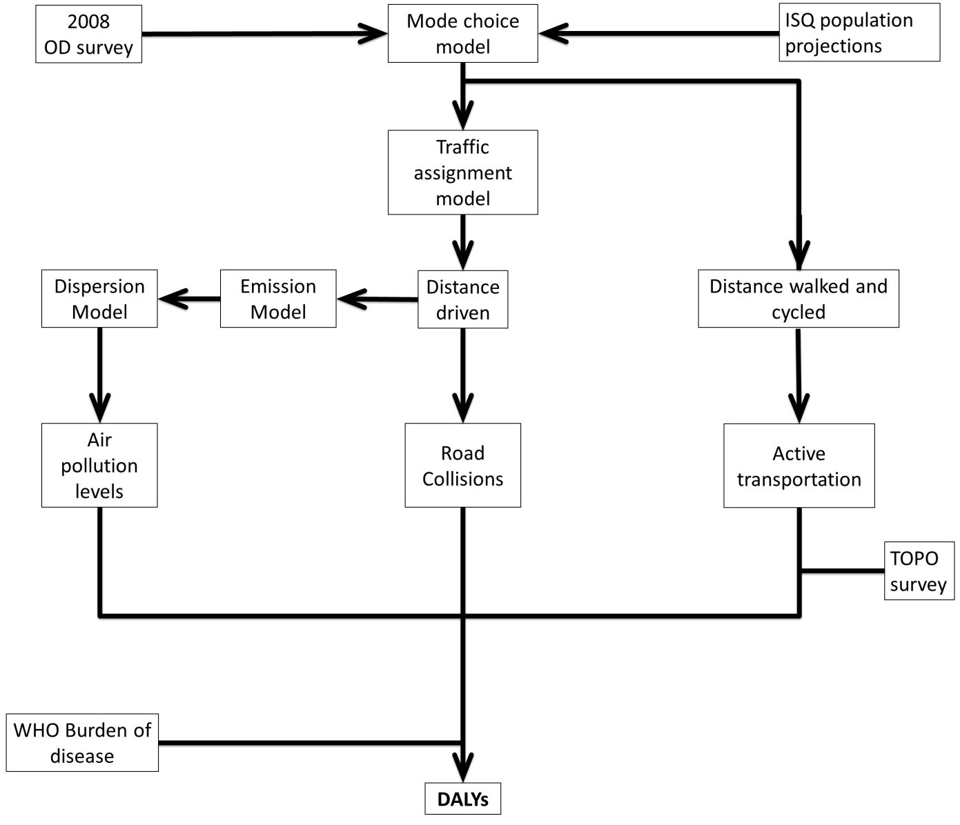.

OD survey: Origin Destination survey

ISQ: Instituts de la statistique du Québec

WHO : World Health Organisation

**Table S1: Territories use in our analyses**

|  |  |  |
| --- | --- | --- |
| **Name of the territory** | **Uses for every territories** | **Number of territories use in our analyses** |
| greater Montreal | Region in which the study was conducted. | 1 |
| Regions of greater Montreal1 | Regions use for the presentation of the exposure and burdens | 3 |
| Local Community Service Centre | Regions for which the age-sex 2031 populations were retrieved | 67 |
| Municipalities from the OD survey | Regions from the OD survey at the base of the calculation used to calculate the burden of road traumas and the gains of active transportation (see figures S3 and S4 for details) | 108 |
| Traffic analysis zones (TAZ) | Regions used for allocating trips in motor vehicles and for the mode choice predictions | 1 552 |
| Dissemination area | Regions for which the age-sex 2031 populations were retrieved | 6 674 |
| Postal code | Region at which the burden of air pollution was calculated | 127 775 |

1central Montreal, inner and outer suburbs

### Description of the greater Montreal Region

Our study is set in Montreal, Canada. The greater Montreal area is a region of 4,258 km2, inhabited by roughly 3.6 million residents in 2006 (more than 10% of the Canadian population) (Statistics Canada 2014). The greater Montreal area, with its international airport and a seaport, is one of the main transportation hub of the North American east coast as well as the principal transportation hub of the province of Quebec (Ministère des transports du Québec 2000). The greater Montreal area is also the principal business center of the province, contributing more than 53.1% of the GDP (Cirano 2014).

### Population of the greater Montreal

The 2031 population was estimated with the *Institut de la Statistique de Quebec* projections for 2031 (Pelletier and Kammoun 2010). These estimates were available at the *Centre locaux de service communautaire* (CLSC). This geographic subdivision of the health care system often encompassed several municipalities. The increase of population per small area (i.e. dissemination blocks or TAZ) was assigned according to the residential land use (DMTI-2007) in each regions of the CLSC. The CLSC population was homogeneously distributed to residential areas of the land use file (irrespective of the population density).

Finally, since population per postal code (PC) stratified by age and sex, needed for the assessment of the burden associated with air pollution, were not available for 2031, we estimated the population of each six digit PC by dividing the age and sex specific population of dissemination blocks by the number of PC embedded in them. This methodology was previously used by Carrier et al. 2014.

**Table S2.** Description of estimated exposure and burden linked to transportation patterns in 2008 and 2031 for the greater Montreal

|  |  |  |  |  |
| --- | --- | --- | --- | --- |
|  | | 2008 | 2031 | Percentage of variation |
| Population | | 3,283,015 | 4,155,891 | +27 |
| Number of trips (total, per capita)  by  Driving  Walking to public transit  Walking  Cycling  Other  Total | | 4,041,556(1.23)  1,319,123 (0.40)  733,145 (0.22)  137,452 (0.04)  384,024 (0.12)  6,615,300 (2.02) | 5,286,602(1.27)  1,561,900 (0.38)  834,649 (0.20)  165,183 (0.04)  540,403 (0.13)  8,388,737 (2.02) | +31 (3)  +18 (-6)  +14 (-10)  +20 (-5)  +41 (11)  +27 (0) |
|  | |  |  |  |
| Km per day by a | |  |  |  |
|  | Cars and light trucks | 41,713,387 | 57,809,509 | +39 |
|  | Pedestrians:  Walking to public transit  Walk to destination | 1,109,238  638,654 | 1,325,345  733,046 | +19  +15 |
|  | Cyclists | 477,765 | 566,443 | +19 |
| Minutes per week spent in active transportation (mean, Q1 Q3) | | 52 (0-85) | 48 (0-83) | -7 |
| NO2 concentration in ppb (mean, Q1-Q3) | | 6.16 (5.19-6.79) | 3.98 (3.94-4.00) | -35 |
| DALYs (total, per 100,000 person) | | 14,972 (456) | 17,281(416) | +15 (-9) |
|  | |  |  |  |
| **Burden** | |  |  |  |
| Road injuries  Air pollution | | 14,404 (427)  4,141 (126) | 17,839 (429)  3,020 (73) | +27 (1)  -27 (-42) |
| **Gain** | |  |  |  |
| Active transportation | | 3,173 (97) | 3,578(86) | +13 (-11) |

a distance traveled by any resident of the greater Montreal

**Table S3**. Mode share and weekly time spent in active transportation for individuals practicing active transportation in the 2031 BAU scenario

|  |  |  |  |  |  |  |  |  |  |  |  |
| --- | --- | --- | --- | --- | --- | --- | --- | --- | --- | --- | --- |
| **OD Regions** | | Public transit | | | Walking | | | Cycling | | | |
| **Mode share (%)** | **Average minutes per day (Q1 Q3)** | | **Mode share**  **(%)** | | **Average minutes per day (Q1 Q3)** | **Mode share**  **(%)** | | **Average minutes per day (Q1 Q3)** | |
| central Montreal | 33.8 | | | 17 (10-22) | | 16.5 | 17 (12-21) | | 2.9 | 17 (14-19) |
| inner ring suburbs | 18.3 | | | 15 (11-20) | | 9.2 | 16 (11-16) | | 1.8 | 19 (14-20) |
| outer ring suburbs | 7.2 | | | 18 (14-17) | | 5.8 | 17 (12-19) | | 1.5 | 17 (9-21) |

**Table S4**. Mode share and weekly time spent in active transportation for individuals practicing active transportation in the 2031 PT scenario

|  |  |  |  |  |  |  |  |  |  |  |  |
| --- | --- | --- | --- | --- | --- | --- | --- | --- | --- | --- | --- |
| **OD Regions** | | Public transit | | | Walking | | | Cycling | | | |
| **Mode share (%)** | **Average minutes per day (Q1 Q3)** | | **Mode share (%)** | | **Average minutes per day (Q1 Q3)** | **Mode share (%)** | | **Average minutes per day (Q1 Q3)** | |
| central Montreal | 34.3 | | | 17 (11-22) | | 16.4 | 15 (12-21) | | 2.8 | 17 (14-19) |
| inner ring suburbs | 18.9 | | | 15 (10-19) | | 9.1 | 16 (11-16) | | 1.8 | 19 (14-22) |
| outer ring suburbs | 7.5 | | | 18 (14-17) | | 5.8 | 17 (12-19) | | 1.5 | 17 (11-21) |

### Description of surveys

#### Origin-Destination survey

This survey is conducted every five years by the Regional Transportation Agency (Agence métropolitaine de transport[AMT] 2010) and contains information on travel behavior for 4% of the greater Montreal region’s households (which can be scaled up to the entire population using sampling weights derived for each geographic sub-area). The questionnaire gathers information on households (number of individuals, localisation and number of motor vehicles), individuals (age, sex, employment, valid driver’s license and number of trips) and trips (origin, destination, mode of transportation, motive, and time of departure). Survey participants were randomly chosen from public lists of residential telephone service subscribers (AMT 2010). In the fall of 2008 (3rd of September to18th of December), 66,100 households were contacted by telephone and asked to characterize the trips made on a business day by all members of a household (roughly 156,000 individuals and 355,000 trips). Trips recorded in this survey are limited to household travel and do not include commercial trips.

#### TOPO 2012 survey

The TOPO survey 2012 is a probabilistic survey conducted on roughly 11 000 Montrealers. In opposition to the OD survey information on weekly active transportation and overall physical activity are available in this survey. Time spent in non-transport related physical activity was inferred by subtracting the total amount of time spent in physical activities by the amount of time spent in transport related physical activity. Since this survey was only available for the population living on the island of Montreal we had to extrapolate the result values form this survey to the population living outside of the island.

Questions of the TOPO 2012 related to total and transport related physical activity:

During the last 7 days, on how many days did you do vigorous physical activities?

How much time did you usually spend doing vigorous physical activities on one of those days?

During the last 7 days, on how many days did you do moderate physical activities?

How much time did you usually spend doing moderate physical activities on one of those days?

During the last 7 days, on how many days did you walk for at least 10 minutes at a time?

How much time did you usually spend walking on one of those days?

During the last 7 days, on how many days did you walk to travel from place to place, including to places like work, stores, movies and so on.

How much time did you usually spend walking for your errands on one of those days?

During the last 7 days, on how many days did you use a bicycle (your own, one you borrowed or BIXI) to get to work, do your grocery shopping, go to a store or a film, or any other destination?

How much time did you usually spend cycling on one of those days?

### Mode choice models

The mode choice models were based on the 2008 trips and predicted the mode probability (i.e. biking/walking, taking the car or the public transit or other modes) of each trip (Eluru et al. 2012). They were developed with multinomial logit regressions with a subsample of the OD survey. The subsample was estimated using data from 20,670 trips (Home-based work 4,387, Home based other 3,101, work based 4,335 and Non-home based 8,847). They were based on the trip origin and destination such as home based work, home based other (such as shopping or leisure), work-based, and non-home based trips; thus four independent models were developed. Predictors of mode choice models included individual and household attributes (such as age, gender, employment status, and vehicle ownership), urban form attributes (such as highway transportation infrastructure, bicycle infrastructure), as well as attributes of the modes themselves (e.g. travel time, travel cost). Models were cross-validated with a sub-sample of the OD survey data that was not used in model estimation.

Models were used to produce predicted mode share for the OD trips in 2031 for both BAU and PT scenarios. For the 2031 scenarios, a weight was associated with each trip in order to take into account the population increase expected for 2031. These weights reflect the projected population increase in Montreal. When we ran the mode choice for the PT scenario, we generated and used a new transit time variable. The transit time for trips with origin and destination within a 1km buffer of planned transit stations were assumed to decrease (i.e. about 13% of the trips [11.3% had either origin or destination near a new station and 1.7% had both origin and destination near a new station]). To compute the appropriate reduction factor, several steps were followed. First, trips were divided into 5 categories based on the distance: trips with distance shorter than 2.5km, between 2.5 to 5km, 5 to 7.5km, 7.5 to 10km, and trips longer than 10km. The trips were further classified based on whether both origin and destination had access to the station or only one of them had access. Second, the average travel times for trips with access to transit station for each distance segment were calculated. Third, for each distance segment, we compute the reduction factor for trips with both origin and destination near future transit station and for trips with either origin or destination near future transit station. The reduction factor is computed as the ratio of average travel time for trips with access to transit station and average travel time without access transit station. Fourth, as the factors generated for distance between 5 to 7.5km and 7.5 to 10km were similar, those two distance categories were merged. Finally, the reduction factors (presented in Table S6) were multiplied with current transit time to compute the new transit time for the PT scenario. For the trips that were not affected by the new transit proposals, the transit time remained the same. It is important to note that the transit time is also a component of travel time for the park and ride and kiss and ride mode. Thus, for the PT scenario, the park and ride and kiss and ride travel times were also updated.

Consider a choice with three alternatives: Car, bus and walk. For the microsimulation process, let us compute the alternative probabilities. Let us assume they are 0.65, 0.20 and 0.15. Based on the probabilities, the cumulative distribution function would be as follows: car (0-0.65), bus (0.65-0.85) and walk (0.85-1.0). Now, let us generate a uniform random number between 0 and 1; based on the value of the random number, the alternative is chosen. In our case, lets say the random number is 0.5125; then the car is the chosen mode. If we repeat this process for a large number of times 65% of the times car is chosen, 20% of the time bus is chosen and 15% of the time walk is chosen. Thus, we represent the probability shares accurately. The reader will note that the mode choice in our case has 8 alternatives and the example approach was appropriately customized for our context.

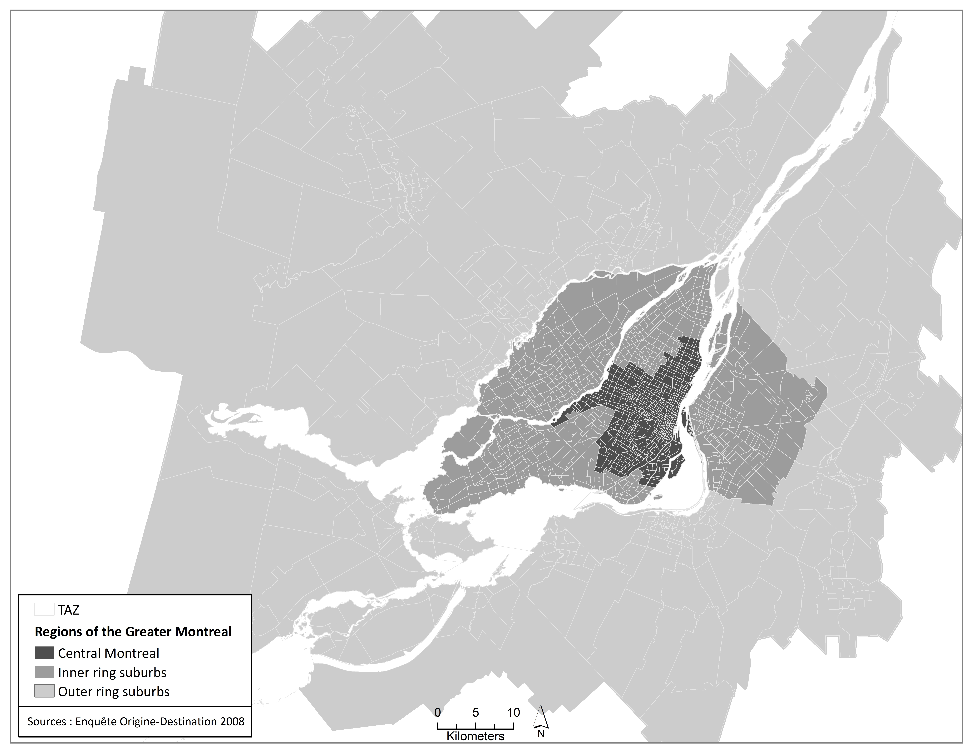

**Figure S2. Geographical scale Traffic analysis zones (TAZ)**

### Vehicle allocation algorithm

The vehicle allocation algorithm was developed by Sider et al., 2013 in order to assign a specific vehicle to each driving trip in the 2008 OD survey. Working at the household level, the main elements involved with vehicle allocation were the number of vehicles owned by a household, each vehicle’s time of availability and geographic coordinates, as well as the vehicle type distribution in the household’s neighborhood (which we obtained from the 2008 Quebec motor vehicle registry at the level of the forward sorting area which is defined by the first three digits of a postal code). The database that we obtained from the provincial registry contained information on vehicle age and type. Therefore, every driving trip in the OD survey was allocated a vehicle type and model year that remained constant over the entire day. The volumes on the road network were estimated according to the mode choice model outputs.

### Air pollution emissions

Emissions of NOx were based on a multi-dimensional look-up table of emission factors in grams/vehicle*kilometer that we generated using the Mobile Vehicle Emissions Simulator (MOVES) 2010 platform developed by the United States Environmental Protection Agency (USEPA) updated with Montreal-specific data (Sider et al. 2015). Individual emission factors generated accounted for vehicle type, model year, speed, road type, and season (winter and summer). In fact, our emission factors were based on hourly temperatures and relative humidity. We also calculated start emissions and these were a function of ambient conditions at the time of starting the vehicle. A total of 4,080 emission factors were generated (Sider et al. 2015). Total emissions on every roadway segment resulted from summing the individual emissions of all vehicles on that segment. Because of randomness in the vehicle path choices (traffic assignment) and vehicle type allocation, we ran the model five different times and used averaged emissions for every link. The standard errors associated with the mean emissions were low (approximately 1%) indicating that even though allocations may vary drastically at the individual level, segment emissions over the entire day (mean of 24 hourly outputs) remain relatively stable (Sider et al. 2015).

### Air pollution concentrations

NO2 dispersal and NOx transformation (Scire et al. 2000a; Scire et al. 2000b) where calculated based on the emission of each road link. First, we ran CALMET using a two-step approach for wind field computation. First, initial guess wind fields were produced by adjusting MM5 winds for terrain effects. Then, these adjusted values were refined through the introduction and processing of data from local meteorological stations across the domain. MM5 data can capture terrain effects (e.g., land breezes) and surface stations are believed to better represent ‘‘microenvironments”. In order to force the simulated winds to follow the wind vectors at the local stations, an appropriate weight was assigned to every surface station. CALPUFF as a Lagrangian puff model estimates the growth/diffusion and transport of released puffs, based on wind fields generated by CALMET. The diffusion of released puffs is governed by turbulence-related boundary layer variables, such as the friction velocity, convective velocity scale, Monin-Obukhow length and boundary layer height. A value of 3 m was considered for the initial vertical dispersion coefficient thus representing traffic-induced mixing near the roadway. Background NO2 concentrations were obtained from a background station at the tip of the Island of Montreal (Sainte Anne de Bellevue), usually upwind to urban road traffic sources. CALPUFF incorporates a set of chemical and physical processes. During the chemical reactions, NOx transforms to NO2. A MESOPUFF II chemistry scheme in CALPUFF was used to reduce NOx concentrations in the presence of O3, solar radiation UV, and VOCs. The NO2/NOx ratio curve/equation is an additional input to the model to account for further reactions that vary with the NO2/NOx ratio which is not always constant. Hourly NO2 levels were simulated over four weeks (one week in each season) and averaged to generate a long-term average NO2 across the modeling domain. The simulation started at 4:00 LST on the 7th and ended at 4:00 LST on the 14th of the following 4 months: January, April, August and October 2008. CALMET and CALPUFF share the same modelling domain. The domain is divided into 200 grid cells in the X direction (Easting) and 140 grid cells in the Y direction (Northing) centered around the Montreal Island; the size of every grid cell is 1 x 1 Km. In terms of vertical model resolution, the domain consists of 10 levels (the elevations of level 1 to level 10 are: 20m, 40m, 80m, 160m, 320m, 700m, 1300m, 1700m, 2300m, and 3000m).Concentrations were estimated for a 1km by 1km grid and were attributed to six digit postal codes (PC) through geographic overlay of their centroid on the NO2 map. The area covered by a PC varies importantly in the greater Montreal region as shown in Table S7.

### Physical activity assignment

The daily distances walked or cycled were calculated according to the shortest distance on the road network. These distances were multiplied by seven and then transformed into weekly time spent travelling, according to the average speed for each mode, obtained from (Ainsworth et al. 2011) (table S8 of the supplemental material). The time spent in active transportation by municipality was then combined and fitted into a log normal distribution by age group, sex and municipality. These distribution were divided into quintiles, the median of which transformed into Metabolic Equivalent of Task (MET) using values from the 2011 compendium of physical activity (Ainsworth et al. 2011). We then reassigned active transportation METs per strata according to the proportion of time spent walking or cycling in each of them. To account for seasonality, we assumed in our computation that cycling in the Montreal region only occurred between the months of April and November. This decision was based on the fraction of the year in which the bike share program BIXI (Bixi Montreal-2015) has bikes available. Thus the weekly estimates were reduced by nearly half. Since the TOPO survey did not show an important variation across seasons of the average time walked (data not shown), we did not apply any correction factor to the weekly time spent walking.

We also used information on weekly physical activity from the Montreal Public Health TOPO survey (Direction de santé publique de Montréal 2012) to obtain a coefficient of variation representative of weekly distribution of time spent doing transport related physical activity and to ascertain the association between transport and non-transport related physical activity Table S9. In opposition to the OD survey, which contains transportation activities, information on weekly active transportation and overall physical activity are available in this survey. Time spent in non-transport related physical activity was inferred by subtracting the total amount of time spent in physical activities by the amount of time spent in transport related physical activity. When the amount of time spent in transport activity exceeded the total active time, we assumed a non-transport related time of physical activities equal to zero. For the TOPO survey, information on physical activity was collected using the validated short version of the International Physical Activity Questionnaire (IPAQ).

As mention above we used daily reported trips in order to estimate the weekly average time spent in active transportation. Since daily trips are not representative of the variability associated with weekly transport patterns, we used the variation coefficient form the weekly active transportation in TOPO and thus correcting indirectly for said variability. Furthermore an important difference was observed for the average time spent doing transport related physical activities in Montreal between the OD and the TOPO survey. Even though the IPAQ used in TOPO is known to overestimate physical activity (Celis-Morales et al. 2012), we used mean time reported in TOPO as our benchmark and increased the physical activity from the OD survey. This increase was performed according to the factor to which the average minutes spent in active transportation in TOPO exceed those of OD (2.78). This decision was based on the fact that most studies assessing health impacts of physical activity used self-report time spent doing physical activities, as retrieved from TOPO.

Non-transport related MET were added to MET from transport related physical activities as follows. This was done as dose-response functions used relate MET from total physical activity (i.e. transport and non-transport) to health outcomes. Non-transport related physical activities for specific geographic divisions (i.e. municipalities, or groups of municipalities as described in Figure S3 of the supplemental material) were estimated with values from the TOPO survey. Briefly, the TOPO transport related physical activity distribution for each demographic group was divided into quartiles for each geographic division. Then for each of these quartiles, we estimated the median MET corresponding to all non-transport related activities in TOPO. These median of non-transport related METS were added to the transport related METs of the OD survey using the corresponding bounds of respective quartile in the TOPO survey.

### Road traumas

Injuries on the municipal road network (local, collector and arterial) were estimated using binomial negative regression models for the 2003-2012 period. These models took into account the connectivity of the road network and the km travelled in motor vehicles, cycling and walking in the municipality of crashes occurrence (eq.2). The connectivity was estimated as the percentage of intersections with more than three branches in a municipality. Crashes were georeferenced with a specific algorithm based on the address and municipality written in the police reports.

Since the specific localization of road traumas on highways was not available we could not use the aforementioned models to estimate the number of injuries per municipality. Instead we multiplied the number of VKTs on highways for each municipality by a per capita rate of injures per highway VKTs. This rate was estimated using the average 2008 rates of highway injuries for Montreal and Laval. Additionally, collisions with trucks were removed from our analyses since information on trips generated by the commercial fleet were not available in the OD survey.

**Table S5.** Description of point estimates and exposure-response relationships used

| **Exposure** | **Health outcomes** | **Shape of the Exposure-Response relationship (exponent of the dose response)#** | **Point estimate\*** | **Population** | **Reference** |
| --- | --- | --- | --- | --- | --- |
| **Air pollution**  **(**µg/m3 of NO2) | Cardiovascular deaths | Linear | 1.008 | Men and women (18 years old and over) | Chen et al. 2013 |
| Incidence of asthma | Linear | 1.004 | Men and women (0-13 years old) | Tetreault et al. 2016 |
| **Physical activity**  (Mets) | Cardiovascular diseases | Curvy-linear (0.25) | 0,9863 | Men and women (18 years old and over) | Sattelmair et al. 2011 |
| Incidence of type II diabetes | Curvy-linear (0.25) | 0,9815 | Men and women (18 years old and over) | Jeon et al. 2007 |
| Breast Cancer | Curvy-linear (0.25) | 0,9992 | Women (18 years old and over) | Wu et al. 2013 |
| Colon Cancer | Curvy-linear (0.25) | 0,9905 | Men and women (18 years old and over) | Wollin et al. 2009 |
| **Traffic**  (Vehicle km travelled/municipality)1 | Fatally and severely Injured cyclists  (per year) | Linear | Ln VKT2: 0.0157  Ln CKT3: 0.9065 | Men and women (all age groups) | This study |
| Fatally and severely Injured motor vehicle occupants | Linear | Ln VKT2: 0.6733 | Men and women (all age groups) | This study |
| Fatally and severely Injured pedestrians | Linear | Ln VKT2: 0.3264  Ln PKT4: 0.8112 | Men and women (all age groups) | This study |

* Exponential form. For pollution and physical activity, point estimates are for an increase of 1 unit of exposure (Air pollution: 1 µg/m3 of NOX; Physical activity: 1 met*h/week); For traffic injuries: point estimates are for an increase of 1 in log km travelled in vehicles,cycled or walked.

# Shape of the Exposure-Response relationship in log linear models

1 Information on kilometers travelled by mode and road traffic injuries were respectively retrieved from the 2008 OD survey and SAAQ database.

2 vehicle kilometers travelled

3 cycling kilometers travelled

4 pedestrian kilometers travelled

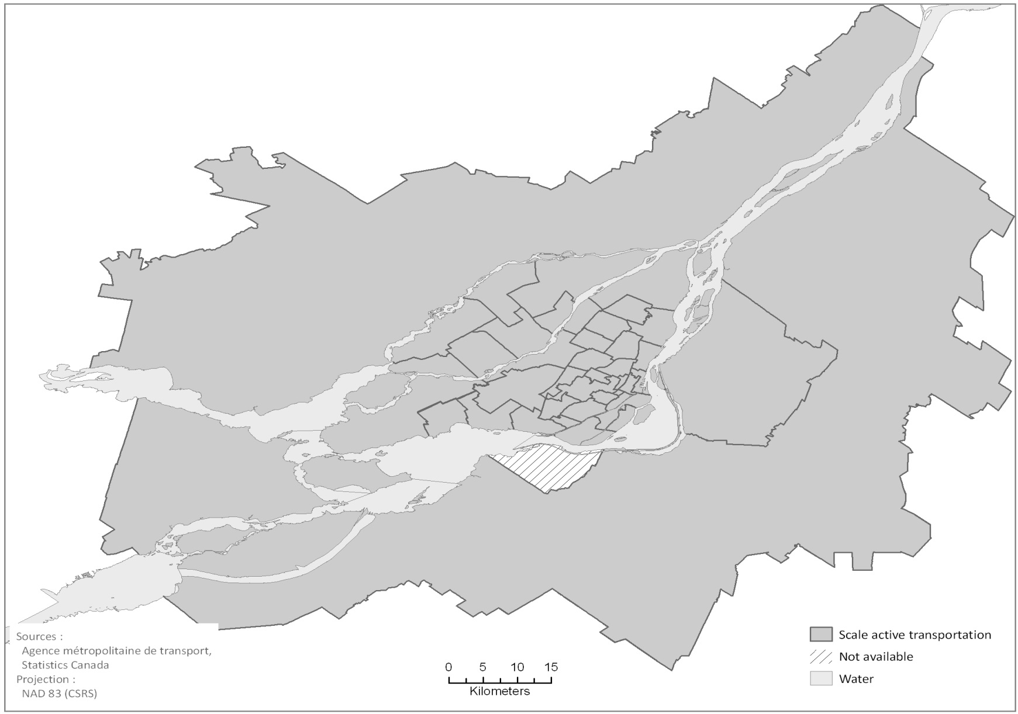

**Figure S3. Geographical scale at which the burden of active transportation for the Health impact assessment**

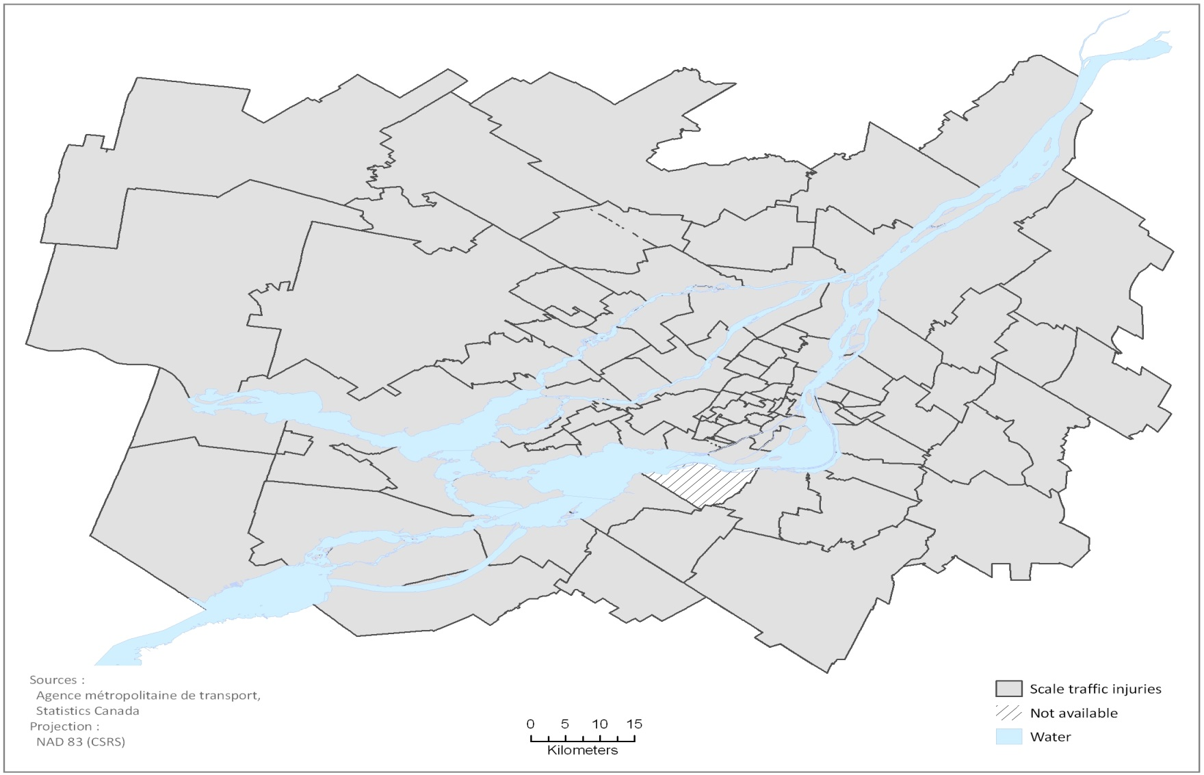

**Figure S4. Geographical scale at which the burden of traffic related air pollutants was calculated for the Health impact assessment**

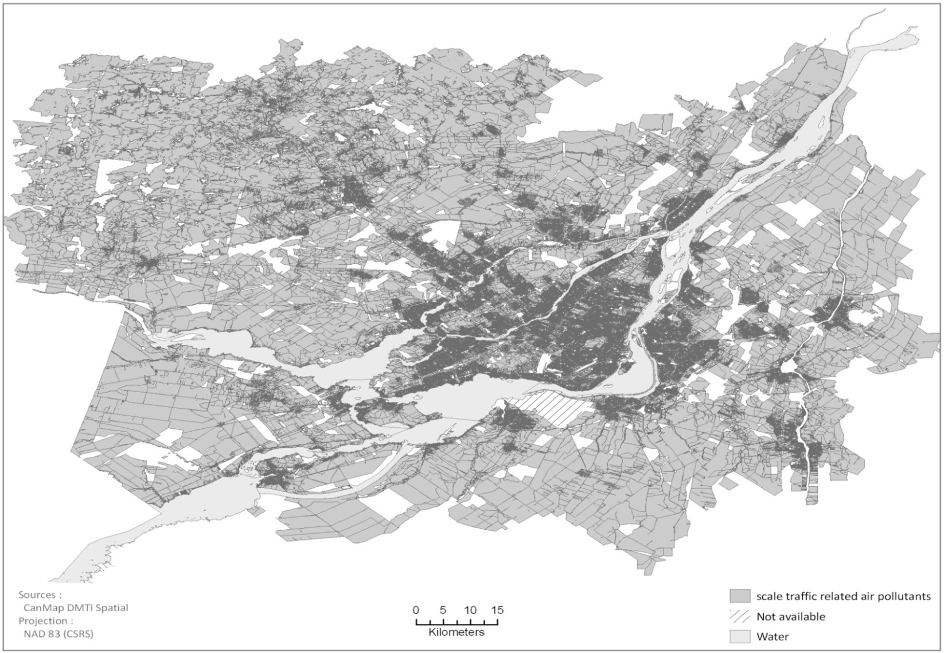

**Figure S5. Geographical scale at which the burden of traffic related air pollutants was calculated for the Health impact assessment**

**Table S6 Transit Time Reduction Factors**

|  |  |  |
| --- | --- | --- |
| Trip Distance | New Transit Station for both Origin and Destination location | New Transit Station for one of the Origin or Destination location |
| 0-2.5km | 0.535 | 0.75 |
| 2.5-5km | 0.8 | 0.8 |
| 5-10 km | 0.7 | 0.8 |
| >10 km | 0.6 | 0.8 |

**Table S7:** Descriptive statistics of the six digit postal codes in the greater Montreal

|  |  |  |
| --- | --- | --- |
| **Regions** | **N** | **Average area in m2 (5th-95th percentile)** |
| central Montreal | 23,398 | 6,049 (514-15,051) |
| inner ring suburbs | 46,672 | 14,437 (747-36,020) |
| outer ring suburbs | 49,328 | 83,109 (765-160,612) |
| greater Montreal | 119,398 | 41,165 (685-56,988) |

**Table S8**. Speed and Metabolic Equivalent of Task (MET) used to quantify the gains of active transportation

|  |  |  |
| --- | --- | --- |
| Mode of transportation | Speed (km/h) | MET per h |
| Walking | 4.5 | 3.3 |
| Cycling | 12.87 | 5.0 |

Retrieved from the 2011 compendium of physical activity

**Table S9.** Metabolic Equivalent of Task (MET)per week spent doing non transport related physical activity in the Greater Montreal

|  |  |  |
| --- | --- | --- |
| Sexe | Age category | Mets/week  Median |
| Male | 15 - 20 | 2,700 |
| Male | 21 - 44 | 1,688 |
| Male | 45 - 69 | 1,545 |
| Male | 60 - 74 | 1,386 |
| Male | > 75 | 828 |
| Female | 15 - 20 | 1,413 |
| Female | 21 - 44 | 1,097 |
| Female | 45 - 69 | 1,179 |
| Female | 60 - 74 | 1,044 |
| Female | > 75 | 297 |

### References

Ainsworth BE, Haskell WL, Herrmann SD, Meckes N, Bassett DR, Jr., Tudor-Locke C, et al. 2011 Compendium of Physical Activities: a second update of codes and MET values. Med Sci Sports Exerc 43(8): 1575-1581.

AMT (Agence métropolitaine de transport). 2010. Enquête origine-destination 2008: La mobilité des personnes dans la région de Montréal. Montreal.

Bixi Montreal. 2015. Ride with bixi. Available: https://montreal.bixi.com/ride-with-bixi/functioning [accessed 07-03 2015].

Carrier M, Apparicio P, Seguin A-M, Crouse D. 2014. The application of three methods to measure the statistical association between different social groups and the concentration of air pollutants in montreal: A case of environmental equity.

Celis-Morales CA, Perez-Bravo F, Ibanez L, Salas C, Bailey ME, Gill JM. 2012. Objective vs. self-reported physical activity and sedentary time: effects of measurement method on relationships with risk biomarkers. PLoS One 7(5): e36345.

Chen H, Goldberg MS, Burnett RT, Jerrett M, Wheeler AJ, Villeneuve PJ. 2013 Long-term exposure to traffic-related air pollution and cardiovascular mortality. Epidemiology 24(1): 35-43.

Cirano. 2014. Produit intérieur brut aux prix de base, 2012. Available: <http://qe.cirano.qc.ca/tab/theme/regions/montreal_et_ses_regions_adjacentes/region_metropolitaine_de_montreal/produit_inter> [accessed 06-25 2014].

Direction de santé publique de Montréal. 2012. TOPO: Faire point sur l'état de santé des Montréalais [accessed 02-18 2015].

Eluru N, Chakour V, El-Geneidy AM. 2012. Travel mode choice and transit route choice behavior in montreal: Insights from mcgill university members commute patterns. Public Transport 4:129-149.

Jeon CY, Lokken RP, Hu FB, van Dam RM. 2007. Physical activity of moderate intensity and risk of type 2 diabetes: a systematic review. Diabetes Care 30(3): 744-752.

Pelletier G, Kammoun N. 2010. La population du québec par territoire des centres locaux de services communautaires, par territoire des réseaux locaux de services et par région sociosanitaire

Sattelmair J, Pertman J, Ding EL, Kohl HW, 3rd, Haskell W, Lee IM. 2011 Dose response between physical activity and risk of coronary heart disease: a meta-analysis. Circulation 124(7): 789-795.

Scire, J. S., F. R. Robe, M. E. Fernau, and R. J. Yamartino. A user’s guide for the CALMET Meteorological Model. Earth Tech, USA, Vol. 37, 2000.

Scire, J. S., D. G. Strimaitis, and R. J. Yamartino. A user’s guide for the CALPUFF dispersion model. Earth Tech, Inc, Vol. 521, 2000, pp. 1-521.

Shekarrizfard, M., Faghih-Imani, A., Tetreault, L.-F., Yasmin, S., Reynaud, F., Morency, P., Plante, C., Drouin, L., Smargiassi, A., Eluru, N., Hatzopoulou, M. Modelling the Spatio-Temporal Distribution of Ambient Nitrogen Dioxide and Investigating the Effects of Public Transit Policies on Population Exposure. Environmental Modelling and Software. 2017a.

Shekarrizfard, M., Faghih-Imani, A., Tetreault, L.-F., Yasmin, S., Reynaud, F., Morency, P., Plante, C., Drouin, L., Smargiassi, A., Eluru, N., Hatzopoulou, M. Regional Assessment of Exposure to Traffic-Related Air Pollution: Impacts of Individual Mobility and Transit Investment Scenarios. Sustainable Cities and Society, 29, 2017b, 68-76.

Sider T., A. Alam, M. Zukari, H. Dugum, N. Goldstein, N. Eluru and M. Hatzopoulou. 2013. "Land-use and socio-economics as determinants of traffic emissions and individual exposure to air pollution," Journal of Transport Geography, 33, Pages 230-239

Sider, T., A. Alam, W. Farrell, M. Hatzopoulou, N. Eluru. 2014. Evaluating vehicular emissions with an integrated mesoscopic and microscopic traffic simulation. Canadian Journal of Civil Engineering, 41 (10): 856-868

Sider T., G. Goulet-Langlois, N. Eluru and M. Hatzopoulou .2015., "Quantifying the Effects of Input Aggregation and Model Randomness on Regional Transportation Emission Inventories", forthcoming Transportation

Transport Canada Canadian Motor Vehicle Traffic Collision Statistics: 2010; T45-3/2010E-PDF; Transport Canada,: 2012; p 6.

Ministère des transports du Québec. 2000. Greater Montréal Area Transportation Management Plan. Quebec.

Tetreault LF, Doucet M, Gamache P, Fournier M, Brand A, Kosatsky T, et al. in press. Childhood exposure to ambient air pollutants and the onset of asthma: An administrative cohort study in québec. Environ Health Perspect

Wu Y, Zhang D, Kang S. 2013 hysical activity and risk of breast cancer: a meta-analysis of prospective studies. Breast Cancer Res Treat 137(3): 869-882.

Woodcock J, Givoni M, Morgan AS. 2013. Health impact modelling of active travel visions for england and wales using an integrated transport and health impact modelling tool (ithim). PLoS One 8:e51462.

Wolin KY, Yan Y, Colditz GA, Lee IM. 2009. Physical activity and colon cancer prevention: a meta-analysis. Br J Cancer 100(4): 611-616.