### Regional [Assessment of Exposure to Traffic-Related Air Pollution](http://www.sciencedirect.com/science/article/pii/S1352231001001443): Impacts of Individual Mobility and Transit Investment Scenarios

Maryam Shekarrizfard1, Ahmadreza Faghih-Imani1, Louis-Francois Tetreault2, Shamsunnahar Yasmin3, Frederic Reynaud4, Patrick Morency5, Celine Plante5, Louis Drouin5, Audrey Smargiassi2, Naveen Eluru3, Marianne Hatzopoulou6

1- Civil Engineering, McGill University

2- Département de Santé Environnementale et Santé au Travail, Université de Montréal

3- Civil, Environmental and Construction Engineering, University of Central Florida

4 – Oliver Wyman Consulting, Montreal

5- Direction régionale de santé publique du CIUSS du Centre-Sud-de-l’Île de Montréal

6- Corresponding Author: Associate Professor, Civil Engineering, University of Toronto,   
35 St George Street, Toronto, ON M5S 1A4, Tel: 1- 416-978-0864, Fax: 1-416-978-6813,   
Email: [marianne.hatzopoulou@utoronto.ca](file:///C:\Users\Maryam\Desktop\marianne.hatzopoulou@utoronto.ca)

### Regional [Assessment of Exposure to Traffic-Related Air Pollution](http://www.sciencedirect.com/science/article/pii/S1352231001001443): Impacts of Individual Mobility and Transit Investment Scenarios

**Abstract**

This paper describes the design and application of an integrated model for the prediction of exposure to traffic related air pollution in an urban area as a result of transport policy scenarios. For this purpose, a travel demand model linked with models for traffic assignment, emissions, and air quality was used to simulate population exposure to ambient Nitrogen Dioxide (NO2) in a base year (2008) and in a horizon year (2031) while incorporating population and demographic projections. The integrated model was used to evaluate the impacts of the planned regional transit and vehicle technology improvements on exposure to NO2. In the 2031 business as usual scenario, an average decrease of 19% in exposure to NO2 is observed across the sample population, compared to the 2008 base case. This decrease is primarily attributed to projected improvements in vehicle technology. In the 2031 transit scenario, we observed an average 10% decrease in exposure compared to the 2031 business as usual. In terms of the spatial variability in air pollution, the transit scenario was observed to achieve large reductions in NO2 concentrations within the downtown area and moderate reductions throughout the suburbs.

Keywords**:** Air quality; Dispersion modelling; Traffic emissions; Nitrogen dioxide (NO2); Transit; Policy scenario, Future horizon, Air pollution exposure

**Highlights:**

►Integrated model evaluated impacts of transit and vehicle improvements on exposure

►We observed an increase in modal share of public transit and lower traffic volumes

►We observed lower emissions and NO2 concentrations in the downtown area

►The effect of transit policy on exposure is smaller than vehicle technology

**Information on funding sources supporting the work**

This study was funded by a collaborative grant from the Canadian Institutes of Health Research and the Natural Sciences and Engineering Research Council of Canada.

1. **Introduction**

The hypothesis that exposure to traffic-related air pollution increases the risk of developing various illnesses (e.g., risk of cardiovascular or respiratory disease, cancer during childhood) has been demonstrated by a number of investigators (Hamra et al., 2015; Parent et al. 2013; Hoek et al., 2013; Cesaroni et al., 2012; Gan et al., 2012; Crouse et al., 2010). In an effort to reduce the effects of transportation on air quality, various researchers have developed tools aiming to assess the impacts of transportation investments on air pollution and health using transportation models extended with capability for evaluating environmental and health impacts (Tobollik et al., 2016; Xia et al., 2015; Perez et al., 2015; Braubach et al., 2015; Bhalla et al., 2014; Dhondt et al., 2013; Colette et al., 2012; Grabow et al., 2012; De Nazelle et al., 2011; Setton et al., 2010). Many of these models are able to predict the impact of travel demand on transportation networks and simulate road traffic emissions. However, most of these models are not able to simulate the diurnal trends in traffic-related air pollution. This must be achieved using spatially and temporally refined dispersion models (Lim et al., 2005).

In the last few years, some important efforts have been made worldwide to develop integrated transportation-emission dispersion models to study the effect of strategies to reduce air pollutant emissions from road transport (Lumbreras et al., 2008). Seika et al. (1996) estimated changes in the concentration of NOx and other pollutants from vehicle emissions under different traffic control strategies using an integrated emission dispersion model. Tobollik et al. (2016) showed how an integrated model can be used to evaluate the greenhouse gas reduction potential of various policies. Several studies also showed the effect on health of replacing vehicles with alternative transport modes (Woodcock et al. 2009; Maizlish et al., 2013; Macmillan et al., 2014; Tobollik et al. 2016). For example, the environmental and health benefits of various alternative transport scenarios for 2030 were quantified in London (Woodcock et al., 2009). In a study by Nieuwenhuijsen et al. (2016), the policies that emphasize changes in travel behaviour, including the increased use of public transit, were shown essential in reducing transport emissions and the adverse health effects of traffic-related air pollution.

While these studies demonstrate the ability of transportation-emission-dispersion models in conducting scenario analysis, the impacts of population mobility on air pollution exposure have been generally ignored. Including population mobility in an integrated emission dispersion model helps to better understand the manner in which air quality and public health interact (Dhondt et al. 2012; Beckx et al. 2009a; Gurram et al., 2015; Shekarrizfard et al., 2016) considering the fact that individuals are exposed to pollutants at different locations and different times of day (Beckx et al., 2009b). As an example, Gurram et al. (2015) estimated the trajectory for each trip using Network Analyst tool in ArcGIS (version 10.0, ESRI, Redlands, CA) to select the shortest path between a trip’s origin and destination. This means that the exposures during travel were estimated using concentrations along the shortest route. Their results showed that ignoring the mobility of individuals underestimates population exposure by 3.6%.

In the present study, we aim to quantify air quality changes associated with planned regional transit and vehicle technology improvements as well as to demonstrate the impact of population mobility using an integrated transportation-emission-dispersion model. For this purpose, we calibrated our modeling system to a base-case scenario for 2008 and simulated a business as usual scenario for 2031 taking into account a projected increase in population. In addition, we simulated the effects on air quality and population exposure of a scenario emphasizing transit expansions. This scenario was simulated in 2031 as well as in 2008 in order to investigate whether the effects of transit investments are similar in the base case vs. the 2031 scenario. We hypothesize that transit investments will have a greater positive impact in the base case scenario because they often tend to be planned based on the existing spatial patterns of population, jobs, and daily mobility of the time.

1. **Materials and Methods**

Our study entails the application of an integrated model of travel demand, traffic emissions, air pollution dispersion, and population exposure. Our model was validated against observed data for traffic flows and air pollution concentrations in 2008. It was then used to simulate the effect of a 2031 business as usual (BAU) scenario as well as a transit investment scenario. Specifically, our methodology consists of two main steps: 1) Model development and generating hourly NO2 exposure surfaces for base, BAU and transit scenario and 2) Exposure analysis, which includes assigning daily trajectories in order to estimate exposure accumulated throughout the day in the base case and future scenarios.

* 1. **Scenario development**

Our study area is the Montreal Metropolitan Area (Fig. 1) and 2008 was chosen as the baseline year. We made projections for a business-as-usual (BAU) scenario for 2031. For this scenario, the region’s projected growth would be 600,000 new residents (from 3,6 to 4,2 million individuals), concentrated within the inner and outer suburbs as suggested by the provincial projections (PMAD, 2011). These projections were generated by the Quebec government and specifically the projections of the Institute of Statistics, Institut de la Statistique de Quebec (Pelletier and Kammoun 2010). They were provided as GIS maps illustrating the various projections that were agreed upon by provincial agencies. The age, gender, and other socio-demographic characteristics of the population were maintained to be identical to those in 2008. The transportation infrastructure was also maintained identical to the one in 2008.

In 2011, a number of metropolitan agencies in Montreal collaborated to develop a long-range master plan for the region with a 2031 horizon. The plan was named “Plan Métropolitain d’Aménagement et de Développement (PMAD; 2011)” and included major public transit investments with the objective of promoting urban consolidation and sustaining the growing mobility of the Greater Montréal population. The transit plan advocates developing the metropolitan mass-transit network so as to increase the modal share of public transit from the current 25% to 30% during the morning rush hour. The expansion of this network, which requires an investment of at least $23 billion CAD, is essential to increasing sustainable mobility and reducing greenhouse gases, a large proportion of which are emitted by road vehicles. The proposed public transit expansions are presented in Fig. 1. These include subway extensions, light rail, and regional rail proposals (PMAD, 2011).

In this study, we coded these transit investments with the assumption that they would all take place at the same time. We simulated their effect on travel both in the 2008 base year and the 2031 BAU. The reason for assessing a policy scenario in the 2008 base year is to control for all other factors such as population growth and improvements in vehicle technology. Our objective is to investigate whether the effect of transit policies is similar in 2008 and 2031 or whether the assumed population growth in 2031 influences the effects of public transit. What if all of these projects had been implemented in 2008? Is there a cost associated with waiting until 2031?

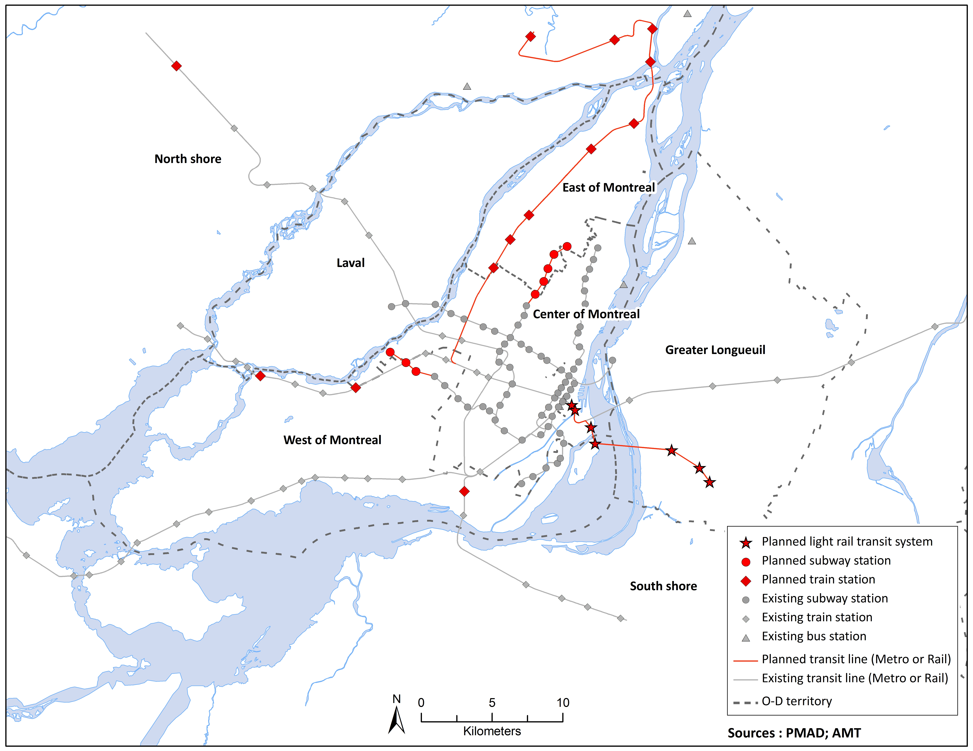

**Fig. 1** The Montreal metropolitan area featuring the existing and planned transit lines

* 1. **Travel demand and emissions**

We developed a travel demand model to generate trips including their respective modes considering travel time and cost, demographics, the land use and built environment, and transportation infrastructure. Using this model we can make a change in the transport infrastructure such as adding a new transit infrastructure and simulate the improved travel times of individuals previously driving and potentially induce mode shift towards public transit. We used an origin-destination (OD) trip diary survey conducted during the fall of 2008 (a single day in October) for the Montreal metropolitan area to develop trip level mode choice models in 2008 and 2031. The 2008 OD data includes information for a 5% sample of the Montreal population, encompassing a total of 66,000 households and approximately 157,000 individuals conducting a total of 355,000 daily trips (AMT, 2010). We categorized trips based on their origin and purpose into four groups: home-based-work (origin is home, purpose is work), home-based-other (origin is home and purpose is non-work), work-based (origin is work and purpose is any) and non-home based (origin is any location other than trip maker’s home, purpose is any). For each category, we estimated a mode choice model separately. Our mode choice models consider various travel modes including drive, passenger, transit, walk, bike, and combinations of these modes (Eluru et al. 2012). The models were estimated on a 7.5% random sample of the 2008 OD data. The trips were simulated for every hour. In the 2031 scenario, a weight was associated to each trip in order to take into account the population increase, expected for 2031. The observed mode choice of the OD survey was used to assess the actual 2008 case, while the predicted mode choice was used to compare the 2008 and 2031 cases. In order to ascertain changes in travel behaviour from 2008 to 2031 and to have a consistent comparison, we estimated both 2008 and 2031 trips with mode choice models. In the 2031 scenario, a weight was associated with each trip based on it’s origin in order to take into account the population increase expected for 2031.

Driving trips (expanded up to the total population) predicted by the mode choice model, were assigned on the road network using the VISUM platform (PTV Vision, 2009) to estimate the traffic volume, average speed and traffic mix on every road segment including 127,217 local and major roads (DMTI, 2007). The model includes road capacities, speed limits, intersection types, and turning restrictions and employs the stochastic user equilibrium approach (SUE) to assign the simulated traffic to the network. The trips made by driving were aggregated into 24 hourly OD matrices based on trip departure times. The OD matrices were generated at the level of each TAZ. The traffic assignment is conducted for each hour of the day (24 assignments).

In addition, we developed a vehicle allocation algorithm (Sider et al., 2013) to assign a specific vehicle to each driving trip in the 2008 OD survey. Working at the household level, the main elements involved with vehicle allocation are the number of vehicles owned by a household, each vehicle’s time of availability and geographic coordinates, as well as the vehicle type distribution in the household’s neighborhood (which we obtained from the Quebec motor vehicle registry). The database that we obtained from the provincial registry contains information on vehicle age and type. Therefore, every driving trip in the OD survey was allocated a vehicle type and model year that remained constant over a day’s worth of trips.

The output of the transportation model includes traffic flow, average speed, and vehicle mix on every road segment (intersection to intersection) in the region. Using this output, we estimated emissions of nitrogen oxides (NOx) using the Mobile Vehicle Emissions Simulator (MOVES) platform developed by the United States Environmental Protection Agency (USEPA) updated with Montreal-specific data. Individual emission factors that accounted for vehicle type, model year, speed, road type, and season (winter and summer) were generated. In fact, our emission factors were based on hourly temperatures and relative humidity. All default input distributions within MOVES were replaced with Montreal-specific data reflecting fuel composition and ambient conditions. Using specifically the vehicle age distribution by type obtained from the vehicle registry database, we generated fleet-wide EFs. These EFs (in g/veh.km) vary by vehicle type (passenger car and passenger truck), age (30 model years), fuel (gasoline), facility type (uninterrupted, interrupted), and average speed (15 speed bins ranging from 2.5mph to >65mph) and are computed for NOx. This leads to a large multi-dimensional look-up table with 5,400 EFs. Following the generation of the look-up table, trip emissions (in grams) are calculated by matching the corresponding EF (grams/vehicle.kilometer) with each link along the trip taking into account vehicle characteristics and multiplying by the length of the link (km). Emissions of NOx were estimated at the level of every individual vehicle based on its type, age, speed, and type of road it is circulating on (e.g. highway vs. arterial road with intersections). Total emissions on every roadway segment result from summing the individual emissions of all vehicles on that segment.

* 1. **Air quality and exposure**

Hourly emission data for each link on the network were used as input into a dispersion model used to simulate hourly NO2 concentrations. We used the CALMET-CALPUFF modelling system to simulate three-dimensional meteorology and NOx dispersion. Briefly, the meteorological model CALMET was used to interpolate winds and temperatures using higher-resolution terrain elevation and land-use data and to create detailed hourly meteorological fields as well as predict boundary layer parameters such as mixing height. For this purpose, data from the fifth-generation NCAR/Penn State Mesoscale Model (MM5) as well as from 10 surface stations were used in order to generate three-dimensional meteorology at a resolution of 1x1Km. CALPUFF is a dispersion model, based on the Lagrangian puff equation, which estimates the growth diffusion and transport of released puffs in the modelling domain. CALMET and CALPUFF share the same modeling domain. The domain extends 200 km×140 km (1 Km x 1 Km grids) centered on the Montreal Island. CALPUFF incorporates a set of chemical and physical processes to transfer NOx to NO2. In the current study, we used O3 concentration as an input to this model chemistry in order to transfer NOx to NO3 and HNO3. The RIVAD chemistry scheme in CALPUFF was used for this simulation. Furthermore, since a part of NOx that transfers to smog in the presence of hydrocarbons varies with the NO2/NOx ratio, a nonlinear regression equation between NO2/NOx ratio and NOx is also used as an input to our model.

The 127,217 road links in Greater Montreal were broken down into smaller segments (less than 0.5 km) to increase the accuracy of road source modelling; in turn, the corresponding coordinates of start and end points of each link were assigned using ArcGISv10.2. All the road segments were treated as road sources and a value of 3.5 meters was considered for the initial vertical dispersion coefficient (sigma z), therefore representing traffic-induced mixing near the roadway. Hourly background NO2 concentrations were included in the simulation using data observed at the city of Montreal’s monitoring station number 99, located at the west tip of the Montreal Island. This station is chosen as background because it is located further away from the urban area and the measured concentrations are not affected by the roads. It is also upstream with respect to the predominant winds. The dispersion model was run on a computer cluster managed by Compute Canada, the average runtime to simulate air quality for 24 hours is 2 days.

In order to represent the effect of seasonality on the dispersion of NOx emissions, we conducted the same simulations for 7–14 of January, April, August and October and averaged concentrations over the four months to obtain an “annual” average concentration at a resolution of 1x1Km. Ideally, we would run a model for the entire year but this would entail larger computing resources than the ones at our disposal. A detailed description of dispersion modeling is provided in Shekarrizfard et al. (2016). The CALMET simulated wind fields were compared with observed data at the Trudeau International Airport (Shekarrizfard et al., 2016). In general, CALMET captured reasonably well the most frequent winds observed at the station (spearman correlations for wind speed and wind direction are 0.64 and 0.82 respectively). The validation of simulated concentrations was conducted along various dimensions. Our validation against observed concentrations entailed matching our simulated concentrations against data from nine fixed monitoring stations in Montreal for 168 hours of each week in January, April, August and October. We then calculated the Spearman correlations between the hourly observed and simulated NO2 concentrations at the 9 fixed air quality stations (managed by the City of Montreal). The correlations vary among weeks and stations: Spearman correlation coefficients range from 0.55 -0.78 for January, 0.45 - 0.83 for April, 0.02 - 0.70 for August, and 0.30 - 0.69 for October. The simulated concentrations agree reasonably well with observations but the model frequently under-predicts the observed concentrations. This is expected since the model focuses on household travel and does not include commercial vehicle movements or other industrial sources. Finally, we compared our simulated NO2 surface with a land use regression surface developed previously (Crouse et al., 2009) and we observed a correlation of 0.78.

Using the resulting concentrations across the study domain, we estimated the 24-hour NO2 exposure at an individual level using information on the daily trips, trajectories, and activity locations of each person. To do this, we used the 2008 OD survey and extracted all driving trips and/or trips conducted by private vehicle passengers (74,000 trips and 29,219 individuals). The trip start time is included in the OD survey. Since the actual trajectory of each individual was not included in the OD survey, the trajectory was derived from the traffic assignment model. Our traffic assignment model was set up as a stochastic user equilibrium which means that each individual does not necessarily take the shortest path and there is a multitude of paths linking an origin and a destination. Probabilistically, among all the possible paths, we assigned a path to each trip (using a path file extracted from the traffic assignment model using a MATLAB script) which has the minimum difference between the assigned travel time and OD survey travel time.

Then the model assigns NO2 concentrations to each link based on the travel time. The exposures estimated based on the activity locations and trajectories that individuals take are referred to as 24-hour mobility exposures (daily NO2 exposures). The individual components of the 24-hour mobility include the time spent at home, time spent during trips, and time spent at various activity locations. Hence, for every individual, the daily exposure was calculated as the average NO2 concentration resulting from the NO2 concentrations at home, activity locations, and trips (Eq. 1). For example, assume an individual leaves her home at 9:05 am and takes a trip to work, arriving at 10:08 am. We followed her trajectory and intersected it with the corresponding air pollution map. This generates an air pollution level for every segment she has crossed, which should be modified by the time she spent at that road segment. Exposures are updated whenever the individual changes her location (even from one road to another) and/or whenever time changes.

$C_{NO2}^{i}=\frac{\sum_{t=1}^{n}{{\left(\sum_{k=1}^{m}{\left[C_{NO2-t}^{k}\left(t\right)× t_{trip}^{k}\left(t\right)+C_{NO2-s}^{k}\left(t\right)× t_{stop}^{k}\left(t\right)\right]}\right)}_{t} }}{N}$ (1)

*i is individual,*

*n is the total number of time steps per day (for hourly time steps n=24),*

*t is indicator for time step*

*m is the total number of locations per individual trip,*

*k is indicator for location number,*

*N is the sum of trip and stop durations (N=24 since the exposure is computed for the entire day),*

$t_{trip}^{k}(t)$*is the time an individual spent in every trip,*

$t_{stop}^{k}\left(t\right)$*is the time an individual spent at every stop or activity location,*

$C_{NO2-s}^{k}\left(t\right)$*is the NO2 concentration during the stop at the end of trip k at time t,*

$C_{NO2-t}^{k}\left(t\right)$*is the NO2 concentration for part of trip k at time t.*

1. **Results**
   1. **Travel demand and emissions**

Fig. 2 illustrates the total number of driving trips in the 2008 base, 2031 BAU, and transit scenarios. It also illustrates the effect of the transit scenario on the total number of trips in 2031, had it been implemented in 2008. Although we observe a minimal effect of transit investments on the total number of driving trips (Table 1), we note that some trips are shifted towards transit especially for individuals who are affected by the new public transit alternatives (this increase is around 2% for the total population and about 11% for the targeted population living within 1km of a new transit station). The numbers represent the increase in modal share of transit for both 2008 and 2031 transit scenarios, comparing to their base cases.

The total number of driving trips in 2031 BAU increased by 33% compared to 2008 base. The main reason for the increase in the number of trips is population growth, mostly in peripheral areas. The driving trips in 2008 and 2031 transit scenarios decreased by less than 1% compared to 2008 base and 2031 BAU respectively. We also observed an increase in the motor vehicle kilometers travelled (VKT) as well as an increase in traffic volumes on the road network in 2031 compared to 2008, clearly driven by an increase in the number of trips and the assumption that no road expansions will occur. The total VKT for 2008 base and 2031 BAU were estimated at 43,411,417 and 60,548,846 respectively. The VKT reduction is 1.8% and 1% in 2008 and 2031 transit scenarios compared to their corresponding base years.

Despite the effect on traffic volumes in 2031, the BAU case resulted in a reduction in total NOx emissions of 92% compared to the 2008 base case. This reduction is mostly associated with projected improvements in vehicle technology. Fig. 2 illustrates the difference in hourly NOx emission rates between the 2008 base and 2031 BAU, highlighting that the larger reductions occur during peak periods where traffic congestion is highest. The difference is higher during rush hours with 82 and 98 gr/km in the morning and afternoon peak, respectively. Fig. 2 illustrates that the difference in total emissions between the 2008 base case and the 2008 transit scenario or between the 2031 BAU and 2031 scenario is minimal.

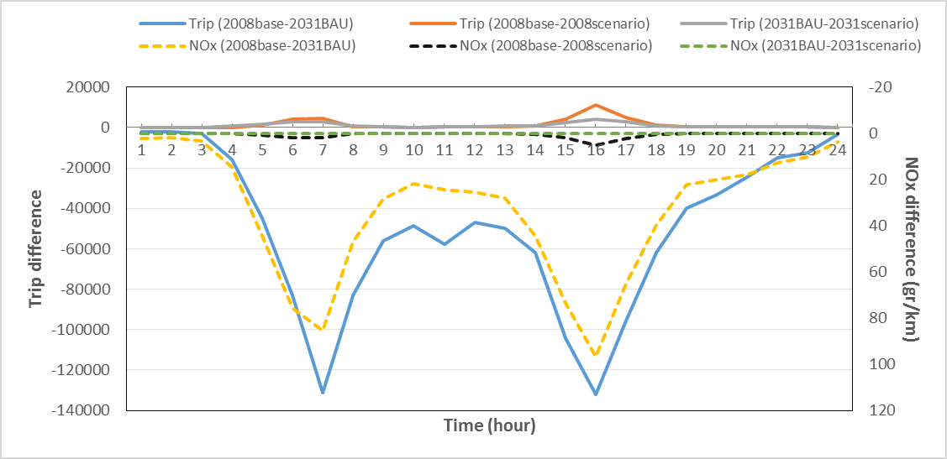

**Fig. 2** Number of driving trips and difference in hourly NOx emissions per unit length (gr/km) for 2008 and 2031 BAU and scenarios.

**Table 1.** Number of trips by mode for different scenarios

|  |  |  |  |  |
| --- | --- | --- | --- | --- |
| **Trips Categories** | **Base 2008** | **Transit 2008** | **BAU 2031** | **Transit 2031** |
| **Drive** | 3,626,805 | 3,599,976 | 4,833,805 | 4,809,305 |
| **Passenger** | 761,791 | 750,495 | 984,546 | 978,194 |
| **Transit** | 1,190,343 | 1,224,232 | 138,8346 | 1,416,476 |
| **Walk** | 754,025 | 746,965 | 866,582 | 861,138 |
| **Bike** | 143,321 | 143,321 | 174,224 | 172,409 |
| **Park/Kiss and Ride** | 150,381 | 160,266 | 207,798 | 218,687 |
| **Other mode** | 433,494 | 434,906 | 618,858 | 617,950 |
| **Total number of trips** | 7,060,161 | 7,060,161 | 9,074,160 | 9,074,160 |

* 1. **Air quality**

The simulated average concentrations for NO2 (1 Km x 1 Km grid) in the 2008 base, 2031 BAU, and transit scenario applied in both years are presented in Fig. 3. The data in these maps represent the mean NO2 contributed by road traffic over the four weeks of simulation. Clearly, the highest concentrations are close to highways and within the dense city center. NO2 concentrations across the study area for 2008 base, 2008 transit, 2031 BAU, and 2031 transit range between 3.9-24.9 ppb, 3.9-16.8 ppb, 3.9-9.5 ppb and 3.9-5.2 ppb, respectively. Compared to the baseline in 2008, the BAU 2031 will result in substantially lower NO2 concentrations. Note that these concentrations reflect the contribution of traffic only, without the contribution of other sources (industrial, residential). In addition, the contribution of traffic does not include truck movements.

|  |  |
| --- | --- |
| **I:\CAL_rd_1_6_2015\scenario analysis_DSP\Latest result Without point\Fig\2008basepolylegend.png**I:\CAL_rd_1_6_2015\scenario analysis_DSP\Latest result Without point\Fig\2008basepoly.png  **(a)** | **I:\CAL_rd_1_6_2015\scenario analysis_DSP\Latest result Without point\Fig\2008scepolylegend.png**I:\CAL_rd_1_6_2015\scenario analysis_DSP\Latest result Without point\Fig\2008scepoly.png  **(b)** |
| **I:\CAL_rd_1_6_2015\scenario analysis_DSP\Latest result Without point\Fig\scale-northarrow.pngI:\CAL_rd_1_6_2015\scenario analysis_DSP\Latest result Without point\Fig\2031basepolylegend.png**I:\CAL_rd_1_6_2015\scenario analysis_DSP\Latest result Without point\Fig\2031basepoly.png  **(c)** | **I:\CAL_rd_1_6_2015\scenario analysis_DSP\Latest result Without point\Fig\2031scepolylegend.png**I:\CAL_rd_1_6_2015\scenario analysis_DSP\Latest result Without point\Fig\2031scepoly.png  **(d)** |

Fig. 3 Average NO2 concentrations in the greater Montreal for four scenarios:   
2008 base (a), 2008 scenario (b), 2031 BAU (c), 2031 scenario (d)

Fig.4a shows the percentage reduction in average NO2 concentrations at the 1km×1km grid level. For most of the grids, NO2 concentrations were reduced as a result of transit investments (base *minus* scenario>0). The mean NO2 reductionin the 2008 scenario compared to the 2008 base is 8% while it is 3% in the 2031 transit scenario compared to the 2031 BAU. This illustrates that the transit scenario, had it been implemented in 2008, would have been more successful at reducing NO2 concentrations than its anticipated effect in 2031. Of course, a larger reduction (by 11% on average) is observed between the simulated NO2 in the 2031 BAU and that in the 2008 base case. Comparing the 2031 transit scenario and the 2008 base case we obtain a reduction of 13%.

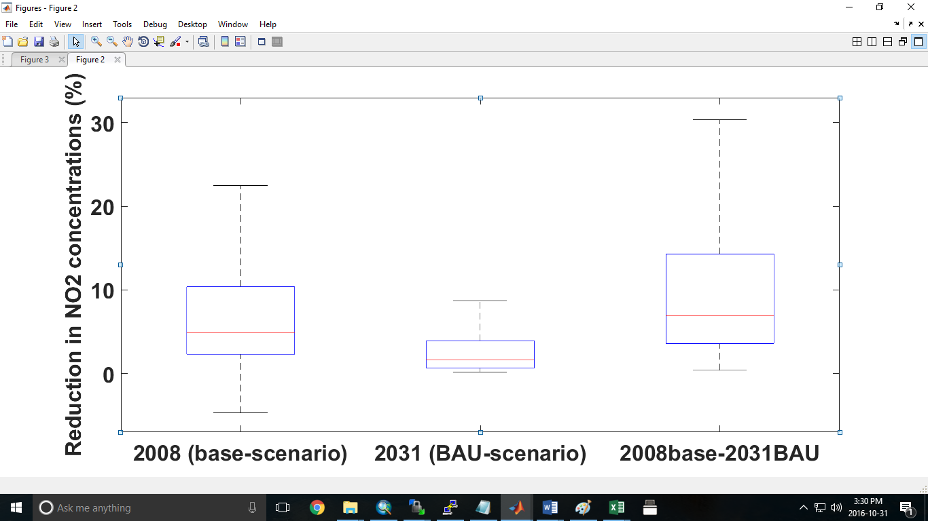

(a)

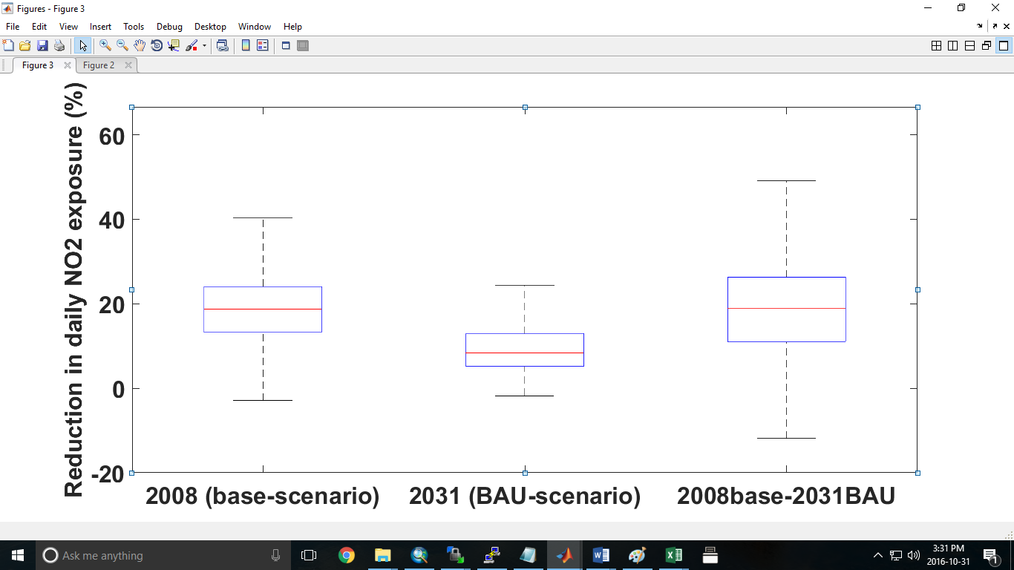

(b)

**Fig 4.** Reductions in NO2 concentrations across gridcells (a) and reductions in daily NO2 exposures across individuals (b)

* 1. **Population exposure**

The percentage reduction of individuals’ daily NO2 exposures is shown in Fig. 4b. Comparing to 2008 base case, the average reduction in individual exposure with the transit scenario is 19% while it is 10% for the 2031 transit scenario compared to the 2031 BAU (Fig. 4b). Also, a 19% reduction in exposure was noted in the 2031 BAU scenario compared to the 2008 base case (Fig. 4b). Comparing the box plots in Figs. 4a and 4b, we observe that the reductions in mean NO2 exposures are higher than the reductions in the mean NO2 concentrations, indicating that the effect of transit investments would have been underestimated if concentrations were simulated without looking at the effect of exposure.

In addition, we observe that the spatial patterns of these reductions are quite different (Fig. 5). For visualization purposes, we calculated exposures at the level of each individual and computed the mean daily exposure across all individuals living within each traffic analysis zone (TAZ) in order to obtain a mean daily exposure per TAZ which represents the exposure of all individuals living in each TAZ throughout their daily activities and movement. Fig. 5 shows the difference in individual daily exposures presented at a TAZ level between 1) base case and transit scenarios in 2008 (the first row of the left column), 2) BAU and transit scenario in 2031 (the second row of the left column), as well as the difference in mean NO2 concentrations aggregated from the gridcell to the TAZ level between 3) base case and transit scenarios in 2008 (the first row of the right column), and 4) BAU and transit scenario in 2031 (the second row of the right column). This figure illustrates that reductions in NO2 exposure are generally higher than reductions in NO2 concentrations for TAZs located in peripheral areas. This can be attributed to the fact that air quality improvements occurred in the central TAZs that are most visited during the day therefore individuals living in peripheral areas reduced their exposure due to the air quality improvements at their work and activity locations. This would explain the fact that NO2 concentration at their home location decreased less than their daily exposure.

|  |  |  |  |
| --- | --- | --- | --- |
|  | **Percentage reduction in daily exposure** | **Percentage reduction in average NO2** |  |
| **2008** | **I:\CAL_rd_1_6_2015\scenario analysis_DSP\Latest result Without point\Fig\8mobredcu.png**  **(Base-Scenario)/Base**  **(BAU-Scenario)/BAU** | **I:\CAL_rd_1_6_2015\scenario analysis_DSP\Latest result Without point\Fig\8NO2redcu.png**  **(Base-Scenario)/Base** | **I:\CAL_rd_1_6_2015\scenario analysis_DSP\Latest result Without point\Fig\8-scale.png** |
| **2031** | **I:\CAL_rd_1_6_2015\scenario analysis_DSP\Latest result Without point\Fig\31mobredcu.png**  **(Base-BAU)/Base** | **I:\CAL_rd_1_6_2015\scenario analysis_DSP\Latest result Without point\Fig\31-scale.pngI:\CAL_rd_1_6_2015\scenario analysis_DSP\Latest result Without point\Fig\31NO2redcu.png**  **(Base-BAU)/Base**  **(BAU-Scenario)/BAU** |  |
| **2008 vs 2031** | **I:\CAL_rd_1_6_2015\scenario analysis_DSP\Latest result Without point\Fig\8-31mobredcu.png** | I:\CAL_rd_1_6_2015\scenario analysis_DSP\Latest result Without point\Fig\2008-31-scale.png**I:\CAL_rd_1_6_2015\scenario analysis_DSP\Latest result Without point\Fig\8-31NO2redcu.png** |  |

**Fig. 5** Reduction in NO2 concentrations and daily NO2 exposure across traffic analysis zones (the white zones represent the places with no individuals in our sample)

1. **Discussion and conclusion**

In this paper, we reported on the use of an integrated transport-emission-dispersion model for the assessment of future transportation scenarios in Montreal, Canada. The integrated model was used to investigate the effects of a regional transit policy on air quality and population exposure. We used data from the 2008 origin-destination survey for Montreal and simulated hourly NO2 concentrations under two different transit scenarios in order to estimate the hourly individual exposures in 2008 and 2031. Our findings are useful for urban planning applications because we can now use the proposed framework to improve urban air pollution spatial analysis and evaluate the effects of various transport policy scenarios on traffic volumes.

With regards to changes in air quality and exposure, in this study both temporal and spatial variations of exposures were investigated between 2008 base, 2031 BAU and scenarios in 2008 and 2031. In terms of spatial variability, although comparing the scenario and base case indicates significant reductions in NO2 concentrations in downtown, individual exposures were reduced throughout all neighborhoods, including the suburbs, due to population mobility patterns. As an example, for 2031 BAU, we observed a significant decrease in NO2 concentrations in downtown and a considerable reduction in individuals’ daily exposure for individuals who live and work in the suburbs. With respect to the 2008 base and 2031 BAU, we observed larger reductions in NO2 concentrations and exposures in the 2008 transit scenario compared to 2031 transit scenario. If we had implemented all of the transit projects in 2008, they would have had a higher positive impact on air quality than if they are implemented in 2031. This is due to the fact that in 2031, our population growth is concentrated in peripheral areas. Also, we observed that the impact of the transit policy in either year is smaller than the impact of vehicle technology as observed when we compare the 2008 base case and 2031 BAU. In terms of traffic volumes, our analysis of a transit scenario for Montreal also reveals an increased modal share of public transit especially for the trips that are affected by the new stations. Therefore, we observe lower traffic volumes on the road network and lower emissions and NO2 concentrations, the latter are mostly reduced in the downtown and central areas where most of the transit expansions are planned.

For the impact of transit scenario on driving trips, several studies have also proposed similar results. Johnston et al. (2008) investigated a scenario, which consists of massive improvements to the transit facilities in Sacramento region. The authors estimated an increase in transit trips of 81% by 2025 compared to the base case (2000). Also, a reduction of 7.7% and 3% was observed in vehicle miles traveled (VMT) and driving trips respectively in the scenario case compared to the base case. In another study in Sacramento, land use and transit policies reduced the VMT by about 5-7% compared to a future scenario with a 20-year time horizon (Rodier at al., 2002). In Germany, with the combined investments in upgrading the public transport system and strong pro-pedestrian and pro-bicycle policies between 1976 and 1991, the total daily trips increased by 30.4%, but automobile trips rose by only 1.3% and the automobile's modal share dropped from 60% to 47%. This occurred in the context of quite rapidly rising automobile ownership (Pucher and Clorer, 1992).

Several studies addressed similar impacts of a transit investment scenario on urban air quality (Woodcock et al., 2009; Perez et al. 2015; Tobollik et al. 2016) and total trips (Lumbreras et al., 2008; Rodier at al., 2002; Johnston et al., 2008 and Pucher and Clorer, 1992). Among those have addressed urban air quality, Lumbreras et al., (2008) observed an increase in mobility but a decreasing trend in future traffic-related NOx emissions, associated with improvements in vehicle technology. They reported an annual car mileage reduction of 10% compared to the base scenario (2003), by shifting from private vehicles to public transport (by enlarging the underground network, improving bus services and building integrated public transport stations) which leads to a 4% lower NOx emission level in 10 years (from 2003 to 2012). Several recent studies have also reported positive impacts of transit scenarios on emissions, health and well-being (e.g., Woodcock et al., 2009; Grabow et al., 2012; Woodcock et al., 2013; Perez et al., 2015; Tobollik et al., 2016). Woodcock et al. (2009) quantified the environmental and health benefits of various alternative transport scenarios for 2030 in London. The authors estimated that over 500 premature deaths could be saved under alternative transport scenarios. Grabow et al. (2012) found that by eliminating the short automobile trips (trips ≤ 8 km) in 11 metropolitan areas in the upper Midwestern United States, the annual average urban PM2.5 would decline by 0.1 µg/m3 and that summer ozone (O3) would increase slightly in cities but decline regionally. Across the study region of approximately 31.3 million people and 37,000 total square miles, mortality would decline by approximately 1,295 deaths/year (95% CI: 912, 1,636) because of improved air quality and increased exercise. Perez et al. (2015) found that under the transition scenario that assumed strict particle emissions standards in diesel cars and all planned transport measures, 3% of premature deaths could be prevented from projected PM2.5 exposure reductions. This is similar to results by Woodcock et al. (2013) in England and Wales, which suggested a reduction of premature deaths between 3% and 9% assuming increased levels of walking and cycling could reach up to 37%. Tobollik et al. (2016) estimated the greenhouse gas reduction potential of various transit scenarios in Rotterdam using a base year of 2010 and projecting to 2020. The authors estimated reductions in PM2.5 of around 40%.

A number of limitations are associated with our study, for example we do not calculate indoor or in-vehicle exposures. In addition, the policy scenario targeted only drivers and passengers. However the results of the current study can be extended in order to access whether the emission reduction simulated by the integrated model for future scenarios can translate to users of other transport modes. This provides useful information to transport planners when implementing emission reduction strategies or modifying transport facilities. Also, in terms of future vehicle technologies, specific scenarios should be developed to investigate how far our assumption about this improvement is feasible and what will be happen if the technology advancements do not meet our predictions. Furthermore, uncertainties are associated with the input data and formulations for each model of this chain and those uncertainties will propagate through the chain. It would, therefore, be of interest to investigate the propagation of uncertainties in modelling chains and the corresponding impacts on air quality and individual exposure. Another limitation is associated with the lack of commercial and truck vehicle movements therefore our model includes household travel only. This limitation is partially overcome by the fact that our model will be mostly used to investigate the effects of scenarios affecting household travel. Our future work will incorporate freight movements and evaluate the impacts of technology on emissions. It also will focus on extending our analysis into an examination of the health effects associated with changes in NO2 exposures. This will be done through the use of known risk functions for various health effects thus allowing us to estimate the health burden of transportation policies (associated with air pollution).

**Acknowledgements**

This work was funded by a Collaborative Health Research Projects grant by the government of Canada. It was also supported with matching funds from the Montreal Department of Public Health. Special thanks are extended to Joseph Scire, David Strimaitis and the entire CALPUFF development team for their immense assistance throughout this study.

**References**

AMT, Agence Metropolitain de Transport, 2010. La mobilite des personnes dans la region de Montreal: Faits Saillants. Enquete Origine-Destination 2008.

Beckx, C., Arentze, T., Int Panis, L., Janssens, D., Vankerkom, J., Wets, G., 2009a. An integrated activity-based modelling framework to assess vehicle emissions: approach and application. Environment and Planning B: Planning and Design 36(6) 1086-1102.

Beckx, C., Int Panis, L., Arentze, T., Janssens, D., Torfs, R., Broekx, S., Wets, G., 2009b. A dynamic activity-based population modelling approach to evaluate exposure to air pollution: methods and application to a Dutch urban area. Environmental Impact Assessment Review 29(3) 179-185.

Bhalla, K., Shotten, M., Cohen, A., Brauer, M., Shahraz, S., Burnett, R., Leach-Kemon, K., Freedman, G., Murray, C., 2014. Transport for health: the global burden of disease from motorized road transport.

Braubach, M., Tobollik, M., Mudu, P., Hiscock, R., Chapizanis, D., Sarigiannis, D.A., Keuken, M., Perez, L., Martuzzi, M., 2015. Development of a quantitative methodology to assess the impacts of urban transport interventions and related noise on well-being. International journal of environmental research and public health 12(6) 5792-5814.

Cesaroni, G., Boogaard, H., Jonkers, S., Porta, D., Badaloni, C., Cattani, G., Forastiere, F., Hoek, G., 2012. Health benefits of traffic-related air pollution reduction in different socioeconomic groups: the effect of low-emission zoning in Rome. Occupational and environmental medicine 69(2) 133-139.

Colette, A., Granier, C., Hodnebrog, Ø., Jakobs, H., Maurizi, A., Nyiri, A., Rao, S., Amann, M., Bessagnet, B., D'Angiola, A., 2012. Future air quality in Europe: a multi-model assessment of projected exposure to ozone. Atmospheric Chemistry and Physics 12(21) 10613-10630.

Crouse, D.L., Goldberg, M.S., Ross, N.A., 2009. A prediction-based approach to modelling temporal and spatial variability of traffic-related air pollution in Montreal, Canada. Atmospheric Environment 43(32) 5075-5084.

Crouse, D.L., Goldberg, M.S., Ross, N.A., Chen, H., Labrèche, F., 2010. Postmenopausal breast cancer is associated with exposure to traffic-related air pollution in Montreal, Canada: a case-control study. Environmental health perspectives 118(1) 1578-1583.

De Nazelle, A., Nieuwenhuijsen, M.J., Antó, J.M., Brauer, M., Briggs, D., Braun-Fahrlander, C., Cavill, N., Cooper, A.R., Desqueyroux, H., Fruin, S., 2011. Improving health through policies that promote active travel: a review of evidence to support integrated health impact assessment. Environment international 37(4) 766-777.

Dhondt, S., Beckx, C., Degraeuwe, B., Lefebvre, W., Kochan, B., Bellemans, T., Int Panis, L., Macharis, C., Putman, K., 2012. Health impact assessment of air pollution using a dynamic exposure profile: implications for exposure and health impact estimates. Environmental Impact Assessment Review 36 42-51.

Dhondt, S., Kochan, B., Beckx, C., Lefebvre, W., Pirdavani, A., Degraeuwe, B., Bellemans, T., Panis, L.I., Macharis, C., Putman, K., 2013. Integrated health impact assessment of travel behaviour: Model exploration and application to a fuel price increase. Environment international 51 45-58.

DMTI Spatial Inc. Database 2007. CanMap Street files.

Eluru, N., Chakour, V., El-Geneidy, A.M., 2012. Travel mode choice and transit route choice behavior in Montreal: insights from McGill University members commute patterns. Public Transport 4(2) 129-149.

Gan, W.Q., Davies, H.W., Koehoorn, M., Brauer, M., 2012. Association of long-term exposure to community noise and traffic-related air pollution with coronary heart disease mortality. American journal of epidemiology 175(9) 898-906.

Grabow, M.L., Spak, S.N., Holloway, T., Stone Jr, B., Mednick, A.C., Patz, J.A., 2012. Air quality and exercise-related health benefits from reduced car travel in the midwestern United States. Environmental health perspectives 120(1) 68.

Gurram, S., Stuart, A.L., Pinjari, A.R., 2015. Impacts of travel activity and urbanicity on exposures to ambient oxides of nitrogen and on exposure disparities. Air Quality, Atmosphere & Health 8(1) 97-114.

Hamra, G.B., Laden, F., Cohen, A.J., Raaschou-Nielsen, O., Brauer, M., Loomis, D., 2015. Lung Cancer and Exposure to Nitrogen Dioxide and Traffic: A Systematic Review and Meta-Analysis. Environmental health perspectives.

Hoek, G., Krishnan, R.M., Beelen, R., Peters, A., Ostro, B., Brunekreef, B., Kaufman, J.D., 2013. Long-term air pollution exposure and cardio-respiratory mortality: a review. Environ Health 12(1) 43.

Johnston, R.A., Gao, S., Clay, M.J., 2008. Modeling long-range transportation and land use scenarios for the Sacramento region, using citizen-generated policies. Institute of Transportation Studies.

Lim, L.L., Hughes, S.J., Hellawell, E.E., 2005. Integrated decision support system for urban air quality assessment. Environmental Modelling & Software 20(7) 947-954.

Lumbreras, J., Valdés, M., Borge, R., Rodríguez, M., 2008. Assessment of vehicle emissions projections in Madrid (Spain) from 2004 to 2012 considering several control strategies. Transportation Research Part A: Policy and Practice 42(4) 646-658.

Macmillan, A., Connor, J., Witten, K., Kearns, R., Rees, D., Woodward, A., 2014. The societal costs and benefits of commuter bicycling: simulating the effects of specific policies using system dynamics modeling. Environmental health perspectives 122(4) 335.

Maizlish, N., Woodcock, J., Co, S., Ostro, B., Fanai, A., Fairley, D., 2013. Health cobenefits and transportation-related reductions in greenhouse gas emissions in the San Francisco Bay area. American Journal of Public Health 103(4) 703-709.

Nieuwenhuijsen, M.J., Khreis, H., Verlinghieri, E., Rojas-Rueda, D., 2016. Transport And Health: A Marriage Of Convenience Or An Absolute Necessity. Environment international 88 150-152.

Parent, M.-É., Goldberg, M.S., Crouse, D.L., Ross, N.A., Chen, H., Valois, M.-F., Liautaud, A., 2013. Traffic-related air pollution and prostate cancer risk: a case–control study in Montreal, Canada. Occupational and environmental medicine oemed-2012-101211.

Perez, L., Trüeb, S., Cowie, H., Keuken, M., Mudu, P., Ragettli, M., Sarigiannis, D., Tobollik, M., Tuomisto, J., Vienneau, D., 2015. Transport-related measures to mitigate climate change in Basel, Switzerland: A health-effectiveness comparison study. Environment international 85 111-119.

Pelletier G, Kammoun N. 2010. La population du québec par territoire des centres locaux de services communautaires, par territoire des réseaux locaux de services et par région sociosanitaire.

PMAD, 2011.http://projet.pmad.ca/fileadmin/user\_upload/pmad2011/documentation/

20110428\_projetPMAD\_summary.pdf

PTV Vision, 2009. VISUM 11.0 Basics.PTV AG, Karlsruhe, Germany.

Rodier, C.J., Johnston, R.A., Abraham, J.E., 2002. Heuristic policy analysis of regional land use, transit, and travel pricing scenarios using two urban models. Transportation Research Part D: Transport and Environment 7(4) 243-254.

Seika, M., Metz, N., Harrison, R.M., 1996. Characteristics of urban and state emission inventories—a comparison of examples from Europe and the United States. Science of the Total Environment 189 221-234.

Setton, E., Marshall, J.D., Brauer, M., Lundquist, K.R., Hystad, P., Keller, P., Cloutier-Fisher, D., 2010. The impact of daily mobility on exposure to traffic-related air pollution and health effect estimates. Journal of Exposure Science and Environmental Epidemiology 21(1) 42-48.

Shekarrizfard, M., A. Faghih-Imani, M. Hatzopoulou. 2016. An examination of population exposure to traffic related air pollution: Comparing spatially and temporally resolved estimates against long-term average exposures at the home location. Environmental Research, 147: 435–444.

Sider, T., Alam, A., Zukari, M., Dugum, H., Goldstein, N., Eluru, N., Hatzopoulou, M., 2013. Land-use and socio-economics as determinants of traffic emissions and individual exposure to air pollution. Journal of Transport Geography 33 230-239.

Tobollik, M., Keuken, M., Sabel, C., Cowie, H., Tuomisto, J., Sarigiannis, D., Künzli, N., Perez, L., Mudu, P., 2016. Health impact assessment of transport policies in rotterdam: Decrease of total traffic and increase of electric car use. Environmental Research 146 350-358.

Woodcock, J., Edwards, P., Tonne, C., Armstrong, B.G., Ashiru, O., Banister, D., Beevers, S., Chalabi, Z., Chowdhury, Z., Cohen, A., 2009. Public health benefits of strategies to reduce greenhouse-gas emissions: urban land transport. The Lancet 374(9705) 1930-1943.

Woodcock, J., Givoni, M., Morgan, A.S., 2013. Health impact modelling of active travel visions for England and Wales using an Integrated Transport and Health Impact Modelling Tool (ITHIM). PLoS One 8(1) e51462.

Xia, T., Nitschke, M., Zhang, Y., Shah, P., Crabb, S., Hansen, A., 2015. Traffic-related air pollution and health co-benefits of alternative transport in Adelaide, South Australia. Environment international 74 281-290.