**Disaggregate Level Simulation of Bus Transit Emissions in a Large Urban Region**

**Asad Shahbaz Waraicha, Sabreena Anowara, Tristano Tenagliab, Timothy Siderc, Ahsan Alamd, Negaar Shabaanzaadeh Minaeia, Marianne Hatzopouloud, Naveen Elurua\***

**\*Corresponding author**

a12800 Pegasus Drive

Department of Civil, Environmental and Construction Engineering

University of Central Florida

Orlando, Florida, USA

Tel: 1-[407-823-4815](tel:407-823-4815); Fax: 1-[407-823-3315](tel:407-823-3315)

Email: [naveen.eluru@ucf.edu](mailto:naveen.eluru@ucf.edu); [sabreena.anowar@ucf.edu](mailto:sabreena.anowar@ucf.edu); [asadwaraich@knights.ucf.edu](mailto:asadwaraich@knights.ucf.edu); negar.minaii@knights.ucf.edu

b 817 Sherbrooke Street West

Department of Civil Engineering and Applied Mechanics

McGill University

Montreal, Quebec, Canada

Email: [tristano.tenaglia@mail.mcgill.ca](mailto:tristano.tenaglia@mail.mcgill.ca)

c Sustrans

70 Cowcross Street

London, United Kingdom

Email: sider.t@gmail.com

d35 Saint George Street

Department of Civil Engineering

University of Toronto

Toronto, Ontario, Canada

Email: [marianne.hatzopoulou@utoronto.ca](mailto:marianne.hatzopoulou@utoronto.ca); ahsan.alam.mcgill@gmail.com

Submission Date: October, 2017

## ABSTRACT

In this study, we demonstrate the development of a methodology for simulating transit bus ridership and GHG emissions (in CO2 equivalent) across a network of 200 bus lines in the city of Montreal, Canada. The current study estimates ridership and emissions at a micro level i.e. at the disaggregate stop level for 24 hours of a typical weekday for all the bus lines (and their trips) in the bus network of Montreal. The disaggregate level simulation process incorporates for specificities such as vehicle type, age, fuel, and passenger load. The micro-simulation platform developed has three embedded modules: (1) stop level boarding and alighting, (2) bus occupancy determination, and (3) disaggregate emission estimation. Our simulation allows us to estimate emissions for individual buses while running as well as while idling at bus stops. The proposed model system provides measures of per capita emissions (total emissions/total boardings), per km emissions (total emissions/total kms travelled), and per person km emissions (total emissions/total person kms travelled on bus transit). To further illustrate the applicability of the proposed study, we conducted several policy scenario analyses. We investigated the effect of a 20 percent systemwide increase in ridership and observed a 1.1% increase in total emissions and a 13% decrease in per capita emissions. We estimated the effects of decreasing the frequency of low occupancy buses and increasing the frequency of high occupancy buses as well and observed that these frequency changes are associated with proportional changes in emissions.

*Keywords*: transit bus emissions, MOVES, air pollution, greenhouse gases, transit ridership, emission modeling

## INTRODUCTION

Overdependence on automobiles for travel has resulted in a vast array of negative consequences including congestion, poor health outcomes, traffic crashes, smog, air pollution, and greenhouse gas (GHG) emissions (Santos et al., 2010a). Development of an efficient intermodal public transportation system comprised of railways (commuter rail, light rail, high-speed rail, inter-urban rail), metro (underground subway), buses (regular buses, articulated buses), and ferries offer a unique and promising solution for mitigating the different road traffic externalities (Santos et al., 2010b). Therefore, not surprisingly, many urban regions are either enhancing or considering improvements to their existing public transportation infrastructure to address the private vehicle use challenge (for example, see transportation plans of Montreal (Ville de Montreal, 2008) and Toronto (Get Toronto Moving, 2014)). Positive impacts of public transit, particularly, in the reduction of harmful emissions such as CO2 have been reported in the literature (Givoni et al., 2009; Chester and Horvath, 2009; Lau et al., 2011). It has also been reported that a few percentage point increase in public transit’s mode share could lead to considerable GHG reductions (Bailey, 2007). Moreover, mass transit systems encourage more resource efficient land use and personal activity patterns (Bailey et al., 2008).

The current study contributes to a burgeoning literature on emissions associated with public transit by developing an urban regional level micro-simulation model for transit bus emissions. While transit in general is an environmentally friendly and sustainable transportation mode, owing to the variations in passenger load, service type, fuel type, weather, time of the day, road grade, vehicle configuration and type, and vehicle age, the emissions output may vary substantially (Alam et al., 2014; Lau et al., 2011). A major portion of the transit bus emission results from the combustion of fuels during vehicle operation. These include: (1) combustion of fuel during transport of passengers between destinations (via bus stops); (2) combustion of fuel while idling (allowing for boarding and alighting of passengers); and (3) combustion of fuel while driving with an empty vehicle, where such driving is a direct result/requirement of transporting passengers such as arriving from the bus depot to the bus route starting point. However, there is a paucity of literature that attempts to quantify and understand the emissions generated by bus transit at the level of an entire system. In our study, we attempt to improve the methodology for bus transit emission evaluation by undertaking disaggregate level analysis of bus transit emissions in Montreal, Canada.

The overall methodology involves the development of a microsimulation platform that considers bus transit emissions for all bus routes and all scheduled trips by simulating boarding and alighting at each stop allowing us to simulate passenger ridership at the finest resolution. Disaggregate boarding information augmented with vehicle type and configuration, vehicle age and fuel type allows us to identify accurate emission factors (EFs) for emission computation. The proposed framework is employed to evaluate bus emissions for all bus routes in the Montreal region. Further, based on ridership numbers and emissions computed, several useful emission indicators are developed. To illustrate the value of the proposed simulator, several scenario analyses are considered: (a) effect of fixed percentage (20%) increase in ridership on emissions, (b) effect of reducing transit bus frequency in low use bus lines, and (c) effect of increasing transit bus frequency in high use bus lines.

The rest of the paper is organized as follows. Section 2 provides a brief literature review. In Section 3, study area, data source and methodology are described in detail. The estimation results are presented in Section 4. Section 5 concludes the paper and presents directions for future research.

## LITERATURE REVIEW

Traffic-related air pollution is a byproduct of the combustion process that occurs in the majority of automobiles, buses and trucks, producing a host of pollutants such as particulate matter, nitrogen oxides (NOx), volatile organic compounds (VOC), and more. A significant amount of research over the past few years has linked exposure to the aforementioned pollutants with a host of chronic and acute health effects (Brauer et al., 2008; Gan et al., 2012; Selander et al., 2009). Thus, there is growing acceptance of the importance of improving urban air quality in transportation and health research communities. Towards improving air quality, an accurate quantification of emissions is absolutely critical. The transportation field has made substantial progress in recent years in developing quantitative frameworks that estimate disaggregate level automobile emissions accounting for the influence of travel patterns, vehicle characteristics (such as age, type and fuel type), and land use patterns on automobile emission outputs (Sider et al., 2013; Sider et al., 2014; Beckx et al., 2013; Beckx et al., 2010; Dons et al., 2011). Multiple studies have examined bus emissions at the urban region level with particular emphasis on bus fleet and fuel decisions for various cities including London, Hong Kong and Macau (Chong et al., 2014; Li et al., 2015; Song et al., 2018). However, these studies estimate bus emissions at an aggregate level and are unlikely to provide detailed person level emissions in the process. Thus, the research on bus emission estimation is yet to be on par with private vehicle emission estimation approaches.

A summary of earlier studies relevant to our research is presented below. In a majority of the studies, researchers investigated operational or lifecycle GHG emissions of transit buses – with Chan et al. (2013) reporting that operational emissions make up the largest part of the lifecycle emissions for bus fleets without any electric vehicles. An early attempt at inventorying the operating transit bus fleet emission was carried out by Regie Autonome des Transports Parisiens, the major transit agency in Paris. Using static instrumentation system, installed in 400 buses (10% of the fleet), they evaluated the effects of changes in bus type, fuel, age, mileage, and other bus-dependent conditions on operating emissions (Dolidze, 2007). Studies dealing with operational GHG emissions were mostly conducted for the peak traffic periods (morning or afternoon or both) to capture the effect of ridership loads as well as the surrounding vehicular traffic. For instance, Lau et al. (2011) modeled exhaust emissions for transit buses operated by Toronto Transit Commission (TTC), Canada. The methodology involved linking of micro simulated transit assignment results with EFs to develop link-based, route-based, and stop based emissions for individual buses under varying combinations of age, fuel type, and Sulphur content. Quite intuitively, the busiest routes were associated with the highest total emissions and the highest dwell emissions were observed at intermodal transfer stations. On average, bus trips were found to be three times more fuel efficient than car trips. However, the highlight of the research findings relates to the sensitivity of transit emissions to occupancy rates; a finding which is also documented by Chester and Horvath (2009).

Some researchers attempted to quantify the impact of different traffic control and operation techniques on emissions. Amongst others, transit signal priority was reported to reduce GHG emissions by 14% in congested conditions (Alam and Hatzopoulou, 2014b) while Alam et al. (2014a) observed that bus lanes and express bus services also reduce emissions significantly and use of smart card reduces idling emissions. In another study, Maghelal (2011) examined the effects of fuel price on transit ridership and CO2 emissions. Specifically, a negative binomial regression model was used to study transit ridership and ordinary least squares (OLS) model was utilized to estimate CO2 emissions. It was observed that an increase in fuel price increases transit ridership and decreases emissions.

An interesting study was conducted by Diana et al. (2007) where they compared the emissions of demand responsive transit service with conventional fixed route transit service by making use of hypothetical scenarios composed of varying road networks, service quality, and demand densities. It was observed that the demand responsive transit service had lower emissions especially under lower demand densities. In another study, Dessouky et al. (2003) evaluated lifecycle environmental impacts of demand responsive (paratransit or dial-a-ride) systems using simulation. Use of hypothetical scenarios for estimation and visualization of emissions by conventional diesel buses was suggested by Li et al. (2009). Another study indicated that the implementation of bus rapid transit system in Mexico City, Mexico resulted in a 20% to 70% reduction of carbon monoxide (CO), benzene, and particulate matters (PM2.5) due to the lower emission rates of the buses and the reduction in commute times (Wohrnschimmel et al., 2008). A set of research studies have developed algorithms for optimal fleet allocation of alternative fuel vehicles to obtain better environmental benefits (for example see Beltran et al., 2009, and Li and Head, 2009).

### 2.1 Current Study in Context

Our literature review indicates that transit bus emissions are receiving more attention from the emission research community in recent years. Evidently, there is a need to quantify the environmental impact and performance of the existing public bus transit systems, so that better deployment, operation, and routing strategies can be formulated. Most of the studies conducted in the field of bus transit emissions are either micro level i.e. bus/route/corridor level studies or macro i.e. aggregate transit system level studies. The micro level studies, while very insightful, provide no information on the overall system; thus, it is very hard to generalize findings from one bus route to the system level. On the other hand, at a macro level, the data used to evaluate the performance of the system is aggregated resulting in ignoring the effects of various factors at a disaggregate level. The current study aims to bridge the gap between the micro and macro level studies by estimating ridership and emissions at a micro level i.e. disaggregate stop level for 24 hours of a typical weekday for all the bus lines (and their trips) in the bus network of Montreal, Canada. To the best of the authors’ knowledge, this is the first attempt to develop such a disaggregate modeling framework to evaluate the emissions of a public bus transit system in a large urban metropolitan region using detailed stop level boardings and alightings.

## STUDY REGION AND RESEARCH METHODS

Our study is set in Montreal, which is the second most populous metropolitan area in Canada with 3.7 million residents. According to the 2008 Montreal Origin-Destination (OD) survey (AMT, 2008), 67.8% of trips are undertaken by car, 21.4% by public transit, and 10.8% by active transportation (walking and bicycling). The annual transit trips made by the residents of Montreal are higher than those made in most major North American cities. The higher share of public transit trips can be attributed to the multimodal transit system of Montreal which includes 4 metro lines, 5 commuter train lines, and over 200 bus lines managed by different travel agencies (Chakour and Eluru, 2016; Eluru et al., 2012). In the last 15 years, the transit patronage (bus, metro, train) has increased by over 25% for the Montreal Metropolitan Region. The Société de transport de Montreal (STM), which serves bus and metro on the Island of Montreal, has reached a record transit ridership in 2011 with 405 million trips, exceeding the previous record of the year 1945 (STM, 2012). Thus, the Montreal metropolitan region with its unique public transit characteristics and culture of the region forms an ideal test bed for our analysis.

Our methodology is divided into the following three modules: (a) ridership simulation for boarding and alighting, (b) bus occupancy determination, and (c) emission estimation. In the following sub-sections, we describe each of the components in detail.

### 3.1 Module 1: Stop Level Boarding and Alighting

At the core of Module 1 is an object oriented programming code written in JAVA to predict boardings and alightings at a stop level for the entire metropolitan region. The program predicts hourly boardings and alightings based on a series of stop level regression models developed for the bus system (a complete description of the models including model structure, data fit measures and validation is available in Chakour and Eluru, 2016). The data employed for the model development is drawn from data collected by STM. Specifically, three stop level regression models for low, medium, and high ridership stops are estimated. The categorization is based on the overall daily ridership (boarding + alighting) at the stop. The stops with daily ridership of less than 50 are characterized as low use stops; stops with daily ridership between 50 and 250 are characterized as medium use stops, and stops with daily ridership of more than 250 are classified as high use stops. Then a separate model for each stop category and time of day is developed (see Chakour and Eluru, 2016 for complete details on the econometric modeling approach and parameters influencing ridership) considering the influence of a whole range of transit accessibility, transport infrastructure, and built environment factors. Eventually, these models are employed to predict the expected number of boardings and alightings at every bus stop for every hour of the day. Considering a uniform rate of arrival in the hour, these boardings and aligthings are converted to per minute arrivals. In cases with multiple buses arriving at the same stop, the boardings and alightings are pro-rated based on frequency of the buses[1].

### 3.2 Module 2: Bus Occupancy Determination

The stop level boarding and alighting information is available across all stops for 24 hours from the first module. In the second module, these boardings and aligthings are assigned to actual buses. The occupancy module starts for a bus route and its first trip as per the bus schedule. Based on the vehicle fleet information of STM bus service, a bus type is probabilistically allocated for this instance of bus route. Now this bus begins its service from the starting origin on schedule. Based on the stop level model, people waiting at the stop, board the bus and the bus occupancy is updated accordingly. As the bus arrives at the next stop, based on the stop level boardings and alightings predicted, we update the bus occupancy. The calculation of occupancy is done in the following manner. Say, a bus with 10 people on board arrived at a stop. According to the ridership model, the predicted number of boardings and alightings are 4 and 2, respectively. Hence, the occupancy of the bus until the next stop is 10+4−2=12. The boardings and alightings at each stop are saved so as to calculate the time for idling at the stop. The procedure is repeated at each stop thus updating bus occupancy, boardings and alightings at every stop.

While these steps are repeated across all stops in the leg, several consistency checks are incorporated. For example, if the bus is at capacity (determined as 75 for a regular bus and 115 for an articulated bus) when it arrives at a particular stop, the passengers are forced to wait for the next bus with space. If the bus has no passengers, no alightings are allowed. The reader would note that the same bus type is employed for the entire leg of the tour. The process is repeated across all legs of the bus route based on its schedule. Once a single bus route has been analyzed, the second bus route is chosen for simulation and so on until all buses in the Montreal system are covered. The outputs from the ridership module include detailed information on bus occupancy at every stop for every route and every leg. The information also includes detailed stop level boarding and alighting numbers.

### 3.3 Module 3: Emission Estimation

In this module, GHG emissions (in CO2 equivalent) are calculated for each bus line by time of day by linking the results of module 2 to EFs. The module connects the bus lines directly to the emissions and further computes both active and idle emissions for each bus line at each bus stop.

#### 3.3.1 Emission Factor (EF) Generation

Bus EFs were generated using MOVES2014 (Motor Vehicle Emission Simulator), the latest emissions inventory model developed by the US Environmental Protection Agency (USEPA, 2010). MOVES has an enriched database for estimating passenger vehicle emissions for both average and instantaneous speeds. But in the case of transit buses, it has many limitations (see Alam and Hatzopoulou, 2015 for more details). Specifically, when only average speeds are available, the MOVES database lacks transit bus specific data and as a result, the estimated emissions might be under/over predicted compared to a local context. Recognizing this, we made an effort to quantify the extent of the difference between emission estimates using MOVES default data and emission estimates generated after embedding local data into the MOVES database.

Towards that end, the MOVES embedded drive cycles were updated using manually collected Montreal specific transit data along eight routes covering a wide variation of built-environments and road geometries. Local data along these routes were collected during a 6-week campaign in 2013 with GPS devices installed on-board transit buses. Repeated observations were conducted at different times of day; each bus route was monitored 6 times in each direction (3 trips in the morning and 3 trips in the afternoon periods). To embed our own drive cycles into the MOVES database we considered only the drives cycles that were collected for zero-grade links. In our data, a total of 1,998 link observations were found having zero grade (1,389 for regular buses and 609 for articulated buses) and we grouped them into 25 speed categories with average speeds ranging from 1 to 25 mph. For speeds between 3 and 17 mph, at least 50 observations were found in each category, while for the other categories at least 10 observations were found.

For each link-level observation, a cumulative operating mode (*opmode)[2]* distribution was developed considering the second-by-second speed profile and onboard passenger number. Later, within each speed category the variations among different link-specific cumulative *opmode* distributions were carefully observed. For each average speed category, a median cumulative *opmode* distribution was identified to represent the drive cycle characteristics of all the observations in that category. It was calculated using the cumulative *opmode* distribution of all individual drive cycles within this category. Then, in each speed category, one drive cycle was selected in such a way that the calculated *opmode* distribution of that selected drive cycle was the closest to the median *opmode* distribution. Later on, Root mean square error (RMSE)[3] for each drive cycle was calculated. For each average speed category, the drive cycle having the lowest RMSE was selected as the representative drive cycle of that category. Then the selected 25 drive cycles for 25 average speed categories were assigned a drivescheduleID. Using the MySQL platform, three files in the MOVES2014 database were modified to incorporate this drivescheduleID. Figure 1 provides sample of locally generated EFs for a 2013 standard bus on urban restricted and unrestricted roads for boarding =40.

#### 3.3.2 Generating Emission Estimates

Once the EFs are generated , bus transit emissions are estimated at the stop level for each bus line for 24 hours of the day using outputs from module 2. The distances between stops for each bus line is calculated using ArcGIS network distance and the time taken to travel between the stops is calculated from the difference between the scheduled arrival times (provided by STM) of the buses at the stops under consideration. Then, the operating speed of the bus between each bus stop is computed by simply dividing the distance by the travel time obtained using the bus schedules. Although direct traffic congestion was not considered for speed calculation, it is dependent on the realistic time which the bus takes to travel from one stop to another (since in designing the bus schedule the arrival times of buses at the stops are set up considering peak and off-peak hour traffic conditions). In fact, it varies by time of day depending upon the traffic conditions or other variables affecting the travel time between the bus stops. However, congestion or delay due to traffic signal or road networks are not explicitly taken into account. The bus type is chosen in Module 2 and given the STM bus model distribution, a model year is also probabilistically selected for each bus line. Finally, roadway grade and type are then calculated using both GIS and GPS.

The EF tables contain factors both in grams/mile for running emission and grams/hour for idle emissions separated by speed, bus type, bus model year, road type, and bus occupancy. We considered zero grade due to relatively flat topography of the island and meteorology data of only summer season. Two EF look-up tables were generated: (1) based on the MOVES default drive cycles associated with different average speeds, and (2) based on the local drive cycles embedded into MOVES to replace the default distributions. Each look-up table includes EFs for two types of buses (regular and articulated), two types of road categories (urban restricted and urban unrestricted), 72 average speed categories with in increment of 1 mph, 30 model years of buses ranging from 1983 to 2013, 75 onboard passenger loads for regular buses, and 125 onboard passenger load for articulated buses. A total of 864,000 EFs were generated for all identified combinations.

Given this information, an EF is selected from the EF look up tables described above. Total emissions include the sum of both the moving emissions given by the EFs and the idling emissions given by idling time. The idling time is considered a function of number of people boarding and alighting at the bus stop. However, to ensure the randomness of the process, we assume each boarding (alighting) to follow a normally distributed time in seconds with mean of 3 (2) and standard deviation of 3 (2). The alighting process is likely to take less time as there is no need to swipe or pay for the ticket. Based on the normal random draws, the total times for boarding and alighting are computed. The higher of the alighting or boarding time is considered as idling time. The emissions procedure is repeated from one stop to another to cover all stops in the leg, all instances of a bus route in a day and all bus routes in the region. The process provided as outputs: (1) total emissions in the region, (2) total emissions by bus route, and (3) emission information that is related to time of day and bus occupancy.

### 3.4 Performance Measures

Based on our micro simulation exercise, we can estimate emissions by bus line as well as by time of day. With disaggregate boarding information, more useful emission indicators can be computed. To understand the overall emission values, we generate a host of system level indicators. The total system level emissions are obtained by aggregating the emissions from all bus lines during the time period of interest. Specifically, we compute emissions for the entire day, AM peak period (6.30 – 9.30), off peak day period (9.30 – 15.30), PM peak period (15.30 – 18.30), and off peak night period (18.30 – 6.30). In addition, we also compute the per capita emissions (total emissions/total boardings), per km emissions (total emissions/total kms travelled), and per person km emissions (total emissions/total person kms travelled on transit). The last indicator requires the knowledge of bus occupancy between each stop. The person kms are computed as a sum of (total occupancy * distance between stops) across the entire system. This metric allows us to come up with a comparable number to emissions from automobile users. The indicators developed above can also be generated at a bus route level or time of day level for identifying inefficiencies in the system.

## RESULTS AND ANALYSIS

In this section, the base case analysis results are presented first followed by the outcomes of the scenario analysis. Our entire emission analysis is based on the output of the ridership model embedded in the emission estimation code. Hence, prior to moving on with the emission analysis, we validated our ridership model using observed ridership. The accuracy of ridership prediction is paramount since it affects the emission calculations directly. Based on our observed ridership from operator data and predicted ridership, the difference for boardings and alightings is 2%. For such a large micro-simulation process these errors are reasonable. Further, the simulations were conducted multiple times to examine the impact of randomness. For the urban region level emissions, the system level boarding, person distance travelled and simulated emission estimates provided very minor changes across runs. The differences from the mean range from a low of 0.002% to high of 0.5%.

### 4.1 Base Case Results

For the base case, we computed the emission indicators based on two sets of EFs from MOVES: default and local. The default emissions rely on the MOVES default values while the local emissions correspond to the customized EFs discussed in the previous section. The comparison of emissions measures (in CO2 equivalent) - total and average for the entire bus network of Montreal indicates that the use of local EFs instead of default MOVES distributions results in an estimate of emissions that is approximately 15 percent higher. Given the observed differences, it is recommended that EFs be customized for the local jurisdiction whenever possible.

In order to better understand the spatial and temporal variation of emissions in the region, the total computed emissions for AM and PM peak periods are plotted using the “Point Density Tool” from ArcGIS. The tool calculates the density from point features (emission) around each output raster cell. Figure 2 and Figure 3 represent the plots. A closer inspection of the figures reveals that the city center of Montreal has high value of emissions as compared to the rest of city. One plausible explanation for the trend is that more bus lines are serving the downtown area because of high ridership. Higher values of emissions were also observed close to intermodal transfer points – particularly, metro-bus transfer points. Presumably, increased number of boardings and alightings takes place at this intermodal junctions, resulting in high emission from buses. Furthermore, a reduction in the emissions can be seen in the suburban areas as compared to the downtown area.

To provide better insight into the base case scenario, we prepared some additional figures. Figure 4 presents the distance traveled by the transit buses, total boardings, total emissions, and emissions per hour categorized by specific time period of the day. From the figure, it is clear that on an hourly basis, peak AM and PM periods contribute larger share of emissions. However, given the longer duration of the OPD and OPN time periods, their contribution to total emission is also significant. Figure 5 presents the three emission indicators categorized by time of day along with total distance traveled by the transit buses and total boardings. As expected, the emissions are always higher during AM and PM peak periods while the lowest average emissions in terms of all three indicators are observed for the off-peak night period. AM peak period has slightly higher per person and per person-kilometer emissions than the PM peak period.

### 4.2 Scenario Analysis

To demonstrate the applicability of the platform developed in terms of policy analysis, we computed the proposed emission indicators for three policy scenarios. For the first scenario, we increased the overall ridership; while for the second and third scenarios, we varied the bus frequencies.

#### 4.2.1 Scenario 1: Increase in Ridership

In order to study the effect of changes in ridership on emissions, the ridership at all the bus stops was increased by 20% and emissions were generated at the bus stop level. Afterwards, the emissions estimated at the stop level were aggregated at a system level. We observed that the increase in ridership resulted in an increase in systemwide emissions. Table 1 provides a comparison between total systemwide emissions before and after the increase in ridership. From the table, we can see that the total emissions for the day increased by 1.1 percent with a 20 percent increase in systemwide boardings and alightings. Also, the average emissions per km increased by the same percentage. However, average emissions per capita and average emissions per person per km decreased by about 13% and 16%, respectively. Clearly, although the increase in transit ridership increases total emissions, it enhances the performance of the system by reducing per capita emissions in addition to decreasing private vehicle emissions presumably resulting from the change in mode choice of additional transit riders. To be sure, improving bus ridership could also be a result of mode shift from subway riders in some cases.

#### 4.2.2 Scenario 2: Effects of Change in Bus Frequency

In order to evaluate the effect of change in bus frequencies on emissions, low and high occupancy buses in the network were identified. The occupancy for each bus line was calculated by dividing the total number of individuals on bus by the capacity of the bus. Later on, the occupancy of the buses was determined at the disaggregate stop level and then aggregated by bus line. The bus lines were then categorized as low or high occupancy buses based on the aggregated sum of occupancy at the bus line level. The scenario was based on the intuition that the frequency of low occupancy buses need to be decreased and the frequency of high occupancy buses need to be increased in order to reduce emissions. The obtained results are presented in Table 2.

##### *4.2.2.1 Decreasing bus frequency for low occupancy buses*

Route 21 was found to be the bus line with the lowest occupancy. Note that it is a morning peak period bus that connects the Lasalle metro station to Bell campus with an average headway of 30 minutes. The total boardings for the morning peak period observed for seven roundtrips is 12 as compared to a capacity of 75. In this scenario, the effect of increasing the headway from 30 minutes to 60 minutes is investigated. Doing so increased the ridership per bus twice. The emissions were estimated for the said scenario of decreasing the bus frequency and doubling the headway. Table 2 presents the emission details as well as a comparison of total emissions for before and after the increase in ridership owing to a decrease in the frequency of buses. We observe that the decrease in bus frequency resulted in a 49% decrease in emissions.

##### *4.2.2.2 Increasing bus frequency for high occupancy buses*

Based on the occupancy values, Route 18 was one of the high occupancy buses. We found that during the PM peak it runs at capacity for 60 percent of the bus stops. Obviously, there is a need to increase the frequency of this bus line in order to improve its service. Note that Route 18 is a major bus line that runs during all 24 hours of the day and connects Honore Beaugrand metro station to Saint Laurent. It contributes almost 2% of the total bus emissions in Montreal. Again, from Table 2, we can see that increasing the frequency by 25% led to a decrease in bus ridership at the cost of increasing total emissions by ~21%. While the total emissions have increased, the intangible parameters such as comfort, seat availability and lower waiting time (as less likelihood of a full bus arriving at a stop) are the positive impacts of such frequency increase. It is also possible that with improved frequency, ridership could potentially increase (not considered in the analysis) thus offsetting the emission increase. Finally, the reader would note that the increase in bus transit emissions with the higher bus frequency could still be lower than the emissions from private vehicles for the current riders.

In our research, the focus was on developing emissions estimates for the entire bus transit system in Montreal. However, the proposed framework can be employed to conduct diagnostic analysis by route allowing us to (1) identify routes where transit riders have to wait for multiple buses as the buses are full when they arrive at stops on the route, (2) identify bus routes that have very low ridership and contribute to high per-capita emissions, and (3) identify routes with high ridership and low per-capita emissions that can benefit from increased bus frequency. In response to these diagnostics, public transit agencies can undertake remedial measures to enhance the service quality in the region. Finally, the research recognizes that vehicle fleet (automobile and bus transit) is evolving. The current study did not explicitly consider automated and electric vehicles in our analysis. In fact, with the emergence of these vehicles, we believe the rich data available can significantly enhance the proposed approach for estimating emissions.

## CONCLUSION

Estimating transit bus emissions is an important step towards the improvement of transit’s carbon footprint in urban areas. While transit is considered as a more environmentally friendly mode of transportation, buses could be as polluting as private cars on a per passenger basis under low ridership situations. Similarly, busy transit corridors going through dense urban neighborhoods may become characterized by poor air quality due to bus emissions especially when fueled with conventional diesel.

In this study, we demonstrate the development of a method for estimating transit emissions over a large network of 200 bus lines, at the level of the individual bus. This method allows us to incorporate bus and route characteristics in the emission modeling process. This in turn will make it feasible to investigate the effects of changing ridership, frequencies, and ultimately bus types and fuels. Such a systems perspective to transit bus emissions is crucial in the evaluation of planning strategies both at the network level and at a corridor level. With this tool, we can help address questions relating to the allocation of buses based on type, size, and technology while keeping GHG emissions at the forefront of planning decisions. The applicability of the emissions platform was evaluated for a base condition and two scenarios. The results from these exercise offered intuitive and useful insights. In terms of future research, the simulation platform will be updated to incorporate traffic congestion (as opposed to schedule-based speeds) in emission calculation. Further refinements to boarding and alighting models will also need to be investigated. The proposed framework can also be expanded to include other pollutants in the future. In the future, with appropriately designed emissions monitoring experiment, the proposed framework can be enhanced/validated using real-time emissions measurements.

## ACKNOWLEDGEMENT

The authors would like to gratefully acknowledge Ahmadreza Faghih-Imani for helping with the GIS data generation.

## REFERENCES

Alam, A., Diab, E., El-Geneidy, A. M., & Hatzopoulou, M. (2014). A simulation of transit bus emissions along an urban corridor: Evaluating changes under various service improvement strategies. *Transportation Research Part D: Transport and Environment, 31*, 189-198.

Alam, A., & Hatzopoulou, M. (2014a). Investigating the isolated and combined effects of congestion, roadway grade, passenger load, and alternative fuels on transit bus emissions. *Transportation Research Part D: Transport and Environment, 29*, 12-21.

Alam, A., & Hatzopoulou, M. (2014b). Reducing transit bus emissions: Alternative fuels or traffic operations? *Atmospheric Environment, 89*, 129-139.

Alam, A., & Hatzopoulou, M. (2015). *Modeling Transit Bus Emissions using MOVES: Validation of Default Distributions and Embedded Drive Cycles with Local Data.* Paper presented at the Transportation Research Board 94th Annual Meeting.

Bailey, L. (2007). *Public Transportation and Petroleum Savings in the US: Reducing Dependence on Oil*: ICF International.

Bailey, L., Mokhtarian, P. L., & Little, A. (2008). The broader connection between public transportation, energy conservation and greenhouse gas reduction: ICF International Fairfax, VA.

Beckx, C., Lefebvre, W., Degraeuwe, B., Vanhulsel, M., Kochan, B., Bellemans, T., . . . Int Panis, L. (2013). Assessing the environmental impact associated with different trip purposes. *Transportation Research Part D: Transport and Environment, 18*(1), 110-116.

Beckx, C., Panis, L. I., Janssens, D., & Wets, G. (2010). Applying activity-travel data for the assessment of vehicle exhaust emissions: Application of a GPS-enhanced data collection tool. *Transportation Research Part D: Transport and Environment, 15*(2), 117-122.

Beltran, B., Carrese, S., Cipriani, E., & Petrelli, M. (2009). Transit network design with allocation of green vehicles: A genetic algorithm approach. *Transportation Research Part C: Emerging Technologies, 17*(5), 475-483.

Brauer, M., Lencar, C., Tamburic, L., Koehoorn, M., Demers, P., & Karr, C. (2008). A cohort study of traffic-related air pollution impacts on birth outcomes. *Environmental Health Perspectives, 116*(5), 680.

Chakour, V., & Eluru, N. (2016). Examining the influence of stop level infrastructure and built environment on bus ridership in Montreal. *Journal of Transport Geography, 51,* 205-217.

Chan, S., Miranda-Moreno, L. F., Alam, A., & Hatzopoulou, M. (2013). Assessing the impact of bus technology on greenhouse gas emissions along a major corridor: A lifecycle analysis. *Transportation Research Part D: Transport and Environment, 20*, 7-11.

Chester, M. V., & Horvath, A. (2009). Environmental assessment of passenger transportation should include infrastructure and supply chains. *Environmental Research Letters, 4*(2), 1-8.

Chong, U., Yim, S.H., Barrett, S.R. and Boies, A.M., 2014. Air quality and climate impacts of alternative bus technologies in Greater London. Environmental science & technology, 48(8), pp.4613-4622.

Dessouky, M., Rahimi, M., & Weidner, M. (2003). Jointly Optimizing Cost, Service, and Environmental Performance in Demand-Responsive Transit Scheduling. Transportation Research Part D: Transport and Environment, 8(6), 433-465. doi:https://doi.org/10.1016/S1361-9209(03)00043-9

Diana, M., Quadrifoglio, L., & Pronello, C. (2007). Emissions of demand responsive services as an alternative to conventional transit systems. *Transportation Research Part D: Transport and Environment, 12*(3), 183-188.

Dolidzé, B. (2007). *RATP Bus Fleet and Network Emissions.* Paper presented at the 14th International Union of Air Pollution Prevention and Environmental Protection Associations World Congress, Brisbane, Australia.

Dons, E., Beckx, C., Arentze, T., Wets, G., & Panis, L. (2011). Using an activity-based framework to determine effects of a policy measure on population exposure to nitrogen dioxide. *Transportation Research Record: Journal of the Transportation Research Board,* 2233, 72-79.

Eluru, N., Chakour, V., & El-Geneidy, A. M. (2012). Travel mode choice and transit route choice behavior in Montreal: insights from McGill University members commute patterns. *Public Transport*, Vol 4 No. 2, pp. 129-149.

Gan, W. Q., Davies, H. W., Koehoorn, M., & Brauer, M. (2012). Association of long-term exposure to community noise and traffic-related air pollution with coronary heart disease mortality. *American Journal of Epidemiology, 175*(9), 898-906.

Get Toronto Moving 2014, accessed on January 7th 2015 from http://www.gettorontomoving.ca/uploads/GTM_Plan_2014_Summary_Report.pdf

Givoni, M., Brand, C., & Watkiss, P. (2009). Are railways climate friendly? *Built Environment, 35*(1), 70-86. doi: 10.2148/benv.35.1.70

Lau, J., Hatzopoulou, M., Wahba, M., & Miller, E. (2011). Integrated multimodel evaluation of transit bus emissions in Toronto, Canada. *Transportation Research Record: Journal of the Transportation Research Board,* 2216, 1-9.

Li, J.Q., & K.L. Head, (2009). Sustainability provisions in the bus-scheduling problem. *Transportation Research Part D: Transport and Environment, 14*(1), 50-60.

Li, J.-Q., Zhang, W.-B., & Zhang, L. (2009). A web-based support system for estimating and visualizing the emissions of diesel transit buses. *Transportation Research Part D: Transport and Environment, 14*(8), 533-540.

Li, L., Lo, H.K. and Cen, X., 2015. Optimal bus fleet management strategy for emissions reduction. Transportation Research Part D: Transport and Environment, 41, pp.330-347.

Maghelal, P. (2011). Investigating the relationships among rising fuel prices, increased transit ridership, and CO2 emissions. *Transportation Research Part D: Transport and Environment, 16*(3), 232-235.

Santos, G., Behrendt, H., Maconi, L., Shirvani, T., & Teytelboym, A. (2010a). Part I: Externalities and economic policies in road transport. *Research in Transportation Economics, 28*(1), 2-45.

Santos, G., Behrendt, H., & Teytelboym, A. (2010b). Part II: Policy instruments for sustainable road transport. *Research in Transportation Economics, 28*(1), 46-91. doi:

Selander, J., Nilsson, M. E., Bluhm, G., Rosenlund, M., Lindqvist, M., Nise, G., & Pershagen, G. (2009). Long-term exposure to road traffic noise and myocardial infarction. *Epidemiology, 20*(2), 272-279.

Sider, T., Alam, A., Zukari, M., Dugum, H., Goldstein, N., Eluru, N., & Hatzopoulou, M. (2013). Land-use and socio-economics as determinants of traffic emissions and individual exposure to air pollution. *Journal of Transport Geography, 33*, 230-239.

Sider, T. M., Alam, A., Farrell, W., Hatzopoulou, M., & Eluru, N. (2014). Evaluating vehicular emissions with an integrated mesoscopic and microscopic traffic simulation. *Canadian Journal of Civil Engineering, 41*(10), 856-868.

Song, Q., Wang, Z., Wu, Y., Li, J., Yu, D., Duan, H. and Yuan, W., 2018. Could urban electric public bus really reduce the GHG emissions: A case study in Macau?. Journal of Cleaner Production, 172, pp.2133-2142.

STM. (2012). Plan Stratégique 2020 Retrieved 16 February, 2013, from <http://stm.info>

Wöhrnschimmel, H., Zuk, M., Martínez-Villa, G., Cerón, J., Cárdenas, B., Rojas-Bracho, L., & Fernández-Bremauntz, A. (2008). The impact of a Bus Rapid Transit system on commuters' exposure to Benzene, CO, PM 2.5 and PM 10 in Mexico City. *Atmospheric Environment, 42*(35), 8194-8203.

**FIGURE 1 Emission Factors for 2013 Model Standard Bus for Boarding =40**

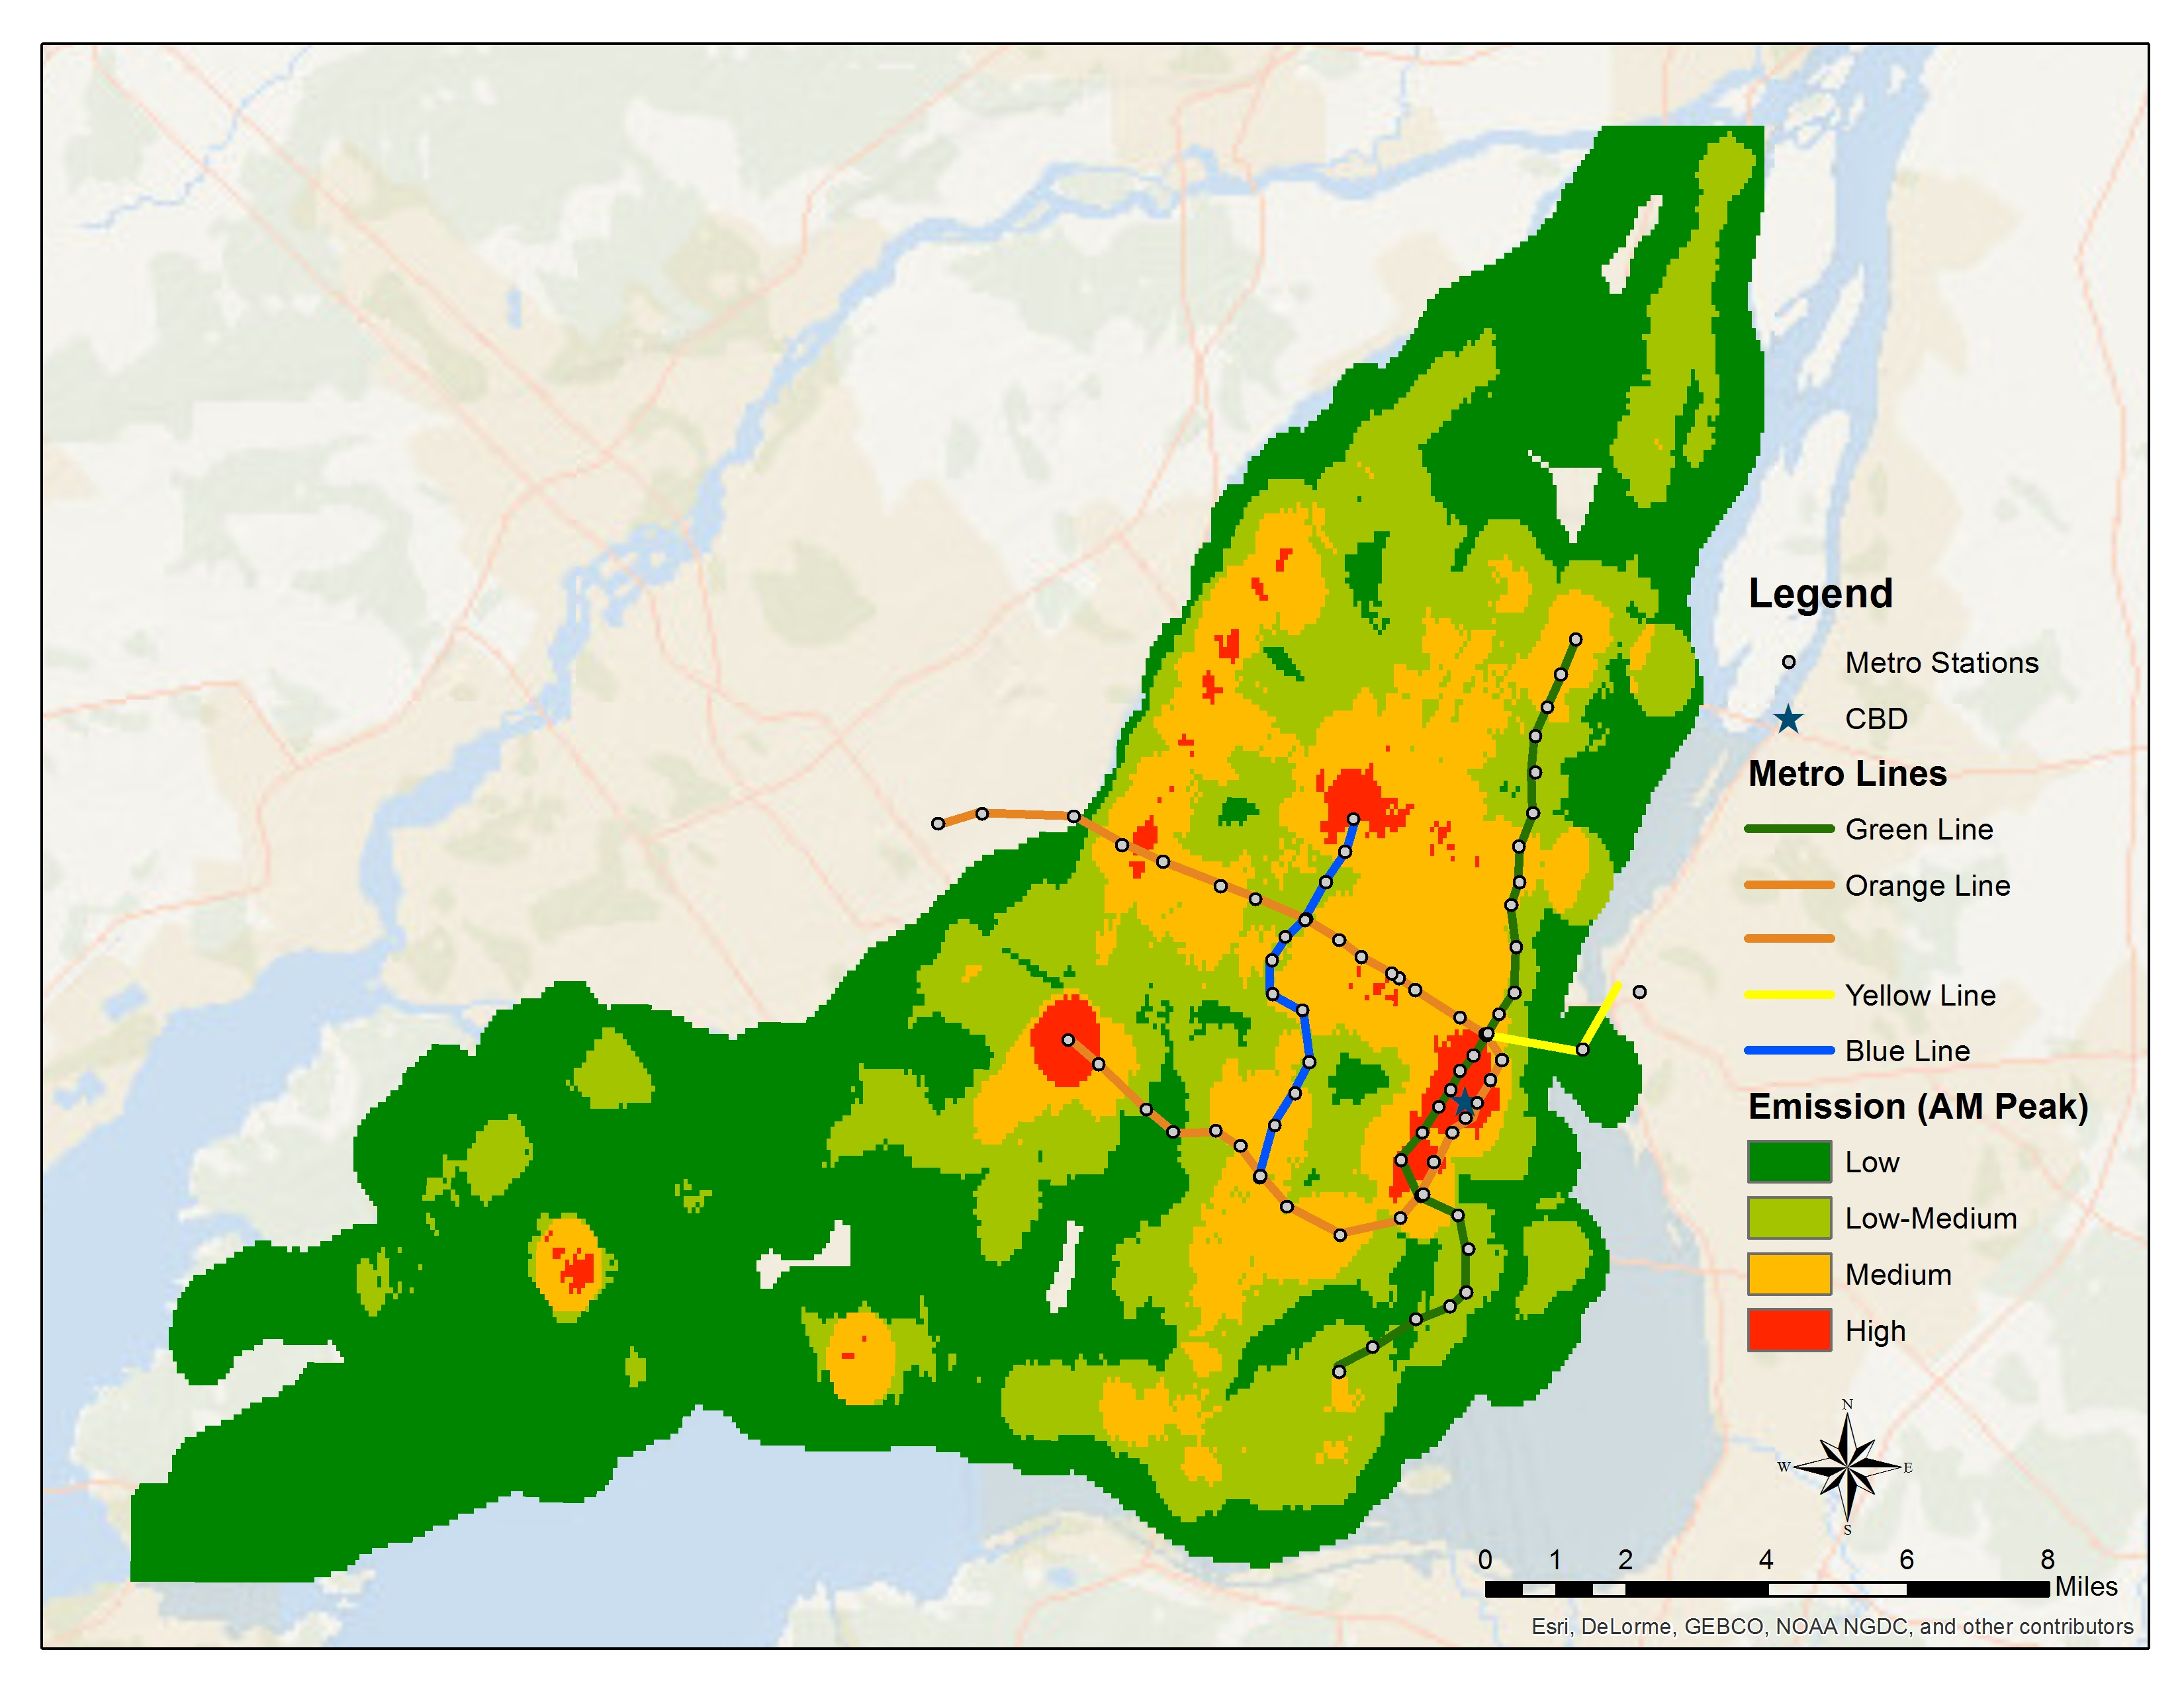

**FIGURE 2 Emissions for AM peak period**

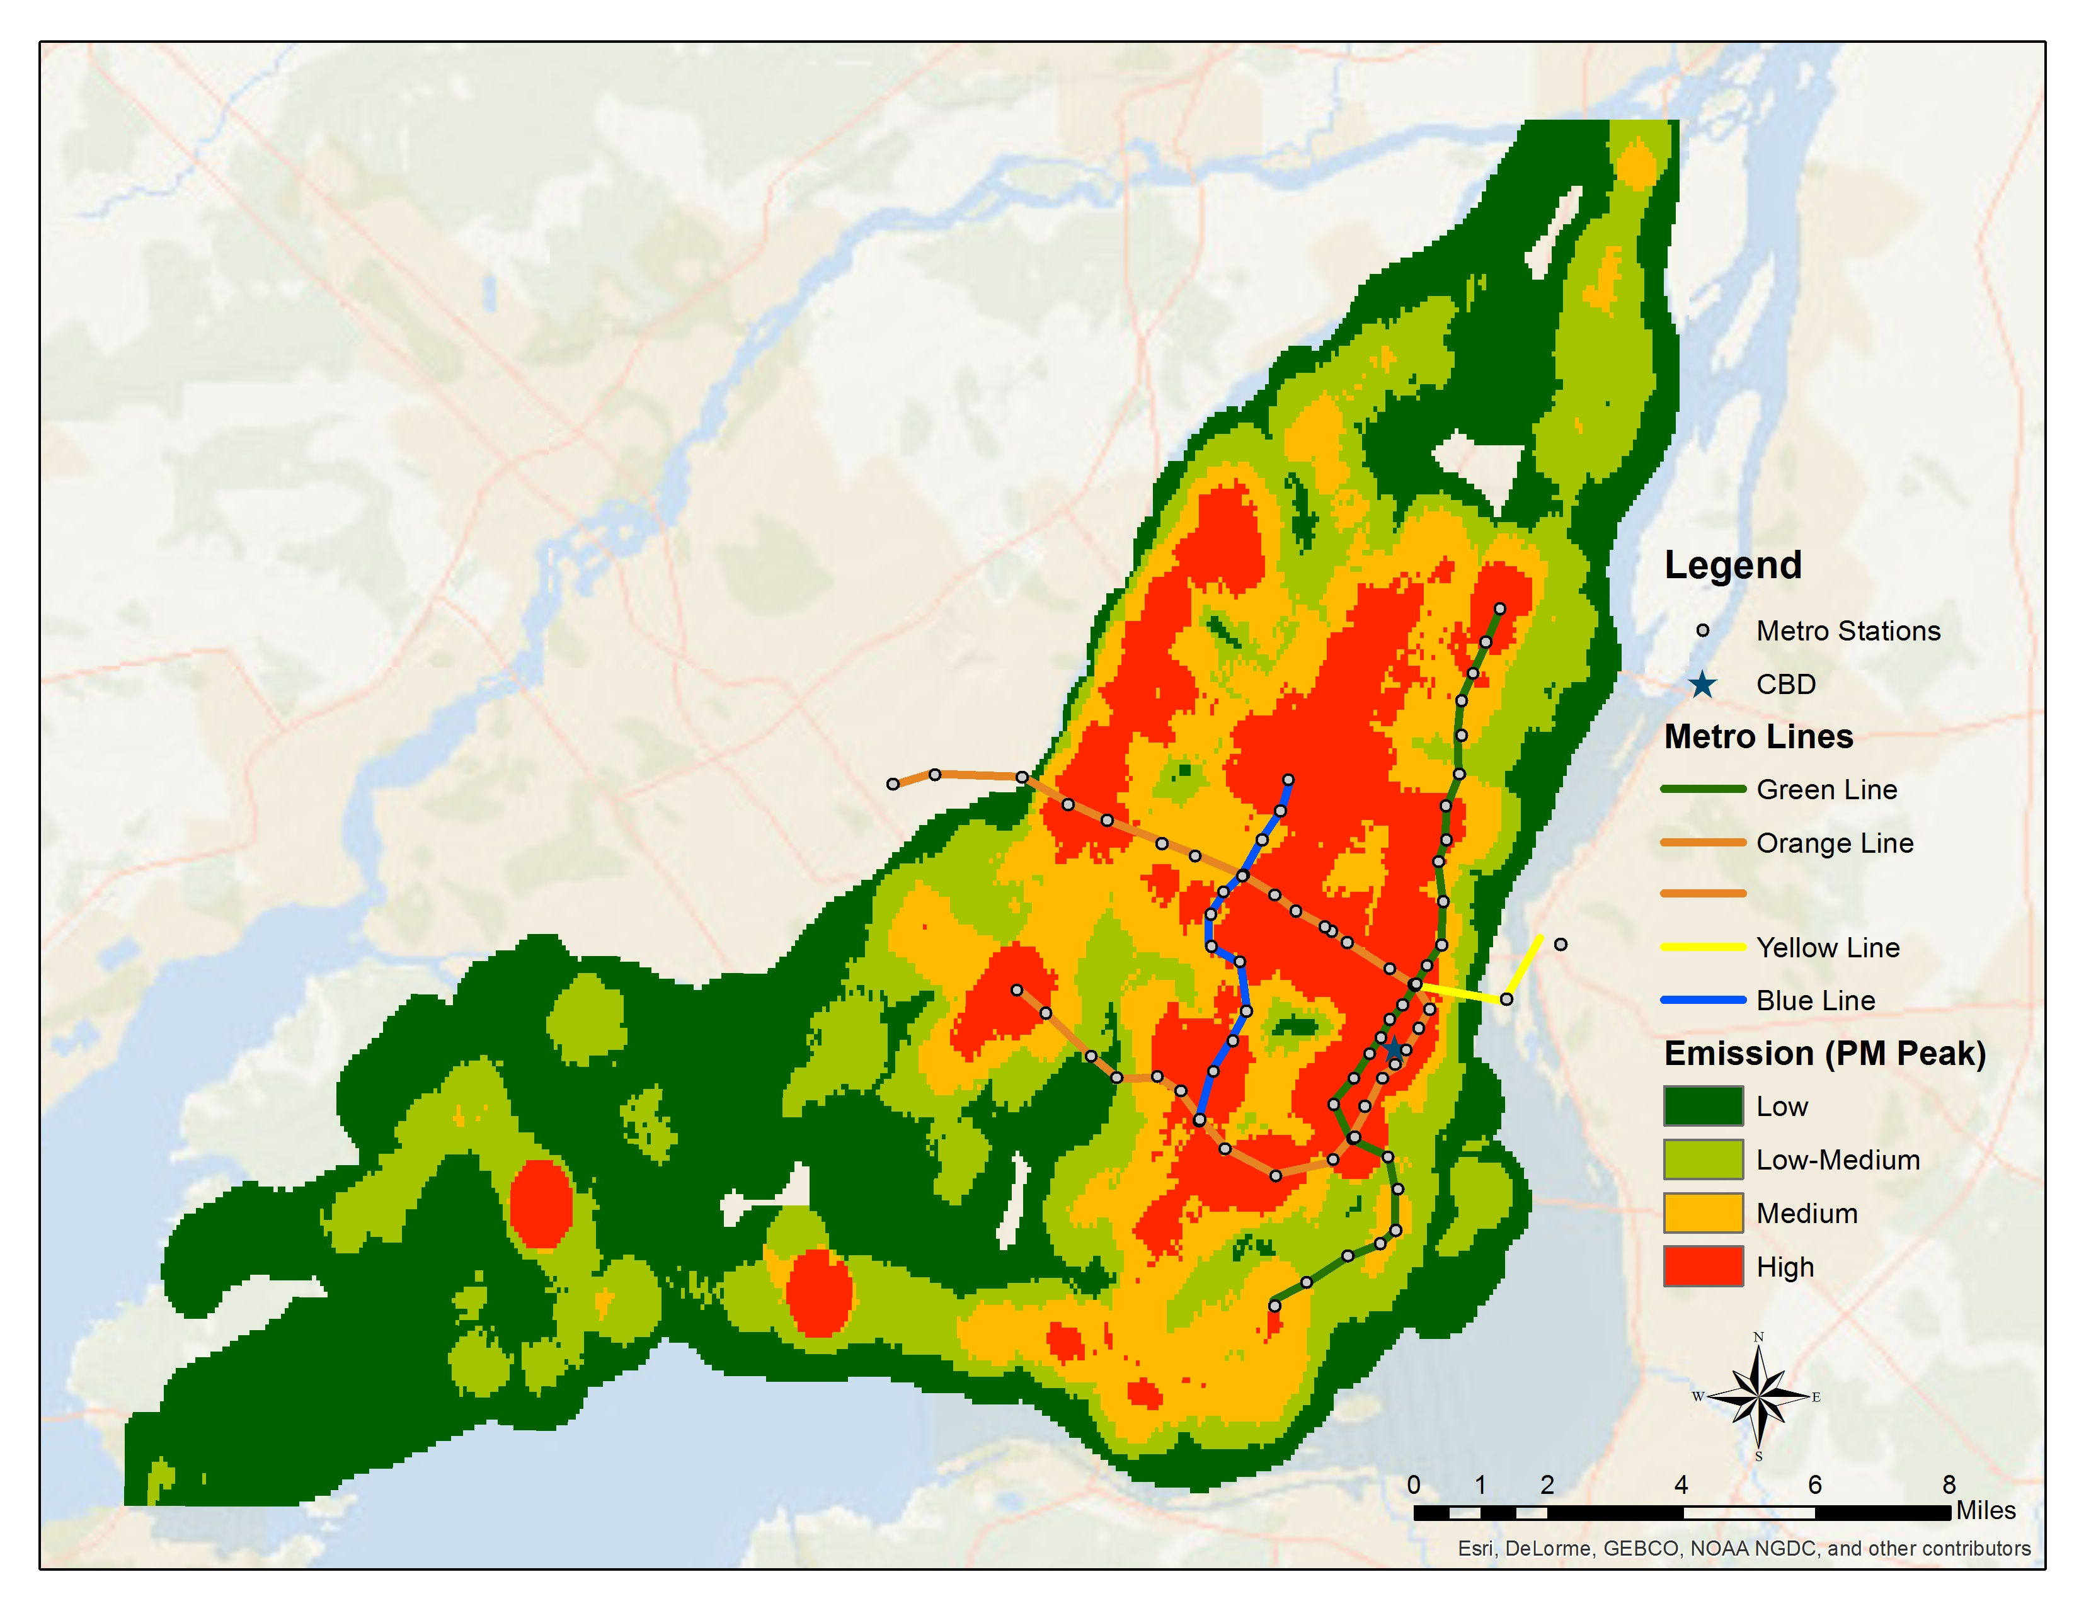

**FIGURE 3 Emissions for PM peak periods**

**FIGURE 4 Total distance, ridership and emissions categorized by time of day**

Note: OPD = Off peak day; OPN = Off peak night

**FIGURE 5 Emission indicators categorized by time of day**

Note: OPD = Off peak day; OPN = Off peak night

**TABLE 1 Comparison of emissions after increase in ridership**

|  |  |  |  |
| --- | --- | --- | --- |
| **Emission indicator** | **Before increase in ridership** | **After 20 % increase in ridership** | **%**  **change** |
| Total emissions for the day  (grams) | 316,369,839 | 319,877,769 | 1.109 |
| Average emissions per capita  (grams/person) | 301.94 | 263.57 | -12.708 |
| Average emissions per km  (grams/km) | 1487.87 | 1504.37 | 1.109 |
| Average Emissions per person per km  (grams/person km) | 99.89 | 84.27 | -15.637 |

**TABLE 2 Comparison of emissions after decrease/increase in frequency of buses**

|  |  |  |  |  |  |  |  |
| --- | --- | --- | --- | --- | --- | --- | --- |
| **Time period** | **No of buses** | **Average headway**  **(mm:ss)** | **Average trip time (mm:ss)** | **Trip distance (km)** | **Base case emissions**  **(grams)** | **Modified emissions**  **(grams)** | **%**  **change** |
| ***Scenario: Decrease in Frequency (50%)*** | | | | | | | |
| AM peak | 13 | 30:00 | 13:00 | 4.21 | 69,948.00 | 35,756.50 | -48.88% |
| ***Scenario: Increase in Frequency (25%)*** | | | | | | | |
| AM peak | 61 | 2:51 | 48:39 | 11.04 | 1,247,372 | 1,502,728 | 20.47% |
| Off peak day | 108 | 3:20 | 49:39 | 11.04 | 2,083,032 | 2,534,865 | 21.69% |
| PM peak | 58 | 3:03 | 50:50 | 11.04 | 1,249,973 | 1,510,724 | 20.86% |
| Off peak night | 85 | 14:45 | 42:25 | 11.04 | 1,596,376 | 1,947,754 | 22.01% |
| Total | 312 | - | - | - | 6,176,753 | 7,496,070 | 21.36% |

1. For example, consider that a stop with predicted hourly boarding of 100 has two routes A and B. Route A has a frequency of 4 buses per hour (or a headway of 15 minutes) and Route B has a frequency of 2 buses per hour (or a headway of 30 minutes). The ridership is allocated to these routes as follows: Route A = (100/6*4) = 66.67 and Route B = (100/6*2) = 33.33.
2. An *opmode* distribution provides the amount of time that the vehicle has spent under different opmode categories. Each opmode is characterized by the combination of vehicle specific power (VSP) and speed. VSP is defined as the engine power output per vehicle unit mass and indicates the tractive power needed to haul the vehicle. It is a function of instantaneous speed, acceleration, vehicle weight, and road grade as shown in equation 1.
3. ; where, $y_{i}$ is the *opmode* fraction of the drive cycle at *opmodeID $‘i’$* ; $ŷ_{i}$ is the *opmode* fraction of the median *opmode* distribution at *opmodeID $‘i’$* ; $‘i’$ is the *opmodeID,* and $n$ is the number of total *opmodeID* which is 23 as MOVES has a total of 23 *opmodes*.