**APPENDIX A: MARGINAL EFFECTS**

The parameters of the exogenous variables in the model estimation (Table 3) do not provide the magnitude of the influence of route choice probabilities. Hence, we undertake the estimation of marginal effects to understand the influence of the variables on route choice. In our approach, given we have unlabeled alternatives, we focus on marginal effects by modifying attributes associated with the chosen alternative. The approach to compute marginal effects is undertaken separately for continuous and indicator variables.

For continuous exogenous variables, we investigate the effect as percentage change in the probability of route alternative by increasing the explanatory variable by 10%. For indicator variables, we undertake the estimation by flipping the indicator variable (i.e. 0 becomes 1 or vice-versa) and appropriately accounting for the directionality of the change. The proposed approach is employed for RUM and RRM model systems. The results from the exercise are presented in Table 1.

Table 1 Comparison of Marginal Probabilities

|  |  |  |
| --- | --- | --- |
| **Variables** | **RUM-MNL** | **RRM-MNL** |
| Travel time | -13.46 | -13.72 |
| Delay | -1.86 | -2.01 |
| Travel Cost | -0.64 | -0.56 |
| Pre-trip* | 5.49 | 3.74 |
| Arterial* | 50.66 | 34.79 |
| En-route  Mobile* | 11.72 | 11.73 |
| En-route  Radio* | 17.23 | 8.82 |

* *Indicator variables*

From the marginal effect estimation, we observe that, in general, the two systems offer similar effects. In fact, as you would expect, all variables exhibit the same signs. In terms of magnitude, Pre-Trip indicator, arterial indicator and En-route Radio indicator variables present differences. Specifically, the RRM model system presents lower marginal effects for these variables.

**APPENDIX B:**

The VoT estimates for the different combinations of the 10th percentile value and 90th percentile value (based on the normal distribution) are presented. The VoT plots for expressways and arterials are presented in Figure 1 and Figure 2 respectively. Table 2 VoT distribution for Expressways and Table 3 present the variation of VoT by model system on expressways and arterials respectively.

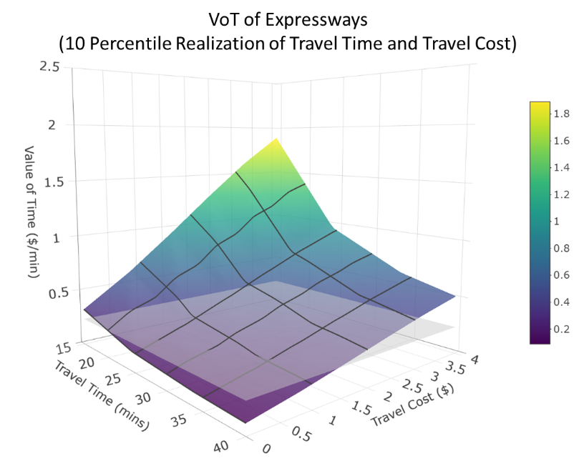 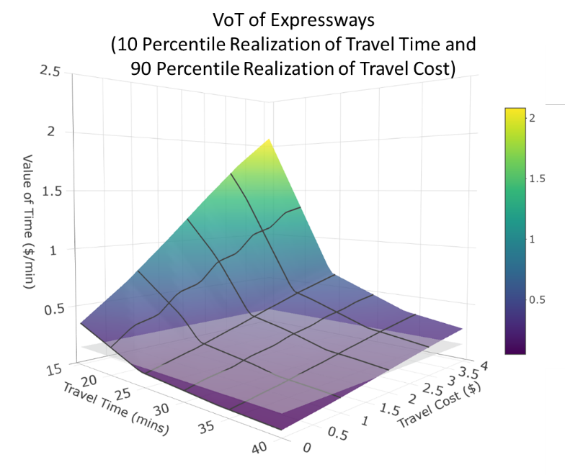

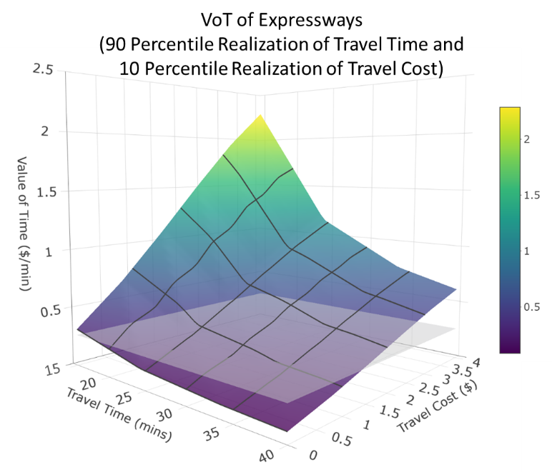 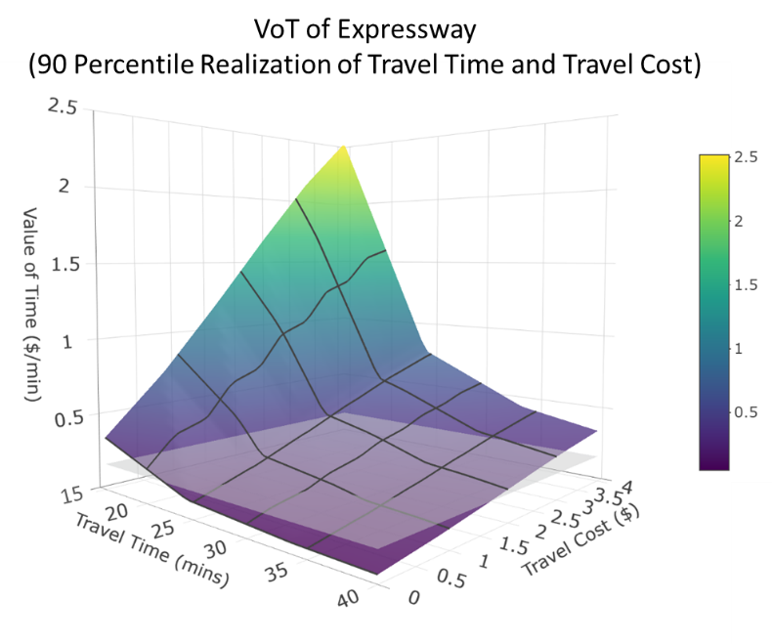

**Figure 1 Distribution of VoT for Expressway**

Table VoT distribution for Expressways

|  |  |  |  |  |
| --- | --- | --- | --- | --- |
| **Scenario** | | **Value of Time** | | |
| **Travel Time** | **Travel Cost** | **RUM-MNL** | **RRM-MNL** | |
| **Minimum** | **Maximum** |
| Mean Value | Mean value | 0.196 | 0.063 | 2.140 |
| 10th Percentile | 10th Percentile | 0.236 | 0.089 | 1.890 |
| 10th Percentile | 90th Percentile | 0.152 | 0.050 | 2.083 |
| 90th Percentile | 10th Percentile | 0.266 | 0.086 | 2.285 |
| 90th Percentile | 90th Percentile | 0.171 | 0.048 | 2.519 |

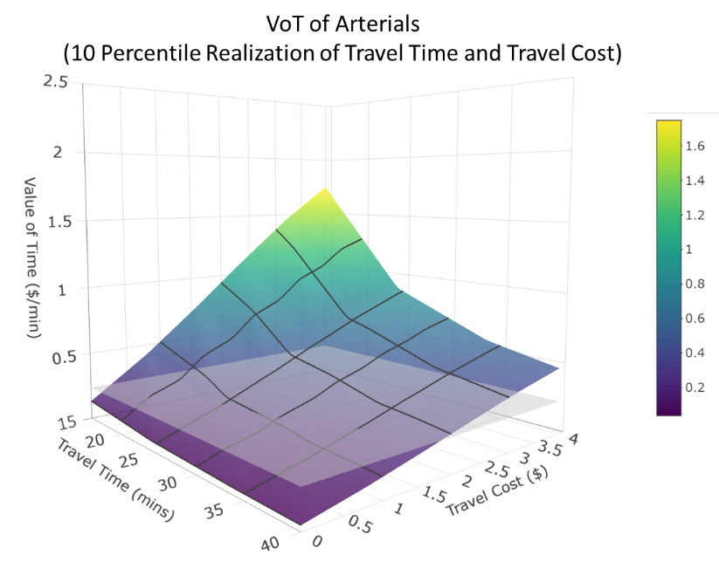 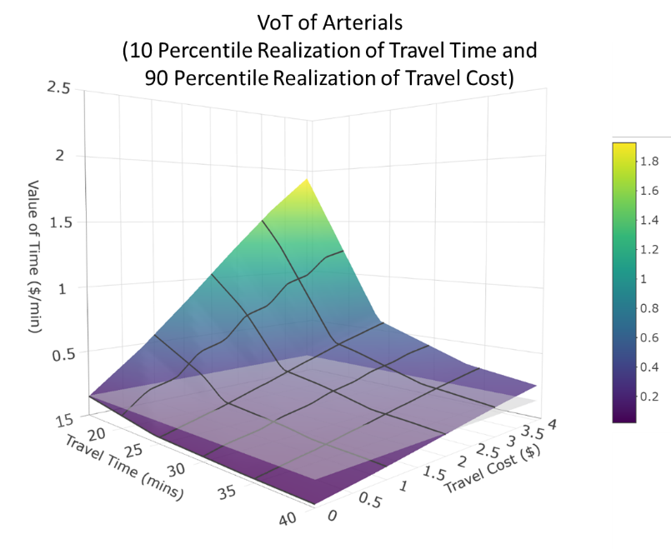

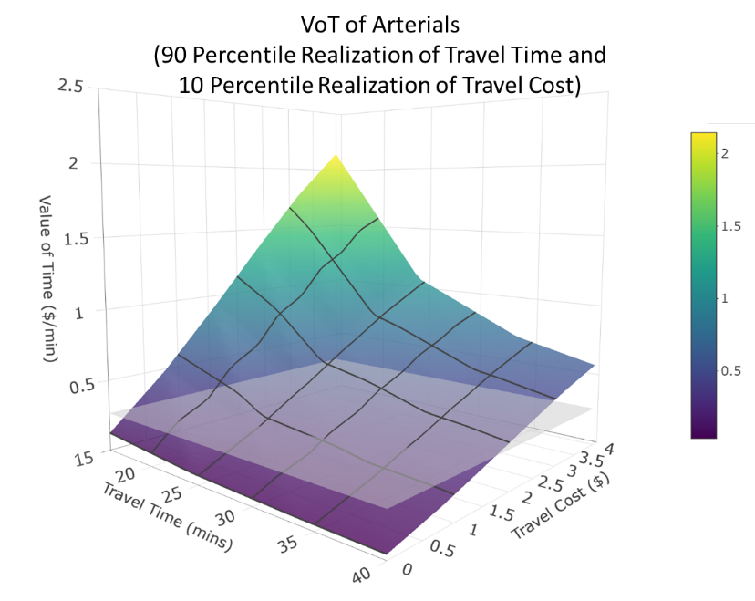 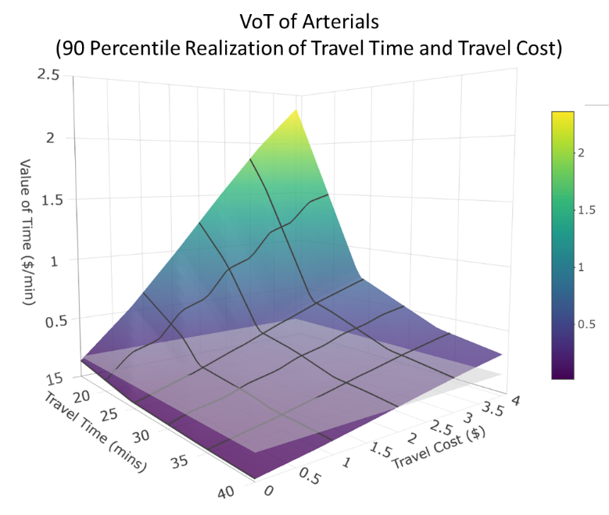

**Figure 2 Distribution of VoT for Arterials**

Table VoT distribution for Arterials

|  |  |  |  |  |
| --- | --- | --- | --- | --- |
| **Scenario** | | **Value of Time** | | |
| **Travel Time** | **Travel Cost** | **RUM-MNL** | **RRM-MNL** | |
| **Minimum** | **Maximum** |
| Mean Value | Mean value | 0.196 | 0.025 | 1.995 |
| 10th Percentile | 10th Percentile | 0.236 | 0.036 | 1.748 |
| 10th Percentile | 90th Percentile | 0.152 | 0.020 | 1.927 |
| 90th Percentile | 10th Percentile | 0.266 | 0.034 | 2.144 |
| 90th Percentile | 90th Percentile | 0.171 | 0.019 | 2.363 |

**APPENDIX C:**

Latent class multinomial logit model with hybrid segments (LCMHS) is tested as an extension to the research effort to test the combination of decision rules with two classes (1 random utility based segment and 1 random regret based segment). The modeling framework is similar to the mathematical framework used by Dey et al 2018. The population share of the two segments are 37% and 63% for the RRM and RUM segments respectively. The model estimates are presented Table 7.

Table 7 Results of LCMHS with two segments (1 RUM based segment and 1 RRM based segment)

|  |  |  |  |
| --- | --- | --- | --- |
| **Attribute Category** | **Variables** | **RRM Segment** | **RUM Segment** |
| **Latent Segmentation** | | | |
| Constant | | -- | 0.517 (3.211) |
| Demographic characteristics | Education: Highschool and college | -- | -0.342 (-2.684) |
| Driving experience: Less than 5 years | -- | 0.521 (3.671) |
| **Route Choice Component** | | | |
| Trip characteristics | Travel Time | -0.165 (-10.707) | -0.207 (-14.002) |
| *Roadway type: Arterial* | 0.031 (3.073) | 0.059 (3.579) |
| *Expressway frequency: every day* | 0.066 (4.071) | -0.103 (-8.711) |
| Delay | -0.211 (-8.569) | -0.067 (-5.892) |
| *Expressway frequency: every day* | 0.071 (2.733) | -0.077 (-3.825) |
| Travel cost | -0.582 (-4.935) | -0.724 (-6.69) |
| *Expressway frequency: every day* | -- | 0.678 (4.409) |
| *Traffic information: pre-trip* | -- | 0.394 (4.329) |
| Roadway type | Arterial | -1.613 (-5.141) | 1.892 (4.244) |
| Availability of traffic information | Pretrip | -0.170 (-1.692) | 0.408 (3.688) |
| Enroute - Mobile | -- | 0.693 (5.318) |
| Enroute - Radio | -- | 0.932 (5.968) |
| **Log-Likelihood** | | **-3876.82** | |

*Latent segmentation component:* The positive sign of the constant reflects a larger likelihood of road users in the RUM segment than the RRM segment. Various demographic characteristics like age, gender, employment status, education status and driving experience are used to segment the sample between the two groups. Only age and driving experience have shown to have significant impact on segmenting the sample, while the others were insignificant. RUM segment is less likely to be comprised of young drivers between the age groups of 18 to 24 and with a driving experience less than 5 years.

*Route choice component:* The exogeneous variables in the panel Mixed RUM-MNL and panel Mixed RRM-MNL specification are used to study the route choice behavior at segment level. From the segment level estimates, it is evident that the variable impacts are significantly different indicating the presence of population heterogeneity. The probability of choosing a route decreases with travel time, delay and cost for both the segments. In both the segments, individuals are willing to lower their sensitivity towards travel time on arterial roads i.e. users are willing to travel slightly longer on arterials relative to expressways. Daily expressway users are more sensitive to delay, but the effect on the segments is opposite. The daily expressway users in RUM segment prefer lower delay routes, while the RRM segments are indifferent to it. Daily expressway users and the individuals with pre-trip information in the RUM segment are less sensitive to travel cost. The arterial roads are preferred over expressways by the RUM segment population, while the RRM segment population are less likely to prefer arterial roads. The pre-trip traffic information has a positive impact on route choice for the RUM segment population while it negatively impacts the RRM segment individuals. Provision of traffic information through mobile and radio while making the trip, positively affect the RUM segment population.

**REFERENCES**

Dey, B.K., Anowar, S., Eluru, N. and Hatzopoulou, M., 2018. Accommodating exogenous variable and decision rule heterogeneity in discrete choice models: Application to bicyclist route choice. PloS one, 13(11), p.e0208309.