**Evaluating the Influence of Information Provision (When and How) on Route Choice Preferences of Road Users in Greater Orlando: Application of a Regret Minimization Approach**

**Naveen Chandra Iraganaboina\***

Graduate Student

Department of Civil, Environmental & Construction Engineering, University of Central Florida

Tel: 321-295-2134; Email: [naveen.chandra@knights.ucf.edu](mailto:naveen.chandra@knights.ucf.edu)

ORCiD number: 0000-0002-1425-6897

**Tanmoy Bhowmik**

Post-Doctoral Scholar

Department of Civil, Environmental & Construction Engineering, University of Central Florida

Tel: 407-927-6574; Fax: 1-407-823-3315; Email:[tanmoy78@knights.ucf.edu](mailto:tanmoy78@knights.ucf.edu)

ORCiD number: 0000-0002-0258-1692

**Shamsunnahar Yasmin**

Research Fellow, Centre for Accident Research and Road Safety – Queensland

Queensland University of Technology, Australia

Tel: +61731384677; Fax: +61731387532; Email: [shams.yasmin@](mailto:shams.yasmin@)qut.edu.au

ORCiD number: 0000-0001-7856-5376

**Naveen Eluru**

Professor

Department of Civil, Environmental & Construction Engineering, University of Central Florida

Tel: 407-823-4815; Fax: 407-823-3315; Email: [naveen.eluru@ucf.edu](mailto:naveen.eluru@ucf.edu)

ORCiD number: 0000-0003-1221-4113

**Mohamed A. Abdel-Aty**

Professor

Department of Civil, Environmental & Construction Engineering, University of Central Florida

Tel: 407-823-4535; Fax: 407-823-3315; Email: [m.aty@ucf.edu](mailto:m.aty@ucf.edu)

ORCiD number: 0000-0002-4838-1573

**Declarations of Interest:** None

*Corresponding author

**abstract**

With the advancement in traffic management systems and improving accessibility to traffic information through various sources such as mobile apps, radio, variable message sign; road users tend to choose their route based on a complex interaction of various attributes including travel time, delay, travel cost and information provision mechanisms. While earlier research has examined route choice preferences in relation to travel time and travel cost (or toll), there is little guidance on the influence of information provision mechanisms. By accommodating for information provision attributes, the proposed research contributes to our understanding of the design of an active traffic management (ATM) system by quantitatively estimating the inherent trade-offs across the various attributes affecting route choice. Specifically, the research designs and elicits data using a web-based stated preference (SP) survey to understand road users’ preferencesin the Greater Orlando Region, USA. In the empirical analysis, the data compiled is utilized to develop random utility maximization and random regret minimization based panel mixed multinomial logit models. Route choice behavior is modeled using a comprehensive set of exogenous variables including trip characteristics, roadway characteristics and traffic information characteristics. The model results are utilized to conduct a comprehensive trade-off analysis across various attributes for the two model frameworks. In this research effort, we also customize the trade-off computation for regret minimization model for accommodating variable interactions. The trade-offs results provide useful insights on travel information provision (when and how).

**Keywords:** Route choice; Integrated active traffic management; Stated Preference; Regret Minimization;

**Highlights:**

* Stated preference (SP) survey to understand route choice preferences in Greater Orlando Region
* Random utility maximization and random regret minimization based mixed multinomial logit models are compared
* Regret frameworks offered improved fit
* Trade-offs associated with travel information provision (when and how) are estimated

# INTRODUCTION

In developed countries such as the United States, a significant number of individuals depend on the automobile as the main mode of transportation. The high auto dependency, in turn, results in high auto travel demand on the roadways. At the same time, the ability to build additional infrastructure is limited by high capital costs, real-estate constraints and environmental considerations. The net result has been that traffic congestion levels in metropolitan areas have risen substantially over the past decade. Specifically, the economic costs of traffic congestion – direct costs (time and fuel wastage) and indirect costs (increase in transportation costs) – amount to nearly 305 billion dollars in 2017 (INRIX, 2018). The annual economic costs add up to nearly $3000 per resident in large urban regions such as Los Angeles and New York City. While the scale of the congestion impact across urban and rural regions is different, congestion does affect all regions significantly. The impact of congestion is also not restricted to the peak hour. An analysis of temporal profile of the delays across the nation has found that 41 percent of these events occur outside the peak hours (in midday and overnight times) (Schrank et al., 2015).

Traffic congestion can generally be attributed to either recurring or non-recurring events. Congestion arising from recurring events is generally a result of mismatched transportation demand and supply (or capacity). Non-recurring congestion, on the other hand, is a result of unexpected (or irregular) events such as abandoned vehicles, adverse weather, spilled loads, highway debris, and traffic crashes. The potential solutions for recurring and non-recurring congestion are typically distinct. Traditional approaches for alleviating recurring congestion focus on the longer horizon solutions that employ travel demand strategies to reduce transportation demand by altering dimensions such as transportation mode and departure time. On the other hand, to alleviate non-recurring congestion solution approaches focus on shorter time horizons and rely on active traffic management systems that provide information on the event and potential alternative routes to the road users. For example, there is evidence to indicate that provision of real time traffic information such as incident reporting and peak hour congestion encourages road users to choose alternate routes (Zhang et al., 2014, Khoo and Asitha, 2016, Gan and Ye, 2014).

In recent years, a bridge between solutions for recurring and non-recurring congestion has been established through advances in technology for real-time data collection and advent of real-time congestion pricing within an integrated active traffic management system. In these systems, road users are provided information on travel time and cost information associated with various route alternatives. A requisite component of such a system is the evaluation of the influence of user preferences for selecting alternative routes. These preferences include facility preferences (such as arterial versus freeway), pricing trade-off (toll versus no-toll), travel time (mean and potential delay), travel time reliability, time of information provision (prior to trip start, on route) and mechanism for information provision (online, mobile app or social media). While earlier research has examined route choice preferences in relation to travel time and travel cost (or toll) there is little guidance on when and how information provision is undertaken. By accommodating for information provision attributes, the proposed research contributes to our understanding of the design of an active traffic management (ATM) system by quantitatively estimating the inherent trade-offs across the various attributes affecting route choice. The research designed and elicited data using a stated preference (SP) survey to understand road users’ preferences. The data from the SP survey is analyzed to understand how various attributes affect individual route choice behavior.

The proposed research augments earlier work by incorporating alternative decision rules for analyzing route choice behavior. In modeling route choice, the prevalent decision rule for developing discrete choice models is the random utility maximization (RUM) approach. RUM based approaches assume that decision makers prefer routes that provide the highest utility or satisfaction (Ben-Akiva et al., 1985, Train, 2009, McFadden, 1974). The approach allows for the consideration of trade-offs across various attributes affecting the choice process. This implicit compensatory nature of the formulation allows for a poor performance on an attribute to be compensated by a positive performance on another attribute (Chorus et al., 2008). Several researchers, motivated by research in behavioral economics, have considered alternative decision rules for developing discrete choice models such as relative advantage maximization (Leong and Hensher, 2015), contextual concavity (Kivetz et al., 2004), fully-compensatory decision making (Arentze and Timmermans, 2007, Swait, 2001), prospect theory (PT) (Kahneman and Tversky, 2013, Tversky and Kahneman, 1992), and random regret minimization (RRM) (Chorus et al., 2008, Chorus, 2010). Among these approaches, we select the regret minimization approach for our route choice analysis due to its mathematical simplicity within a semi-compensatory decision framework. We compare the performance of RUM based multinomial logit (MNL) and random regret minimization (RRM) based MNL models. The reader would note that the SP data elicitation exercise involves multiple responses from each individual. Hence, the research employs a panel mixed modeling approach that accommodates for the influence of common unobserved factors on respondent choice process. Furthermore, we also conduct a comprehensive trade-off analysis to highlight the differences across the two model approaches. The trade-off analysis will provide useful insights for ATM system operators.

The remaining document is organized as follows: Section 2 focuses on earlier research and positions the current work. Section 3 presents the materials and methods used in the research, including details of the route choice survey conducted in the Greater Orlando region and the mathematical modeling framework. Section 4 discusses model results that provides insights on route choice decision process. Trade-off analysis is presented in Section 5. Lastly, Section 6 summarizes the work and provides concluding comments.

# EARLIER RESEARCH AND CURRENT STUDY IN CONTEXT

Given the prevalence of traffic management strategies to enhance transportation systems, it is not surprising that the several research efforts have studied route choice decision processes. Studies examined decision processes across road users (motorists, non-motorists, and public transportation), travel purpose (commute versus discretionary trips), pricing, message content, message dissemination platforms (such as message signs, online or mobile) and message delivery time (such as before the trip and on route). An exhaustive review of earlier research on the topic is beyond the scope of our paper. Hence, we narrow our literature review based on the following parameters relevant to our research: (1) studies focused on motorist travel behavior, (2) studies developing quantitative models for understanding route choice processes using survey data (3) studies conducted recently (2005 and after) and (4) studies focused on route choice behavior based on route attribute summary[1]. Based on these parameters, the relevant literature is summarized in Table 1.

Table 1 Literature Review Matrix

| **Study** | **Survey type** | **Area** | **Target** | **Type of users** | **Type of facility** | **Attributes considered** | **Methodological approach** |
| --- | --- | --- | --- | --- | --- | --- | --- |
| (Chorus et al., 2007) | SP  (Likert Scale) | Netherland | Examine travelers’ need for traffic information | General population | Any road | * Socio-economic characteristics * Current travel behavior * Traffic information * Service of travel information * Mode of traffic information | Structural equation modeling (SEM) |
| (Zhang et al., 2014) | SP | Central Texas | Effect of traffic information on toll road usage | Commuters | Freeway (toll road) | * Traffic information * Current travel behavior * Socio-economic characteristics | Nested and multinomial logit model |
| (Khoo and Asitha, 2016) | SP | Klang Valley region of Malaysia | Evaluate effect of traffic app on driver’s route choice behavior | General population | Arterial and Freeway | * Perceived traffic information accuracy * Traffic information * Real time rerouting advice * Incident and delay estimation * Navigation & service subscription | Bivariate probit models |
| (Gan and Ye, 2014) | SP | Shanghai Pudong international airport. | Examine motorist’s diversion decision behavior under VMS** | General population | Freeway | * Socio-economic Characteristics * Diversion decision under VMS | Cross sectional logit model and Mixed logit model |
| (Petrella et al., 2014) | SP | US-75 corridor in Dallas, Texas; I-15 corridor in San Diego, California | Explore travelers’ response to real time traffic and traveler information | Commuters | Freeway | * Socio-economic characteristics * Level of satisfaction with trip * Level of traffic congestion * Predicted trip time * Overall driving time * Traffic information | Descriptive analysis |
| (Tseng et al., 2013) | RP | Dutch A12 motorway corridor | Effect of traffic information on traveler behavior | Commuters | Freeway | * Expected travel time * Time difference * Delay * Weather | Mixed logit model |
| (Javid et al., 2013) | RP | Lahore, Pakistan | Effect of radio on traveler route choice behavior | Commuters | Any road | * Socio-economic characteristics * Trip characteristics * Tendency to listen radio * Performance service attribute of radio | Structural equation modeling (SEM) |
| (Bagloee et al., 2014) | RP | Tehran, Iran | Examine drivers’ response to radio (traffic information) | Commuters | Any road | * Socio-economic characteristics * Work-related information * Driver behavior information * Traffic information (radio) | Neural network model, Ordered probit and Binary logit model |
| (Choocharukul, 2008) | SP and RP | Bangkok, Thailand | Explore the contributing factors for drivers’ route diversion | General population | Intersection | * Traffic delay * Socio-economic Characteristics * Trip characteristics * VMS | Structural equation modeling (SEM) |
| (Meng et al., 2017) | SP and RP | Northern and Eastern side of Singapore | Examine the travel behavior of commuter motorists | Commuters | Any road | * Socio-economic characteristics * Trip characteristics * Traffic delay and cost | Binary logit model |
| (Al-Deek et al., 2009) | SP and RP | Orlando | Analyze the effect of VMS on route choice | Commuters | Freeway and Expressways (Toll roads) | * Socio-economic characteristics * Trip Characteristics * Traffic Information | Binary Logit Model |
| (Ardeshiri et al., 2015) | SP and Driving simulator | Baltimore metro area | Analyze driver response behavior under real-time route guidance through VMS | General population | Expressways and local arterial | * Socio-economic characteristics * VMS & Traffic information | Ordinal logistic regression |
| (Ben-Elia et al., 2008) | SP | Hypothetical routes | Analyze the effect of traffic information on route choice | General population | Not specified | * Traffic information | Linear mixed model |
| (Lee et al., 2010) | Likert Scale (SP) | Wisconsin | Analyze the effect of VMS on route choice | General population | Interstate Highway network | * Prior knowledge of the routes (Likert scale) | Logistic regression trees with unbiased selection (LOTUS) |
| (Gan and Ye, 2012) | SP | Shanghai, China | Study route diversion response to VMS | General population | Freeway and Local roads | * Socio-economic characteristics * Trip characteristics | Binary probit model |
| (Gan and Ye, 2014) | SP | Shanghai, China | Study route diversion response to VMS | General population | Freeway and Local roads | * Socio-economic characteristics * Trip characteristics | Multinomial logit (MNL) and Mixed MNL |
| (Gan et al., 2013) | SP | Shanghai, China | Study route diversion response to travel time | General population | Freeway and Local roads | * Socio-economic characteristics * Trip characteristics | Generalized estimation equations (GEEs) with logit link function |
| (Gan and Chen, 2013) | SP | Shanghai, China | Study route choice to Graphical Route Information Panel (GRIP) | General population | Freeway and Local roads | * Socio-economic characteristics * Trip characteristics | Binary logit model |
| (Kusakabe et al., 2012) | SP | Japan | Study route diversion response to incident information VMS | General population | Expressway and Arterial | * Traffic information | Multinomial logit (MNL) |
| (Majumder et al., 2013) | SP | Calgary, Canada | Study driver response to VMS | Commuter | Expressway and Arterials | * Socio-economic characteristics * Network familiarity * Information access * Trip characteristics | Generalized ordered logit (GOL) |
| (Moghaddam et al., 2019) | SP and Driving simulator | Maryland | Role of travel time reliability on route choice | General population | Expressway and Arterials | * Socio-economic characteristics * Trip characteristics | Binary probit, Binary logistic regression and Multinomial logistic regression |
| (Peeta and Ramos, 2006) | SP | Indiana | Driver response to traffic information through VMS | General population | Expressway | * Socio-economic characteristics * Trip characteristics | Binary logit model |
| (Poulopoulou et al., 2015) | SP | Athens | Driver response to incident information through VMS | Taxis and Trucks | Expressway | * Socio-economic characteristics * Trip characteristics | Ordered probit model with random effects |
| (Song et al., 2017) | Driving simulator | Indiana | Effect of real time information on route choice | General population | Expressway and arterials | * Socio-economic characteristics * Trip characteristics | Binary logit model and Hybrid choice model with latent variables |
| (Wang et al., 2017) | SP | China | Driver route choice behavior | General population | All roads | * Socio-economic characteristics * Trip characteristics | Binary probit model |
| (Zhao et al., 2019) | RP and SP | China | Driver response to incident information through VMS | General population | Expressway and arterials | * Socio-economic characteristics * Trip characteristics * Road information | Multinomial logit model |

*\* Note: ATIS (Advanced Traveler Information System)*

*\*\* Note: VMS (Variable Message Sign)*

The table provides information on the study, type of survey conducted, study location, objective of the study, type of roadway facilities, independent attributes considered, and the modeling framework employed. Several observations can be made from Table 1. *First*, three approaches of survey data collection are observed including (a) SP Survey - a choice set with the exhaustive choices, attributes and combinations are provided to the respondent mimicking a real world scenario (b) Revealed Preference (RP) Survey -- the respondent reveals the choice along with the attributes associated with the chosen alternative (non-chosen alternatives and their attributes are usually inferred by analysts) and (c) a joint RP and SP survey – a survey approach that elicits both revealed and stated preferences of respondents. *Second*, the geographical extent of the research covers various countries including Netherlands, Malaysia, China, USA, Ireland, Pakistan, Iran, Switzerland, Thailand, Singapore, Canada and Japan. *Third*, the attributes considered cover the following categories: trip characteristics, individual and household socio-demographics, roadway type, and traffic information (media and accessibility). *Fourth*, methodologies considered in these studies vary from simple analysis of variance (ANOVA) approaches to modeling approaches such as multinomial logit, ordered logit and structural equation modeling techniques. Among advanced econometric approaches, researches have employed nested logit and panel mixed multinomial logit models. More recently, studies have also employed machine learning models including Artificial Neural Networks (ANNs). From literature search, it is observed that only few studies emphasized on importance of accessibility of traffic information, most importantly on the stage of availability of traffic information (like pre-trip and en-route) (Zhang et al., 2014, Khoo and Asitha, 2016). Some studies have exclusively studied traffic information provision through one media mode such as radio (Javid et al., 2013, Bagloee et al., 2014), variable message sign (VMS) (Gan and Ye, 2014, Al-Deek et al., 2009, Ardeshiri et al., 2015, Lee et al., 2010, Gan and Ye, 2012), mobile apps (Skelley et al., 2013, Khoo and Asitha, 2016, Song et al., 2017) and other sources (Gan and Chen, 2013).

It is evident from the literature review that substantial research has been conducted to examine the relationship between various attributes and route choice decision processes. However, several questions about route choice decision processes remain unanswered. First, while multiple studies have conducted route choice analysis, the trade-off between travel attributes (such as travel time and delay) and information provision strategies (such as how and when to provide information) are not well understood. Second, while these studies stressed the role of information provision media to be adopted, the interactions for information provision (when and how) with other attributes is not well explored (Zhang et al., 2014). Specifically, important attributes such as availability of traffic information (available or not and the stage of availability like pre-trip or en-route) and media to access traffic information (mobile apps, radio and VMS) and their interaction with other attributes are not considered in the analysis process. Third, among commonly employed quantitative route choice models, there is an inherent preference for adopting the RUM based MNL model for analysis. While the traditional MNL model provides useful insights, the emergence of semi-compensatory modeling approaches such as RRM based MNL model might offer improved insights on route choice decision processes. Finally, earlier research on regret minimization approaches developed trade-off measures with only main effects. In our route choice model, several interaction effects are considered along with the main effects. Hence, we customized the trade-off computation for regret minimization models to accommodate for these interactions. The proposed research conducted a SP survey-based data elicitation of route choice preferences in the Greater Orlando Region.

# MATERIALS AND METHODS

The city of Orlando, also known as “The City Beautiful” and “The Theme Park Capital of the World” has a metropolitan population of 2 million according to 2018 census (US-DOC, 2018). Orlando city, ranks 23rd in traffic congestion within the US with the annual monetary cost of congestion amounting to nearly a thousand dollars per road user (INRIX, 2018). Greater Orlando region has a roadway system with a number of tolled expressways (SR 408, SR 414, SR417, SR 429 and SR 528), arterials and the interstate freeway (I-4).

## Route Choice Survey

In order to study the factors effecting the route choice in Greater Orlando Region, a survey is designed and disseminated to potential drivers in the Greater Orlando region. Our survey focuses on obtaining responses from road users along three different dimensions. These are:

1. Demographic information (including gender, age, education level, employment type, years of driving experience and car availability),
2. Trip level information (including use of expressway, smartphone owner, current mode of accessing traffic information and preferred mode of accessing traffic information), and
3. Hypothetical route choice scenarios (series of route scenarios for respondents).

Among the aforementioned dimensions, first two sections record direct responses to the questions related to the respondent demographics and trip characteristics. The major focus of the survey design was on implementing an appropriate experimental design for generating the hypothetical route choice scenarios. In an effort to develop a customized survey experience for respondents, we developed route choice scenarios for the respondent’s home location and their most commonly used destination (possibly work or other). To reduce the privacy burden on respondents, the location information was compiled at the zip code level. Based on the information provided, customized Google Maps based route alternatives were generated with detailed information on the various route alternatives provided pictorially. The customized images were only generated for a sample of origin-destination zip code pairs. For respondents outside these zip code pairs, a non-pictorial version of the survey was designed. Prior to the experimental design exercise, an important step in SP survey design includes identifying and defining, clearly and adequately, the attributes that characterize the available alternatives of the choice context (Hensher, 1994, de Dios Ortúzar and Rodrı́guez, 2002, Anowar et al., 2017). The attributes that are adopted in our study are roadway type, travel time, added delay, availability of traffic information, media for accessing traffic information and toll cost. A detailed description of these attributes along with the various levels considered for the SP design are presented in Table 2. The reader would note that there are differences in the attributes used in the pictorial and non-pictorial scenario. In the pictorial version, the route was not labelled as predominantly arterial or expressway as the respondent is likely to decipher this information from the figure. Second, the travel time information in the pictorial choice scenario is based on the actual travel times[2] for each route with additions/subtractions as defined. For the non-pictorial version, we have two defined travel time attribute levels shown in the table determined randomly for each respondent.

Table 2 Attribute Levels for Route Choice Scenarios

| **Attribute** | **Definition** | **Attribute levels for identified ZIP codes** | **Attribute levels for unidentified ZIP codes** |
| --- | --- | --- | --- |
| **Roadway types** | **Roadway types** refers to the class of roadway. | These are not provided in the attributes list, but a graphical representation of the route is provided | **2 attribute levels defined as** |
| 1.     Arterial (25 to 55 mph) |
| 2.     Expressway (>55mph) |
| **Travel time (minutes)** | **Travel time** refers to the time that you are likely to observe while travelling from your trip origin to trip destination. | **6 attribute levels defined as** | **6 attribute levels defined as (Expressway/Arterial)** |
| 1.     Travel time extracted from Google map – 6 | 1.     15/20 |
| 2.     Travel time extracted from Google map – 3 | 2.     20/25 |
| 3.     Travel time extracted from Google map | 3.     25/30 |
| 4.     Travel time extracted from Google map + 3 | 4.     30/35 |
| 5.     Travel time extracted from Google map + 6 | 5.     35/40 |
| **Added delay** **(minutes)** | **Added delay** refers to the additional time required to travel from your trip origin to trip destination if there were congestion due to heavy traffic or some other incidents (such as a crash). | **4 attribute levels defined as** | **4 attribute levels defined as** |
| 1.     0 | 1.     0 |
| 2.     3 | 2.     3 |
| 3.     6 | 3.     6 |
| 4.     10 | 4.     10 |
| **Availability of traffic information** | **Availability of traffic information** refers to the stage of traffic information. | **3 attribute levels defined as** | **3 attribute levels defined as** |
| 1.     None | 1.     None |
| 2.     Pre-trip | 2.     Pre-trip |
| 3.     En-route | 3.     En-route |
| **Media for accessing traffic information** | **Media for accessing traffic information** refers to the media sources available for traffic information. | **4 attribute levels defined as** | **4 attribute levels defined as** |
| 1.     None | 1.     None |
| 2.     Mobile app | 2.     Mobile app |
| 3.     Twitter | 3.     Twitter |
| 4.     Radio | 4.     Radio |
| **Toll cost ($)** | **Toll cost** refers to the charge payable for permission to use a road. | **4 attribute levels defined as** | **4 attribute levels defined as** |
| 1.     0 | 1.     0 |
| 2.     1.5 | 2.     1.5 |
| 3.     3 | 3.     3 |
| 4.     4 | 4.     4 |

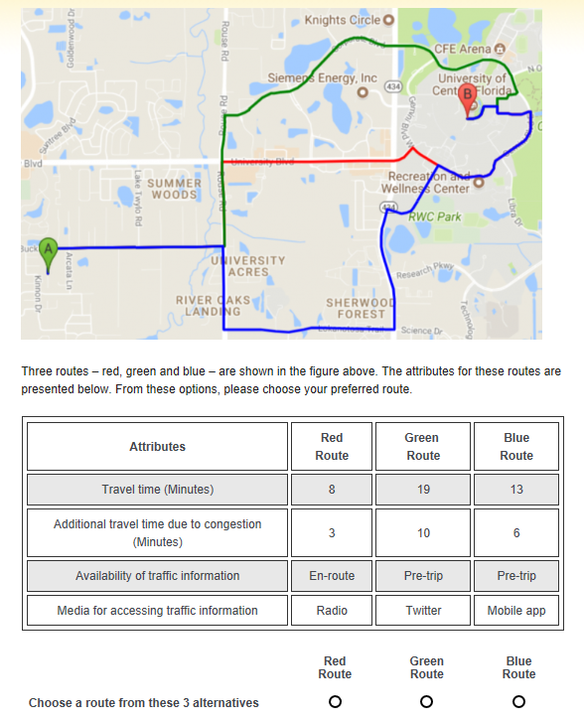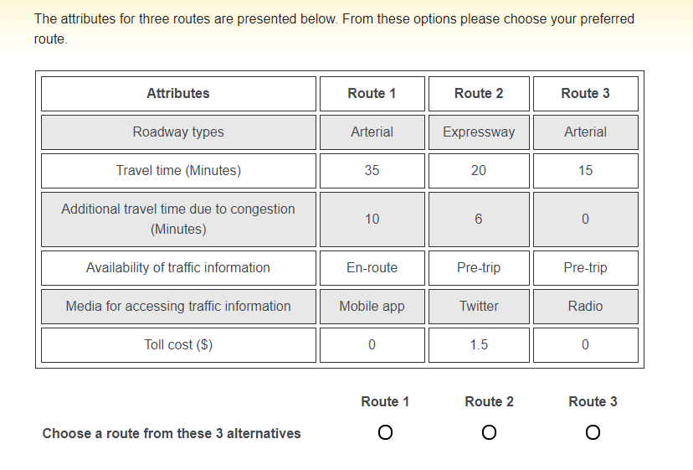

**(a) For OD pairs in selected zip codes (b) For OD pairs outside selected zip codes**

Figure 1 Sample Scenario for SP section

Within each choice question, three alternative routes (with different levels of the five (identified ZIP codes)/six (unidentified ZIP codes) route attributes selected) were presented, and the respondent was asked to make a choice among the alternatives presented. The consideration of 3 scenarios in the SP design is very common in transportation and SP route choice analysis (see Anowar et al., 2017, Sener et al., 2009). We used the experimental design routines in SAS (fractional factorial design) to develop the route choice alternatives in each scenario presented to the respondents. The design was checked to ensure that the attribute levels of the alternatives did not create dominating alternatives. The survey experiments for the pictorial and non-pictorial cases are presented in Figure 1. As the pictorial version of the survey provides route alternatives familiar to the respondent, it is expected to be less burdensome. Hence, these respondents were provided 6 choice scenarios while the non-pictorial version respondents were provided 5 choice experiments.

The survey was designed online using a combination of JavaScript and Java programs. It was then coded on the University of Central Florida (UCF) Qualtrics platform with compatibility tested for computers and mobile phones. Before disseminating the survey, a pilot survey was conducted to debug and find any inconsistencies. After multiple iterations based on feedback gathered from pilot surveys, the survey was finalized. The SP scenarios were preceded by clear definitions of the attributes. We adopted several survey dissemination, distribution, and advertisement schemes for collecting responses. For instance, web-links to the surveys were emailed to individuals, university electronic mailing lists, organizations, and groups; posts related to the survey were uploaded in different social media platforms including Facebook, LinkedIn, Instagram and Twitter. Individuals who learnt about our survey from these sources were encouraged to distribute it to their peers, colleagues, family, and friends. Owing to the sampling technique, it is likely that most of the respondents had access to computers and/or smart phones. The survey design was approved by UCF Institutional Review Board (IRB) before disseminating the survey.

## Empirical Results

In the preliminary pilot testing of the survey, it has been observed that the minimum time to fill the survey is about five minutes. So, to make sure that the survey is filled with adequate consideration of the questions, the responses with a minimum completion time of 4 minutes were only considered for further analysis. Of the 1602 responses obtained, 567 responses do not meet the minimum time criteria and 106 responses do not have complete information. Therefore, these records were removed. Among the remaining 929 survey responses, 165 responses are with identified ZIP codes (6 scenarios in response) and 764 responses are with unidentified ZIP codes (5 scenarios in each response). Thus, the final dataset has 4810 choice scenarios from 929 respondents. Descriptive statistics for the sample used in this study are presented in Figure 2(a) and Figure 2(b).

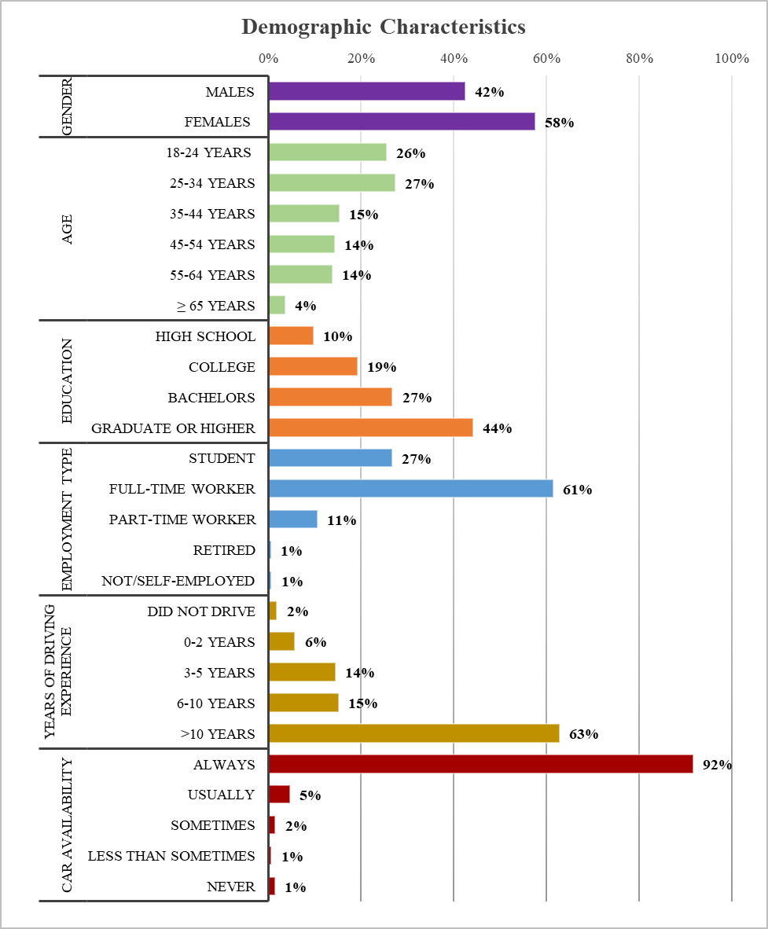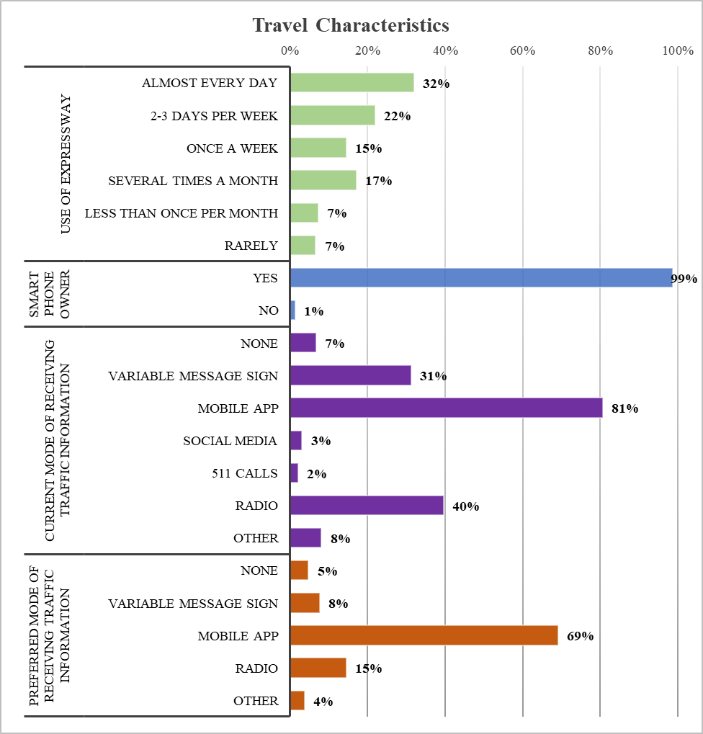

**(a) (b)**

**Figure 2 Characteristics of Survey Respondents [(a) Demographic, (b) Travel**

## Demographic Profile

From Figure 2(a) and Figure 2(b), we can see that out of 929 respondents, 42.4% are male and 57.6% are female. In terms of age categories, almost half of the respondents belong to younger age group category (18-34 years). Only 3.7% of the respondents are aged above 65 years. Majority of respondents are highly educated (71%) amongst which almost 44% held at least graduate degree while around 27% had completed a bachelor’s degree. One fourth of the respondents are students and more than half are fully employed. Around one tenth are employed part-time and less than 1% are either unemployed or self-employed. Among the full-time employees, around 85% have a graduate degree.

Out of 929 respondents, about 62% of them have driving experience of more than 10 years while only around 2% did not drive at all. In case of use of expressway, around 30% of the respondents use expressway on a daily basis. However, more than one-third of the respondents do not use expressway very frequently. From Table 3 we can see that, almost 96% of the respondents have a car available to them always and just 1.4% do not have a car available. In the survey, we also asked the participants about their current mode of receiving traffic information and we allow them to select multiple options. Result shows that more than 80% people used mobile app as their source of traffic information, followed by radio (40%) and variable message signs (31%). From the table, it is evident that respondents often use multiple modes for accessing traffic information. Moreover, we asked the respondents about their preferred mode for accessing traffic information and from the sample, we found that, around 69% of the people preferred mobile app as their source for traffic information.

## Methods

In the current research effort, we compare random utility-based panel mixed multinomial logit (Panel MRUM) and regret-based panel mixed multinomial logit (Panel MRRM) model formulation for our responses. In this section, we explain the econometric frameworks of these models employed in the current study.

Let $t (t=1,2,…,T)$ be the index for respondents, $r (1, 2, …, R)$ be the index for route alternative, and $k (1, 2, …, K)$ be the index for choice occasions for each respondent. In our case, $R=3$ and $K=5 or 6$ for all $t$. With this notation, the random utility formulation takes the following familiar form:

|  |  |  |
| --- | --- | --- |
|  | $$U_{trk}=\left(α^{'}+η_{t}^{'}\right)z_{trk}+ξ_{trk}$$ | (1) |

$z_{trk}$ is a vector of route attributes influencing the utility of respondent $t$ for route alternative $r$ at the $k^{th}$ choice occasion. $α^{'}$ is a corresponding vector of coefficients (representing mean effects), $η_{t}^{'}$ is another vector representing unobserved factors specific to respondent $t$– the elements of $η_{t}^{'}$ are considered to be independent realizations from a normal population distribution $\left(η_{t}^{'}\sim N\left(0,σ^{2}\right)\right)$, and $ξ_{trk}$ is a random error term assumed to be identically and independently Type 1 Extreme Value distributed. Then, in case of Panel MRUM approach, the probability that any road user $t$ will select route $r$ for a given value of $η_{t}^{'}$ can be expressed as:

|  |  |  |
| --- | --- | --- |
|  |  | (2) |

In case of Panel MRRM approach, the random regret associated with the route choice is given as

|  |  |  |
| --- | --- | --- |
|  | $${RR}_{trk}=\sum_{s≠r}{\sum_{n=1,2,…, N}{ln⁡\{1+exp⁡[\left(β'+ψ_{t}^{'}\right){(z}_{tsnk}-z_{trnk})]\}ε_{trk}}}$$ | (3) |

where $s$ and $r$ are routes and each route is characterized by $N$ attributes. $z_{trn}$ and $z_{tsn}$ are route attributes including all interactions influencing the regret associated to the route choice. $β^{'}$ is a corresponding vector of coefficients (representing mean effects), $ψ_{t}^{'}$ is another vector representing unobserved factors specific to respondent $t$– the elements of $ψ_{t}^{'}$ are usually considered to be independent realizations from a normal population distribution $\left(ψ_{t}^{'}\sim N\left(0,ω^{2}\right)\right)$, and $ε_{trk}$ is a random error term assumed to be identically and independently Type 1 Extreme Value distributed. Then, in case of Panel MRRM approach, the probability that any road user $t$ will select route $r$ at the $k^{th}$ choice occasion can be expressed as:

|  |  |  |
| --- | --- | --- |
|  |  | (4) |

The unconditional probability, for both Panel MRUM and Panel MRRM can be written as:

|  |  |  |
| --- | --- | --- |
|  |  | (5) |
|  |  | (6) |

where 𝑭 is the multivariate cumulative normal distribution. The log-likelihood (LL) function is estimated using maximum simulated likelihood (MSL) estimation. For this study, we use a quasi-Monte Carlo (QMC) approach with 500 draws for the MSL estimation (see (Bhat, 2001) for more details). It should be noted that we do not have any alternative specific variables since the alternatives are “unlabeled” and characterized by route attributes. The reader would note that it is possible to consider alternative error distributions for estimating unobserved effects. For example, for travel time and travel cost variables a log-normal error distributional assumption is suggested to avoid any positive density distribution. However, in our empirical exercises the normal distributional assumption yielded very small proportion of positive population density. Further, considering log-normal distributional assumption resulted in poorer data fit across several empirical datasets in our experience.

# MODEL RESULTS

Several models were estimated with the attributes presented in Table 3. The models developed and their corresponding log-likelihood (LL) values are (a) random utility based multinomial logit (RUM-MNL): -4057.7, (b) random regret based multinomial logit (RRM-MNL): -4011.1, (c) panel mixed RUM-MNL: -3661.52 and (d) panel mixed RRM-MNL: -3647.64. From the LL values, it is evident that models recognizing the influence of common unobserved factors specific to repeated measures for each individual offered improve data fit compared to simpler models which did not account for the influence of unobserved factors. Across the RUM and RRM models, for our data, the RRM models outperform the RUM counterparts.

The final specification of the model development was based on removing the statistically insignificant variables in a systematic process based on 90% confidence level. Table 3Table 3 presents the estimation results of the route choice models for panel mixed RUM-MNL and panel mixed RRM-MNL models. In the panel mixed RUM-MNL model, a positive (negative) coefficient corresponds to increased (decreased) likelihood of selecting the route alternative. Similarly, in the panel mixed RRM-MNL model, the positive (negative) coefficient indicates that potential regret increases (decreases) when the non-chosen alternative performs better than the chosen alternative. In the ensuing discussion, the model estimates from the two models are discussed by variable groups: (a) Trip characteristics (travel time, travel cost and delay), (b) Roadway type (Arterial or expressway) and (c) availability of traffic information (with no trip information being the base). The model specification process considered multiple interactions of variables across the three categories.

*Trip Characteristics*

Trip characteristics such as travel time, delay and travel cost are expected to have a significant impact on route choice decision process. In addition to their main effects, several variables were generated that incorporate the interactions between trip characteristics and roadway type and user travel habits.

The coefficient for travel time, as expected, has a negative impact on route choice preference indicating a lower regret of people towards longer routes. Our results are in line with the results reported in earlier studies (Abdel-Aty et al., 1997, Khattak et al., 1996, Abdel-Aty et al., 1995). At the same time, the model estimates also indicate a statistically significant random parameter for travel time indicating that the impact of travel time varies across the sample population. The parameter estimate is intuitive with the travel time coefficient being negative for 98.8% of the respondents. The interaction with roadway type (arterial) offers interesting results. Specifically, individuals are willing to lower their sensitivity towards travel time on arterial roads i.e. users are willing to travel slightly longer on arterials relative to expressways. In terms of road user travel habits, frequency of expressway use moderates the impact of travel time. Specifically, the model estimates indicate that individuals who use expressway regularly are likely to be more sensitive to travel time relative to other road users. The delay variable refers to the additional travel time required to travel from trip origin to trip destination due to heavy traffic or some other incidents (bad weather or crashes). The coefficient for delay, as expected, has negative impact on route choice preference indicating a lower regret for people towards longer routes (see Peeta and Ramos, 2006, Poulopoulou et al., 2015, Zhao et al., 2019 for similar results). Some of the results in earlier research also has drawn similar conclusions based on travel time savings (a variable that is the opposite of delay) (Khoo and Asitha, 2016, Gan and Ye, 2014, Gan and Ye, 2012). The interaction of delay variable with daily expressway users provides a valuable insight. Specifically, daily expressway users are more sensitive to delay i.e. these individuals prefer low delay routes with higher propensity. Also, the model results indicate a statistically significant random parameter on delay. The parameter estimate is intuitive with the delay coefficient being negative for 98% of the respondents. This indicates that there is a very small subset of respondents that are not affected if delay is very small.

Travel cost in our study is defined as the toll cost of expressways. The arterial alternative has been assigned a zero toll cost. The coefficient of the variable indicates a lower preference among respondents towards the routes with tolls (similar findings can be seen in Khoo and Asitha, 2016). The interaction with daily expressway users indicates that daily expressway users are less sensitive to travel cost. Also, from the interaction of travel cost with pre-trip information availability, we observe that sensitivity towards travel cost reduces in the presence of such information i.e. individuals that receive trip information are less sensitive to travel cost highlighting a willingness to pay for this information. Finally, the model estimates also indicate a statistically significant random parameter for travel cost. The parameter estimate is intuitive with the coefficient of cost being negative for approximately 90% of the respondents.

*Roadway Type*

In the model estimation, the coefficient for arterials is estimated with expressways as base. The coefficient for arterial roadway type has a positive impact on route choice, indicating that arterials are preferred over expressways by the road users. At the same time, the model estimates also indicate a statistically significant random parameter for arterial roadway type, indicating that nearly 33% of respondents prefer expressways to arterials and 67% of respondents prefer arterials. The result highlights the presence of heterogeneity for road user preferences.

*Availability of Traffic Information*

This information is provided to the road users as two attributes: (a) timing of information provision and (b) mechanism of information provision. The reader would note that if the attribute level of timing of information is never, then the mechanism of information provision will automatically be none. This attribute combination is considered as the base level for the parameter estimation. In terms of model estimates, the coefficient for pre-trip traffic information has a positive impact on route choice indicating that the road users prefer traffic information before starting the trip. The model estimates also indicate a statistically significant variation due to unobserved effects in the sensitivity to pre-trip information. There are nearly 60% of respondents who are sensitive to the pre-trip information. Secondly, importance of en-route information is studied along with the media to access that information. The coefficients for en-route traffic information through mobile app and radio have a positive impact on respondent preferences for these routes (see Zhang et al., 2014, Song et al., 2017 for similar findings). Finally, the estimate for en-route information through mobile app has statistically significant random parameter due to unobserved heterogeneity. The parameter estimate is intuitive with the en-route traffic information through mobile app coefficient being positive for three-fourths of the respondents.

Table 3 Model Estimation Results

| **Attribute Category** | **Attribute** | **Attribute Levels** | **Panel mixed RUM-MNL** | | **Panel mixed RRM-MNL** | |
| --- | --- | --- | --- | --- | --- | --- |
| **Estimate (t-stat)** | | **Estimate (t-stat)** | |
| Trip characteristics | Travel time | Travel time | -0.209 (-27.554) | | -0.150 (-21.363) | |
| *Standard deviation* | 0.095 (10.249) | | 0.072 (10.599) | |
| *Roadway type: Arterial* | -- | | 0.021 (2.296) | |
| *Expressway frequency: every day* | -- | | -0.015 (-1.759) | |
| Delay | Delay | -0.167 (-17.307) | | -0.113 (-17.8) | |
| *Standard deviation* | 0.097 (6.807) | | 0.056 (5.413) | |
| *Expressway frequency: every day* | -0.032 (-1.869) | | -0.025 (-2.233) | |
| Travel cost | Travel cost | -1.063 (-7.583) | | -0.653 (-7.132) | |
| *Standard deviation* | 0.802 (5.054) | | 0.548 (4.543) | |
| *Expressway frequency: every day* | 0.432 (2.332) | | 0.177 (1.657) | |
| *Traffic information: pre-trip* | 0.331 (4.759) | | 0.173 (3.533) | |
| Roadway Type | Arterial | Arterial | 1.896 (15.758) | | 0.826 (3.392) | |
| *Standard deviation* | 2.546 (19.103) | | 1.851 (17.891) | |
| Availability of Traffic Information  (Base: No information available) | Pre-trip | Pre-trip | 0.193 (3.225) | | 0.087 (2.093) | |
| *Standard deviation* | 0.426 (3.823) | | 0.345 (4.96) | |
| En-route  Mobile | En-route  Mobile | 0.410 (4.287) | | 0.277 (4.316) | |
| *Standard deviation* | 0.692 (2.996) | | 0.412 (2.56) | |
| En-route  Radio | En-route  Radio | 0.600 (7.085) | | 0.205 (3.481) | |
| Log-likelihood at convergence (N = 929) | | | | -3661.52 | | -3647.64 |
| Akaike information criterion (AIC) | | | | 7355.04 | | 7331.28 |
| Bayesian Information Criterion (BIC) | | | | 7458.70 | | 7418.29 |

# TRADE-OFF ANALYSIS

In this section, we present the methodology employed to conduct our trade-off analysis and discuss the findings[3]. In our trade-off analysis, we estimate the following trade-offs: (a) trade-off between travel time and travel cost (often referred to as Willingness to Pay (WTP) or Value of Time (VoT) measure), (b) trade-off between travel delay and travel cost and (c) trade-off between information provision attributes and travel cost.

This section provides details of the trade-off analysis between travel time and delay with travel cost. These trade-offs are valuation of route attributes in terms of cost, is also termed as willingness to pay (WTP) for improvements in route attributes. In other words, it explains how much the road users are willing to pay to improve the considered route attributes.

Trade-off between travel time and travel cost defined as ratio of marginal effects of travel time and travel cost, can be expressed as:

|  |  |  |
| --- | --- | --- |
|  | $$VoT= \frac{(∂U/∂tt)}{(∂U/∂tc)}$$ | (7) |

where $U$ is utility derived for the alternative, $tt$ is travel time and $tc$ is the travel cost variable.

In random utility framework, trade-off is independent of levels of attributes. So, VoT takes the following form:

|  |  |  |
| --- | --- | --- |
|  | $${VoT}_{RUM}= \frac{β_{tt}+ \sum_{k}{β_{tk} X_{k}}}{β_{tc}+ \sum_{l}{β_{Cl} Y_{l}}}$$ | (8) |

where $β_{tt}$ and $β_{tc}$ are estimates of travel time and travel cost respectively. $X_{k}$ and $Y_{l}$ are interaction variables to travel time and travel cost respectively. $β_{tk}$ and $β_{cl}$ are estimates of interactions to travel time and travel cost respectively.

In random regret framework, the trade-offs are dependent on levels of attributes. The computation for utility without interaction terms is simple (Chorus, 2012). However, the interaction terms in the model estimation increase the complexity of VoT expressionas follows:

${VoT}_{RRM}= \frac{\sum_{j ≠i}{{-β}_{tt}\left(1+\frac{1}{\exp\left[β_{tt}\left(t_{j}-t_{i}\right)\right]}\right)}+\sum_{k}{\left(\sum_{j ≠i}{{-β}_{tk} X_{k}\left(1+\frac{1}{\exp\left[β_{tk}X_{k}\left({X_{kj}t}_{j}-{X_{ki}t}_{i}\right)\right]}\right)}\right)}}{\sum_{j ≠i}{{-β}_{tc}\left(1+\frac{1}{\exp\left[β_{tc}\left(c_{j}-c_{i}\right)\right]}\right)}+\sum_{l}{\left(\sum_{j ≠i}{{-β}_{cl} Y_{l}\left(1+\frac{1}{\exp\left[β_{cl}Y_{l}\left({Y_{lj} c}_{j}-{Y_{li}c}_{i}\right)\right]}\right)}\right)}}$ (9)

Where $t_{i}$ and $t_{j}$ are represent the travel time attribute for the chosen route $i$ and considered route $j$, respectively. $c_{i}$ and $c_{j}$ are represent the travel time attribute for the chosen route $i$ and considered route $j$, respectively. Trade-off for delay and other information provision attributes can also be computed by using the same formulations as presented in Equations 8 and 9 by appropriately replacing travel time parameters with delay and information provision attributes.

The aforementioned discussion represents the coefficients of the various attributes as fixed parameters. However, as discussed earlier, in our analysis, we estimated random parameters for travel cost and travel time. Hence, across various trade-off computations, one or both the coefficients are normally distributed. The evaluation of the complete distribution of these trade-offs can be computationally quite involved (see for example Bliemer and Rose, 2013) and is beyond the scope of our paper. In our analysis, we focus on presenting the results at the following three points: (1) mean value of the parameters, (2) at the 10th percentile value based on the normal distribution and (3) at the 90th percentile value. The formulation from equation 8 and 9 can be applied by replacing the coefficient with the corresponding realization for that attribute. For the ease of presentation, we only present the results for the mean values in the paper. The results for the other two realizations are presented in the Appendix B. While the computation at these three realizations does not represent the full distribution, it provides a range of trade-off values.

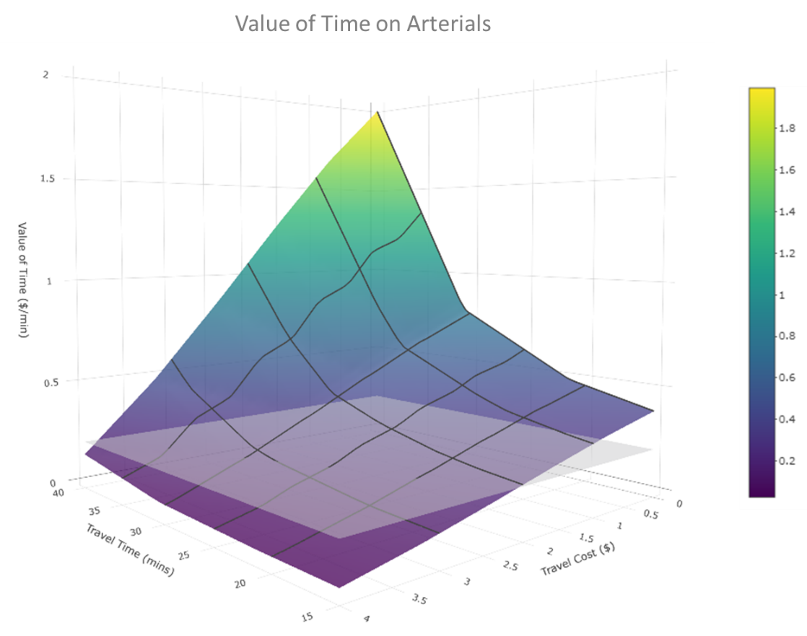

**(a)**

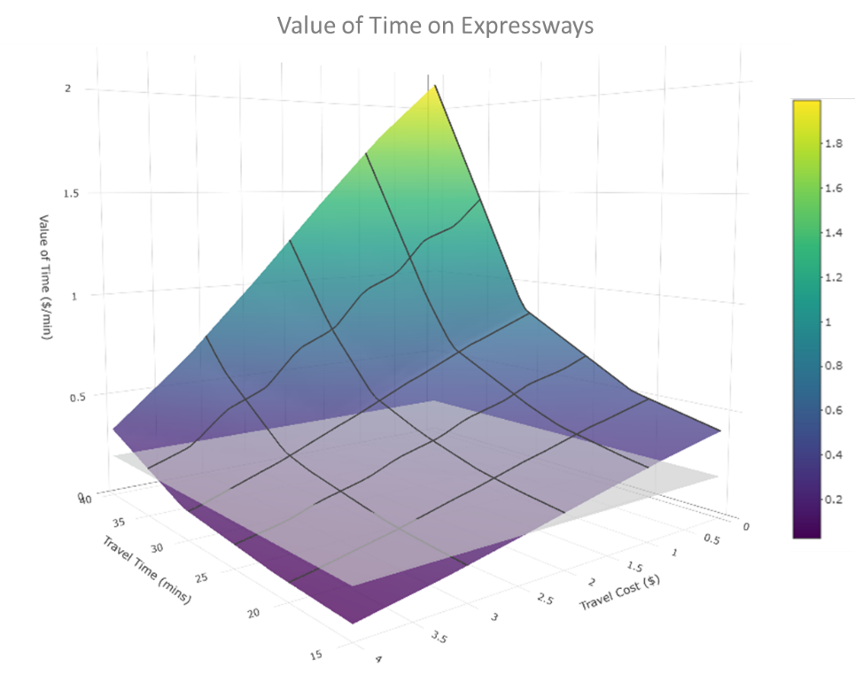

**(b)**

**Figure 3 Value of Time [(a) Arterial; (b) Expressway]**

The reader would note that there are differences in VoT representation across RUM and RRM models due to the inherent differences in how they are computed. In RUM models, a constant trade-off value i.e. is attribute invariant is generated. However, for RRM models, the VoT value generated varies based on the attribute level. Hence, in a single plot for VoT for RUM and RRM systems, the RUM plot would take the form of a horizontal plane while the RRM plot would be a surface across different levels of travel time and cost. The same relationship holds for other trade-offs as well. The results for VoT and trade-off for delay are presented in Figure 3 and Figure 4, respectively.

(b**)**

**Figure 3 Value of Time [(a) Arterial; (b) Expressway]**

(a) and (b**)**

**Figure 3 Value of Time [(a) Arterial; (b) Expressway]**

(b) represent VoT on arterial and expressway, respectively. For the RRM approach, VoT on arterial roads varies from 0.025 to 2 $/min, whereas on expressways it ranges from 0.06 to 2.14 $/min. From RUM approach, the VoT is 0.18$/min for arterials and 0.20$/min for expressways. The VoT estimates are conformable with the VoT for Orlando (17.67$/hr or 0.295 $/min for 2014) (Schrank et al., 2015). From the result, it is evident that VoT on expressways are slightly higher than that of arterials. Further, the surface plot of VoT using RRM approach, explains that road users with high travel time and low travel cost are willing to pay more to reduce their travel time than the users with low travel time and high travel cost.

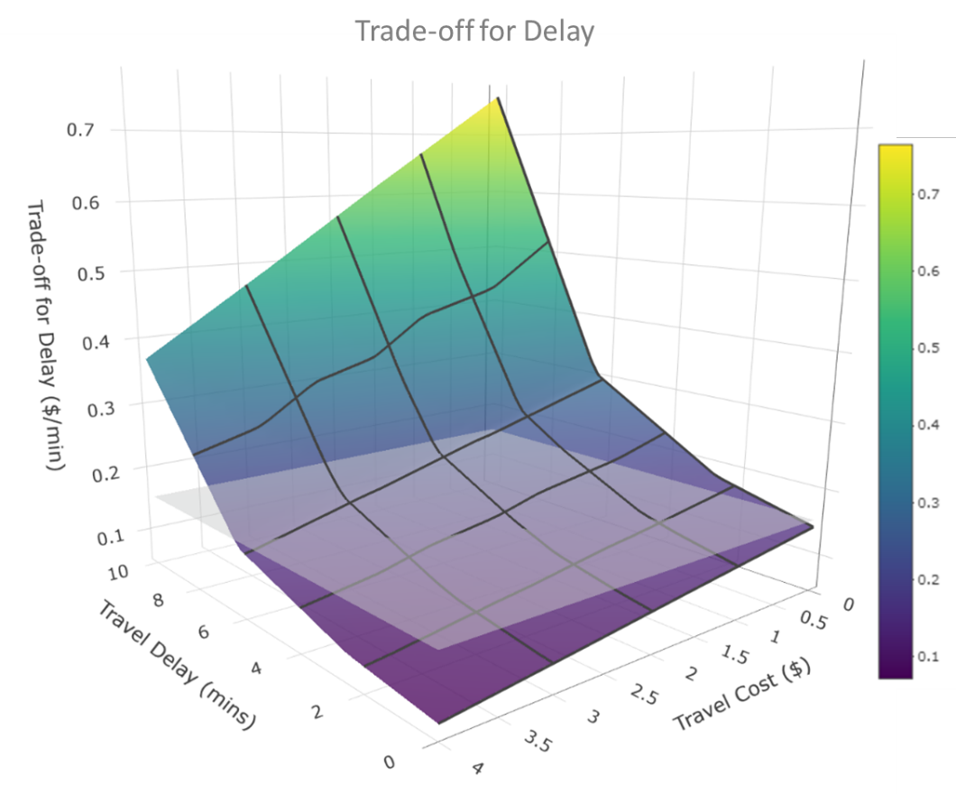

**Figure 4 Trade-off for Delay**

The trade-off for delay is presented in Figure 4. For the RRM approach, the trade-off varies from 0.07 to 0.77 $/min while the RUM approach provides a constant trade-off of 0.16$/min. The reader would note that the trade-off for delay is not affected by roadway type. The surface plot of trade-off for delay using RRM approach indicates that road users with more delay and lower travel cost are willing to pay more to reduce the delay incurred on the route than the users with less delay and more travel cost.

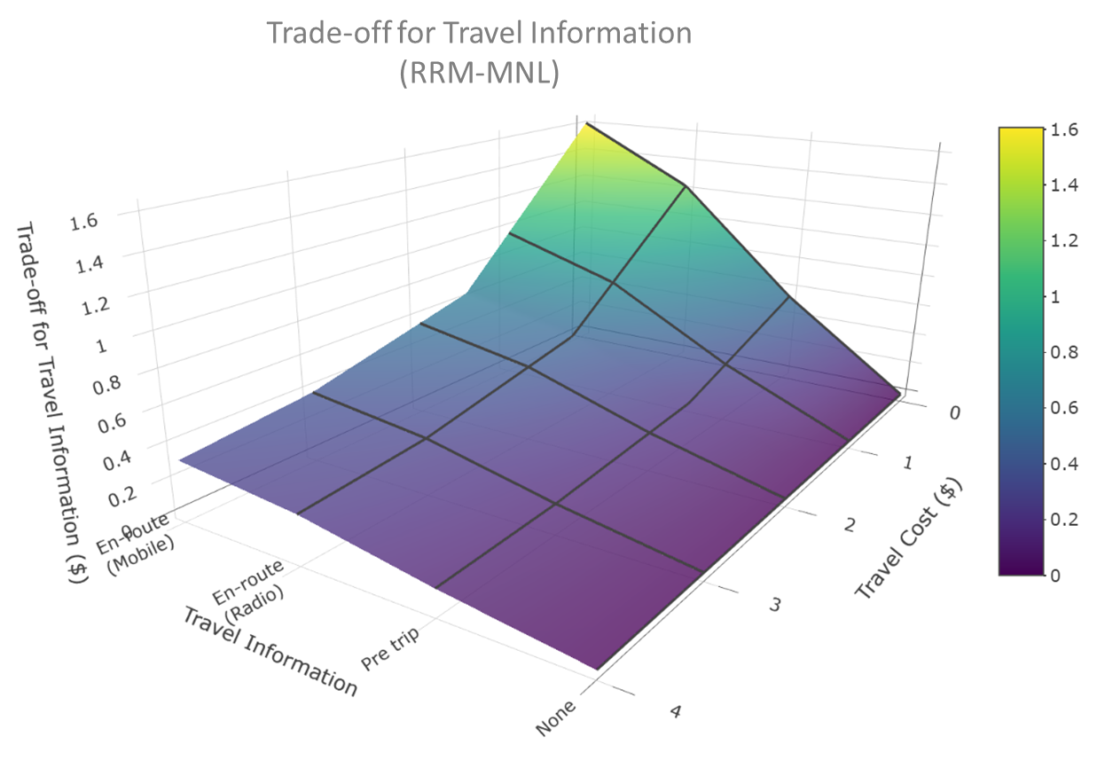

**(a)**

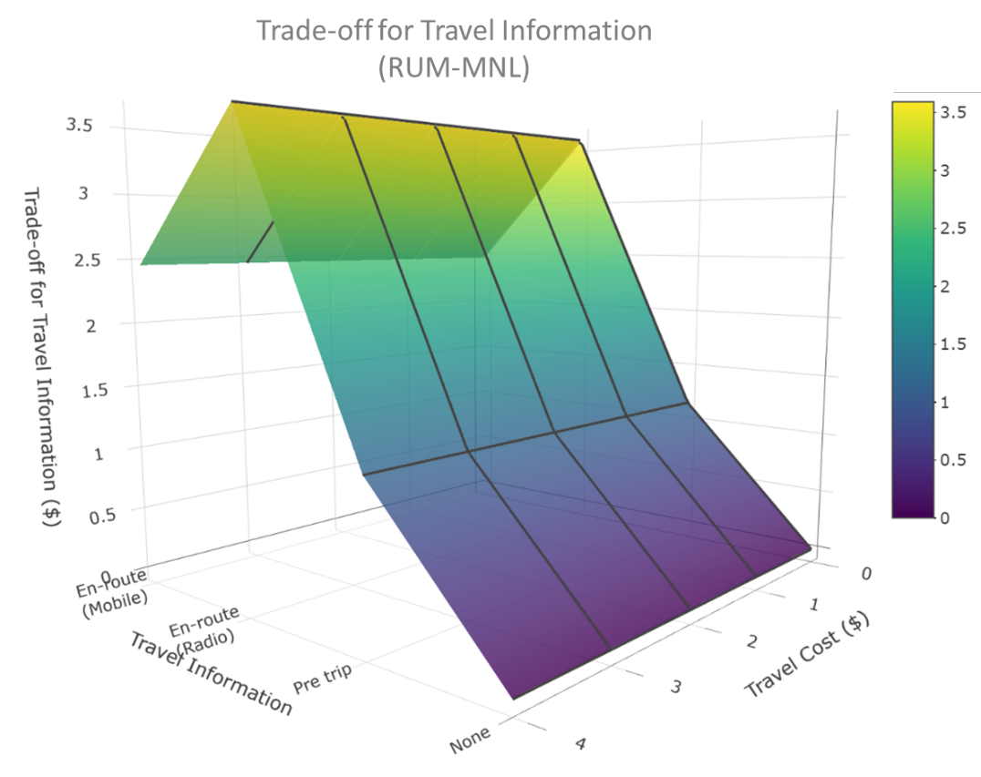

**(b)**

**Figure 5 Trade-off for Travel Information [(a) RRM-MNL, (b) RUM-MNL]**

The trade-off for travel information is estimated for three levels of information provision; (a) pre trip, (b) en-route through radio, and (c) en-route through mobile app. The trade-off for travel information is presented in Figure 5. In the figure, the surface plot of trade-off for travel information is varying from 0 to 1.61$ is estimated using regret-based approach and 0 to 3.59 $ is estimated using utility-based approach. The surface plot of trade-off for travel information using RRM approach, explains that road user’s willingness to pay to receive the information decreases with travel cost, whereas the trade-off from RUM shows constant trade-off within each mode of travel information. From both the plots it can be observed that the road users are willing to pay more for en-route information (mobile applications followed by radio) than pre trip[4].

# SUMMARY AND CONCLUSIONS

Traffic congestion can generally be attributed to either recurring or non-recurring events. The potential solutions for recurring and non-recurring congestion are typically distinct. However, in recent years, a bridge between solutions for recurring and non-recurring congestion has been established through advances in technology for real-time data collection and advent of real-time congestion pricing within an active traffic management (ATM) system. In these systems, road users are provided information on travel time and cost information associated with various route alternatives. While earlier research has examined route choice preferences in relation to travel time and travel cost (or toll), there is little guidance on the influence of information provision mechanisms. By accommodating for information provision attributes, the proposed research contributes to our understanding of the design of an ATM system by quantitatively estimating the inherent trade-offs across the various attributes affecting route choice. Specifically, the research designed and elicited data using a stated preference (SP) survey to understand road users’ preferences in the context of an ATM system in the Greater Orlando region, USA. The data from the SP survey was utilized to develop random utility maximization (RUM) and random regret minimization (RRM) based panel mixed multinomial logit models. Across the RUM and RRM models, for our data, the RRM models outperformed the RUM counterparts. Overall, the route choice decisions are influenced by travel time, travel cost and delay indicating lower preference for routes with higher values specific to these variables. In terms of availability of traffic information, the results indicated that road users preferred pre trip and en-route information, while en-route traffic information through mobile app and radio found to influence route choice decision positively. Earlier studies on regret minimization approaches developed trade-off measures with only main effects. In our route choice model, several interaction effects offered significant parameters. Hence, we customized the trade-off computation for regret minimization models to accommodate for these interactions. The estimated VoT from RRM-MNL vary between 0.025 to 2 $/min for arterials whereas it varies from 0.06 to 2.14 $/min for expressways. The trade-off for delay is 0.07 to 0.77 $/min. The estimated trade offs for travel information reveals that the road users are willing to pay more for en-route than pre trip information. Also, the road user’s willingness to pay to receive travel information decreases with travel cost.

To be sure, the study is not without limitations. The findings are based on data compiled through a web-based survey that can be affected by respondent selection bias. The web survey design only considered a fixed set of attributes for our hypothetical scenarios. However, increasing the number of attributes included by focusing on the different components of congestion, travel cost might be considered in studies conducted with emphasis on these attributes. The modeling approaches in the paper can be improved by considering novel variants of random regret minimization approaches developed for accommodating additional observed and unobserved heterogeneity through latent segmentation based model systems (for example see Charoniti et al., 2020; Dey et al., 2018). Further, the data is from the Greater Orlando region and the model findings such as VoT measures are not directly transferable to other regions.

**ACKNOWLEDGEMENT**

The authors acknowledge the critical comments from UCF graduate students during the pilot survey which helped in fine tuning the survey. We also thank UCF for their support and help for providing the mailing lists of staff and students of UCF to distribute the survey link. The authors also acknowledge the financial support provided by Florida Department of Transportation (FDOT).

**REFERENCES**

Abdel-Aty, M. A., Kitamura, R. & Jovanis, P. P. 1995. Exploring route choice behavior using geographic information system-based alternative routes and hypothetical travel time information input. *Transportation Research Record*.

Abdel-Aty, M. A., Kitamura, R. & Jovanis, P. P. 1997. Using stated preference data for studying the effect of advanced traffic information on drivers' route choice. *Transportation Research Part C: Emerging Technologies,* 5**,** 39-50.

Al-Deek, H., Venkata, S. R. C. C., Flick, J. & Khattak, A. 2009. Dynamic message sign deployment and diversion behavior of travelers on Central Florida toll roads. *Transportation Research Record,* 2129**,** 24-34.

Anowar, S., Eluru, N. & Hatzopoulou, M. 2017. Quantifying the value of a clean ride: How far would you bicycle to avoid exposure to traffic-related air pollution? *Transportation research part A: policy and practice,* 105**,** 66-78.

Ardeshiri, A., Jeihani, M. & Peeta, S. 2015. Driving simulator-based study of compliance behaviour with dynamic message sign route guidance. *IET intelligent transport systems,* 9**,** 765-772.

Arentze, T. & Timmermans, H. 2007. Parametric action decision trees: Incorporating continuous attribute variables into rule-based models of discrete choice. *Transportation Research Part B: Methodological,* 41**,** 772-783.

Bagloee, S. A., Ceder, A. & Bozic, C. 2014. Effectiveness of en route traffic information in developing countries using conventional discrete choice and neuralnetwork models. *Journal of Advanced Transportation,* 48**,** 486-506.

Ben-Akiva, M. E., Lerman, S. R. & Lerman, S. R. 1985. *Discrete choice analysis: theory and application to travel demand*, MIT press.

Ben-Elia, E., Erev, I. & Shiftan, Y. 2008. The combined effect of information and experience on drivers’ route-choice behavior. *Transportation,* 35**,** 165-177.

Bhat, C. R. 2001. Quasi-random maximum simulated likelihood estimation of the mixed multinomial logit model. *Transportation Research Part B: Methodological,* 35**,** 677-693.

Bhat, C. R. & Sardesai, R. 2006. The impact of stop-making and travel time reliability on commute mode choice. *Transportation Research Part B: Methodological,* 40**,** 709-730.

Bliemer, M. C. & Rose, J. M. 2013. Confidence intervals of willingness-to-pay for random coefficient logit models. *Transportation Research Part B: Methodological,* 58**,** 199-214.

Charoniti, E., Kim, J., Rasouli, S. and Timmermans, H.J., 2020. Intrapersonal heterogeneity in car-sharing decision-making processes by activity-travel contexts: A context-dependent latent class random utility–random regret model. *International Journal of Sustainable Transportation*, pp.1-11.

Choocharukul, K. 2008. Effects of attitudes and socioeconomic and travel characteristics on stated route diversion: Structural equation modeling approach of road users in Bangkok, Thailand. *Transportation Research Record: Journal of the Transportation Research Board***,** 35-42.

Chorus, C. 2012. Random regret minimization: an overview of model properties and empirical evidence. *Transport Reviews,* 32**,** 75-92.

Chorus, C. G. 2010. A new model of random regret minimization. *European Journal of Transport and Infrastructure Research,* 10.

Chorus, C. G., Arentze, T. A. & Timmermans, H. J. 2008. A random regret-minimization model of travel choice. *Transportation Research Part B: Methodological,* 42**,** 1-18.

Chorus, C. G., Arentze, T. A., Timmermans, H. J., Molin, E. J. & Van Wee, B. 2007. Travelers' need for information in traffic and transit: Results from a web survey. *Journal of Intelligent Transportation Systems,* 11**,** 57-67.

De Dios Ortúzar, J. & Rodrı́guez, G. 2002. Valuing reductions in environmental pollution in a residential location context. *Transportation Research Part D: Transport and Environment,* 7**,** 407-427.

Dey B. K., S. Anowar, N. Eluru, and M. Hatzopoulou (2018), "Accommodating Exogenous Variable and Decision Rule Heterogeneity in Discrete Choice Models: Application to Bicyclist Route Choice", *PLoS ONE* 13(11): e0208309.

Gan, H.-C., Bai, Y. & Wei, J. 2013. Why do people change routes? Impact of information services. *Industrial Management & Data Systems,* 113**,** 403-422.

Gan, H. & Chen, S. 2013. Why Do Drivers Change Routes? Impact of Graphical Route Information Panels. *Institute of Transportation Engineers. ITE Journal,* 83**,** 38.

Gan, H. & Ye, X. 2012. Urban freeway users' diversion response to variable message sign displaying the travel time of both freeway and local street. *IET Intelligent Transport Systems,* 6**,** 78-86.

Gan, H. & Ye, X. 2014. Leave the expressway or not? Impact of dynamic information. *Journal of Modern Transportation,* 22**,** 96-103.

Hensher, D. A. 1994. Stated preference analysis of travel choices: the state of practice. *Transportation,* 21**,** 107-133.

Inrix. 2018. *Interactive Traffic Congestion Ranking & City Dashboards* [Online]. Available: <http://inrix.com/scorecard/> [Accessed 01 June 2019].

Javid, M. A., Okamura, T., Nakamura, F. & Rui, W. 2013. Analysis and Modeling of Commuters’ Perception to Radio Traffic Information in Lahore, Pakistan. *20th ITS World Congress Tokyo*.

Kahneman, D. & Tversky, A. 2013. Prospect theory: An analysis of decision under risk. *Handbook of the fundamentals of financial decision making: Part I.* World Scientific.

Khattak, A., Polydoropoulou, A. & Ben-Akiva, M. 1996. Modeling revealed and stated pretrip travel response to advanced traveler information systems. *Transportation Research Record: Journal of the Transportation Research Board***,** 46-54.

Khoo, H. L. & Asitha, K. 2016. User requirements and route choice response to smart phone traffic applications (apps). *Travel Behaviour and society,* 3**,** 59-70.

Kivetz, R., Netzer, O. & Srinivasan, V. 2004. Alternative models for capturing the compromise effect. *Journal of marketing research,* 41**,** 237-257.

Kusakabe, T., Sharyo, T. & Asakura, Y. 2012. Effects of traffic incident information on drivers’ route choice behaviour in urban expressway network. *Procedia-Social and Behavioral Sciences,* 54**,** 179-188.

Lee, C., Ran, B., Yang, F. & Loh, W.Y. 2010. A hybrid tree approach to modeling alternate route choice behavior with online information. *Journal of Intelligent Transportation Systems,* 14**,** 209-219.

Leong, W. & Hensher, D. A. 2015. Contrasts of relative advantage maximisation with random utility maximisation and regret minimisation. *Journal of Transport Economics and Policy (JTEP),* 49**,** 167-186.

Majumder, J., Kattan, L., Habib, K. N. & Fung, T. S. 2013. Modelling traveller response to variable message sign. *International Journal of Urban Sciences,* 17**,** 259-280.

Mcfadden, D. 1974. The measurement of urban travel demand. *Journal of public economics,* 3**,** 303-328.

Meng, M., Memon, A. A., Wong, Y. D. & Lam, S.H. Impact of traveller information on mode choice behaviour. Proceedings of the Institution of Civil Engineers-Transport, 2017. Thomas Telford (ICE Publishing), 11-19.

Moghaddam, Z. R., Jeihani, M., Peeta, S. & Banerjee, S. 2019. Comprehending the roles of traveler perception of travel time reliability on route choice behavior. *Travel Behaviour and Society,* 16**,** 13-22.

Peeta, S. & Ramos, J. L. Driver response to variable message signs-based traffic information. IEE Proceedings-Intelligent Transport Systems, 2006. IET, 2-10.

Petrella, M., Minnice, P. & Lappin, J. 2014. Traveler Use of and Response to Real-Time Traffic and Traveler Information: Evidence from Integrated Corridor Management Traveler Surveys in Dallas, Texas, and San Diego, California. *Transportation Research Record: Journal of the Transportation Research Board***,** 44-51.

Poulopoulou, M., Spyropoulou, I. & Antoniou, C. Parameters affecting professional driver response to VMS messages. 2015 IEEE 18th International Conference on Intelligent Transportation Systems, 2015. IEEE, 1563-1568.

Prato, C. G. 2009. Route choice modeling: past, present and future research directions. *Journal of choice modelling,* 2**,** 65-100.

Prato, C. G. 2014. Expanding the applicability of random regret minimization for route choice analysis. *Transportation,* 41**,** 351-375.

Schrank, D., Eisele, B., Lomax, T. & Bak, J. 2015. Urban mobility scorecard. *The Texas A&M Transportation Institute & INRIX*.

Sener, I. N., Eluru, N. & Bhat, C. R. 2009. An analysis of bicycle route choice preferences in Texas, US. *Transportation,* 36**,** 511-539.

Skelley, T., Namoun, A. & Mehandjiev, N. The impact of a mobile information system on changing travel behaviour and improving travel experience. International Conference on Mobile Web and Information Systems, 2013. Springer, 233-247.

Song, D., Peeta, S., Hsu, Y.-T. & Agrawal, S. 2017. Role of Psychological Effects of Real-Time Travel Information Provision on En Route Traveler Route Choice Decisions. *International Driving Symposium on Human Factors in Driver Assessment, Training and Vehicle Design***,** 277-283.

Swait, J. 2001. A non-compensatory choice model incorporating attribute cutoffs. *Transportation Research Part B: Methodological,* 35**,** 903-928.

Train, K. E. 2009. *Discrete choice methods with simulation*, Cambridge university press.

Tseng, Y.-Y., Knockaert, J. & Verhoef, E. T. 2013. A revealed-preference study of behavioural impacts of real-time traffic information. *Transportation Research Part C: Emerging Technologies,* 30**,** 196-209.

Tversky, A. & Kahneman, D. 1992. Advances in prospect theory: Cumulative representation of uncertainty. *Journal of Risk and uncertainty,* 5**,** 297-323.

US-DOC. 2018. *United states census bureau; QuickFacts - Orlando city, Florida* [Online]. Available: <https://www.census.gov/quickfacts/fact/table/orlandocityflorida/PST045218> [Accessed 03 June 2019].

Van Cranenburgh, S., Prato, C. G. & Chorus, C. 2015. Accounting for variation in choice set size in Random Regret Minimization models. working paper.

Wang, J., Chang, A. & Gao, L. 2017. Binary Probit Model on Drivers Route Choice Behaviors Based on Multiple Factors Analysis. *Information Technology and Intelligent Transportation Systems.* Springer.

Zhang, G., Wang, Z., Persad, K. R. & Walton, C. M. 2014. Enhanced traffic information dissemination to facilitate toll road utilization: a nested logit model of a stated preference survey in Texas. *Transportation,* 41**,** 231-249.

Zhao, W., Quddus, M., Huang, H., Lee, J. & Ma, Z. 2019. Analyzing drivers’ preferences and choices for the content and format of variable message signs (VMS). *Transportation research part C: emerging technologies,* 100**,** 1-14.

1. The reader would note that several research studies have examined link level route choice decisions of users on real or simulated networks. For such studies, the reader is referred to Van Cranburgh et al., 2015; Prato, 2014 and Prato, 2009. In these link level studies, accommodating for the influence of information provision will be quite challenging and can be a potential avenue for future research.
2. The times accessed from Google Map are for expected (or realistic) travel times for an origin destination pair.
3. In addition to the trade-off computation, we also computed marginal effects for the different variables. Due to space and readability considerations, these results are presented in the Appendix A.
4. The reader would note that marginal effects for different explanatory variables are also generated and presented in the Appendix for the sake of brevity.