**Travel Mode Choice and Transit Route Choice Behavior in Montreal: Insights from McGill University Members Commute Patterns**

**Naveen Eluru\***

Assistant Professor

Department of Civil Engineering and Applied Mechanics

McGill University

Suite 483, 817 Sherbrooke St. W.

Montréal, Québec, H3A 2K6

Canada

Ph: 514 398 6823, Fax: 514 398 7361

Email:naveen.eluru@mcgill.ca

**Vincent Chakour**

Department of Civil Engineering and Applied Mechanics

McGill University

Suite 483, 817 Sherbrooke St. W.

Montréal, Québec, H3A 2K6

Canada

Ph: 514 398 6823, Fax: 514 398 7361

Email:vincent.chakour@mail.mcgill.ca

**Ahmed M. El-Geneidy**

Assistant Professor

School of Urban Planning

McGill University

Suite 400, 815 Sherbrooke St. W.

Montréal, Québec, H3A 2K6

Canada

Ph.: 514-398-8741, Fax: 514-398-8376

E-mail: [ahmed.elgeneidy@mcgill.ca](mailto:ahmed.elgeneidy@mcgill.ca)

*corresponding author

June 2012

**ABSTRACT**

In developed countries such as Canada and United States, a significant number of individuals depend on automobile as their main mode of transport. There has been a stronger push towards analyzing travel behavior at the individual level so that transportation agencies can formulate appropriate strategies to reduce the auto dependency. Towards this pursuit of enhancing our understanding on travel behavior, we examine individual home to work/school commute patterns in Montreal, Canada with an emphasis on the transit mode of travel. The overarching theme of this paper is to examine the effect of the performance of the public transportation system on commuter travel mode and transit route choice (for transit riders) in Montreal. We investigate two specific aspects of commute mode choice: (1) the factors that dissuade individuals from commuting by public transit and (2) the attributes that influence transit route choice decisions (for those individuals who commute by public transit). This study employs a unique survey conducted by researchers as part of the McGill University Sustainability project. The survey collected information on commute patterns of students, faculty and staff from McGill University. In addition, detailed socio-demographic and residential location information was also collected. The analysis was undertaken using multinomial logit model for the travel mode choice component and a mixed multinomial logit model for the transit route choice component. The model estimation results were employed to conduct policy sensitivity analysis that allows us to provide recommendations to public transportation and metropolitan agencies.

Key words: Transit route choice, mode choice, commute patterns, transit attributes and travel behavior

**MOTIVATION**

In developed countries such as Canada and United States, a significant number of individuals depend on the automobile as the main mode of transportation. The high auto dependency, in turn, results in high auto travel demand on all roads. At the same time, the ability to build additional infrastructure is limited by high capital costs, real-estate constraints and environment considerations. The net result has been that traffic congestion levels in metropolitan areas of Canada and United States have risen substantially over the past decade (see Schrank et al., (2011)). The increase in traffic congestion levels not only impacts travel delays and stress levels of drivers, but also adversely affects the environment as a result of rising air pollution and greenhouse gas (GHG) emissions. An effective means of reducing the over reliance on the auto mode and ensuing negative externalities is to encourage public transportation ridership (Hodges (2009)). Towards this end, it is imperative that public transit agencies examine the determinants and deterrents to public transit usage. Specifically, it is important for public transit agencies to quantify the impact of various exogenous factors such as individual and household socio-demographics, transit level of service measures and accessibility to public transportation on the individual decision making process.

In the current paper, with the objective of enhancing our understanding of public transit usage behavior, we examine individual home to work/school commute patterns in Montreal, Canada. The research is focussed on identifying how the performance of existing transit infrastructure affects transit choice vis-à-vis automobile choice and transit route choice (with multiple transit options available to transit riders). To achieve these objectives the current study employs a two pronged approach. First, we examine the individual decision making process in the context of travel mode choice (automobile versus transit). To elaborate, we identify the factors that dissuade individuals from commuting to work/school by transit. The analysis will enable us to draw insights on the mode choice decision process thus allowing us to make recommendations to enhance the attractiveness of the transit mode to commuters. Second, we study how the performance of the different transit modes in Montreal affect route choice decisions for transit riders. Montreal with its unique multimodal public transportation system consisting of bus, metro and commuter train offers multiple transit route alternatives to individuals commuting to downtown. The examination of individual transit route choice behavior will enable us to identify important attributes that influence route choice decisions. In both phases, the analysis evaluates the impact of various exogenous factors on the choice process including (1) individual and household demographics, (2) level of service measures of the transportation system (auto and public transit), and (3) accessibility to public transportation facilities. The results will be employed to provide recommendations to transit agencies on enhancing transit services in the urban region.

This research study employs a unique survey conducted by researchers as part of the McGill University Sustainability project. The survey collected information on commuting patterns of students, faculty and staff from McGill University. McGill University, located in downtown Montreal, with its workforce of about 50,000 individuals offers a unique opportunity to examine travel behavior of a large sample of individuals commuting to the downtown. The analysis is undertaken using a multinomial logit model for the travel mode choice component and a mixed multinomial logit model for the transit route choice component. The estimation results are employed to undertake policy sensitivity analysis to evaluate how potential changes to public transportation performance affect travel mode choice and transit route choice.

The rest of the paper is organized as follows. Section 2 provides a brief review of earlier research and positions the current research effort in context. Section 3 provides details about the survey and outlines data assembly procedures. Section 4 briefly outlines the econometric methodology employed in estimating the different models. Section 5 presents the results while discussing their implications through a host of sensitivity analysis. Section 6 concludes the paper.

**LITERATURE REVIEW AND CURRENT STUDY IN CONTEXT**

The objectives of the research effort are two-fold. First, we investigate individual’s decision framework to choose between transit and car mode of transportation for commuting to McGill University. Second, for individuals choosing to commute by transit, the decision process of finalizing the transit alternative to commute is examined.

The first objective has received wide attention within the transportation research community in general and travel behavior research community in particular. Transportation researchers have made giant strides in formulating advanced behavior-oriented frameworks and developing enhanced data collection strategies to accurately model travel mode choice decisions. A comprehensive review of earlier literature examining mode choice decisions is beyond the scope of the current paper. We present a brief summary of the most important characteristics of earlier research efforts investigating travel mode choice decisions.

1. Earlier research has clearly shown that individual and household socio-demographics exert a strong influence on travel mode choice decisions. Specifically, gender, income, car ownership, employment status affect travel mode decisions (Bhat 1997, Bhat and Sardesai, 2006).
2. Researchers have identified that tour complexity influences mode choice substantially (Stratham and Dueker 1995, Ye et al., 2007). Individuals with more complex commute tours (possibly with multiple stops) prefer to employ the auto mode of transportation.
3. Residential location, neighborhood type and urban form play a prominent role in determining the favored travel mode for commute (Vanwee and Holwerda, 2003, Pinjari et al., 2007, Frank et al., 2008). At the same time, individuals with inclination to commute to work by public transportation locate themselves in neighborhoods with adequate access to transit.
4. There has also been extensive focus on evaluation of the willingness to pay (i.e. amount of money travellers are willing to pay to reduce their travel time by unit time) for reducing travel time (Bhat 1997, Hensher, 2001; Wardman 2004; Bhat and Sardesai, 2006; Fosgerau, 2006). In more recent research studies, reliability of travel time is also incorporated within the framework to compute the value of travel time (Noland and Polak, 2002; Small et al., 2005; Bhat and Sardesai, 2006; Li et al., 2010; Börjesson et al., 2012).
5. Other attributes that influence travel mode choice include travel distance (Scheiner, 2010), and household constraints such as picking up or dropping a child.
6. Earlier research has also highlighted the importance of attitudes, personality traits and awareness of transportation alternatives on travel mode choice decisions (Johansson et al., 2006, Garvill et al., 2003)
7. Advanced modelling frameworks including the mixed multinomial logit model and the generalized extreme value (GEV) models (see Bhat et al., 2008 and Koppelman and Sethi 2008 for an exhaustive list) have been adopted to investigate travel model choice behavior.

On the other hand, the second objective of our research study, has received very little attention. There has been very little empirical work within the public transportation community to examine transit route choice behavior from an individual perspective. To be sure, there have been research efforts examining transit route choice within the traffic assignment context. Liu et al., 2010 conduct an extensive review of literature on transit route choice. The paper classifies transit choice literature into three groups: (1) studies that employ shortest-path heuristics, random utility maximization frameworks of route choice within a user equilibrium based assignment (for example Marguier and Ceder, 1984; Lam and Xie (2002), Cepeda *et al.* (2006)), (2) studies that consider intra-day dynamics within transit route choice, and dynamic traffic assignment (for example Nuzzolo and Crisalli (2004), Hamdouch and Lawphongpanich (2008)), and (3) emerging studies that incorporate day-to-day dynamics, and real-time dynamics in transit route choice behavior (Coppola and Rosati (2009), Wahba and Shalaby (2009)).

The above approaches focus on transit route choice behavior from the system perspective i.e. the focus is on routing transit users based on transit network system pricing, level of service (LOS) measures and network congestion attributes. The individual user behavior is incorporated into the model indirectly. However, there has been little research that examines transit route choice from the individual’s perspective. Bovy and Hoogendoorn-Lanser (2005) is the only study that has investigated transit route choice decisions at the individual level. However, the focus of the study was on examining the influence of route choice with train as the primary mode of transportation with a combination of walking, bicycling and car modes. The study conducted in Rotterdam–Dordrecht region in Netherlands examined the influence of travel time, waiting time, number of transfers (between trains) and walking time on individual route choice. The study developed a hierarchical generalized extreme value model to examine the choice of combination of transit route choice and choice of railway station types. The study was conducted using a small sample of records (235 observations) and considers only one public transportation mode (train).

In this context, the current study offers an opportunity to examine the public transit usage choices of a large sample of commuters travelling to downtown Montreal. It is not surprising that commuters travelling to downtown Montreal have multiple transit alternatives to choose from. For example for an individual, (1) Walk – Bus – Metro – Walk, (2) Walk – Metro – Bus – Walk, (3) Walk – Train – Walk, and (4) Walk – Train – Bus – Walk are all feasible alternatives. These transit alternatives differ in terms of travel time, travel cost, transfers, walking times, and waiting times. It is important to recognize that individuals residing in urban regions with multiple transit route alternatives face an important decision. Understanding this decision framework will allow public transportation agencies to target improved coordination across their services to deliver enhanced transit service to urban residents. There has been very little work undertaken to behaviorally examine how transit users choose among such multiple alternatives (except Bovy and Hoogendoorn-Lanser, 2005). The current study extends Bovy and Hoogendoorn-Lanser (2005) research by considering multiple modes of public transportation (bus, metro and train) and estimating the model for a larger sample of transit road users.

Further, a mixed multinomial logit modelling framework is employed to examine transit route choice model. There are two reasons for adopting the more complex mixed logit model for our analysis. First, the impact of exogenous variables (such as travel time, waiting time, and walking time) might vary across different individuals. In the traditional multinomial logit model framework these intrinsic unobserved taste preferences are not accounted for (Bhat et al., 2008). The mixed logit model allows us to estimate individual level parameters through distributional assumptions on the nature of the parameter. Second, it is possible that there is a host of unobserved attributes that are common to various alternatives an individual faces in the route choice decision. To elaborate, within the multiple alternatives available to different transit riders, it is possible that there are overlapping attributes (observed and unobserved) in the choice set for each individual. The occurrence of such overlap across the alternatives inherently violates the independent and identically distributed error term assumption of the traditional multinomial logit model. Neglecting the presence of such potential dependence across alternatives will result in incorrect estimates of the attribute influence on decision process.

In summary, the current study estimates a multinomial logit model of travel mode choice and a mixed logit model of transit route choice behavior on a large sample of data. The results from the analysis will offer insights that are particularly useful for public transit agencies in Montreal and Canada.

**DATA SOURCE AND ASSEMBLY**

**Study region**

A very good reason for the lack of empirical work on transit route choice behavior is the lack of well-connected multimodal public transportation systems in North America. Montreal, Quebec with its unique multimodal system provides us with a test bed to examine transit route choice behavior. Montréal is the second most populous metropolitan region in Canada with 3.7 million residents. According to the 2008 Montréal origin-destination (OD) survey (AMT 2008), 67.8% of trips are undertaken by car, 21.4% by public transit, and 10.8% by active transportation (walking and bicycling). Montreal has a relatively high share of transit ridership (for a North American city). Montreal metropolitan organizations and other public transportation agencies are currently focussing their energies on further enhancing the transit ridership. The current research effort is focussed on providing recommendations to increasing public transit ridership in Montreal.

**Data source**

The data employed in the current study is drawn from a web-based survey of the McGill community members (students, staff and faculty) conducted during the months of April and May 2011. The survey collected information on the community members’ socio-demographic information (age, gender, vehicle ownership), and McGill University experience (in years). Further, the survey gathered details on community members’ regular commuting patterns. In particular, the respondents were requested to provide the sequence of their regular commute to McGill with information on their start time to work, arrival time to work, transportation mode, and detailed transit route information for transit users. A screenshot of the web-based survey requesting the commuting pattern information is provided in Figure 1. The figure provides the sequence of questions for a respondent who has walked to the metro station, travelled by metro and then walked to reach campus. Information on the exact metro line is also collected. In addition to the above information, origin and destination postal codes were obtained for all respondents through a McGill internal employee and student database.

The web-survey was hosted and administered internally within the McGill University. A total of 19,662 surveys were distributed among the McGill community members. The survey administered elicited 5,016 responses prior to the closing date. The data thus collected was thoroughly examined for consistency and erroneous reporting and the inconsistent records were eliminated from the database[1]. The resulting sample consisted of 4,698 entries. Of these records 2,616 respondents (56%) are McGill employees (which includes both faculty and staff), and 2,032 respondents (43%) are McGill students, and the remaining 50 respondents (1%) included exchange students, and visiting professors. The reader would note that the web-based survey intentionally oversampled the employee community relative to the student community. For our analysis, we limited ourselves to community members commuting to the downtown campus.

**Data set assembly for analysis**

The dataset preparation involved two distinct components. The initial part of the data assembly process focussed on compiling the travel mode choice dataset for the car versus transit model. The subsequent part of the data assembly was targeted at generating all transit alternatives for the individuals’ choosing to commute by transit. The following discussion provides more details of the data assembly process for each component individually.

In our empirical case, we are interested in examining why the automobile users are not commuting to work by transit. So, we select only those commuters that employ either the car mode or the transit mode in our analysis. The sample consists of 1778 records. Of these 1228 (69.1%) respondents commute using transit while 550 (30.9%) respondents commute by car. For these respondents we need to generate the LOS attributes for modes under consideration. The research team employed two sources for generating the LOS information. First, car in-vehicle travel times for all individuals (irrespective of their choice) were generated using LOS matrices for postal code origin and destinations. Second, Google Maps were employed to generate the best transit alternative available to the individuals using car at the time of his/her departure to work. For respondents choosing transit, the actual transit route alternative information compiled in the survey was employed to tag the chosen alternative. Thus, the authors have ensured that the respondent reported LOS bias of the chosen mode does not affect the choice process being investigated (see pg 21, Small and Verhoef, 2007).

The second component of the data assembly process generated alternative transit routes for the transit commuters. The alternative generation was achieved using a Google Maps procedure that identifies unique alternative transit routes between the respondent’s origin and destination (see Figure 2 for an example). The routes obtained are compared with the respondent’s transit commute route and the chosen alternative is tagged. The transit alternatives for respondents varied from one to six in the following proportions: 5.5%, 33.6%, 31.7%, 23.9%, 4.9% and 0.4%. Clearly, a larger proportion of transit users (89.2%) have between two to four alternatives to commute to work. This statistic clearly highlights that transit commuters to Montreal downtown region have multiple alternatives to choose from.

**Sample Statistics**

Descriptive statistics for the samples for travel mode choice and transit route choice are presented in Table 1. The sample statistics for travel mode choice dataset are presented in the top part of the table followed by the statistics for transit route choice dataset.

*Travel mode choice*

The average travel time values for transit and car modes are substantially different. It is not surprising that travel times by transit are superior especially given the large share of proportion of transit users. The average initial waiting time for transit users is on the lower side for a North American city (7.9 minutes). The sample consists of a larger share of females compared to men. The majority of the respondents are in the age groups of 25-45 and 45-65. A majority of the respondents are full-time McGill community members. The vehicle ownership analysis indicates a large proportion of 0 vehicle and 1 vehicle households in the sample. The number of transfers for transit varies from 0 through 4. The proportion of 0 and 1 transfers (~83%) highlights the well-connected public transportation system in Montreal.

*Transit route choice*

The average travel time is about 24 minutes for transit alternatives which is higher than the 19 minutes reported earlier because this dataset involves the chosen as well as the not chosen transit alternatives. The average walking time for transit alternatives is about 17 minutes, while the average waiting time is only 3.7 minutes. The mean values of transit waiting time in the dataset are on the lower side (particularly for a North American city). The reason for this could be attributed to (1) well-connected public transportation system in Montreal and (2) location of McGill University in the core portion of the downtown region.

**MODELLING METHODOLOGY**

*Travel mode choice model*

A classical Multinomial Logit (MNL) model is employed to examine travel mode choice. The modeling framework is briefly presented in this section. Let *q* be the index for commuters (*q* = 1, 2, ..., *Q*)and *i* be the index for travel mode alternatives (i = 1, 2,… I). With this notation, the random utility formulation takes the following familiar form:

$u_{qi}^{*}=α'x_{qi}+ε_{qi}$ (1)

In the above equation, $u_{qi}^{*}$ represents the utility obtained by the *qth* commuter in choosing the *ith* alternative.  is a column vector of attributes influencing the choice framework. $α$ is a corresponding coefficient column vector of parameters to be estimated, and  is an idiosyncratic error term assumed to be standard type-1 extreme value distributed. Then, in the usual spirit of utility maximization, commuter *q* will choose the alternative that offers the highest utility. The probability expression for choosing alternative *i* is given by:

$P_{qi}=\frac{exp⁡(α'x_{qi})}{\sum_{j=1}^{I}{exp⁡(α'x_{qj})}}$ (2)

The log-likelihood function is constructed based on the above probability expression, and maximum likelihood estimation is employed to estimate the $α$ parameter. The reader would note that the travel mode choice model with two alternatives collapses to the conventional binary logit model.

*Transit route choice model*

The mixed logit modelling framework employed to study transit route choice behavior is briefly presented in this section. Let *q* be the index for commuters (*q* = 1, 2, ..., *Q*)and *i* be the index for transit route alternatives (i = 1, 2,… I). With this notation, the random utility formulation takes the following familiar form:

$v_{qi}^{*}=\left(β^{'}+δ_{q}^{'}\right)x_{qi}+ξ_{qi}$ (3)

In the above equation, $v_{qi}^{*}$ represents the utility obtained by the *qth* commuter in choosing the *ith* alternative.  is a column vector of attributes influencing the choice framework. $β$ and $δ_{q}$ are column vector of parameters to be estimated, where $β$ represents the mean effect and $δ_{q}$ represents individual level disturbance of the coefficient. $ξ_{qi}$ is an idiosyncratic error term assumed to be standard type-1 extreme value distributed. In the current paper we assume that the elements of $δ_{q}$ are independent realizations from normal population distribution: $δ_{q}$ ~ $N(0,σ_{m}^{2})$.

Then, in the usual spirit of utility maximization, commuter *q* will choose the alternative that offers the highest utility. The probability expression for choosing alternative *i* is given by:

$P_{qi}=\int{\frac{\exp\left(\left(β^{'}+δ_{q}^{'}\right)x_{qi}\right)}{\sum_{j=1}^{I}{\exp\left(\left(β^{'}+δ_{q}^{'}\right)x_{qj}\right)}}}$ (2)

In the usual mixed logit form, the dimension of the integral is same as the number of elements in $δ_{q}$ vector (see Bhat et al., 2008). The log-likelihood function is constructed based on the above probability expression, and maximum simulated likelihood estimation is employed to estimate the $β$ and $δ_{q}$ parameters. In this paper, quasi-monte carlo (QMC) approach with 400 Halton draws is employed for the MSL estimation (see Bhat 2001 and Bhat et al., 2008 for more details on estimating mixed logit models with Halton draws). The reader would note that in the transit route choice model, alternative specific variables cannot be introduced; hence appropriate interactions with LOS attributes are computed to incorporate the effect of individual socio-demographics on route choice preferences.

**EMPIRICAL ANALYSIS**

The empirical analysis in the paper involves the estimation of the travel mode choice model (binary logit model) and the transit route choice model (mixed multinomial logit model). Several variables were considered in the empirical analysis, including individual and household socio-demographics - age, gender, driving license, employment status, vehicle ownership, and LOS attributes - travel time, travel time by mode, walking time, initial waiting time, waiting time in transit, number of transfers, and time of day. We also considered several interaction effects among the variables in both the mode choice and transit route choice model. The specification process was guided by prior research and intuitiveness/parsimony considerations. The final specification was based on a systematic process of removing statistically insignificant variables. We should also note here that, for the continuous variables in the data (such as age, travel time, walk and waiting times), we tested alternative functional forms that included a linear form, and non-linear forms such as square terms. In the subsequent discussion, we present the results from model estimations.

**Travel mode choice**

In this model we examine the influence of factor influencing respondents’ inclination to use the Transit mode. The mode choice component offers intuitive results. Travel mode choice binary logit model estimation results are presented in Table 2. The car mode of transportation is considered to be the base alternative for all variables except for the travel time variable where we estimate a generic travel time coefficient.

*Model fit*

The log-likelihood value at convergence for the binary logit model is -685.7. The log-likelihood value at constants is – 1099.8. The hypothesis that the variables in the model do not offer any statistically significant improvement in model fit is rejected at any level of significance. The McFadden’s adjusted rho-square value for the model is computed. It is defined as ${\overline{ρ}}^{2}=1 - \frac{L\left(β\right)-M}{L(C)}$ where *L(β)* represents log-likelihood at convergence for the model, represents log-likelihood at sample shares and *M* is the number of parameters in the model (Windmeijer, 1995). The travel mode choice model has a rho-square value of 0.37 denoting that the model explains travel behavior adequately.

*Model parameters*

The constant corresponding to the transit mode is significantly positive. After introducing exogenous parameters the constant captures the mean influence of variables not considered in our analysis. Individual and household socio-demographics attributes influence the choice process. Age exerts a significantly negative influence on choosing the transit mode. This is expected because younger individuals of the McGill community (students and younger employees) are more likely to use the public transportation mode compared to older members of the McGill community. The result is further supported based on the influence of the role of the respondent. The adoption of transit is the highest among students followed by staff members compared to faculty members. Among the employees, full-time employees and students are more likely to commute by transit compared to part time employees and students. The full-time members have a more definite work schedule, making it easier for them to commute to work by transit. The license status of the individual significantly affects the choice between transit and car. Within the student community it is possible a number of individuals do not have driver licenses and are captive to the public transportation mode. Household car ownership also has a strong negative effect on the choice of transit mode. Households with more cars are least likely to commute to work by transit.

LOS attributes including travel time, number of transfers, walking time, and initial wait time significantly influences the choice between auto and transit modes. Specifically, increasing travel time reduces the likelihood of choosing the alternative (see Pinjari and Bhat, 2006, Bhat and Sardesai, 2006 for similar results). The increase in the amount of walking within the transit alternative significantly reduces the likelihood of the respondent using transit for commuting. Further, increase in the number of transfers for travelling by transit reduces the likelihood of using transit substantially. The initial waiting time for the transit alternative exerts a strong influence of car evrsus transit choice. As, the initial waiting time increases the likelihood that respondents choose transit reduces substantially.

**Transit route choice model**

The mixed multinomial logit model of transit route choice evaluates the propensity for choosing the transit route alternatives based on route LOS attributes and their interactions with a host of individual and household socio-demographics,. The results also support our hypothesis of considering the mixed multinomial logit model as opposed to the traditional multinomial logit model. The results of the estimation are presented in Table 3.

*Model fit*

The log-likelihood value at convergence for the mixed multinomial logit model with 17 parameters is -681.7. The log-likelihood value for the multinomial logit model with 14 parameters is -691.5. The hypothesis that the additional variables from the mixed logit model do not offer any statistically significant improvement in model fit is rejected at any level of significance. The McFadden’s adjusted rho-square value for the model is 0.42. The adjusted rho-square denotes that the model describes the route choice behavior satisfactorily.

*Model parameters*

The transit route alternatives in the choice set are a combination of bus, metro and train alternatives. Hence, it is possible to evaluate the intrinsic preferences of respondents towards commuting by each public transportation alternative. The results indicate a clear preference order for transit alternatives: metro, bus and train. The result is along expected lines given the winter weather conditions in Montreal. Metro service is underground and usually protects commuters from weather. The intrinsic disinclination for the train mode accounts for the presence of fewer train stations compared to bus and metro stations in the alternative set. The reader should note here that unobserved intrinsic preferences towards the transit modes were insignificant.

In this model, we evaluate the influence of two overall route characteristics on route choice: (a) shortest travel time route and (b) route that allows the respondent to arrive at work earliest. Individuals are likely to evaluate routes based on such characteristics and hence are considered in the model. These variables are essentially dummy variables that are set to 1 for the route alternatives that satisfy the criterion of interest. The results indicate that commuters are likely to choose alternatives that allow them to arrive at the earliest travel time and are not really influenced whether the alternative is the shortest or not.

The travel time coefficients clearly indicate the negative propensity towards travel for respondents. A closer examination of the travel time results leads to interesting insights. In the model, we introduced travel time by mode. The coefficient on each of these modes provides the sensitivity to travel time for respondents by that mode. The results indicate that individuals find travel time on the bus mode the most onerous while the sensitivity to travel time on metro and train are quite similar on average (see Börjesson and Eliasson, 2012 for similar results). Public transportation agencies should investigate the reasons for this apparent discomfort and propose remedial measures to alter this. Further, the results indicate that there is substantial variability across the population on how individuals perceive travel time on the train as indicated by the significant standard deviation (0.043). A plausible explanation for the variability in the effect of travel time is probably related to weather conditions in Montreal. During snow storms trains schedules are often affected thus making commuters place a higher premium on travel time. There is a need for future research to examine this aspect in detail. The reader should note that in spite of the statistically significant variation, the likelihood that train travel time is more onerous than bus travel time is very small (<1%). It is important to note that we have not explicitly compiled travel cost variable in our survey. Hence we have not considered it in our analysis. However, the respondents in our study are regular commuters and are likely to own monthly transit passes in Montreal. These monthly passes are of similar price range for all public transit alternatives. So, we believe, the non-inclusion of cost variable is not expected to affect the results.

The influence of walking time is along expected lines. Specifically, transit route alternatives with smaller walk times are preferred. The model results indicate the presence of a non-linear relationship (linear and square terms). Further, the results indicate a substantial variation on the mean effect of the walking time variable. The result is quite intuitive, because, different individuals are likely to be differentially sensitive to walking time. There are individuals who will consider walking time to transit as an opportunity to relax or exercise while others might consider it a burden. The overall effect at the individual level for walking time results in a downward parabola with a shifting peak (based on the mean value).

The alternatives considered in our analysis involve a significant share of alternatives with transfers. Further, there is a potential waiting time associated with each of these transfer points. We attempted to incorporate their influence on transit route choice in multiple ways. We examined both variables separately and jointly in the model. Further, we explored the waiting time per transfer variable. The best statistical and intuitive fit was obtained for the specification that includes the transfer variable as well as the waiting time per transfer variable. As expected, alternatives with fewer transfers were preferred. At the same time, individuals exhibited higher likelihood of choosing alternatives with smaller waiting time per transfer. The reader should note that the impact of number of transfers varied significantly across the population as indicated by the standard deviation coefficient. The variation is expected because it is possible that some individuals are less averse to transfers compared to other individuals. Further, the convenience of a transfer varies substantially depending on where they board and where they make the transfer. In some cases, the transfer points are within the same transfer center while for others, commuters need to walk to farther locations.

In a route choice model, it is not possible to evaluate the effect of socio-demographics directly. Hence, we evaluate their influence by estimating interactions terms with LOS attributes. In the model we consider interactions of gender, age, employment status with total travel time (sum of travel time by all modes in a route). The results offer interesting findings. Travel time interacted with female gender results in a positive coefficient indicating that females are less sensitive to travel time compared to males. To be sure, the overall sensitivity to travel time for females is still negative. However, it is lower than the sensitivity of travel time for males. The results corresponding to the interaction variable involving age and total travel time indicate that with increasing age of the respondent, there is a marginal reduction in the sensitivity of travel time. The result might seem counter-intuitive and requires more detailed future analysis. The interaction of total travel time variable with the role of McGill community members provides intuitive effects. Faculty members are more sensitive to travel time compared to the students and staff members

**POLICY SENSITIVITY ANALYSIS**

The exogenous variable effects presented in Tables 2 and 3 do not directly provide the magnitude of the impact of variables on the choice process at work. To do so, we conduct a sensitivity analysis of attribute effects on travel mode choice and transit route choice models.

**Travel mode choice**

The objective of the policy sensitivity analysis is to investigate the influence of exogenous variables on transit usage. The aggregate “elasticity effects” computation involves the following steps: (a) binary logit model results at convergence presented in Table 2 are used to compute the base probabilities for all respondents in the dataset using the attribute levels as reported. (b) The attribute of interest is chosen and new attribute levels for all respondents are computed in a pre-defined manner. (c) The new attribute computed is employed in the place of the base attribute along with the other base attributes and new probability measures are generated, and (d) percentage change in probabilities relative to the sum of base aggregate shares is computed.

The scenarios considered for analysis include: (a) reduced travel time by transit - five and ten minutes, (b) increased travel time by car– five and ten minutes, (c) reduce walking time for transit – five and ten minutes, (d) reduce transit transfers by 1, and (e) reduce vehicle ownership by 1. The percentage change in mode share for transit and car for the above scenarios are provided in Table 4.

The following observations can be made based on the results. First, the results provide a clear ordering of LOS variables: (1) No. of transfers, (2) in-vehicle travel time, (3) walking time and (4) initial waiting time. Second, the reduction in transit number of transfers by 1 would increase transit share by 9.17%. The results indicate that each transfer that individuals are faced with has an effect similar to that of a reduction in travel time by 10 minutes. In other words, individuals consider every transfer that they have to make along their route to be as burdensome as an additional travel time of approximately 10 minutes. The result clearly highlights the need for public transportation agencies to investigate the possibility of developing more direct services between downtown and rest of Montreal. Third, the results clearly indicate that travel mode shares are very sensitive to the level of service attributes i.e. by enhancing the public transportation modes we can encourage more travellers to use the transit mode. The changes in travel times by mode provide intuitive results. Fourth, we see that a change in transit (reduction) or car (increase) travel time lead to similar percentage changes in the overall aggregate share. Fifth, the influence of walking time on travel mode is lower than the effect of travel time on mode choice. Public transportation agencies must recognize that reducing walking time by increasing accessibility of public transportation mode is less expensive than reducing transit travel time financially. Hence, adequate resources need to be allocated to identify urban pockets that have inadequate transit accessibility (bus, metro or train) and improve accessibility in these urban pockets either by increasing the number of stations or improving feeder services to metro and train stations. Sixth, a reduction in initial waiting time marginally improves the likelihood of choosing the alternative. Finally, the effect of vehicle ownership is staggering on the travel model choice. Even a reduction of household vehicle ownership by 1 might change the share of transit ridership by about 16%. Policy makers need to consider incentives to residents in Montreal towards altering vehicle ownership because it might lead to a significant increase in transit ridership.

**Transit route choice**

The approach employed to undertake sensitivity analysis for the transit route choice model is very similar to the approach described for the travel mode choice except for one small change. In the route choice context, however there are no alternative specific coefficients as the case was in the travel mode choice model. Hence changes to attribute levels do not capture the change in probability adequately. Instead, we focus on changes to attributes based on the presence of different transit modes within the alternative. For instance, for alternatives with bus mode we reduce the travel time by bus by five minutes while the alternatives that do not have bus are not altered.

The scenarios considered for analysis include: (a) reduced travel time by bus, metro and train - five and ten minutes, and (b) reduced walking time for alternatives involving bus, metro and train - five and ten minutes. The change in transit route choice probabilities for all the scenarios is provided in Table 5.

The following observations can be made based on the results. First, change in travel time by bus has the most positive effect, i.e. if alternatives involving bus mode can be improved to reduce travel times the likelihood of individuals choosing that alternative increases substantially. The public transportation agencies and metropolitan organization for Montreal city need to coordinate and develop a dedicated bus priority signalization and/or exclusive bus lanes in order to improve bus travel times. Second, reduction in travel time by train has the least influence indicating that respondents using trains are relatively satisfied with current train travel times. Finally, changes to walking time are likely to affect alternatives with bus and metro substantially, whereas alternatives with trains are only marginally affected by improving accessibility to trains.

**CONCLUSIONS**

A significant number of individuals depend on the automobile as the main mode of transportation in developed countries. The high auto dependency, in turn, results in high auto travel demand on highways. As transportation professionals, there is need for us to investigate the reasons for this automobile usage and suggest recommendations to encourage more people to employ transit for their travel. Towards this end, we examine two specific aspects of commute mode choice. First, we study the factors that dissuade individuals from commuting to work/school by transit. Second, for individuals commuting to work/school by transit we analyze their transit route choice decision. Montreal with its unique multimodal public transportation system consisting of bus, metro and commuter train offers multiple route alternatives to individuals commuting to downtown. The data employed in the current study is drawn from a web-based survey of the McGill community members (students, staff and faculty) conducted during the months of April and May 2011. The survey collected information on the community members’ socio-demographic information (age, gender, vehicle ownership), and McGill University experience (in years). Further, the survey gathered details on community members’ regular commuting patterns. The analysis in the research is undertaken using multinomial logit model for travel mode choice component and mixed multinomial logit model for the transit route choice component.

The travel mode choice results clearly highlight the role of travel time, number of transfers, walking time, and initial waiting time on the propensity to choose transit. Further, the results also indicate that faculty members are least likely to choose the transit mode for commuting compared to staff and students. The policy sensitivity analysis conducted using the convergence results for travel mode choice indicate that reduction of transfers within transit route alternatives will offer the maximum advantages. Further, reduction in travel times by transit mode will result in increase in the proportion of riders using transit. Hence, public transportation agencies must consider the possibility of providing direct services to downtown from various parts of the city and consider implementing exclusive bus lanes or bus prioritized signals to improve transit times within the Montreal region. The results also highlight the role of walking and initial waiting time while choosing commute mode. Longer walking and initial waiting times act as deterrents to choosing transit mode. Hence, it is necessary for public transportation agencies to increase bus accessibility as well as provide better feeder access (through bus) to metro and train stations while reducing headways across the different services.

The transit route choice results provide interesting insights. The results indicate that individuals find travel time on the bus mode the most onerous while they are similarly sensitive to travel time on metro and train. Public transportation agencies should investigate the reasons for this apparent discomfort and propose remedial measures to alter this. The results also clearly highlight the variability in sensitivity to various exogenous factors across the population supporting our hypothesis of employing a mixed multinomial logit model. The influence of gender on route choice indicates that women are less sensitive to travel time compared to men. Within the McGill context, faculty are likely to be more sensitive to travel time compared to staff and students. The policy analysis conducted indicates that reducing travel time by bus increases the likelihood of such alternatives being chosen substantially. So, public transportation agencies need to enhance bus travel times either through bus priority signalization or exclusive bus lanes. The policy results also indicate that routes with bus and metro alternatives are more sensitive to walking time. Hence, it is imperative that public transit agencies consider means to reduce passenger walk times to metro and bus.

The research presented in the study is not without limitations. The authors recognize that the survey is conducted for a single work place. However, the large size of McGill University provides us with a relatively large sample to eliminate any intrinsic biases. The current study does not explore the impact of residential location choice on travel decisions adequately. At the same time, travel times for car travellers are computed based on LOS matrices that are quite likely to be different from the actual travel times experienced by individual drivers. However, generating the LOS matrices at an individual level is quite complex and is a topic of research that is beyond the scope of the paper. Further, the influence of the reliability of transit services in Montreal on transit choice and transit alternative choice is not considered in our study. In future research, impact of transit travel time reliability on transit mode choice and route choice needs to be explored.

**ACKNOWLEDGEMENTS**

We would like to thank the McGill Office of Sustainability and McGill Campus and Space Planning for their feedback and guidance at various stages of this project. We would also like to thank Daniel Schwartz, from IT Customer Services, for his assistance in developing the online survey and managing the distribution of the survey to the McGill Community. Thanks to Marianne Hatzopoulou, Jacob Mason, Cynthia Jacques, Kevin Manaugh for their help throughout the survey design process. Also we would like to thank Guillaume Barreau for modeling the transit trips to McGill in google maps. Finally, we express our gratitude to the McGill Sustainability Projects Fund for providing funding for this project. The corresponding author would also like to acknowledge the financial support from Natural Sciences Engineering Research Council (NSERC) Discovery Grant. The authors would also like to acknowledge the feedback from two anonymous reviewers on an earlier version of the paper.

**REFERENCES**

AMT 2008, Mobilité des personnes – Enquête O-D, obtained from Agence métropolitaine de transport (accessed on 19th July 2011, <http://www.enquete-od.qc.ca/docs/EnqOD08_Mobilite.pdf>)

Bhat, C.R. (1997), "Work Travel Mode Choice and Number of Nonwork Commute Stops", Transportation Research Part B, Vol. 31, No. 1, pp. 41-54

Bhat, C.R. (2001), "Quasi-Random Maximum Simulated Likelihood Estimation of the Mixed Multinomial Logit Model", Transportation Research Part B, Vol. 35, No. 7, pp. 677-693

Bhat, C.R., and R. Sardesai (2006), "The Impact of Stop-Making and Travel Time Reliability on Commute Mode Choice," Transportation Research Part B, Vol. 40, No. 9, pp. 709-730

Bhat, C.R., N. Eluru, and R.B. Copperman (2008), "Flexible Model Structures for Discrete Choice Analysis", Handbook of Transport Modelling, 2nd edition, Chapter 5, pp. 75-104, edited by D.A. Hensher and K. J. Button, Elsevier Science

Börjesson, M. and Eliasson J., (2012) Experiences from the Swedish Value of Time study. CTS Working paper 2012:8.

Börjesson, M., Eliasson, J., Franklin, J.P., 2012. Valuations of travel time variability in scheduling versus mean–variance models. Transportation Research Part B: Methodological 46 (7), 855-873.

Bovy, P. H. L. and S. Hoogendoorn-Lanser (2005). "Modelling route choice behaviour in multi-modal transport networks." Transportation 32(4): 341-368.

Cepeda, M., R. Cominetti, and M. Florian (2006). "A frequency-based assignment model for congested transit networks with strict capacity constraints: characterization and computation of equilibria." Transportation Research B 40(6): 437-459.

Coppola, P. and Rosati, L. (2009) Simulation-based evaluation of advanced public transportation information systems (APTIS), in: N. H. M Wilson and A. Nuzzolo (Eds) Schedule-Based Modeling of Transportation Networks: Theory and Applications, pp. 195–216 (New York: Springer).

Eluru (2010). "Developing advanced econometric frameworks for modeling multidimensional choices : An application to integrated land-use activity based model framework" Dissertation, University of Texas at Austin (182)

Fosgerau, M., 2006. Investigating the distribution of the value of travel time savings. Transportation Research Part B: Methodological 40 (8), 688-707.

Frank, L., M. Bradley, et al. (2008). "Urban form, travel time, and cost relationships with tour complexity and mode choice." Transportation 35(1): 37-54.

Garvill, J., Marell, A., Nordlund, A., 2003. Effects of increased awareness on choice of travel mode. Transportation 30 (1), 63-79.

Hamdouch, Y. and S. Lawphongpanich (2008). "Schedule-based transit assignment model with travel strategies and capacity constraints." Transportation Research B 42(7-8): 663-684.

Hensher, D.A., 2001. Measurement of the valuation of travel time savings. Journal of Transport Economics and Policy (JTEP) 35 (1), 71-98.

Hodges, T. (2009) Public Transportation’s Role in Responding to Climate Change, Prepared for February 3rd 2012 at: <http://www.fta.dot.gov/documents/PublicTransportationsRoleInRespondingToClimateChange.pdf>

Johansson V., M., Heldt, T., Johansson, P., 2006. The effects of attitudes and personality traits on mode choice. Transportation Research Part A: Policy and Practice 40 (6), 507-525.

Kaplowitz, M.D., Hadlock, T.D., Levine, R., 2004. A comparison of web and mail survey response rates. Public opinion quarterly 68 (1), 94-101.

Koppelman F.S, and V. Sethi (2008). "Closed-form discrete choice models" D.A. Hensher, K.J. Button (Eds.), Handbook of Transport Modelling (second ed.), Elsevier Science, pp. 211–225

Lam, S.-H. and F. Xie (1981). "Transit Path-Choice Models That Use Revealed Preference and Stated Preference Data." Transportation Research Record 1799: 58-65.

Li, Z., D. A. Hensher, and J.M. Rose (2010). "Willingness to pay for travel time reliability in passenger transport: A review and some new empirical evidence." Transportation Research Part E: Logistics and Transportation Review 46(3): 384-403.

Liu, Y., J. Bunker, and L. Ferreira (2010). "Transit Users’ Route-Choice Modelling in Transit Assignment: A Review." Transport Review 30(6): 753-769.

Manfreda L., K., Bosnjak, M., Berzelak, J., Haas, I., Vehovar, V., 2008. Web surveys versus other survey modes. International Journal of Market Research 50 (1), 79-104.

Marguier, P. H. J. and A. Ceder (1984). "Passenger waiting strategies for overlapping bus routes." Transportation Science 18(3): 207-230.

Noland, R. B. and J. W. Polak (2002). "Travel time variability: a review of theoretical and empirical issues." Transport Reviews 22(1): 39-54.

Nuzzolo, A. and Crisalli, U. (2004) The schedule-based approach in dynamic transit modeling: a general review, in: A. Nuzzolo and N. H. M. Wilson (Ed) Schedule-Based Dynamic Transit Modeling: Theory and Applications, pp. 1–22 (Boston, MA: Kluwer).

Pinjari, A. R., R. M. Pendyala, C.R. Bhat and P.A. Waddell (2007). "Modeling residential sorting effects to understand the impact of the built environment on commute mode choice." Transportation 34(5): 557-583.

Pinjari, A.R., and C.R. Bhat (2006), "On the Nonlinearity of Response to Level of Service Variables in Travel Mode Choice Models," Transportation Research Record, Vol. 1977, pp. 67-74

Scheiner, J. (2010). "Interrelations between travel mode choice and trip distance: trends in Germany 1976-2002." Journal of Transport Geography 18(1): 75-84.

Schrank, D., T. Lomax and B. Eisele (2005). The 2011 Urban mobility report: Texas Transportation Institute.

Small, K. A., C. Winston, et al. (2005). "Uncovering the Distribution of Motorists' Preferences for Travel Time and Reliability." Econometrica 73(4): 1367-1382.

Small, K.A., Verhoef, E.T., 2007. The economics of urban transportation Psychology Press.

Strathman, J. and K. Dueker (1995). Understanding trip chaining. Special Reports on Trip and Vehicle Attributes, US Department of Transportation.

Van Wee, B., H. Holwerda, et al. (2003). "Preferences for modes, residential location and travel behaviour: the relevance of land-use impacts on mobility." European Journal of Transport and Infrastructure Research 2 2(3-4): 305-315.

Wahba, M. and Shalaby, A. (2009) MILATRAS: A new modeling framework for the transit assignment problem, in: N. H. M. Wilson and A. Nuzzolo (Eds) Schedule-Based Modeling of Transportation Networks: Theory and Applications, pp. 171–194 (New York: Springer).

Wardman, M., 2004. Public transport values of time. Transport policy 11 (4), 363-377.

Windmeijer, F. A. G. (1995) Goodness-of-fit measures in binary choice models. Econometric Reviews 14, (101-116).

Ye, X., R. Pendyala, G. Giovanni (2007). "An exploration of the relationship between mode choice and complexity of trip chaining patterns." Transportation Research B 41: 96-112.

LIST OF FIGURES

Figure 1: Screenshots of Commuter sequence questions in the Web-based Survey

Figure 2: Transit route choice alternatives generated by Google Maps for a sample origin to McGill University

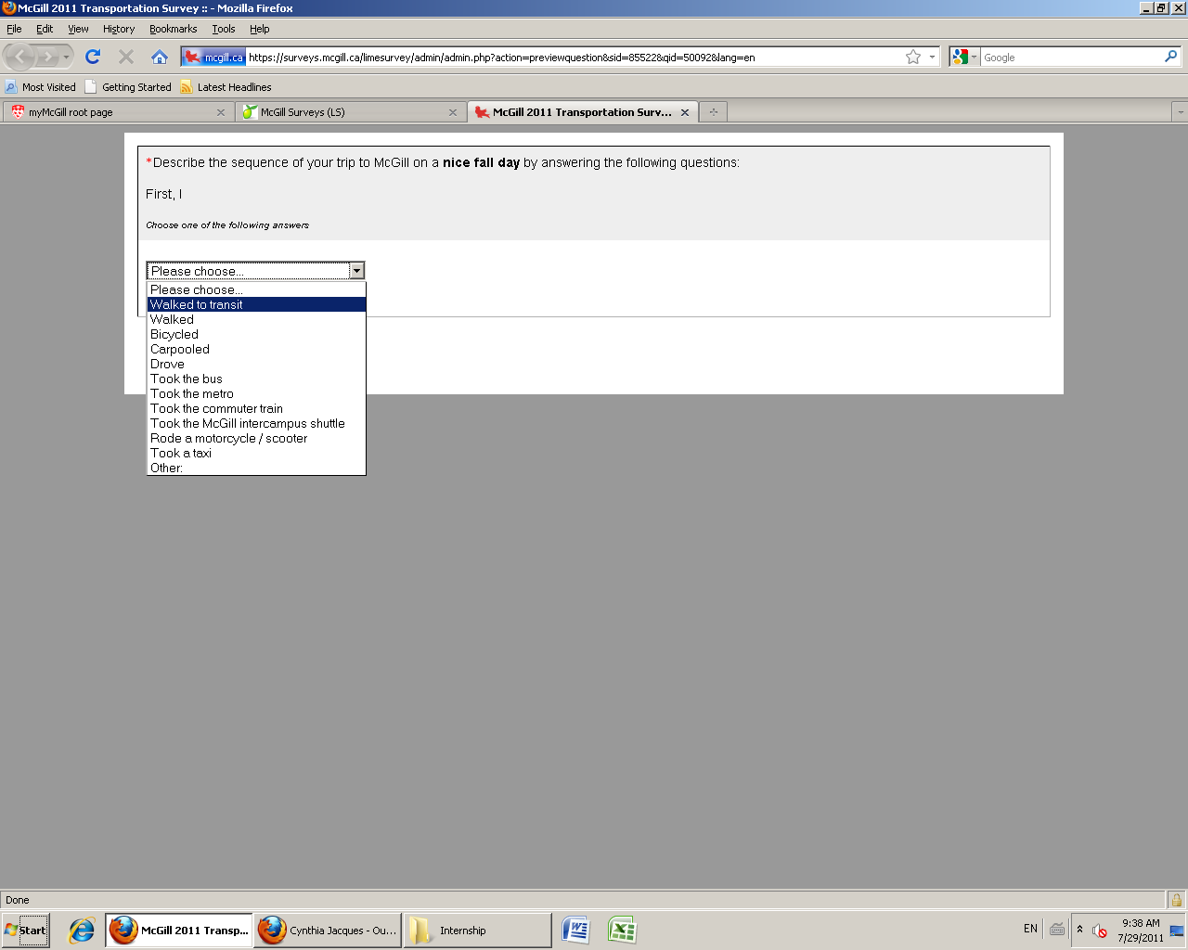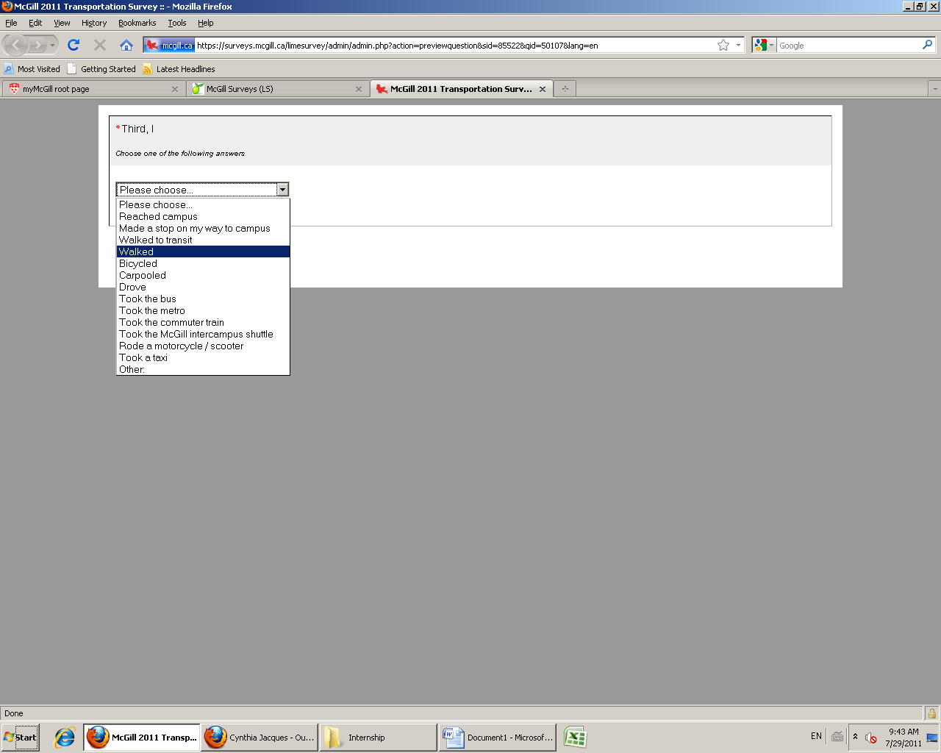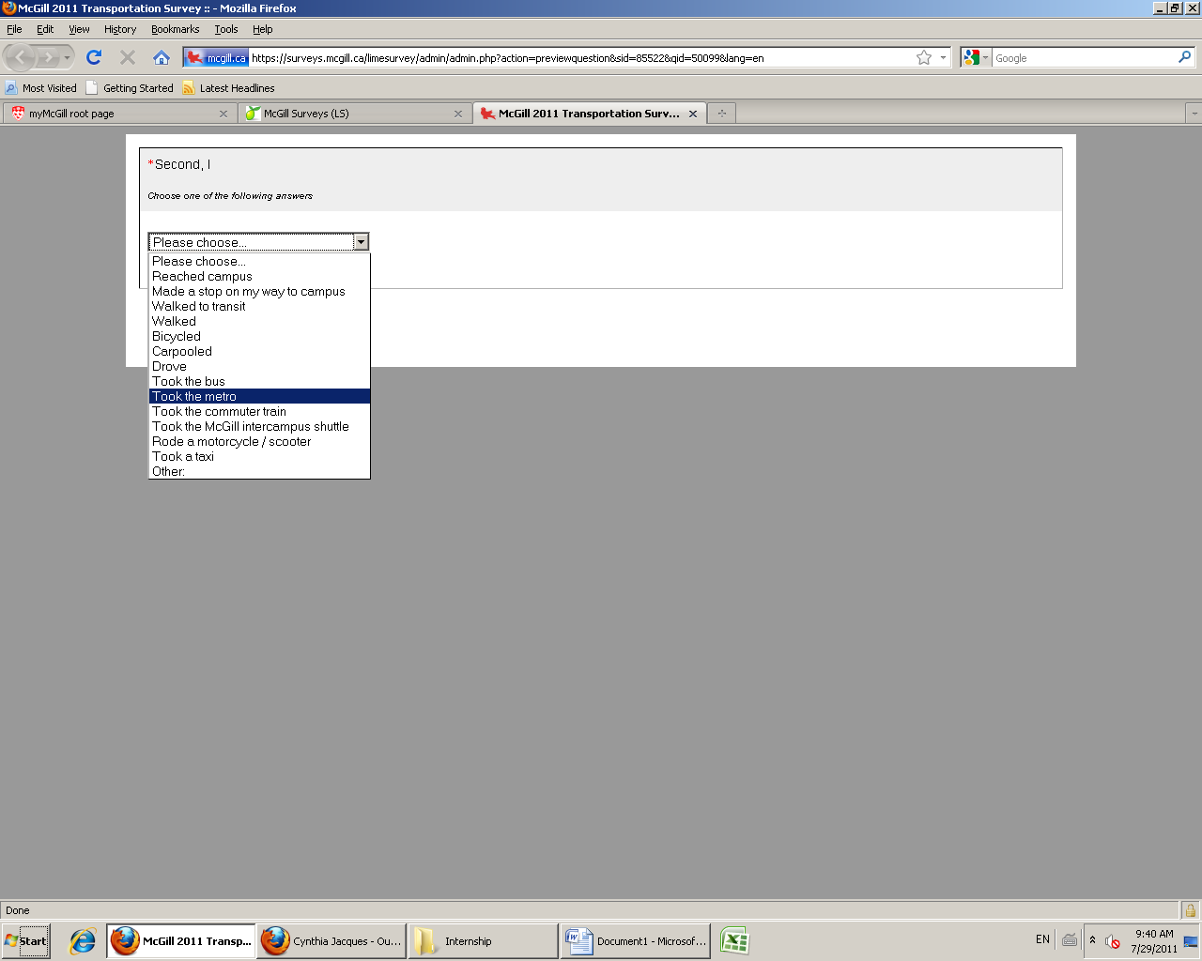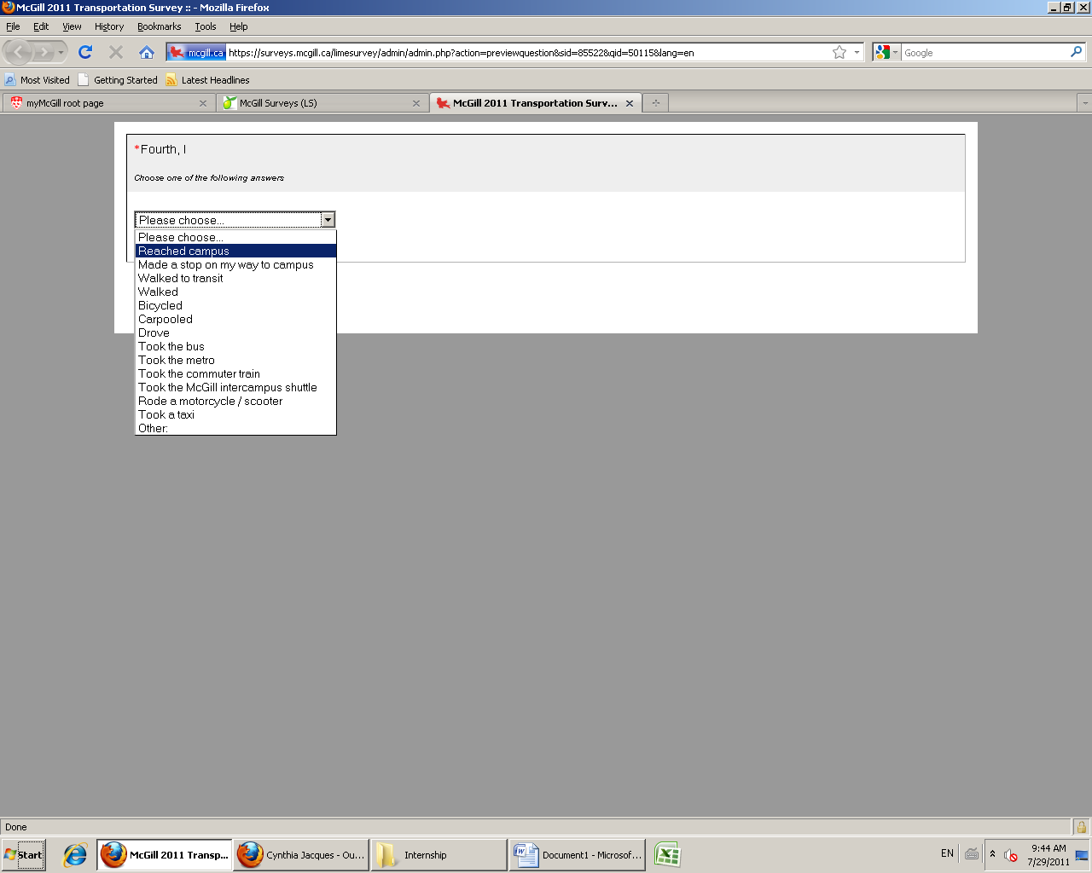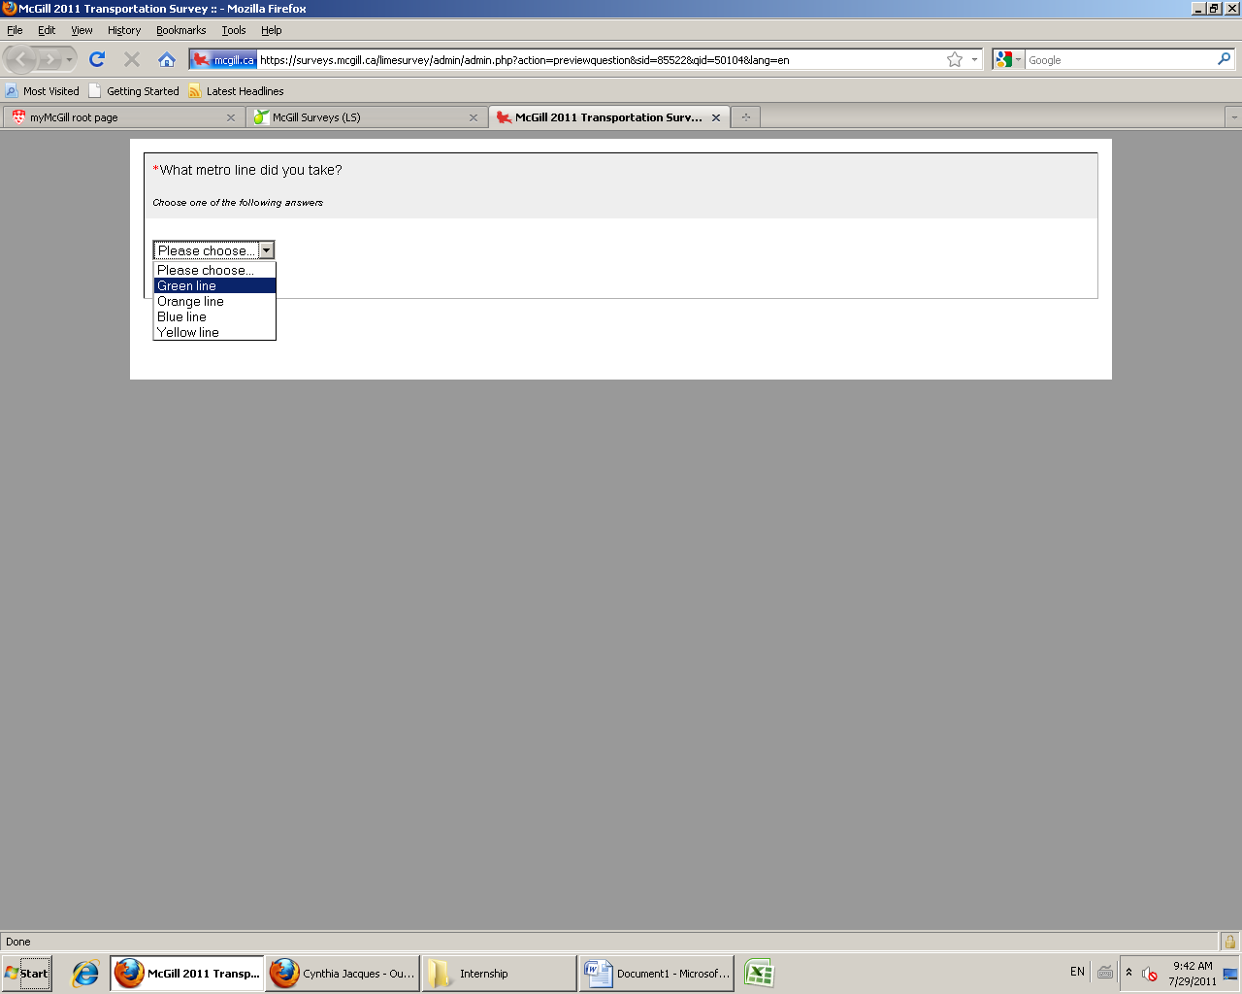

Figure 1: Screenshots of Commuter sequence questions in the Web-based Survey

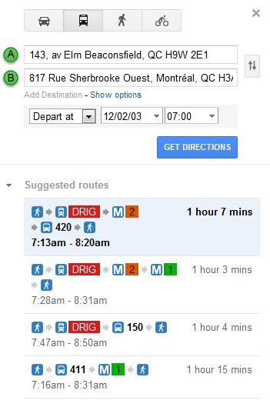

Figure 2: Transit route choice alternatives generated by Google Maps for a sample origin to McGill University

LIST OF TABLES

Table 1: Database summary statistics

Table 2: Binary logit model results for Home-Work commute mode choice

Table 3: Mixed Multinomial logit model results for transit route choice

Table 4: Policy sensitivity analysis of the travel mode choice model

Table 5: Policy sensitivity analysis of the transit route choice model

Table 1: Database summary statistics

|  |  |
| --- | --- |
| **Travel mode choice dataset** |  |
| Mean travel time by transit (min) | 19.0 |
| Mean in-vehicle travel time by car (min) | 37.1 |
| Initial Transit waiting time for transit users (min) | 7.9 |
| *Gender* |  |
| Males | 39.0 |
| Females | 61.0 |
| *Age* |  |
| <25 | 20.5 |
| 25-45 | 42.9 |
| 45-65 | 33.7 |
| >65 | 2.9 |
| *Employment Type* |  |
| Part-Time | 12.3 |
| Full-Time | 87.7 |
| *Vehicles Ownership* |  |
| 0 | 26.0 |
| 1 | 43.2 |
| 2 | 25.4 |
| 3 | 3.8 |
| 4+ | 1.6 |
| *Number of transfers for the transit alternative* |  |
| 0 | 49.6 |
| 1 | 33.5 |
| 2 | 15.0 |
| 3+ | 1.9 |
| **Transit route choice dataset** |  |
| Mean Travel Time | 23.5 |
| Mean Total Walking Time | 17.0 |
| Mean Total Waiting Time | 3.7 |
| Transit route alternatives comprising |  |
| Bus | 69.0 |
| Metro | 49.5 |
| Train | 14.8 |
| Average travel time by mode (min) |  |
| Bus | 21.4 |
| Metro | 10.3 |
| Train | 24.3 |

Table 2: Binary logit model results for Home-Work commute mode choice

|  |  |  |
| --- | --- | --- |
| Attributes | Parameter | t-stats |
| (Car alternative is the base) |  |  |
| Constant | 9.1685 | 8.691 |
| Age | -0.2425 | -6.062 |
| Age squared | 0.0022 | 5.453 |
| Respondent status |  |  |
| Staff member | 0.6073 | 3.915 |
| Student | 0.8001 | 2.913 |
| Full time member of the community | 0.3433 | 1.735 |
| Driver license status | -1.2406 | -3.559 |
| Household car ownership | -1.0623 | -11.582 |
| In-vehicle Travel time | -0.0594 | -7.004 |
| Transfers | -0.8143 | -9.145 |
| Walk time | -0.0145 | -1.419 |
| Initial Waiting Time | -0.0244 | -5.054 |
| Log-likelihood at Convergence | -685.7 | |
| Log-likelihood at constants | -1099.8 | |
| McFadden rho-square | 0.37 | |

Table 3: Mixed Multinomial logit model results for transit route choice

|  |  |  |
| --- | --- | --- |
| Attribute | Parameter | t-stats |
| Transit alternative has bus | -0.2375 | -1.066 |
| Transit alternative has metro | 0.6378 | 2.145 |
| Transit alternative has train | -1.5665 | -2.142 |
| The alternative with the earliest arrival time | 0.2361 | 2.209 |
| Travel time in bus | -0.2690 | -5.997 |
| Travel time in metro | -0.1616 | -3.238 |
| Travel time in train | -0.1737 | -3.420 |
| *Standard Deviation* | 0.0496 | 2.000 |
| Total Walking time | -0.3550 | -7.806 |
| Total Walking time squared | 0.0013 | 1.441 |
| *Standard Deviation* | 0.1297 | 4.191 |
| Number of transfers | -2.4985 | -8.101 |
| *Standard Deviation* | 0.9752 | 2.293 |
| Waiting Time per transfer | -0.0766 | -2.341 |
| Total travel time interactions with Socio-demographics |  |  |
| Female | 0.0688 | 2.955 |
| Age | 0.0012 | 1.584 |
| Faculty | -0.0395 | -1.465 |
| Log-likelihood at Convergence | -681.7 | |
| Log-likelihood at Equal shares | -1207.4 | |
| McFadden rho-square | **0.42** | |

Table 4: Policy sensitivity analysis of the travel mode choice model

|  |  |  |
| --- | --- | --- |
| **Attribute** | **Car** | **Transit** |
| Travel time by Transit reduced by 5 minutes | -11.51 | 5.15 |
| Travel time by Transit reduced by 10 minutes | -21.68 | 9.71 |
| Travel time by Car increased by 5 minutes | -11.60 | 5.20 |
| Travel time by Car increased by 10 minutes | -22.49 | 10.07 |
| Walking time to transit reduced by 5 minutes | -2.88 | 1.29 |
| Walking time to transit reduced by 10 minutes | -5.53 | 2.48 |
| Initial Waiting Time reduced by 5 minutes | -3.66 | 1.64 |
| Initial Waiting Time reduced by 10 minutes | -5.74 | 2.57 |
| No. of transfers (for transit) reduced by 1 | -18.75 | 8.39 |
| Household vehicle ownership reduced by 1 | -35.39 | 15.85 |

Table 5: Policy sensitivity analysis of the transit route choice model

|  |  |  |  |  |  |  |
| --- | --- | --- | --- | --- | --- | --- |
|  | **Bus** | | **Metro** | | **Train** | |
| **Reduction in Attribute by** | *5 minutes* | *10 minutes* | *5 minutes* | *10 minutes* | *5 minutes* | *10 minutes* |
| Travel Time | 19.41 | 31.13 | 9.33 | 18.27 | 7.51 | 20.08 |
| Walking Time | 27.37 | 42.09 | 20.04 | 38.74 | 9.80 | 20.59 |

1. The response rate from our survey is ~26%. The rate falls within the acceptable response rates observed from earlier literature (see Kaplowitz et al., 2004; Manfreda et al., 2008)