**A Flight Level Analysis of Departure Delay and Arrival Delay Using Copula-based Joint Framework**

**Sudipta Dey Tirtha**

Post-Doctoral Scholar

Department of Civil, Environmental & Construction Engineering

University of Central Florida

Tel: 407-543-7521

Email: [sudiptadeytirtha2018@knights.ucf.edu](mailto:sudiptadeytirtha2018@knights.ucf.edu)

ORCiD number: 0000-0002-6228-0904

**Tanmoy Bhowmik\***

Post-Doctoral Scholar

Department of Civil, Environmental & Construction Engineering

University of Central Florida

Tel: 1-407-927-6574; Fax: 1-407-823-3315

Email: [tanmoy78@knights.ucf.edu](mailto:tanmoy78@knights.ucf.edu)

ORCiD number: 0000-0002-0258-1692

**Naveen Eluru**

Professor

Department of Civil, Environmental & Construction Engineering

University of Central Florida

Tel: 407-823-4815, Fax: 407-823-3315

Email: [naveen.eluru@ucf.edu](mailto:naveen.eluru@ucf.edu)

ORCiD number: 0000-0003-1221-4113

Submitted To: Transportation Research Record: Journal of the Transportation Research Board

Submission Date: June 3, 2022

*Corresponding author

**ABSTRACT**

The main goal of the current study is to identify the factors affecting flight level airline delay by jointly modeling departure and arrival delays. Towards this end, we develop a novel copula-based group generalized ordered logit (GGOL) model system that accommodates for the influence of common observed and unobserved effects on flight departure and arrival delays. The proposed model is estimated using 2019 marketing carrier on time performance data compiled by BTS for 67 airports in the continental US. The delay data is augmented with a comprehensive set of independent variables including traffic conditions at the origin and destination airports in the hours preceding flight departure and arrival, trip level attributes, weather variables for the entire flight duration, spatial, and temporal factors. The model estimation results highlight that Joe copula model with parameterization provides the best data fit. The model performance is further established to be excellent using a holdout sample. Finally, to illustrate the applicability of the model for prediction and highlight the impact of independent variables, we perform a prediction exercise under a host of hypothetical scenarios. The illustration provides a mechanism for employing the proposed model as a tool for airline carrier level or airport level delay prediction analysis using weather forecasts while controlling for a host of independent variables.

**Keywords:** Departure delay, Arrival delay, Group generalized ordered logit, Weather factors, Traffic conditions

# INTRODUCTION

## Background and Earlier Research

In the United States, domestic airline industry is a key contributor to the economy. According to Federal Aviation Administration (FAA), commercial aviation industry accounts for 5.2% of US Gross Domestic Product (*1*). According to Bureau of Transportation Statistics (BTS), 21.03% of all flights operated in the US arrived late by 15 minutes or more in 2019 (the highest such percentage since 2015). Airline delays cause both direct and indirect costs to several components of the industry. The cost of airline delays attributed to passengers is estimated at $18.1 billion in 2019 (*2*). Costs attributed to airlines from additional expenses for crews, fuel and maintenance is estimated at $8.3 billion (*2*) not considering the impact of the worsening customer experience on airline attractiveness (*3*). Airline delays also cause indirect costs to different business sectors amounting to nearly $4.2 billion (*2*). Given these substantial negative impacts of airline delays on the US economy, understanding the factors influencing airline on time performance will allow airlines to improve their on-time performance or mitigate the delays by increasing and reallocating their resources such as aircrafts, crews, and staff.

In airline literature, airline delay can be considered as a departure and/or an arrival delay. According to BTS, departure/arrival delay can be defined as the time difference between scheduled and actual gate departure/arrival time. Traditionally, earlier studies identified the factors affecting airline delays and developed prediction models. A summary of previous studies examining airline delay is provided in Table 1 with information on the delay measure of interest, spatial resolution of analysis, number of airports considered, study objectives, methodology employed, and independent variables considered. From Table 1, we can make several observations. *First*, earlier studies on airline delay study three types of delay measures: (a) departure delay, (b) arrival delay and (c) both departure and arrival delay. From the review, a majority of earlier research analyzed either departure or arrival delay. The studies, modeling both departure and arrival delays, modelled the two delay categories independently. *Second*, earlier research on airline delay is conducted at three resolutions: (a) flight, (b) airport and (c) national airspace system (NAS) level. In the first resolution, studies analyzed airline delay for individual flights while in the latter two resolutions, delay is analyzed at an aggregate level of airport or network as an average daily delay. The review also shows that earlier studies analyzed airline delay data mostly employing a limited set of airports[1]. *Third*, the factors considered in modeling airline delays vary across the studies and include traffic conditions (average queuing delay, average arrival delay, total operations), trip specific factors (carrier, route, distance), weather conditions (visibility, wind speed, thunderstorm, precipitation, snow depth), spatial factors (location of origin and destination airports), and temporal factors (season, weekday/weekend, time of the day). Based on our review, weather factors considered in earlier research efforts can be grouped into three categories: airport level, route level and NAS level. Some of these studies conducted comprehensive analysis to examine the effect of convective weather condition on flight delay. For example, Hsiao & Hansen (*4*) analyzed airline delay at the system level and considered airport level and route level weather conditions using grid variables. Yu et al. (*5*) also considered route level weather condition in flight level model and considered delay records of previous flights along the same route as a surrogate measure. Dai et al. (*6*) proposed a model system to determine NAS level delay and employed system and airport specific weather variables in the model. Liu et al. (*7*) proposed an innovative approach to identify if a flight may encounter a convective weather condition along its route or not, using multiple weather data sources. *Fourth*, several mathematical models were employed in literature to predict airline delays and they can be broadly classified as (a) discrete outcome and (b) continuous outcome models. In discrete outcome models, the dependent variable is characterized as a binary outcome (flight delayed or not based on the BTS threshold of 15 minutes) or a categorical variable (for example, Gui et al. (*8*) categorized flight arrival delay in 4 groups). Among discrete outcome models, binary/multinomial logit models are generally employed to determine the factors affecting airline delay. Among continuous outcome models, where delay is measured in minutes, commonly employed models include: (a) linear regression model, (b) time series analysis, (c) machine learning approaches, (d) survival model, (e) piecewise regression model, and (f) optimization methods. *Finally*, discrete outcome models are more commonly employed in flight level analysis while continuous outcome models are employed in both disaggregate and aggregate level analysis.

## Contributions of the Current Study

In this study, our goal is to model departure and arrival delays in a joint framework at the disaggregate resolution of flights.

A major contribution of this study to literature arises from data enhancement for flight delay analysis. The variables processed from 2019 BTS marketing carrier on time performance data are augmented with a comprehensive set of independent variables sourced from secondary data sources including Automated Surface Observing System (ASOS) dataset (sourced from Iowa Environment Mesonet) and FAA’s Aviation System Performance Metrics (ASPM). We prepare weather variables – wind speed, hourly precipitation, thunderstorm proportion and visibility - from ASOS dataset. The data compilation is achieved by charting the potential airline flight route to identify weather conditions near the flight’s origin airport, along the route, and at the destination airport. Towards processing this weather data, we divide the continental US into a latitude longitude grid of 5 degrees and compile hourly weather data from all weather stations within each grid while estimating the flight path and its intersection with the grid system (more details in Data Section). The detailed process allows us to generate weather conditions for the entire duration of the flight. Subsequently, we employ ASPM data to determine air traffic conditions at the origin and destination airports in the hours preceding the flight’s departure and arrival, respectively. Finally, we perform spatial data enhancement in our study by considering all flights between 67 airports across the US to capture the effects of spatial factors on flight level delay. The selected 67 airports are a subset of ASPM 77 airports and include all operational evolution partnership (OEP-35) airports in the US. The data for our analysis is augmented with other independent variables including (a) trip specific factors (carrier and flight distance), (b) spatial factors (region of origin and destination airports) and (c) temporal factors (season, day of the week and time of the day). The reader would note that the current study is the first effort to consider the influence of high resolution spatio-temporal weather conditions along the entire flight on flight delay.

Employing the data prepared, the current research contributes to airport departure and arrival delay analysis by developing a novel copula-based group generalized ordered logit (GGOL) model. The proposed framework recognizes that delay measure in minutes is not exclusively a categorical variable or a continuous variable. A cursory examination of delay variable would indicate the presence of clusters of data points as delay increases i.e., as delay increases, it is likely to be rounded to larger time bins (such as 5 minutes or 15 minutes). For analyzing such data, the application of a purely discrete outcome model system while feasible, does not allow the estimation of a continuous measure in prediction (without any strong assumptions). On the other hand, employing a continuous variable representation is not appropriate with rounded values. Thus, in our proposed research we employ a hybrid framework that ties the continuous delay measure to a categorical variable allowing us to estimate the model as a discrete outcome system with the inherent ability to predict as a continuous variable (*9*–*11*) (more details in the Econometric Methodology section).

Our proposed model system also recognizes that it is very plausible that there might be some common unobserved factors influencing both delay categories. Given the obvious interactions between two types of delay variables, we develop a copula-based group generalized ordered logit model framework that accommodates for the influence of common observed and unobserved effects on flight departure and arrival delays. In this study, we also estimate and parameterize the error variance of the delay component to account for heteroscedasticity. The two GGOL model components are then stitched together as a joint distribution using the flexible copula-based approach. In our analysis, we employ six different copula structures – the Gaussian copula, the Farlie-Gumbel-Morgenstern (FGM) copula, and set of Archimedean copulas including Frank, Clayton, Joe and Gumbel copulas (see (*12*) for a detailed discussion). The value of the proposed model system is illustrated by comparing predictive performance of the proposed model relative to independent models of flight departure and arrival on a holdout sample (records not used in estimation). Finally, we conduct an application analysis to present the policy implications of the current research. The illustration provides a mechanism for employing the proposed model as a tool for airline carrier level or airport level delay prediction analysis using weather forecasts.

The rest of the paper is divided into five sections. In the subsequent section, we present the econometric methodology employed in the research including the GGOL model and the bivariate Copula model of departure and arrival delays. Next, we present data assembly and compilation procedures, and sample descriptive statistics in the Dataset Description section. The Analysis and Results section describes model selection processes, model estimation results and validation exercise. The Model Illustration section presents the application of the proposed model using different hypothetical scenarios of origin, route, and destination weather conditions. Finally, the concluding remarks are included in the last section.

**TABLE 1 Summary of Literature Review**

|  |  |  |  |  |  |  |
| --- | --- | --- | --- | --- | --- | --- |
| **Study** | **Dependent Variable** | **Spatial Resolution** | **No. of Airports** | **Objective** | **Method** | **Independent variables** |
| Hao et al. (*13*) | Average daily arrival delay (continuous) | Airport level | New York airports and OEP 32 airports | Estimating impact of NY airports’ delay on other airports | 2SLS regression model | Air traffic condition such as total operations and average queuing delay, weather factors including portion of thunderstorms in different regions in the US |
| Nayak and Zhang (*14*) | Average daily arrival delay (continuous) | Airport level | OEP 34 airports and other airports in NAS | Estimating impact of single airport delay on NAS | Multivariate simultaneous regression model | Air traffic condition such as queuing delay, observed arrival delay at other airports and NAS, weather factors (thunderstorms and IMC condition), temporal factors including seasonal and year |
| Schaefer and Millner (*15*) | Average arrival and departure delay per flight (continuous) | Airport level | 3 sample airports | Modeling propagation of delay | Air traffic simulation | Weather factors (IMC duration) |
| Klein et al. (*16*) | Average daily arrival delay (continuous) | Airport level | Major airports in US | Estimating airport delay using weather data | Regression model | NAS and airport weather conditions including wind speed, snow depth, IMC condition, queuing delay |
| Markovic et al. (*17*) | Average daily punctual flights (continuous) | Airport level | 1 airport in Germany | Identifying weather impact on arrival delays | Hybrid regression/time series modelling | Weather factors such as wind speed, snow depth, the traffic flow, and the airport system state (strikes, air traffic control failures, roadworks or safety related shutoffs) |
| Abdel-Aty et al. (*18*) | Average daily arrival delay and flight arrival delay (continuous) | Airport and flight level | 1 airport – MCO | Identifying periodicity in arrival delays | Multinomial logit model | Temporal factors, weather factors (precipitation) |
| Choi et al. (*19*) | Arrival delay (binary) | Flight level | 45 major airports in US | Identifying weather factors of arrival delay | Machine learning approach | Temporal factors, and weather factors such as wind speed, visibility, precipitation, snow depth, and weather intensity code |
| Perez Rodríguez et al. (*20*) | Arrival/departure delay (binary) | Flight level | All US airports | Estimating the daily probabilities of delay in aircraft arrivals. | Bayesian model | Trip specific factors including distance and airlines, temporal factor such as day of the week |
| Gui et al. (*8*) | Arrival Delay (categorical) | Flight level | -- | Flight delay prediction | Machine learning method (long short-term memory) | Air traffic condition, weather condition, temporal factors, spatial factors including origin and destination airport |
| Arora and Mathur (*21*) | Departure delay (binary) | Flight level | All US airports | Identifying the impact of airline choice and temporality on flight delays | Binary logit model | Trip specific factor (carrier) and Temporal factors |
| Wong and Tsai (*22*) | Flight delay propagation (continuous) | Flight level | -- | To study relationship between flight delays and the associated causes | Survival Model | Trip specific factors such as delay cause, aircraft type, air traffic condition (turnaround buffer time), temporal factors such as time of the day and season |
| Bhat (*23*) | Arrival delay (binary) | Flight level | -- | Identifying operating and financial factors of airline delays | Binary logit model | Operating and financial variables such as capital ratio and current ratio |
| Xu et al. (*24*) | Arrival delay (continuous) | Airport level | 34 OEP airports | To predict flight delays at airports in 15-min epochs | Piecewise linear regression model | Delay cause, Departure delay, Time, GDP holding time |
| Wong et al. (*25*) | Arrival and departure delay (continuous) | Flight level | 1 – Taipei airport | Identifying the factors and predict airline delays | Optimization model | Departure and arrival patterns, number of departure and arrival routes |
| Mueller and Chatterji (*26*) | Average daily arrival and departure delay (continuous) | Airport level | 10 airports in the US | Examining relation between airline demand and flight delay | Least Squares method | Traffic demand related factors such as number of departures, number of arrivals, time of the day, casual factors |
| Kim (*27*) | Arrival delay (continuous) | Flight level | 1 airport – Denver International Airport | Forecasting flight arrival time | Nonparametric additive techniques | Arriving and departing airport capacity, weather and airline, temporal factors including day of the month and month |
| Deshpande and Arıkan (*28*) | Truncated block time (continuous) | Flight level | All airports in US | Identifying the impact of scheduled block time on arrival delay | Ordinary least square regression | Route, carrier, temporal and spatial factors, traffic condition |
| Lee and Zhong (*29*) | Arrival delay (continuous) | Flight level | 1 airport – Singapore | Identifying the correlation between weather condition and flight delay | Linear regression and square root regression model | Weather factors such as rainfall and thunderstorm duration |
| Allan et al. (*30*) | Arrival delay type (categorical) | Airport level | 1 airport – Newark airport | Determining the delay cause and delay type based on weather data | Descriptive analysis | Weather factors including wind speed ceiling, visibility, and thunderstorm |
| Greenfield (*31*) | Arrival delay per flight (continuous) | Carrier and route level | Top 100 airports in US | To study the effects of market competition on airline delay | Regression analysis | Weather condition, airport traffic and market structure market structure, airline demand |

# ECONOMETRIC METHODOLOGY

In this section, econometric formulation of the copula-based group generalized ordered logit model (GGOL) model is presented. First, we present the formulation of independent GGOL models of flight departure and arrival delay. In independent GGOL models, we estimate two separate model systems without any dependency between the dependent variables. In bivariate Copula model, we consider the dependency between the departure and arrival delays by using different Copula dependency profiles.

## Flight Delay Model

Let *q (q=1,2,…,Q)*, and *k (k=1,2,…,K;K=2)* be the indices to represent flight and the corresponding delay type (departure/arrival), respectively. Let $j_{k}$*(=1,2,…J;J=6*) be the index for the discrete outcome that corresponds to delay levels for delay type $k$. In the group ordered response model, the discrete flight delay levels ${(y}_{qk})$ are assumed to be associated with an underlying continuous latent variable ($y_{qk}^{*}$). This latent variable is typically specified as follows:

|  |  |
| --- | --- |
| $y_{qk}^{*}=(α_{k}+ η_{qk}) z_{qk}+ε_{qk}$, $y_{qk}=j_{k}$ if $ψ_{j_{k}}<y_{qk}^{*}<ψ_{j_{k}+1}$ | (1) |

Where, $z_{qk}$ is a vector of exogenous variables for delay type $k$ for a flight $q$, $α_{k}$ is row of unknown parameters, $η_{qk}$ is a vector of coefficients representing the impact of unobserved factors moderating the influence of corresponding element of $z_{qk},$ $ψ_{j_{k}}$ and $ψ_{j_{k}+1}$ are the observed lower bound threshold and upper bound threshold, respectively for time interval level $j_{k}$ for delay type $k$. In this study, $ψ$ takes a value from -α, 5, 10, 15, 30, 60, +α. $ε_{qk}$ captures the idiosyncratic effect of all omitted variables for delay type $k$. The error terms are assumed to be independently logistic distributed with variance $λ_{qk}^{2}$. The variance vector is parameterized as follows:

|  |  |
| --- | --- |
| $λ_{qk}=\exp\left(ρ_{k}g_{qk}\right)$ | (2) |

Where, $g_{qk}$ is a set of exogenous variables (including a constant) associated with delay type $k$ for a flight $q$ and $ρ_{k}$ is the corresponding parameters to be estimated. $g_{qk}$ accommodates for the potential presence of heteroscedasticity within the grouped ordered framework. Finally, to allow for alternative specific effects, we also introduce threshold specific deviations in the model as $σ_{j_{k}}= τ_{j_{k}}z_{qk}$. The probability for delay type $k$ for time interval in category $j_{k}$ is given by:

|  |  |
| --- | --- |
| *Pr*($y_{qk}=j_{k}$) = $Λ\left(\frac{ψ_{j_{k}+1}-((α_{k}+η_{qk}) z_{qk}+σ_{j_{k}})}{λ_{qk}}\right)$- $Λ\left(\frac{ψ_{j_{k}}-((α_{k}+ η_{qk}) z_{qk}+σ_{j_{k}})}{λ_{qk}}\right)$ | (3) |

Where, $Λ(.)$ is the cumulative standard logistic distribution.

## Bivariate Copula Model

In examining the grouped time intervals across two delay types simultaneously, the levels of correlations between two dimensions of interests depend on the type and extent of dependency among the stochastic terms $(ε_{qk})$ of Equation 1. The joint probability function of involving departure delay level $j_{q1}$ and arrival delay level $j_{q2}$ for flight *q* can be expressed as (*32*):

|  |  |
| --- | --- |
| $$\operatorname{Pr}\left(y_{q1}=j_{q1}, y_{q2}=j_{q2}\right) ={Pr(ψ}_{j_{q1}}<{ y}_{q1}^{*}<ψ_{j_{q1}+1}, ψ_{j_{q2}}<{ y}_{q2}^{*}<ψ_{j_{q2}+1})$$ | (4) |

Now, the Equation 4 can be written as follows (*32*):

|  |  |
| --- | --- |
| $$\operatorname{Pr}\left(y_{q1}=j_{q1}, y_{q2}=j_{q2}\right)$$ $$=\sum_{a_{1}=1}^{2}{\sum_{a_{2}=1}^{2}{{(-1)}^{a_{1}+a_{2}}\left[Pr(y_{q1}^{*}<ψ_{j_{q1}+a_{1}-1}, y_{q2}^{*}<ψ_{j_{q2}+a_{2}-1})\right]}}$$ | (5) |

The copula is a device or function that generates a stochastic dependence relationship (*i.e.*, a multivariate distribution) among random variables with pre-specified marginal distributions (*12*), and can be defined as:

|  |  |
| --- | --- |
| $$C_{θ}(u_{1},u_{2},u_{3},…,u_{I})={Pr(U}_{1}<u_{1}, U_{2}<u_{2}, U_{3}<u_{3}, …, U_{I}<u_{I})$$ | (6) |

where $θ$ is a parameter vector of the copula commonly referred to as the dependence parameter vector. The Equation 5 can be written within a Copula system as (*32*):

|  |  |
| --- | --- |
| $$\operatorname{Pr}\left(y_{q1}=j_{q1}, y_{q2}=j_{q2}\right)$$ $$=\sum_{a_{1}=1}^{2}{\sum_{a_{2}=1}^{2}{{(-1)}^{a_{1}+a_{2}}\left[C_{θ_{q}}(u_{j_{q1}+a_{1}-1}, u_{j_{q2}+a_{2}-1})\right]}}$$ | (7) |

To allow for the dependency structure to vary across flights, the dependence parameter $θ_{q}$ is parameterized as a function of observed attributes as follows:

|  |  |
| --- | --- |
| $$θ_{q}=fn({γs}_{q})$$ | (8) |

where, $s_{q}$ is a column vector of exogenous variables, $γ$ is a vector of unknown parameters (including a constant) and $fn$ represents the functional form of parameterization. Based on the dependency parameter permissible ranges, alternate parameterization forms for the four copulas are considered in our analysis. For the Clayton and Frank copulas we employ $θ_{q}=exp({γs}_{q})$, and for Joe and Gumbel copulas we employ $θ_{q}=1+exp⁡({γs}_{q})$ (see (*33*–*35*) for a similar approach)*.* In our analysis we employ Gaussian copula, Farlie-Gumbel-Morgenstern (FGM) copula and four Archimedean copulas Frank, Clayton, Joe and Gumbel copulas (*12*).

In examining the model structure of flight delay across two delay types, it is also necessary to specify the structure for the unobserved vector $η_{qk}$ represented by **Ω**. In this paper, it is assumed that $η_{qk}$ is drawn from a normal distribution: Ω $\sim N(0, {π_{k}}^{2})$. Thus, the conditional likelihood function for flight *q* based on the joint probability expression in Equation 7 can be expressed as:

|  |  |
| --- | --- |
|  | (9) |

where $w_{qj_{1}j_{2}}$ is a dummy indicator variable. For a flight *q*, $w_{qj_{1}j_{2}}$ takes a value of 1 if departure delay level is $j_{1}$ and arrival delay level is $j_{2}$, and 0 otherwise. The unconditional likelihood function for flight *q* can be constructed as:

|  |  |
| --- | --- |
|  | (10) |

Now, we can express the log-likelihood function as follows:

|  |  |
| --- | --- |
| $$LL= \sum_{q=1}^{Q}{ln(L_{q})}$$ | (11) |

The parameters to be estimated in the copula model are $α_{k},τ_{j_{k}}, ρ,γ, π_{k}$. All the parameters are estimated by maximizing the log-likelihood function presented in Equation 11. The reader would note that the proposed discrete outcome model system can be employed to predict a continuous measure of delay by generating the estimate of $y_{qk}^{*}$ based on model results. Thus, the proposed hybrid approach allows us to handle the presence of rounded delays (see (*9*) for implementation details).

# DATASET DESCRIPTION

The main data for our study is drawn from the BTS 2019 non-stop domestic marketing carrier on time performance dataset. Marketing on time performance dataset includes departure and arrival data for 10 marketing carriers who market flights for themselves and their regional code share partners. On-time performance dataset offers flight level information including scheduled and actual gate departure/arrival date and time, departure/arrival delay in minutes, delay cause, cancellation and diversion indicator, origin and destination airports, marketing carrier and operating carrier. Initially, we started our analysis considering all the 77 ASPM airports. However, 10 of these airports do not report any considerable operations and hence, we excluded these airports from the dataset. The final dataset consists of all the flights operated in 2019 between 67 selected airports in the US. After excluding all cancelled and diverted flights, the final dataset results in a total 5,053,375 observations.

For our estimation sample, we randomly sample 200 flights departing from each of the selected 67 airports, resulting in a dataset of 13,400 records. For a validation sample, we sampled 100 flights departing from each airport amounting to 6,700 records. The dependent variables, departure delay and arrival delay are categorized (in minutes) into 6 groups (0-5, 5-10, 10-15, 15-30, 30-60, >60 minutes). Distributions of departure and arrival delay categories are presented in Figure 1. From the figure, we observe that 18.12% of the domestic flights in 2019 departed late and 17.97% flights arrived late by more than 15 minutes.

**FIGURE 1 Distribution of flight departure and arrival delays**

## Independent Variables

Airline delay variables are augmented with a host of independent variables. The variables considered in this study are chosen based on variables considered in earlier research and our judgement. We significantly improve flight data for delay analysis by preparing high-resolution weather and traffic condition data in our study. Detailed description of the variable generation process by variable group follows.

### Airport Level Traffic Conditions

Airport level traffic conditions includes air traffic and delay variables at the origin and destination airports. FAA’s ASPM dataset provides hourly air traffic and delay information at the airport level. In this study, we aggregate hourly level data in the preceding 6 hours before scheduled departure and arrival time of a flight at the origin and destination airports. Airport level traffic condition at the origin (destination) airport includes scheduled number of departures (arrivals), percentage of on time gate departures (arrivals), percentage of on time airport departures, average gate departure (arrival) delay, average taxi out (in) delay, and average airport departure delay.

### Trip Level Attributes

Trip level attributes are mainly sourced from BTS airline on time performance dataset and includes distance and operating carrier. In case of operating carrier, we consider 7 major operating carriers including Southwest Airlines, American Airlines, Delta Air Lines, United Air Lines, SkyWest Airlines, JetBlue Airways, and other airlines based on the distribution.

### Weather Factors

We compile a comprehensive set of weather variables including thunderstorm occurrence, hourly precipitation, visibility, and wind speed at the origin, destination and along the route sourced from ASOS dataset from Iowa Environmental Mesonet (*36*). The weather variable data generation process includes series of steps. First, the airline route is generated for every origin destination pair considering the shortest geodesic path between the origin and destination[2]. Second, we divide continental US into a latitude longitude grid of 5 degrees (see Figure 2) and compile hourly weather data from all weather stations within each grid. Third, we identify weather conditions at the origin airport during flight departure by aggregating weather data from multiple stations during departure hour and preceding 2 hours at the origin grid. Similarly, we identify weather conditions at the destination airport considering weather conditions during arrival hour and preceding 2 hours. Third, we identify the sequence of exact grid units along a route allowing us to generate the time when a flight passes through a grid and record its corresponding weather condition based on weather stations in the grid. To find the intermediate grid, we first identify the shortest route between origin and destination airports considering geodesic distance. Routes between the airports considered in this study are presented in Figure 2. Then, we identify direction of a flight in terms of grids using distance between origin airport and centroids of intermediate grids. In our processed dataset, number of intermediate grids between origin and destination airports varies from 0 to 11 (higher number of grids for longer flights). Finally, we allocate flight duration based on the distances between origin airport and grids’ cut points to determine the hour of passing and corresponding weather condition[3]. This process allows us to generate weather conditions during the entire flight.

**FIGURE 2 Grid system and routes between the airports**

To illustrate the whole process, we describe the weather variable generation process in Figures 3a to 3c for a flight from John F. Kennedy International Airport (JFK) to Seattle International Airport (SEA). Consider a non-stop flight that is scheduled to depart at 6:30am Coordinated Universal Time (UTC) and arrive at 12:30pm UTC. First, we identify weather conditions (90 percentile wind speed, 90 percentile precipitation, thunderstorm proportion and 10 percentile visibility across weather stations) in the origin grid at 4am-5am, 5am-6am and 6am-7am. Similarly, we identify weather condition in destination grid for 10am-11am, 11am-12pm and 12pm-1pm. Then, we aggregate weather condition measures of 3 hours to estimate origin and destination weather variables (see Figure 3a). Second, we identify the shortest route between JFK and SEA and obtain a path of 10 intermediate grids. Now, we rank intermediate grids from 1 to 10 based on distance between JFK and centers of the grids as shown in Figure 3b. Third, we estimate the distances of grid cut points from JFK and calculate the average distances of the grids. Based on average distance, scheduled departure time, trip length and trip duration, we determine the hour when a flight passes a grid (see Figure 3c) and identify the weather conditions in each individual intermediate grid.

### Spatial Factors

We consider the location of origin and destination airports in terms of US regions including South, Northeast, West, and Midwest.

### Temporal Factors

In this current study, we also investigate presence of any temporal variability in flight delays. We consider different temporal variables including time of the day, day of the week and season.

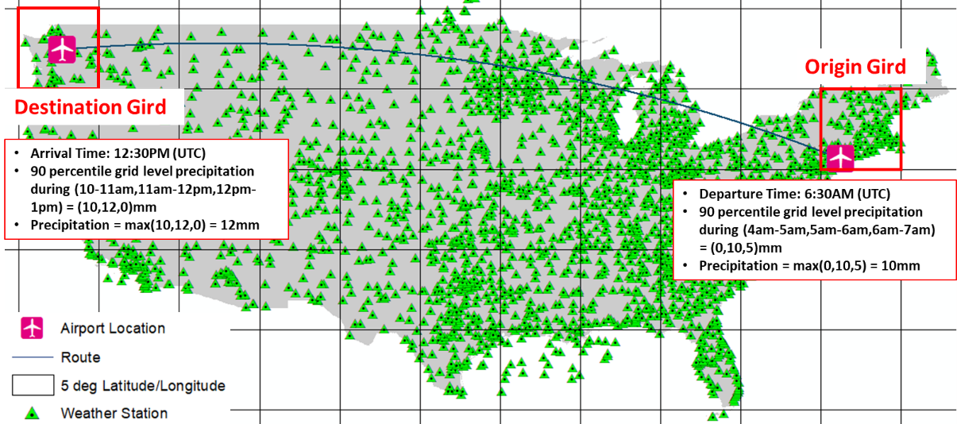

**FIGURE 3a** **Weather condition at origin and destination airports**

**FIGURE 3b** **Identification of intermediate grids and their sequence**

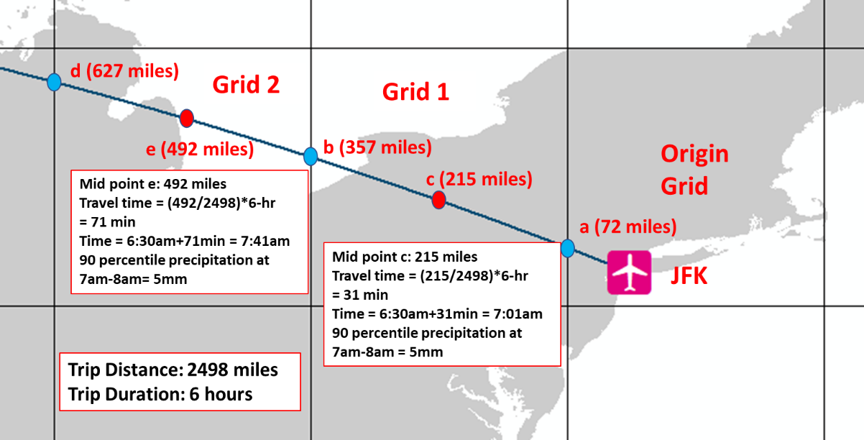

**FIGURE 3c** **Weather condition estimation at intermediate grid**

Table 2 offers the summary statistics (minimum, maximum and average values for continuous variables; frequency for categorical variables) of the considered exogenous variables for the estimation sample.

**TABLE 2 Descriptive Statistics of Independent Variables**

|  |  |  |  |
| --- | --- | --- | --- |
| **Continuous Variables** | | | |
| **Variable** | **Description** | **Mean** | **Min/Max** |
| ***Airport Level Traffic Condition*** | | | |
| Origin Airport Level Traffic Condition | | | |
| Scheduled departures | Scheduled departures in preceding 6-hrs of flight departure | 84.71 | 0.00/522.00 |
| On time gate departures | % On time gate departures in preceding 6-hrs of flight departure | 80.35 | 0.00/100.00 |
| On time airport departures | % On time airport departures in preceding 6-hrs of flight departure | 73.23 | 0.00/100.00 |
| Gate departure delay | Average gate departure delay (min) in preceding 6-hrs of flight departure | 12.68 | 0.00/344.00 |
| Taxi out time | Average taxi out time (min) in preceding 6-hrs of flight departure | 15.80 | 0.00/86.00 |
| Taxi out delay | Average taxi out delay (min) in preceding 6-hrs of flight departure | 5.42 | 0.00/76.75 |
| Airport departure delay | Average airport departure delay (min) in preceding 6-hrs of flight departure | 16.65 | 0.00/367 |
| Destination Airport Level Traffic Condition | | | |
| Scheduled arrivals | Scheduled arrivals in preceding 6-hrs of flight arrival | 152.8 | 0.00/530.00 |
| On time gate arrivals | % On time gate arrivals in preceding 6-hrs of flight arrival | 80.06 | 0.00/100.00 |
| Taxi in delay | Average taxi in delay (min) in preceding 6-hrs of flight arrival | 3.12 | 0.00/38.99 |
| Block delay | Average block delay (min) in preceding 6-hrs of flight arrival | 3.49 | 0.00/67.61 |
| Gate arrival delay | Average gate arrival delay (min) in preceding 6-hrs of flight arrival | 13.51 | 0.00/211.00 |
| ***Trip Level Attributes*** | | | |
| Distance | Ln(Trip Distance+1) | 6.48 | 4.22/7.91 |
| ***Weather Factors*** | | | |
| Origin Grid Level Weather Condition | | | |
| Wind Speed | Max(90 percentile wind speed (mph) in origin grid during departure hour, 1 hour before, and 2 hours before departure) | 12.92 | 2.30/35.27 |
| Hourly Precipitation | Max(90 percentile precipitation(mm) in origin grid during departure hour, 1 hour before, and 2 hours before departure) | 0.18 | 0.00/6.96 |
| Thunderstorm proportion | Max(percentage of weather stations recording a thunderstorm event in origin grid during departure hour, 1 hour before, and 2 hours before departure) | 1.55 | 0.00/59.79 |
| Visibility | Min(10 percentile visibility (miles) in origin grid during departure hour, 1 hour before, and 2 hours before departure) | 7.09 | 0.22/10.00 |
| Route Level Weather Condition[4] | | | |
| Wind Speed | 90 percentile wind speed (mph) in intermediate grid during the hour of passing | 12.02 | 0.00/40.86 |
| Precipitation | 90 percentile precipitation(mm) in intermediate grid during the hour of passing | 0.12 | 0.00/6.48 |
| Thunderstorm | Percentage of weather stations recording a thunderstorm event in intermediate grid during the hour of passing | 1.24 | 0.00/75.00 |
| Visibility | 10 percentile visibility (miles) in intermediate grid during the hour of passing | 7.92 | 0.21/10.00 |
| Destination Grid Level Weather Condition | | | |
| Wind Speed | Max(90 percentile wind speed (mph) in destination grid during arrival hour, 1 hour before, and 2 hours before arrival) | 13.08 | 1.38/37.45 |
| Precipitation | Max(90 percentile precipitation(mm) in destination grid during arrival hour, 1 hour before, and 2 hours before arrival) | 0.17 | 0.00/8.83 |
| Thunderstorm | Max(percentage of weather stations recording a thunderstorm event in destination grid during arrival hour, 1 hour before, and 2 hours before arrival) | 1.55 | 0.00/56.67 |
| Visibility | Min(10 percentile visibility (miles) in destination grid during arrival hour, 1 hour before, and 2 hours before arrival) | 7.41 | 0.25/10.00 |
| **Categorical Variables** | | | |
| **Variable** | **Description** | **Freq.** | **Percent** |
| ***Trip Level Attributes*** | | | |
| Operating Carrier | | | |
| Southwest Airlines |  | 3602 | 26.88 |
| American Airlines |  | 1719 | 12.83 |
| Delta Air Lines |  | 1659 | 12.38 |
| United Air Lines |  | 994 | 7.42 |
| SkyWest Airlines |  | 919 | 6.86 |
| JetBlue Airways |  | 714 | 5.33 |
| Other Airlines | Endeavor Air Inc., Alaska Airlines Inc., Spirit Air Lines, etc. | 3793 | 28.31 |
| ***Spatial Factors*** | | | |
| Region (Origin Airport) | | | |
| South |  | 5000 | 37.31 |
| Northeast |  | 2400 | 17.91 |
| West |  | 3800 | 28.36 |
| Midwest |  | 2200 | 16.42 |
| Region (Destination Airport) | | | |
| South |  | 5281 | 39.41 |
| Northeast |  | 1953 | 14.57 |
| West |  | 4005 | 29.89 |
| Midwest |  | 2161 | 16.13 |
| ***Temporal Factors*** | | | |
| Time of the Day (Departure) | | | |
| Morning | 6am – 10am (local time) | 3829 | 28.57 |
| Midday | 10am – 4pm (local time) | 4818 | 35.96 |
| Evening | 4pm – 8pm (local time) | 3231 | 24.11 |
| Nighttime | 8pm – 6am (local time) | 1522 | 11.36 |
| Time of the Day (Arrival) | | | |
| Morning | 6am – 10am (local time) | 2474 | 18.46 |
| Midday | 10am – 4pm (local time) | 4748 | 35.43 |
| Evening | 4pm – 8pm (local time) | 3189 | 23.80 |
| Nighttime | 8pm – 6am (local time) | 2989 | 22.31 |
| Day of the Week (Departure) | | | |
| Saturday |  | 1586 | 11.84 |
| Other Days |  | 11814 | 88.16 |
| Day of the Week (Arrival) | | | |
| Saturday |  | 1613 | 12.04 |
| Other Days |  | 11787 | 87.96 |
| Season | | | |
| Spring | March, April, May | 3519 | 26.26 |
| Summer | June, July, August | 3367 | 25.13 |
| Fall | September, October, November | 3354 | 25.03 |
| Winter | December, January, February | 3160 | 23.58 |

# ANALYSIS AND RESULTS

## Model Selection

The empirical analysis involves the estimation of models by using six different copula structures: a) FGM, b) Frank, c) Gumbel, d) Clayton, e) Joe and f) Gaussian copulas. A series of models were estimated, and the best data fit is chosen based on Bayesian Information Criterion (see Figure 4). First, an independent copula model (separate GGOL models for flight departure delay and arrival delay) is estimated to establish a benchmark for comparison. Second, we recognize that arrivals and departures delay models have similar coefficients for 3 origin and destination grid weather variables (wind speed, precipitation, and thunderstorms). Therefore, we estimate a restricted version of independent copula model where we restrict 3 origin and destination grid weather variables to be same across departure and arrival delays. The restricted model offered improved fit relative to unrestricted model in terms of BIC. Third, six different models considering six copula dependency structures across departure delay and arrival delay are estimated. Based on log-likelihood (LL) and BIC measures, Joe copula dependency structure provides the best fit. Subsequently, the copula profile of selected Joe model has been parameterized (see Equation 8). Parameterized Joe copula model shows improved data fit in terms of the BIC measure. Further, the log-likelihood ratio test yields a statistics value of 20.64 which is substantially larger than the critical value (= 9.21) with 2 degrees of freedom at 99% confidence level. Therefore, Joe copula model with parameterization of the copula profile is selected as the final model[5].

The readers should note that the sample size employed in the modeling can be possibly biased. Hence, prior to finalizing the model results, we have conducted a rigorous examination of the model performance based on different samples. The analysis procedure and results are included in the supplementary materials. The results illustrate that our model estimation results are stable and quite representative of the data.

* Joe-Param. = Joe copula model with parameterization

**FIGURE 4** **Comparison of alternative models**

## Estimation Results

In this sub-section, we discuss estimation results from the joint copula model with Joe copula dependency (with parameterization).

### Airport Level Traffic Conditions

Airport level traffic conditions at origin and destination airports are found to be significantly associated with flight departure and arrival delay, respectively. Among the variables considered in the analysis, number of scheduled departures and average gate departure delay at the origin airport during previous 6 hours of a flight affect departure delay while average gate arrival delay at the destination airport during previous 6 hours of flight arrival affects arrival delay. The estimation results show that increased number of scheduled departures and gate departure delay at origin airport increase the likelihood of a flight to be delayed. Similarly, increased average gate arrival delay at the destination airport increases the likelihood of a flight to be delayed. This result is very intuitive in that adverse traffic condition at the origin and destination airports mostly trigger flight delay.

### Trip Level Attributes

Among trip specific factors, trip distance and operating carrier have significant effect on flight delay. Interestingly, we find the influence of trip distance on the departure delay only. The results indicates that departure delay increases with increased trip distance in general.It is an interesting finding that only departure delay is influenced by trip distance. It is plausible that longer flights have more opportunity to compensate for any initial delay by adjusting their route, a mechanism called “direct routing” (*37*). Given this flexibility, it is possible airports alter the departure times of flights with longer distance more often than other flights.In terms of operating carrier, we find Delta Air Lines to provide the best on time performance as indicated by the negative coefficient on both departure and arrival delay. Further, the parameter estimates also suggest reduced departure delay if the flight is operated by United Air Lines and SkyWest Airlines. In terms of arrival delay, flights operated by American Airlines, JetBlue Airways and other airlines are susceptible to longer delays as indicated by the positive coefficient in Table 3.

### Weather Factors

The results corresponding to the weather level factors highlight the important role of weather in flight’s delay (both departure and arrival). In this current study, we consider three set of weather variables: origin level, along the route and destination level. Origin level weather factors are considered in departure delay component. On the other hand, route level and destination level weather variables are considered in arrival delay component. As discussed earlier, effects of the corresponding origin level and destination level weather variables (same effect for wind speed on departure and arrival delay; similar too for hourly precipitation, and thunderstorm proportion) are restricted to be same on departure delay and arrival delay. All the weather level variables offer expected trends for both departure and arrival delay. For instance, if adverse weather condition exists at/near the origin/destination airports including higher precipitation, higher wind speed and higher frequency of thunderstorm, a flight will be more likely to experience increased departure and arrival delay which is intuitive. Further, our results also underscore the association of visibility with the arrival delay. As expected, decreased level of visibility near destination airport causes increased arrival delay. Under adverse weather conditions, flight operators are unlikely to operate under optimal conditions affecting flight speed and landing operations. It is important to note that effects of intermediate grid level weather variables are accommodated in the arrival delay model. The number of intermediate grids between origin and destination airports varies from 0 to 11. So, the maximum number of weather variable columns is 22 (2 significant weather factors * 11 intermediate grids). For example, a flight from JFK to SEA has 11 intermediate grids and will have 11 potential non-zero values for precipitation (mm) for the 11 grids (grid1, grid2, …., grid11). On the other hand, a flight from TUS to SEA has only 3 intermediate grids and hence only 3 potential non-zero value of precipitation. It should be also noted that for each weather indicator, we estimate a single effect across all intermediate grids. The results indicate that intermediate grid level hourly precipitation and thunderstorm proportion have significant positive impact on arrival delay indicating the higher likelihood of arrival delay with increased amount of precipitation and thunderstorm along the route (as expected).

### Spatial Factors

The influence of spatial factors (such as location of origin and destination airports) represent factors specific to these airports that are usually unobserved to the analyst. For example, the airport crew hours and shifts are likely to be similar in a region and thus can positively or negatively affect delay. The exact details of these variables are not easy to obtain. Hence, it is accommodated through regional and/or temporal indicator variables. It is evident from estimation results that flight delay is closely associated with location of origin and destination airports. Flights departing from airports located in Northeast region in the US experience less departure delay compared to flights from other regions in the US (when all other factors are the same). For arrival delay model component, we observe that flights destined to airports in the West region experience increased arrival delay compared to airports in other regions (when all other factors are the same).

### Temporal Factors

Among the temporal factors considered in this study, time of the day, day of the week and season were significantly associated with flight delays. In general, departure delay is found to be less in the morning time period and higher in the evening time period compared to nighttime and midday even after controlling for scheduled arrivals and departures. On the other hand, arrival delay is found to be lower in morning and midday periods compared to other times of the day. From the parameter estimates, we found effects of day of the week and season consistent across departure and arrival delay. Results show that departure and arrival delays are lower on Saturday compared to other days in a week. It is also evident that both departure delay and arrival delay are more frequent in summer season and less frequent in fall season relative to delays in winter and spring seasons.

### Threshold Specific Effects

The proposed delay model also accommodates for threshold specific effects on various predefined thresholds. The estimation results of these parameters are reported in the second-row panel of Table 3 and have no substantive interpretation.

### Variance Components

We estimate variance of delay model components as a function of exogenous variables. From the results, it is evident that the morning time period variable contributes to the variance profiles of both departure and arrival delay models. Specifically, morning time period delay is subject to a higher variance relative to delay in other time periods. Additionally, Northeast region variable affects variance component of the departure delay model. Significance of such factors indicates the presence of heteroscedasticity in the delay data.

### Dependence Effects

As indicated earlier, the estimated Joe copula based GGOL model with parameterization provides the best fit incorporating the correlation between departure delay and arrival delay. The result of the dependency profile is presented in the last row panel of Table 3. The results clearly highlight the presence of common unobserved factors affecting departure delay and arrival delay. Joe dependency is found positive indicating upper tail dependency between departure and arrival delays. Such correlation indicates that unobserved factors modifying the likelihood of higher-level departure delay categories also modify the likelihood of higher-level arrival delay categories. Among the various variables considered, we found that season variable affects dependence structure. Specifically, the results indicate a stronger dependence between departure and arrival delay during Spring and Summer seasons.

**TABLE 3 Parameter Estimates of Delay Model**

|  |  |  |  |  |
| --- | --- | --- | --- | --- |
| **Variables** | **Departure Delay** | | **Arrival Delay** | |
| **Estimates** | **t statistics** | **Estimates** | **t statistics** |
| **Propensity Component** | | | | |
| Constant | -70.194 | -15.603 | -39.431 | -18.244 |
| ***Airport Level Traffic Condition*** | | | | |
| Origin airport's delay condition in previous 6-hr | | | | |
| Scheduled departures | 0.016 | 3.945 | -- | -- |
| Average gate departure delay (min) | 0.205 | 6.743 | -- | -- |
| Destination airport's delay condition in previous 6-hr | | | | |
| Average gate arrival delay (min) | -- | -- | 0.391 | 13.950 |
| ***Trip Level Attributes*** | | | | |
| Distance | 5.477 | 9.104 | -- | -- |
| Operating Carrier (base: Southwest Airlines) | | | | |
| Delta Air Lines | -11.636 | -5.947 | -6.282 | -3.306 |
| American Airlines | -- | -- | 7.046 | 5.940 |
| United Air Lines | -9.071 | -6.149 | -- | -- |
| SkyWest Airlines | -6.703 | -4.186 | -- | -- |
| JetBlue Airways | -- | -- | 4.952 | 2.910 |
| Other Airlines | -- | -- | 7.600 | 8.150 |
| ***Weather Factors*** | | | | |
| Origin level weather condition | | | | |
| Wind speed (mph) | 0.332 | 5.345 | -- | -- |
| Hourly precipitation (mm) | 1.083 | 2.278 | -- | -- |
| Thunderstorm proportion | 0.198 | 3.842 | -- | -- |
| Destination level weather condition | | | | |
| Wind speed (mph) | -- | -- | 0.332 | 5.345 |
| Hourly precipitation (mm) | -- | -- | 1.083 | 2.278 |
| Thunderstorm proportion | -- | -- | 0.198 | 3.842 |
| Visibility (miles) | -- | -- | -0.468 | -3.594 |
| Route level weather condition | | | | |
| Hourly precipitation (mm) | -- | -- | 1.842 | 4.953 |
| Thunderstorm proportion | -- | -- | 0.258 | 6.756 |
| ***Spatial Factors*** | | | | |
| Region (origin airport) (Base: other regions) | | | | |
| Northeast | -6.937 | -3.173 | -- | -- |
| Region (destination airport) (Base: other regions) | | | | |
| West | -- | -- | 2.377 | 2.976 |
| ***Temporal Factors*** | | | | |
| Time of the day (Departure) (base: midday and nighttime) | | | | |
| Morning | -21.277 | -8.169 | -- | -- |
| Evening | 4.189 | 4.508 | -- | -- |
| Time of the day (Arrival) (base: evening and nighttime) | | | | |
| Morning | -- | -- | -14.882 | -5.786 |
| Midday | -- | -- | -6.509 | -7.017 |
| Day of the week (Departure) (base: other day of the week) | | | | |
| Saturday | -6.830 | -3.726 | -- | -- |
| Day of the week (Arrival) (base: other day of the week) | | | | |
| Saturday | -- | -- | -9.387 | -5.394 |
| Season (base: Spring and winter) | | | | |
| Summer | 4.604 | 3.114 | 4.329 | 2.957 |
| Fall | -8.899 | -5.667 | -8.701 | -5.747 |
| **Threshold Specific Effect** | | | | |
| Threshold 2 | 6.930 | 10.707 | 8.034 | 12.490 |
| Threshold 3 | 2.749 | 6.724 | 3.330 | 8.144 |
| Threshold 5 | -3.664 | -6.575 | -2.724 | -5.113 |
| **Variance Component** | | | | |
| Constant | 3.463 | 139.902 | 3.467 | 148.611 |
| Time of the day (Departure) (base: other time) | | | | |
| Morning | 0.152 | 3.691 | -- | -- |
| Time of the day (Arrival) (base: other time) | | | | |
| Morning | -- | -- | 0.100 | 2.359 |
| Region of origin airport (Base: Other regions) | | | | |
| Northeast | 0.119 | 3.067 | -- | -- |
| **Dependence Effect** | | | | |
| **Variables** | **Estimates** | | **t statistics** | |
| Constant | 0.822 | | 24.693 | |
| Season (base: Fall and Winter) | | | | |
| Spring | 0.198 | | 4.064 | |
| Summer | 0.177 | | 3.661 | |

## Model Validation

To test the predictive performance of the proposed model, we perform a validation exercise with the 6700-record holdout sample. For testing the predictive performance of the copula model and its independent counterpart, 25 data samples of 500 records each, are randomly generated from the hold out validation sample. The average log-likelihood and BIC score for the proposed copula model are -807.81 [-824.98, -790.63] and 1895.27 [1860.92, 1929.62], respectively. The average log-likelihood and BIC score for independent model (with restriction) of departure and arrival delays are -968.54 [-987.24, -949.85] and 2235.39 [2198.01, 2272.77], respectively. The validation results clearly highlight the superiority of the proposed copula model over independent models (see Figure 5a). Further, we evaluate the performance of the model on training and testing datasets by comparing average log-likelihood values. The average LL values on training and testing datasets are -1.58 and -1.59. These numbers clearly indicate that the model fit is quite similar for both datasets. Finally, we compare predicted shares of delay categories with observed shares for the validation sample. The comparison results are presented in Figures 5b and 5c. From the figures, we can clearly see that predicted shares of delay categories are very close to the observed shares.

# MODEL ILLUSTRATION

Parameter estimates from Table 3 do not directly provide the magnitudes of the impacts of various independent variables. To illustrate the impact of independent variables, we compute the probability changes of both departure and arrival delay categories for bidirectional flights between an OD pair. We estimate probability of flight delay based on five hypothetical scenarios. For these hypothetical scenarios, we consider different weather condition attributes at the origin grid, intermediate grid, and destination grid level. In generating the probability profile, we consider the following conditions:

**Scenario 1:** Origin (Destination) precipitation = 0mm, Thunderstorm proportion = 0%, Wind speed = 10 mph, Intermediate grid thunderstorm proportion = 0% for all grids

**Scenario 2:** Origin (Destination) precipitation = 10mm, Thunderstorm proportion = 0%, Wind speed = 10 mph, Intermediate grid thunderstorm proportion = 0% for all grids

**Scenario 3:** Origin (Destination) precipitation = 10mm, Thunderstorm proportion = 25%, Wind speed = 10 mph, Intermediate grid thunderstorm proportion = 0% for all grids

**Scenario 4:** Origin (Destination) precipitation = 10mm, Thunderstorm proportion = 25%, Wind speed = 30 mph, Intermediate grid thunderstorm proportion = 0% for all grids

**Scenario 5:** Origin (Destination) precipitation = 10mm, Thunderstorm proportion = 25%, Wind speed = 30 mph, 3rd Intermediate grid thunderstorm proportion = 25% and 0% for others

In these scenarios, the remaining variables are considered to be the same. For ease of presentation, we identify flight delay probability as a two-alternative prediction - delay under 15 minutes or delay over 15 minutes. The probability values for delay over 15 minutes based on the above-mentioned scenarios are plotted in Figure 6. Departure and arrival delay probabilities are plotted for each airport considering bidirectional flights. For example, departure and arrival delay probabilities are plotted for John F. Kennedy International Airport (JFK) considering flights to and from Los Angeles International Airport (JFK-LAX and LAX-JFK). From the plots, we can clearly see that probability of delay increases with adverse weather conditions with a probability of arrival delay increasing to about 30%. Among the impact of weather variables we consider, precipitation is found to have the highest influence on flight delay while thunderstorm proportion has the least influence. It is also evident that route level weather conditions affect arrival delay, not departure delay. It is important to note that these plots are illustrations for the chosen hypothetical scenarios and can be easily generated for different values of independent variables. The readers should note that these plots are provided for demonstrating how the proposed model can be applied at a flight level and the results are likely to vary significantly based on base scenario under consideration.

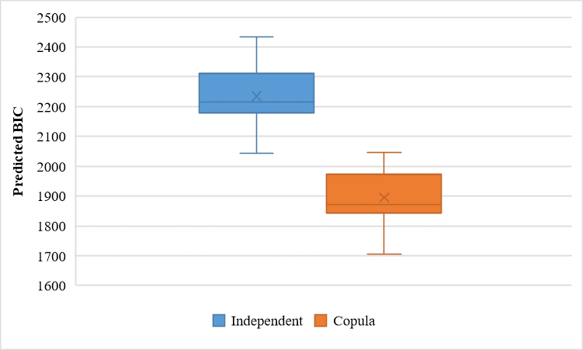

**FIGURE 5a Comparison of predictive performance of two models**

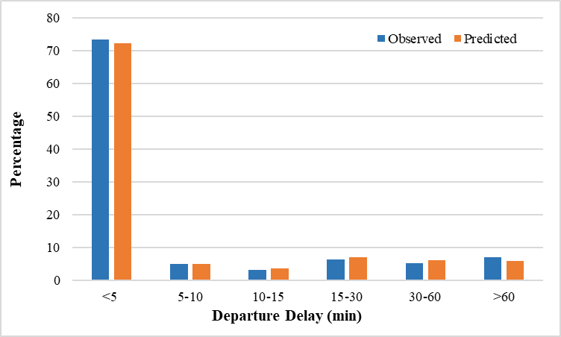

**FIGURE 5b Comparison of predicted and observed share of departure delay**

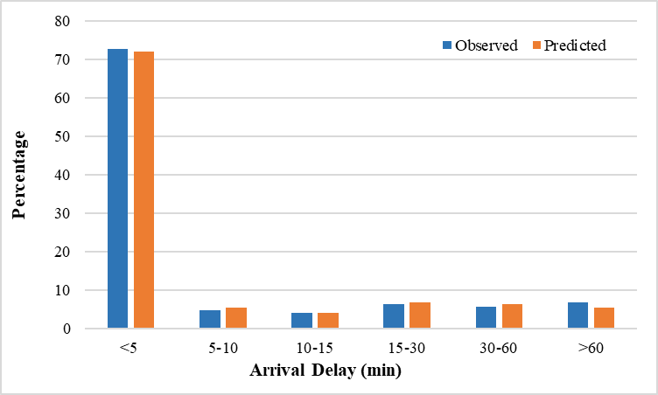

**FIGURE 5c Comparison of predicted and observed share of arrival delay**

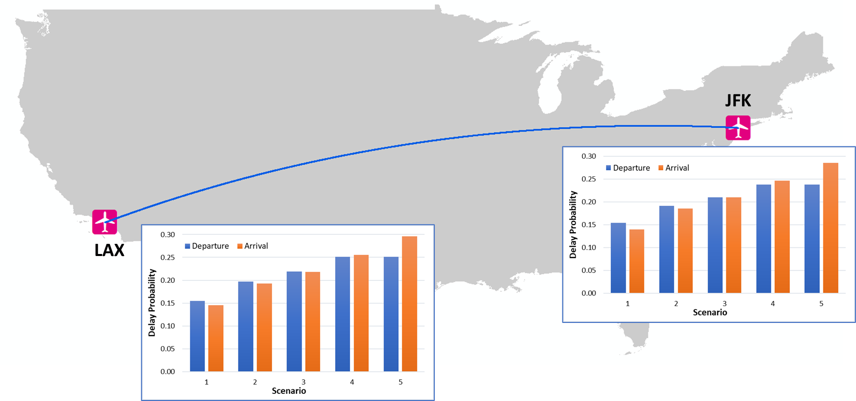

**FIGURE 6 Departure and arrival delay probability based on hypothetical scenarios**

# CONCLUSION

The main focus of the current study is to identify the key factors affecting airline delay by modeling departure and arrival delays at the flight level. This study makes several contributions to airline delay literature. The first contribution of the current study arises from data enhancements for the delay analysis. The main data source of the current study is the 2019 marketing carrier on time performance data compiled by BTS. The variables processed from BTS dataset are augmented with a comprehensive set of independent variables sourced from secondary data sources including ASOS dataset and ASPM dataset. Using ASOS dataset, we prepare a comprehensive set of weather variables for the entire flight duration near the origin airport, along the flight route and the destination airport. Also, we process ASPM data to determine the traffic conditions at the origin and destination airports in the hours preceding the flight departure and arrival. The current research also contributes to airport departure and arrival delay analysis by developing a novel copula-based group generalized ordered logit (GGOL) model. The proposed model accommodates for the influence of common observed and unobserved effects on flight departure and arrival delays. In our analysis, we employ six different copula structures – the Gaussian copula, the Farlie-Gumbel-Morgenstern (FGM) copula, and set of Archimedean copulas including Frank, Clayton, Joe and Gumbel copulas.

We compare the predictive performance of independent models of departure and arrival delays and the proposed joint model with different dependency profiles. Based on the model fit measures, Joe copula model with parameterization provides the best result. The final model indicates that flight delay is significantly influenced by airport level traffic conditions, trip specific factors, weather factors, spatial factors, and temporal factors. We test the predictive performance of the proposed model by performing a validation exercise with a holdout sample. The results illustrate the superiority of the proposed model system. Finally, to illustrate the potential applicability of our model system and illustrate the impact of independent variables, we generate the probabilities for arrival and departure delays under a host of hypothetical scenarios for one bidirectional origin-destination pair. The generated airport level delay probabilities provide a framework for airlines and airports across the nation, to evaluate departure and arrival delay possibilities for their flights based on current weather predictions. The delay analysis can offer potential strategies to improve boarding, deplaning and luggage handling of flights (identified in advance to have a delay) to improve on time departure and/or quick turnaround for the next flight.

To be sure, the current study is not without limitations. In this study, we process weather variables at 5-degree latitude/longitude resolution. It would be interesting to examine if a finer resolution analysis can improve the accuracy of model by considering more localized weather data. The dataset available to us can also be improved with airline carrier specific route information to enhance the weather data collection process and contribute to an improved model. Moreover, a comparison of the developed model with machine learning approaches would be an interesting avenue for future research.

# ACKNOWLEDGMENTS

The authors would like to acknowledge Bureau of Transportation Statistics (BTS) and Iowa Environmental Mesonet (IEM) to provide access to their datasets.

# AUTHOR CONTRIBUTION STATEMENT

The authors confirm contribution to the paper as follows: study conception and design: Naveen Eluru, Tanmoy Bhowmik, Sudipta Dey Tirtha; data collection: Sudipta Dey Tirtha, Tanmoy Bhowmik, Naveen Eluru; model estimation: Sudipta Dey Tirtha, Tanmoy Bhowmik, Naveen Eluru; analysis and interpretation of results: Sudipta Dey Tirtha, Tanmoy Bhowmik, Naveen Eluru; draft manuscript preparation: Sudipta Dey Tirtha, Tanmoy Bhowmik, Naveen Eluru. All authors reviewed the results and approved the final version of the manuscript.

# CONFLICT OF INTEREST STATEMENTS

The authors do not have any conflicts of interest to declare.

# REFERENCES

1. FAA. Air traffic by the numbers. https://www.faa.gov/air_traffic/by_the_numbers/. Accessed Jul. 27, 2021.

2. FAA. Cost of Delay Estimates. *https://www.faa.gov/data_research/aviation_data_statistics/media/cost_delay_estimates.pdf.* Accessed Jun. 20, 2021.

3. Suzuki, Y. The Relationship between On-Time Performance and Airline Market Share: A New Approach. *Transportation Research Part E: Logistics and Transportation Review*, Vol. 36, No. 2, 2000, pp. 139–154.

4. Hsiao, C. Y., and M. Hansen. Econometric Analysis of U.S. Airline Flight Delays with Time-of-Day Effects. Transportation Research Record, Vol. 104, No. 1951, 2006, pp. 104–112.

5. Yu, B., Z. Guo, S. Asian, H. Wang, and G. Chen. Flight Delay Prediction for Commercial Air Transport: A Deep Learning Approach. Transportation Research Part E: Logistics and Transportation Review, Vol. 125, 2019, pp. 203–221.

6. Dai, L., M. Hansen, M. O. Ball, R. H. Smith, and D. J. Lovell. Having a Bad Day? Predicting High Delay Days in the National Airspace System. Europe Air Traffic Management Research and Development Seminar, 2021.

7. Liu, Y., M. Hansen, M. O. Ball, and D. J. Lovell. Causal Analysis of Flight En Route Inefficiency. Transportation Research Part B: Methodological, Vol. 151, No. June 2020, 2021, pp. 91–115.

8. Gui, G., F. Liu, J. Sun, J. Yang, Z. Zhou, and D. Zhao. Flight Delay Prediction Based on Aviation Big Data and Machine Learning. *IEEE Transactions on Vehicular Technology*, Vol. 69, No. 1, 2020, pp. 140–150.

9. Tirtha, S. D., T. Bhowmik, and N. Eluru. Understanding the Factors Affecting Airport Level Demand (Arrivals and Departures) Using a Novel Modeling Approach. *Working Paper, University of Central Florida*, 2021.

10. Tirtha, S.D., S. Yasmin, and N. Eluru. Modeling of Incident Type and Incident Duration Using Data from Multiple Years. *Analytic Methods in Accident Research*, Vol. 28, 2020, p. 100132.

11. Yasmin, S., and N. Eluru. A Mixed Grouped Response Ordered Logit Count Model Framework. *Analytic Methods in Accident Research*, Vol. 19, 2018, pp. 49–61.

12. Bhat, C. R., and N. Eluru. A Copula-Based Approach to Accommodate Residential Self-Selection Effects in Travel Behavior Modeling. *Transportation Research Part B: Methodological*, Vol. 43, No. 7, 2009, pp. 749–765.

13. Hao, L., M. Hansen, Y. Zhang, and J. Post. New York, New York: Two Ways of Estimating the Delay Impact of New York Airports. *Transportation Research Part E: Logistics and Transportation Review*, Vol. 70, No. 1, 2014, pp. 245–260.

14. Nayak, N., and Y. Zhang. Estimation and Comparison of Impact of Single Airport Delay on National Airspace System with Multivariate Simultaneous Models. *Transportation Research Record*, No. 2206, 2011, pp. 52–60.

15. Schaefer, L., and D. Millner. Flight Delay Propagation Analysis with the Detailed Policy Assessment Tool. *Proceedings of the IEEE International Conference on Systems, Man and Cybernetics*, Vol. 2, 2001, pp. 1299–1303.

16. Klein, A., C. Craun, and R. S. Lee. Airport Delay Prediction Using Weather-Impacted Traffic Index (WITI) Model. *AIAA/IEEE Digital Avionics Systems Conference - Proceedings*, 2010, pp. 1–13.

17. Markovic D, Hauf T, Röhner P, Spehr U. A statistical study of the weather impact on punctuality at Frankfurt Airport. *Meteorological Applications: A journal of forecasting*, *practical applications, training techniques and modelling*, Vol. 15, No. 2, 2008, pp. 293–303.

18. Abdel-Aty, M., C. Lee, Y. Bai, X. Li, and M. Michalak. Detecting Periodic Patterns of Arrival Delay. *Journal of Air Transport Management*, Vol. 13, No. 6, 2007, pp. 355–361.

19. Choi, S., Y.J. Kim, S. Briceno, and D. Mavris. Prediction of weather-induced airline delays based on machine learning algorithms. *In 2016 IEEE/AIAA 35th Digital Avionics Systems Conference (DASC), 2016*, pp. 1–6.

20. Pérez–Rodríguez, J. V., J. M. Pérez–Sánchez, and E. Gómez–Déniz. Modelling the Asymmetric Probabilistic Delay of Aircraft Arrival. *Journal of Air Transport Management*, Vol. 62, 2017, pp. 90–98.

21. Arora, S. D., and S. Mathur. Effect of Airline Choice and Temporality on Flight Delays. *Journal of Air Transport Management*, Vol. 86, No. April, 2020, p. 101813.

22. Wong, J. T., and S. C. Tsai. A Survival Model for Flight Delay Propagation. *Journal of Air Transport Management*, Vol. 23, 2012, pp. 5–11.

23. Bhat, V. N. A Multivariate Analysis of Airline Flight Delays. *International Journal of Quality & Reliability Management*, Vol. 12, No. 2, 1995, pp. 54–59.

24. Xu, N., L. Sherry, and K. B. Laskey. Multifactor Model for Predicting Delays at U.S. Airports. *Transportation Research Record*, No. 2052, 2008, pp. 62–71.

25. Wong, J. T., S. L. Li, and D. Gillingwater. An Optimization Model for Assessing Flight Technical Delay. *Transportation Planning and Technology*, Vol. 25, No. 2, 2002, pp. 121–153.

26. Mueller, E. R., and G. B. Chatterji. Analysis of Aircraft Arrival and Departure Delay Characteristics. *AIAA’s Aircraft Technology, Integration, and Operations (ATIO) 2002 Technical Forum*, No. October, 2002, pp. 1–14.

27. Kim, M. S. Analysis of Short-Term Forecasting for Flight Arrival Time. *Journal of Air Transport Management*, Vol. 52, 2016, pp. 35–41.

28. Deshpande, V., and M. Arikan. The Impact of Airline Flight Schedules on Flight Delays. *Manufacturing and Service Operations Management*, Vol. 14, No. 3, 2012, pp. 423–440.

29. Lee, Y. X., and Z. W. Zhong. A Study of the Relationship between Adverse Weather Conditions and Flight Delay. *Journal of Advances in Technology and Engineering Research*, Vol. 2, No. 4, 2016, pp. 113–117.

30. Allan, S. S., J. A. Beesley, J. E. Evans, and S. G. Gaddy. 4 Th USA/Europe Air Traffic Management R&amp;D Seminar Analysis of Delay Causality at Newark International Airport. No. December, 2001, pp. 1–11.

31. Greenfield, D. Competition and Service Quality: New Evidence from the Airline Industry. *Economics of Transportation*, Vol. 3, No. 1, 2014, pp. 80–89.

32. Laman, H., S. Yasmin, and N. Eluru. Joint Modeling of Traffic Incident Duration Components (Reporting, Response, and Clearance Time): A Copula-Based Approach. *Transportation Research Record*, Vol. 2672, No. 30, 2018, pp. 76–89.

33. Yasmin, S., N. Eluru, A. R. Pinjari, and R. Tay. Examining Driver Injury Severity in Two Vehicle Crashes – A Copula Based Approach. *Accident Analysis & Prevention*, Vol. 66, 2014, pp. 120–135.

34. Wang, K., S. Yasmin, K. C. Konduri, N. Eluru, and J. N. Ivan. Copula-Based Joint Model of Injury Severity and Vehicle Damage in Two-Vehicle Crashes. *Transportation Research Record: Journal of the Transportation Research Board*, Vol. 2514, 2015, pp. 158–166.

35. Eluru, N., R. Paleti, R. Pendyala, and C. Bhat. Modeling Injury Severity of Multiple Occupants of Vehicles: Copula-Based Multivariate Approach. *Transportation Research Record: Journal of the Transportation Research Board*, No. 2165, 2010, pp. 1–11.

36. Iowa State University. Iowa Environmental Mesonet. https://mesonet.agron.iastate.edu/request/download.phtml?network=FL_ASOS. Accessed Jul. 24, 2020.

37. HowStuffWorks. How Do Pilots Make Up Time in the Air? https://science.howstuffworks.com/transport/flight/modern/do-pilots-make-up-time-in-air.htm. 2019. Accessed Oct. 20, 2021.

1. 35 Operational Evolution Partnership Airports (OEP-35) are the largest set of airports considered by the airport level studies (*13*, *14*). However, flight level studies considered flights operated in most of the major airports across the US.
2. The route generated might not necessarily match the exact proprietary carrier flight path, but it still provides an excellent surrogate route for consideration.
3. It is important to note that the proposed model system is flexible to accommodate for varying number of intermediate grids for flights.
4. Given the varying number of grids, there is no good way to provide a summary of the data that is representative of the sample. Hence, we provide descriptive statistics of weather variables across all grids by flight.
5. We investigated random effects of the variables and we found 1 random parameter offered a statistically significant result. However, the model with the random parameter does not improve BIC value of the model compared to the BIC value of the model without the random parameter. Hence, we did not consider the model with random parameter as our final model.