Evaluation of Freeway Demand in Florida during COVID-19 Pandemic from a Spatiotemporal Perspective

Md Istiak Jahan
Graduate Research Assistant
Department of Civil, Environmental & Construction Engineering
University of Central Florida, Florida, USA
Email: mdistiakjahan@knights.ucf.edu
ORCiD number: 0000-0002-4056-7816

Tanmoy Bhowmik, PhD*
Postdoctoral Scholar
Department of Civil, Environmental & Construction Engineering
University of Central Florida, Florida, USA
Email: tanmoy78@knights.ucf.edu
ORCiD number: 0000-0002-0258-1692

Naveen Eluru, PhD
Professor
Department of Civil, Environmental & Construction Engineering
University of Central Florida, Florida, USA
Email: naveen.eluru@ucf.edu
ORCiD number: 0000-0003-1221-4113
*Corresponding Author

ABSTRACT
This study contributes to our understanding of the changes in traffic volumes on major roadway facilities in Florida due to COVID-19 pandemic from a spatiotemporal perspective. Three different models were tested in this study- a) Linear regression model, b) Spatial Autoregressive Model (SAR) and c) Spatial Error Model (SEM). For the model estimation, traffic volume data for the year 2019 and 2020 from 3,957 detectors were augmented with independent variables, such as- COVID-19 case information, socioeconomics, land-use and built environment characteristics, roadway characteristics, meteorological information, and spatial locations. Traffic volume data was analyzed separately for weekdays and holidays. SEM models offered good fit and intuitive parameter estimates. The significant value of spatial autocorrelation coefficients in the SEM models support our hypothesis that common unobserved factors affect traffic volumes in neighboring detectors. The model results clearly indicate a disruption in normal traffic demand due to the increased transmission rate of COVID-19. The traffic demand for recreational areas, especially on the holidays, was found to have declined after March 2020. In addition, change in daily COVID-19 cases was found to have larger impact on South Florida (District 6)’s freeway demand on weekdays compared to other parts of the state. Further, the gradual increase of demand due to the rapid vaccination was also demonstrated in this study. The model system will help transportation researchers and policy makers understand the changes in freeway volume during the COVID-19 period as well as its spatiotemporal recovery.

Keywords: COVID-19, traffic volume, spatiotemporal, spatial panel mix model.

PRACTICAL APPLICATIONS
The model framework developed in our study provides transportation planners with insight on infrastructure usage across freeways in Florida. Within this broad context, the study makes three important contributions. First, the study highlights the impact of a host of variables on traffic demand under normal conditions and the varying impact of these variables due to a shock. The model developed quantitatively identifies the varying spatiotemporal influence of variables on demand evolution in response to a shock. The proposed approach can be applied in other contexts such as a recession to reflect changes in traffic demand over time. Second, employing the model for Florida provides an understanding of the locations that exhibit faster recovery rates – such as recreational locations in Central and South Florida. Thus, in the future transportation planning can accommodate for potentially faster recovery in infrastructure usage in these locations. The finding might also be important for policy making to support various economic sectors to diversify the workforce adequately. Finally, the overall framework will also assist policy makers in assessing infrastructure usage over time under various scenarios to obtain inputs for efficient transportation asset management. An accurate estimation of demand over time while recognizing the freight share (not considered in our work) will allow evaluation of infrastructure deterioration and upkeep.

INTRODUCTION
As of November 2021, Coronavirus disease 2019 (COVID-19) pandemic, has affected the entire world with reported cases (and fatalities) amounting to 261 million (5 million) (Worldometer, 2021). The pandemic has significantly taxed the social, health and economic systems affecting the mental and physical health of populations (Bhowmik & Eluru, 2021; The World Bank, 2020). United States is one of the significantly affected countries with the highest number of confirmed cases (about 48 million) and deaths (about 776 thousand) in the world (Centers for Disease Control and Prevention, 2021). The emergence of pandemic and the associated social distancing, mask mandates and stay-at-home orders affected nearly every facet of life. The US economy was significantly affected by COVID-19 with an unemployment rate of 14.7% by April 2020 (The Economics Daily, 2020). For perspective, the unemployment rate was only as high as 10% during the great recession. The economy also significantly transformed with a rapid shift to teleworking. About 71% of the total workforce moved to teleworking during the pandemic period from the pre-pandemic levels of about 20% (Parker et al., 2020). In recent months, the largely successful vaccination drive in the United States – about 437 million shots delivered by October 2021 – has contributed to reducing cases, and fatalities (Bloomberg, 2021). While public health professionals are wary of potential variants and their impact on unvaccinated populations, there is growing optimism among the public and many communities are emerging into a post-pandemic environment.
As described earlier, the pandemic has delivered a shock to every facet of life and the transportation system is no exception. For instance, after the stay-at-home orders were issued the average daily travel distance in the USA has declined by 80% (Hendrickson & Rilett, 2020). Traffic volume detector measurements in Florida for April 2020 indicated a drop of 41% relative to traffic volume measurements in April 2019. Transportation system usage patterns are a complex interaction of employment patterns, demographics, socioeconomics, transportation system attributes and urban regional characteristics. We hypothesize that spatial differences across regions are likely to result in varying evolution patterns across the country. As the country re-emerges from the pandemic, transportation system usage indicators can serve as important proxies for how the various communities were affected and possibly are reemerging from the pandemic.
In our study, employing transportation system usage measures (such as traffic volumes) on major roadways as a surrogate for community mobility, we focus on (a) understanding how local COVID-19 case history, socio-demographics, socioeconomics, transportation system characteristics, and urban form influence system usage and (b) examine disparities across communities in transportation system demand recovery and draw insights on factors contributing to the recovery. Florida serves as an ideal test bed for our analysis with diversity in regional features, population, and COVID-19 spread. The study employs data from 3,957 detectors, across 4 major interstate highways (I-4, I-10, I-75 and I-95) of Florida, sourced from the Regional Integrated Transportation Information System (RITIS) for 2019 and 2020. To analyze the rich database of traffic volumes across the two years for the large number of sites, we employ a spatiotemporal mixed linear regression model. The traffic volume data is augmented with a host of independent variables including detailed COVID-19 information (such as per capita COVID cases), socio-economic characteristics (such as median income, household vehicle availability), land-use characteristics (such as residential, commercial, and recreational area), built environment attributes (such as number of restaurants, and shopping centers), roadway characteristics (such as number of lanes, and maximum speed limit), meteorological information (such as wind speed and precipitation) and spatial locations of the traffic count detectors. The proposed spatiotemporal transportation volume model can offer insights to transportation and economic agencies on factors influencing the recovery process. The performance of the proposed model is further illustrated by predicting traffic volumes for data records not used in the model estimation. The model provides a framework to predict demand recovery as conditions improve across the country.

EARLIER RESEARCH
Examining traffic volumes on major transportation roadways is a well-researched objective. Several researchers develop regional models focusing on the drivers of travel using travel demand modeling approaches such as trip-based model and activity-based models (Bowman & Ben-Akiva, 2001; Pendyala et al., 2012; Pinjari et al., 2008; Sider et al., 2013; Ziemke et al., 2019). However, these approaches are focused on capturing regional trends and are not appropriate for modeling traffic volumes on specific facilities. In our review, we focus on research efforts that are developed to specifically study traffic volumes on roadway facilities. The review is organized along two groups of studies. The first group of studies examine approaches to study traffic volumes on roadways. The second group of studies are focused on understanding volume evolution in response to changes/shocks to the system.
The first group of studies analyzes traffic volume data by developing frameworks to (a) identify the factors affecting traffic volumes and (b) predict traffic volumes in the near future. The various traffic volume variables considered in earlier literature include traffic volumes (Kim et al., 2003; Ma et al., 2020), transformed traffic volumes such as natural logarithm or Box-cox transformation (Boonekamp et al., 2018; Faghih-Imani & Eluru, 2016b; Tamin & Willumsen, 1989) and change in traffic volumes over time (Abu-Eisheh & Mannering, 2002). The prevalent approaches for analysis of the volume variable with a focus on identifying important factors include simple linear regression models (Kusam & Pulugurtha, 2016), two stage least squares techniques (Boonekamp et al., 2018), geographically and temporally weighted regression model (Ma et al., 2020), dynamic simultaneous equation systems (Abu-Eisheh & Mannering, 2002), spatial mixed linear model(Faghih-Imani & Eluru, 2016a), autoregressive integrated moving average model (Williams & Hoel, 2003), and spatial panel mixed multilevel ordered logit model (Faghih-Imani & Eluru, 2016b). Multiple research efforts have also been developed with a focus on improving volume prediction drawing on machine learning and artificial intelligence-based research approaches including artificial neural networks (Yun et al., 1998; Zhu et al., 2014), support vector machines (Xie et al., 2010), gaussian processes (Xie et al., 2010), k-nearest neighbors algorithm (Z. Wang et al., 2019; Zheng & Su, 2014) and CNN-LTSM model (Shao et al., 2021). The most important factors identified in these research as affecting traffic volumes include population density, employment rate, land-use and built environment characteristics (such as number of restaurants, and proportion of commercial area), temperature and rain.
The second stream of studies are focused on understanding changes to traffic volumes in response to a major transportation system change (such as addition of new lanes, addition of significant public transit facility along the roadway corridor) (Beaudoin et al., 2015; Shams & Zlatkovic, 2020; Slavin et al., 2013) or system level shocks (such as a major economic recession or a pandemic) (Lo & Hall, 2006; Park & Sener, 2019). The reader would note that some studies focused on understanding air quality impacts of COVID-19 and as part of their analysis developed aggregate traffic volume trends/predictions (Elshorbany et al., 2021; Tian et al., 2021; Xiang et al., 2020) and are not directly relevant to our study. A number of research efforts examined how COVID-19 is affecting transportation volumes on multiple roadways. For example, Loske (2020) and Lee et al. (2020) examined COVID-19 data until March 2020 and examined how transport volumes were affected. The studies developed linear regression models with only one variable of interest (COVID-19 cases). Macioszek and Kurek (2021) employed data for 2019 and 2020 from a small number of intersections in an urban region to examine the changes in average daily traffic, changes to traffic at different points of the pandemic using linear combinations of Gaussian functions. Parr et al. (2020) employed data from Florida from more than 200 sites to evaluate the differences in traffic volumes between 2019 and 2020. The study conducted a host of univariate analyses comparing how traffic volumes in 2019 and 2020 changed for (a) specific locations (such as South Florida), (b) between urban and rural locations, (c) between arterials and interstates. Patra et al. (2021) examined changes in traffic volumes using Wi-Fi MAC Scanners (WMS) at two intersections in India in response to the multiple phases of COVID-19 lockdowns and found that traffic initially dropped. However, when enforcement was lax, traffic volumes were closer to normal due to the population ignoring the mandates.

Current Study
The literature presented clearly illustrates how several researchers have examined traffic volume data in response to COVID-19 pandemic. However, prior research efforts have several limitations. First, a majority of these research efforts have focused on a short time frame between a few weeks and 3 months to study the impact of COVID-19. Second, a majority of these studies employed very simple descriptive measures (such as traffic volume percentage change) or linear regression models with only one variable. Third, earlier studies (with the exception of Parr et al. (2020)) focused on less than ten sites to conduct the analysis. Fourth, differences in traffic volumes between weekdays and holidays was not explicitly recognized. Finally, all the earlier research that developed statistical models used simple linear regression models without considering for potential spatial correlations between traffic volume sites. The proposed research addresses these limitations by conducting a detailed spatiotemporal analysis of traffic volumes considering 3,957 detectors processing data for the full 2019 and 2020 years on major Florida interstate facilities. The research develops three model systems: a) Linear regression model, b) Spatial Autoregressive Model (SAR) and c) Spatial Error Model (SEM) (see for earlier work using these methods (Faghih-Imani & Eluru, 2016b; Ferdous et al., 2013; Frazier et al., 2005; X. C. Wang et al., 2012; X. Wang & Kockelman, 2006)). The model development is conducted using a host of independent variables from seven categories: 1) COVID-19 related factors, 2) socioeconomics, 3) land-use characteristics, 4) built environment attributes, 5) roadway characteristics, 6) meteorological variables and 7) spatial factors. The model estimation results are intuitive and highlight various important factors affecting traffic volumes. The results also support our hypothesis that common unobserved factors have a significant impact on traffic volumes.

DATA
The data for our analysis is obtained from the Regional Integrated Transportation Information System (RITIS) data archive (RITIS, 2021). The RITIS database is an automated data sharing system with real time data feeds providing information including the hourly traffic count data, detector coordinates and details of the roadway. The traffic count data for the current research effort is obtained for 4 major interstates in the state of Florida from 5,978 detectors for the years 2019 and 2020. The interstates considered include I-4, I-10, I-75, and I-95. The number of detectors for each interstate facility range between 910 and 2,061. A spatial map of the interstates along with the detector locations considered for the empirical study is presented in Figure 1.

Dependent Variable
Hourly traffic data for the evening peak period (4PM – 7PM) was the main variable of interest of this study. The dataset obtained from the RITIS data portal contain daily traffic volume at hourly resolution. For evening peak period, traffic volume data of 4PM to 7PM duration were aggregated. In our study, the I-10 corridor covers two time zones. The data compiled for our analysis for each detector is based on the local time at the detector location. The daily traffic volume for the peak period was compiled for each day for 2019 and 2020. The data was not available for all 5,978 detectors for the 24 months duration. Hence, to maximize detector coverage and ensure adequate number of records from each detector, we compiled data from 3,957 detectors across the various roadway facilities with traffic volume data available for at least 20 months. The reader would note that several detectors on the eastern part of the I-10 corridor were not considered in our analysis as data was unavailable across multiple months. The aggregated daily peak volumes dataset was classified into weekdays and holidays (weekends and Florida state holidays). From the weekday and holiday dataset, one record per month for the two-year duration is randomly sampled for our analysis. We employed the one day per month randomly to reduce computational complexity. We examined the stability of model estimation by employing multiple random samples following the same process used for the estimation sample. The results of the comparison exercise are documented in Appendix A. The final weekday and holiday datasets contain a total of 94,373 (Total records = $\sum_{M=20}^{24}{M*detectors with M records}$; 20 x 27 + 21 x 36 + 22 x 132 + 23 x 115 + 24 x 3,647) and 94,197 (20 x 34 + 21 x 48 + 22 x 164 + 23 x 163 + 24 x 3548) observations respectively. The reader would note that appropriate modifications were made to ensure the spatial matrix employed always has an order of 3,957 x 3,957 with zero’s added in for detectors with missing data for the corresponding time period.

Independent Variables
The traffic volume data compiled was augmented with a host of independent variables from seven categories: 1) COVID-19 related factors, 2) socioeconomics, 3) land-use characteristics, 4) built environment attributes, 5) roadway characteristics, 6) meteorological variables and 7) spatial factors (regional location of the detectors).
COVID-19 data compiled from the Johns Hopkins University COVID-19 data archive (Dong et al., 2020), was employed to identify county level COVID case information (see Bhowmik et al., 2021 for details) for each day in 2020 data (excluding January and February). The detectors were assigned to the corresponding county data based on their location. The data sources for other independent variables include the United States Census Bureau (for demographics and socio-economics) (US Census Bureau, 2019), Florida Department of Revenue parcel level data (for land-use and built environment data) (Property Tax Data Portal, 2015), Florida Department of Transportation website (for roadway characteristics and spatial factors) (Geographic Information System, 2019) and Florida Automated Weather Network (FAWN) data portal (2019 and 2020 meteorological data) (Florida Automated Weather Network, 2021).
The data for socioeconomics, land-use, built environment and roadway information were aggregated within a 1.61 km (1 mile) buffer for each detector for our analysis. In earlier work, the use of different buffer sizes for predicting several transportation modal demand and crash analysis is prevalent. For instance, Chakour & Eluru (2016), and Rahman et al. (2020) examined various buffer size and found 800 m or 0.50 mile offering the best fit. Further, for predicting toll road or freeway traffic behavior Mathew et al. (2021), and Pulugurtha & Sambhara (2011) considered 1.61 km (1 mile) buffer area. So, in our analysis, we tested with 800 m (0.5 mile), and 1.61 km (1 mile) buffer and the estimation results with 1.61 km (1 mile) buffer offered improved model fit. Using US census data at CT resolution, we generate buffer specific variable measures by allocating full CTs directly and employing area-weighted characteristics from partially covered CTs.
The meteorological data from 27 weather stations across the state of Florida have been assigned to the 3,957 traffic detectors considered in this study. The near table tool in ArcGIS software was used to assign the weather information of the nearest weather station to each of the detector. The descriptive statistics of the distance between the traffic detectors and the weather stations are shown in Table 1.
It is observed that the mean distance between weather stations and traffic detectors is 27.60 km (17.15 miles). Ideally, we would like the distance to be even lower. However, given that the data is needed reliably across the year, this is a reasonable compromise.
The reader would note that several lockdown measures were implemented across the state. However, lockdown and COVID-19 policy implementations across the state were not readily available for consideration in our models. Hence, we employed COVID-19 temporal factors and spatial factors to serve as controls for these differences. For temporal factors, we examined indicator variables by month to represent the varying actions considered as time elapsed since the beginning of the pandemic. The variables considered include indicator variables for 1st March 2020 and later, 1st April 2020 and later and so on. For spatial factors, we created indicator variables for the seven Florida Department of Transportation Districts. Further, we considered the potential interactions of these two variable groups with all independent variables in our analysis.
The reader would recognize that temporal and spatial factors (and the various interactions) serve as surrogates for pandemic policy implementation across the state.

Sample Characteristics
A descriptive summary of the dependent and independent variables is provided in Table 1 and 2. An illustration of the sudden impact of COVID-19 emergence and its continuing influence on weekly traffic volumes is presented in Figure 2. From Figure 2, we can observe the sudden drop (46.19%) in traffic volumes in March 2020. The figure also overlays the weekly count of COVID-19 cases in the state. The traffic volume data indicates a reasonable recovery from middle of 2020 with traffic volumes very close (13% to 15% difference) to 2019 traffic volumes as we get to the end of 2020, when the difference was 4.03%. Surprisingly, the August surge in COVID-19 cases results in a minor dip (13.02%) in traffic volumes. Further, it is interesting to note that the December surge in COVID-19 cases did not influence the weekly traffic volumes.

METHODOLOGY
The formulation of the different spatial panel models considered in our analysis are described in Elhorst (2003). Let $i (=1,2,3, ,N)$ be an index to represent each detector (N = 3,957), and $t (=1,2,3, , 24)$ be an index to represent the time period of data collection. The general form of the pooled linear regression model considering spatial effects has the following structure:
$$y_{it}=β^{'}X_{it}+ε_{it}+δ_{i} (1)$$
where, $y_{it}$ is the natural logarithm of traffic volume incremented by 1, $X_{it}$is a matrix of variables at detector $i$ and time $t$, $β$ is the model coefficients to be estimated and $ε_{it}$ are independently and identically distributed error terms for all $i$ and $t$, with zero mean and variance $σ^{2}$. The $δ_{i}$ represents the spatial effect to account for all the detector-specific time-invariant unobserved attributes. Now, conditional on the specification, this $δ_{i}$ can be treated as fixed or random effect in the model estimation. However, a fixed effect model is not suitable in the presence of time-invariant exogenous variables (Faghih-Imani & Eluru, 2016b). In our analysis, socioeconomics and land use patterns did not change over the months for any detector. Hence, we adopt the spatial random effect model formulation for our study context.
Several specifications are used for accounting spatial dependence in the literature including Spatial Lag or Autoregressive Model (SAR), Spatial Error Model (SEM), and Geographically Weighted Regression Model (GWRM). In the current study, we restrict ourselves to the use of SAR and SEM models. The SAR accommodates for the spatial dependency by adding a spatial lagged dependent variable in the model while the SEM model considers a spatial lagged error structure for incorporating spatial correlation.
The general form of the SAR (see equation 2) and SEM (see equation 3 and 4) are as follows (Elhorst, 2003):
$$y_{it}=α\sum_{j=1}^{N}{W_{ij}y_{jt}}+β^{'}X_{it}+ε_{it}+δ_{i} (2)$$
$$y_{it}=β^{'}X_{it}+δ_{i}+ϑ_{it} (3)$$
$$ϑ_{it}=γ\sum_{j=1}^{N}{W_{ij}ϑ_{jt}}+ε_{it} (4)$$
where, $α$ represent the spatial autoregressive coefficient; $γ$ indicates the spatial autocorrelation coefficient, $ϑ_{it}$ is the spatial autocorrelated error term and $W$ is the spatial weight matrix. To be specific, $W_{ij}$ depicts the element of the weight matrix between detector $i$ and $j$. In spatial econometrics, several functional forms of the weight matrix are commonly adopted including neighboring units, inverse of squared distance, inverse of distance or different threshold values (such as unit within 500 meters, 1.61 km (1 mile), 8.05 km (5 miles), 16.10 km (10 miles) and 32.19 km (20 miles)). In our empirical study, we considered several weight matrices and a correlation structure representing reducing correlation as a function of the distance that dissipates to 0 beyond 16.10 km (10 miles) offered the best results in terms of statistical data fit and interpretation. The reader should note that, the diagonal of Weight matrix is set to be zero to prevent the use of $y_{it}$to model itself. Further, the W matrix is normalized across rows to increase the model estimation stability (Elhorst, 2003). The models are estimated in Matlab using the routines provided by (Elhorst, 2003, 2014b). All the parameters are estimated using the maximum likelihood approaches (see (Elhorst, 2014a) for details on likelihood functions).

MODEL ESTIMATION RESULT

Model Fit Measures
In our empirical analysis, we estimated the following models: (a) traditional linear regression model, (b) Spatial Autoregressive Model (SAR) and (c) Spatial Error Model (SEM). These models were estimated for weekday and holiday datasets separately. The performance of these models are compared on the basis of the log-likelihood (LL) at convergence, Bayesian Information Criterion (BIC) (Burnham & Anderson, 2004) and overall interpretability of the model. The model goodness of fit measures is presented in Table 3. Two observations can be made from the model fit results. First, models considering spatial correlation (SAR and SEM) significantly outperform the simple linear regression model in terms of statistical data fit. This result clearly highlights the importance of accommodating spatial unobserved heterogeneity in regression approaches. Second, we observe that SEM model offered marginal improvement in terms of data fit compared to the SAR model for both weekday and holiday model. Further, the variable interpretations for SAR model were less intuitive and hence we preferred the SEM model that offers an improved interpretation with a good fit.

Variable Effects
The SEM estimates for weekdays and holidays are shown in Table 4. For both the models, only the statistically significant variables (at 90% significance level) are included in the model estimation. A positive (negative) sign in Table 4 indicates the increased (decreased) traffic volume corresponding to the temporal period (weekday and holiday). The model results are discussed by variable group for the two datasets.

COVID-19 Related Factors
The inclusion of these variables depicts the relation between the transmission of COVID-19 and travel demand on interstates. As case rates change across the county, the impact on traffic volumes is likely to vary over time. Therefore, in our models COVID-19 transmission variables with 1, 2 and 3-week lag have been tested. Among these variables, ‘ln (2-week lagged COVID-19 cases per 1M population)’ was found to offer the best model fit. The sign of this variable in both the models indicates a decrease in travel demand with the increase of the COVID-19 transmission rate two weeks prior (see similar trends reported in Lee et al. 2020; Macioszek and Kurek 2021; Parr et al. 2020). In addition, to capture the impact of the increasing and decreasing COVID-19 transmission rates on traffic volume, we included a percentage difference variable which represents the change in weekly cases relative to the 3-week moving average. This variable indicates that the percentage change in the COVID-19 transmission rate has a significant impact on traffic volume. The model results also indicate a higher impact of percentage difference in COVID-19 cases for the South Florida region (District 6) on weekdays. It indicates a reduction in traffic in this region due to a gradual increase in COVID-19 cases.

Socioeconomics
Several socio-economic variables were tested in our model. The detector locations in neighborhoods with low median household income (≤ $35,200) are likely to have lower volumes for weekdays. Interestingly, the weekday traffic volumes in these locations are substantially lower after the pandemic started. The result highlights the disproportionate impact of the pandemic on the vulnerable population. The variable proportion of zero vehicle households in the vicinity of the detector provides an expected reduction in traffic volumes for both weekdays and holidays.

Land-use Characteristics
Traffic volumes on interstates are potentially affected by surrounding land-use characteristics. In our analysis, several land use variables were tested. Of these variables, distance from the nearest Central Business Domain (CBD), proportion of commercial, industrial, and recreational area, interaction of these variables with COVID-19 after 1st March 2020 have been found to be significant. For the weekday model, distance of the detectors from the nearest CBD is found to have a negative impact on the traffic volume, which is similar to the impact reported in Faghih-Imani and Eluru (2016a). However, for the holiday model this impact is positive. The result indicates that peak traffic volume is higher (lower) closer to the CBD areas in the weekdays (holidays). Further, a positive sign for the variable proportion of industrial areas within the 1.61 km (1 mile) buffer zone of the detectors in the weekday model indicates traffic volume is positively associated in industrial areas on the weekdays. On the contrary, the proportion of commercial areas within the same buffer zone has a negative association with traffic volume in the holiday model. Finally, the proportion of recreational areas in 1.61 km (1 mile) vicinity of the detector has a positive impact on traffic volumes on holidays. Further, the impact of recreational areas has lowered after COVID-19 emergence. The reader would note that recreational areas still contribute to traffic volumes on holiday, but the magnitude is lower during the pandemic. The impact of commercial and recreational areas on the holidays’ traffic are quite similar to earlier literature (Ma et al., 2020).

Built Environment Attributes
In terms of built environment attributes, number of shopping centers within the 1.61 km (1 mile) buffer zone is found to have a positive impact on traffic volume in weekday and holiday models (see similar results reported in Faghih-Imani and Eluru (2016a). However, the contribution to traffic volume has lowered, yet remains positive, after the emergence of the pandemic.

Roadway Characteristics
Only one variable – number of lanes– offered statistically significant parameters in either the weekday or the holiday model. As expected, number of lanes is positively associated with traffic volume in both models. A similar relationship has been reported in Kusam and Pulugurtha (2016).

Meteorological Variables
Meteorological variables such as average wind speed, rainy day (=1, if average precipitation is ≥ 0.64 cm or 0.25 inch) were considered in our study to capture the effect of weather on traffic volume. The weather impacts are observed to follow the trends reported in earlier literature (Faghih-Imani & Eluru, 2016a). The negative sign of both variables in both models indicates a lowering of traffic volume in high wind and heavy rainy conditions.

Spatial Factors
To capture the influence of detector locations, we incorporated the district categorization for the Florida region (see Figure 1 for districts). These variables represent the fixed effects of the locations and are not interpretable after adding other variables. The reader would recognize that temporal and spatial factors (and the various interactions) serve as surrogates for different pandemic policies (such as mask regulations, business openings and occupancy) implemented across the state.

Temporal Variables
We considered multiple traffic volume lag variables including 1-, 7-, 14-, 21- and 28-day lag volumes in our modeling. For weekday and holiday models 7-day lag traffic volume was found to be positive and offered the best fit. Similar impacts are reported in (Faghih-Imani & Eluru, 2016b).

Correlation Factors
The reader would note that the weight matrix in our study follows the inverse of distance within 16.10 km (10 miles) and 0 outside 16.10 km (10 miles) relationship. As hypothesized, for this relationship, spatial correlation was significant in the two models. The result highlights the role of common unobserved factors affecting volumes across detectors that are spatially close.

PREDICTION ANALYSIS
One of the principal objectives of this study is providing insight on spatiotemporal changes in future traffic demand while accommodating for the uncertainty of future COVID-19 transmission rate. In early 2021, mass vaccination efforts across the entire US have resulted in sharp reduction in cases encouraging more travel. However, COVID-19 transmission rate increased substantially after the month of May 2021. To evaluate the impact of this sudden rise, the spatial and temporal recovery in traffic volume for the months of June, August and October has been presented in Figure 3 and 4 for weekdays and holidays respectively.
To compare our model performance in reflecting the improving pandemic condition in Florida, we employ our model system to predict future traffic volumes (for time periods not considered in the model development) and examine the difference in observed and predicted recovery rates using equations (5) and (6). A value greater than 0.95 would imply either similar (0.95 to 1) or higher (>1) volume in 2021 relative to 2019, representing a near to full recovery of traffic volumes.
$True recovery rate= \frac{Observed traffic volume of the year 2021}{Observed traffic volume of the year 2019} (5)$
and, $Predicted recovery rate= \frac{Predicted traffic volume of the year 2021}{Observed traffic volume of the year 2019} (6)$
The confusion matrix with recovery rate categories as: <0.81, 0.81 – 0.90, 0.90 – 0.95 and > 0.95 for weekday and holiday model are presented in Table 5. From the table, we can observe that the weekday model predicts (1.34+2.59+64.03=) 67.96% of the alternatives correctly, while the corresponding number for the holiday model is (0.97+3.10+50.48=) 54.55%. It is also important for the reader to recognize that these accuracy values are excellent given that the model is built on 2020 data that does not consider vaccinations in 2021.
Several observations can be made from these figures. First, weekday traffic volumes present varying spatial patterns across the state. Traffic volumes in Central Florida (District 5) and West Central Florida (District 7) regions are well into the recovery while parts of the southwest (District 1), northeast (District 2) and northwest (District 3) regions are away from a full recovery. Central Florida region (District 5) with multiple tourist attractions including several amusement parks in Orlando and beaches on the east coast experienced a faster recovery (recovery rate is more than 0.95) due to the pent-up demand because of pandemic closures. On the contrary, northeast, and northwest regions of Florida are home to commercial entities. As several businesses and institutions continued work-from-home patterns even in 2021, the recovery was relatively slower (less than 0.90) in those regions. Second, for holidays, the trend is slightly different. The results indicate an overall slower pattern of recovery across the state potentially highlighting how COVID-19 has reduced discretionary travel. Interestingly, for holiday travel, the Southeast (District 4) and Central Florida (District 5) region appears to be recovering at a faster rate (more than 0.95) compared to the rest of the state. Southeast district is home to several beach destinations and benefitted from tourism demand (similar to Central Florida). Overall, the results indicate a faster recovery in locations with high share of tourism activity. Third, the results also illustrate changing traffic volumes over time. As we move from June through August the number of detectors that experienced recovery of traffic volume closer to 2019 levels have declined (in particular for weekdays). For instance, 1,718 detectors indicate a full recovery (> 95%) with respect to weekday traffic volume in August 2021, a decrease of around 13.5% from June 2021. On the contrary, in holidays the recovery rate is found to remain almost constant from June through August with a full recovery in 40% of the total detectors. However, in October, traffic volume for weekdays and holidays begins to be recover. Overall, the figures clearly illustrate how the proposed model can be utilized to examine the spatiotemporal traffic trends at a high resolution. A representation of traffic volumes in earlier months of 2021 are included in the Appendix B for interested readers.

CONCLUSION
Several earlier research efforts have examined the impact of COVID-19 on traffic volumes. However, these efforts were either limited to a very short time frame and/or examine data from a small number of locations. Further, earlier work employed simple descriptive comparisons or statistical models that do not control for a host of factors that affect traffic volumes. In our current study, using traffic volume data for 2019 and 2020 from 3,957 detectors on four interstate facilities in Florida, an econometric framework for traffic volume spatiotemporal analysis is developed. Recognizing the presence of multiple repeated datapoints for each detector and the presence of common unobserved factors affecting traffic volumes at neighboring detectors, a comprehensive set of panel spatial models are estimated. The dataset was also partitioned for weekdays and holidays to capture intrinsic differences in traffic volumes on weekdays and holidays. The model estimation process considered an exhaustive set of independent variables including detailed COVID-19 information (such as per capita COVID cases), socioeconomic characteristics (such as employment rate, median income), land-use characteristics (such as residential, commercial, and recreational area), built environment attributes (such as number of restaurants, and shopping centers), roadway characteristics (such as number of lanes, and maximum speed limit), meteorological information (such as wind speed and precipitation) and spatial factors (district-wise detectors location). Among the spatial models, Spatial Error Model offered the best fit for weekdays and holidays.
The model estimates clearly highlight the impact on COVID-19 on traffic volumes. The model also recovered several important associations with other independent variables. The findings from the model highlight the inequity in the impact of pandemic on lower income households. The model for holidays indicates that traffic volumes during the pandemic are lower for recreational areas (relative to pre-pandemic conditions). The model estimation results are further augmented with a policy analysis exercise to illustrate the value of the proposed model system. The policy analysis clearly identifies spatiotemporal variations across the state in terms of traffic volume recovery. Further, the recovery patterns are quite different for weekdays and holidays. For weekdays, Central Florida region (District 5) appears to have recovered close to pre-pandemic traffic volumes while the northwest (District 3), northeast (District 2) and southwest region (District 1) are below the pre-pandemic levels. For holidays, the trends are quite different with both Central (District 5) and southeast region (District 4) are closer to recovery than rest of the state. Further, across the state, holidays have lower traffic volumes highlighting the impact of COVID-19 on discretionary travel.
The proposed model system has wide application for understanding traffic volume patterns as well as traffic volume prediction. With the number of cases increasing rapidly across the country, it is possible that increased measures to reduce COVID-19 spread might be instituted affecting traffic volume recovery. Employing the growing case numbers the proposed model system can offer guidelines on future recovery paths for traffic volumes on weekdays and holidays. The model developed can be enhanced by incorporating vaccination data at the county level in future research to incorporate spatiotemporal variations in vaccination rates across Florida.
This paper is not without any limitations. First, in our study traffic volume including different vehicle classes were considered in the same category due to data unavailability. In future research, it might be useful to explore traffic trends by vehicle class. Second, the data compiled from RITIS does not identify traffic incidents on roadways. Hence, an interruption of the regular traffic due to traffic incidents has not been explicitly accommodated in this study. We examined the potential prevalence of such incidents affecting traffic volume and observed them to be a small share of our sample. However, in future efforts of traffic flow prediction it might be useful to consider data with this information. Third, due to the absence of origin and destination of the trips, it has not been possible to differentiate the pass-through traffic from the local traffic in the interstate system. It would be beneficial to consider data that clearly demarcates demand by origin-destination characteristics in future research. Fourth, in our analysis we tested 800 m and 1.61 km (1 mile) buffers to generate estimates of CT variables around each traffic sensor. It might be beneficial to test alternative formulations of catchment areas for the sensors in future research. Fifth, while we employed COVID-19 case numbers, it might be interesting to consider data on COVID-19 fatalities and recoveries to further enhance the proposed models. Finally, the work can be further extended in the future by comparing the estimated models with the Geographically Weighted Regression Model.

DATA AVAILABILITY STATEMENT
Some or all data, model or code that supports the findings of this study are available from the corresponding author upon reasonable request. Available documents:
- SPSS syntax for data preparation and model
- Used datasets

ACKNOWLEDGEMENT
The authors would like to gratefully acknowledge Regional Integrated Transportation Information System (RITIS) and Florida Automated Weather Network (FAWN) for providing access to traffic volume and meteorological data for the state of Florida respectively.

AUTHOR CONTRIBUTION STATEMENT
The authors confirm contribution to the paper as follows: study conception and design: Naveen Eluru and Tanmoy Bhowmik; data collection: Md Istiak Jahan, Tanmoy Bhowmik; analysis and interpretation of results: Md Istiak Jahan, Tanmoy Bhowmik, Naveen Eluru; draft manuscript preparation: Md Istiak Jahan, Tanmoy Bhowmik, Naveen Eluru; All authors reviewed the results and approved the final version of the manuscript.

REFERENCES
Abu-Eisheh, S. A., & Mannering, F. L. (2002). Forecasting automobile demand for economies in transition: A dynamic simultaneous-equation system approach. Transportation Planning and Technology, 25(4), 311–331. https://doi.org/10.1080/0308106022000019026
Beaudoin, J., Farzin, Y. H., & Lin Lawell, C. Y. C. (2015). Public transit investment and sustainable transportation: A review of studies of transit’s impact on traffic congestion and air quality. Research in Transportation Economics, 52, 15–22. https://doi.org/10.1016/J.RETREC.2015.10.004
Bhowmik, T., & Eluru, N. (2021). A Comprehensive County Level Framework to Identify Factors Affecting Hospital Capacity and Predict Future Hospital Demand. MedRxiv, 2021.02.19.21252117. https://doi.org/10.1101/2021.02.19.21252117
Bloomberg. (2021). More Than 3.44 Billion Shots Given: Covid-19 Vaccine Tracker. Bloomberg. Accessed on 2021-07-12. https://www.bloomberg.com/graphics/covid-vaccine-tracker-global-distribution/
Boonekamp, T., Zuidberg, J., & Burghouwt, G. (2018). Determinants of air travel demand: The role of low-cost carriers, ethnic links and aviation-dependent employment. Transportation Research Part A: Policy and Practice, 112(February), 18–28. https://doi.org/10.1016/j.tra.2018.01.004
Bowman, J. L., & Ben-Akiva, M. E. (2001). Activity-based disaggregate travel demand model system with activity schedules. Transportation Research Part A: Policy and Practice, 35(1), 1–28. https://doi.org/10.1016/S0965-8564(99)00043-9
Burnham, K. P., & Anderson, D. R. (2004). Multimodel Inference: Understanding AIC and BIC in Model Selection. Sociological Methods & Research, 33(2), 261–304. https://doi.org/10.1177/0049124104268644
Centers for Disease Control and Prevention. (2021). CDC COVID Data Tracker. Accessed on 2021-06-20. https://covid.cdc.gov/covid-data-tracker/?CDC_AA_refVal=https%3A%2F%2Fwww.cdc.gov%2Fcoronavirus%2F2019-ncov%2Fcases-updates%2Fcases-in-us.html#cases_casesper100klast7days
Chakour, V., & Eluru, N. (2016). Examining the influence of stop level infrastructure and built environment on bus ridership in Montreal. Journal of Transport Geography, 51, 205–217. https://doi.org/10.1016/J.JTRANGEO.2016.01.007
Dong, E., Du, H., & Gardner, L. (2020). An interactive web-based dashboard to track COVID-19 in real time. The Lancet. Infectious Diseases, 20(5), 533–534. https://doi.org/10.1016/S1473-3099(20)30120-1
Elhorst, J. P. (2003). Specification and Estimation of Spatial Panel Data Models: International Regional Science Review, 26(3), 244–268. https://doi.org/10.1177/0160017603253791
Elhorst, J. P. (2014a). Spatial Panel Data Models. 37–93. https://doi.org/10.1007/978-3-642-40340-8_3
Elhorst, J. P. (2014b). Matlab Software for Spatial Panels. International Regional Science Review, 37(3), 389–405. https://doi.org/10.1177/0160017612452429
Elshorbany, Y. F., Kapper, H. C., Ziemke, J. R., & Parr, S. A. (2021). The Status of Air Quality in the United States During the COVID-19 Pandemic: A Remote Sensing Perspective. Remote Sensing 2021, Vol. 13, Page 369, 13(3), 369. https://doi.org/10.3390/RS13030369
Faghih-Imani, A., & Eluru, N. (2016a). Determining the role of bicycle sharing system infrastructure installation decision on usage: Case study of montreal BIXI system. Transportation Research Part A: Policy and Practice, 94, 685–698. https://doi.org/10.1016/j.tra.2016.10.024
Faghih-Imani, A., & Eluru, N. (2016b). Incorporating the impact of spatio-temporal interactions on bicycle sharing system demand: A case study of New York CitiBike system. Journal of Transport Geography, 54, 218–227. https://doi.org/10.1016/j.jtrangeo.2016.06.008
Ferdous, N., & Bhat, C. R. (2013). A spatial panel ordered-response model with application to the analysis of urban land-use development intensity patterns. J Geogr Syst, 15, 1–29. https://doi.org/10.1007/s10109-012-0165-0
Florida Automated Weather Network. (2021). University of Florida. Accessed on 2021-02-15. https://fawn.ifas.ufl.edu/data/
Frazier, C., Kockelman, K. M., & Luce, C. B. (2005). Spatial Econometric Models for Panel Data: Incorporating Spatial and Temporal Data. Transportation Research Record, 80–90.
Geographic Information System. (2019). Florida Department of Transportation. Accessed on 2021-01-26. https://www.fdot.gov/statistics/gis/default.shtm#Designated
Hendrickson, C., & Rilett, L. R. (2020). The COVID-19 Pandemic and Transportation Engineering. Journal of Transportation Engineering, Part A: Systems, 146(7), 01820001. https://doi.org/10.1061/jtepbs.0000418
Kim, K. W., Seo, H. Y., & Kim, Y. (2003). Forecast of domestic air travel demand change by opening the high speed rail. KSCE Journal of Civil Engineering, 7(5), 603–609. https://doi.org/10.1007/bf02838323
Kusam, P. R., & Pulugurtha, S. S. (2016). Spatial Proximity and Dependency to Model Urban Travel Demand. Journal of Urban Planning and Development, 142(2), 04015014. https://doi.org/10.1061/(asce)up.1943-5444.0000281
Lee, H., Park, S. J., Lee, G. R., Kim, J. E., Lee, J. H., Jung, Y., & Nam, E. W. (2020). The relationship between trends in COVID-19 prevalence and traffic levels in South Korea. International Journal of Infectious Diseases, 96, 399–407. https://doi.org/10.1016/J.IJID.2020.05.031
Lo, S. C., & Hall, R. W. (2006). Effects of the Los Angeles transit strike on highway congestion. Transportation Research Part A: Policy and Practice, 40(10), 903–917. https://doi.org/10.1016/J.TRA.2006.03.001
Loske, D. (2020). The impact of COVID-19 on transport volume and freight capacity dynamics: An empirical analysis in German food retail logistics. Transportation Research Interdisciplinary Perspectives, 6, 100165. https://doi.org/10.1016/j.trip.2020.100165
Ma, X., Ji, Y., Yuan, Y., Van Oort, N., Jin, Y., & Hoogendoorn, S. (2020). A comparison in travel patterns and determinants of user demand between docked and dockless bike-sharing systems using multi-sourced data. Transportation Research Part A: Policy and Practice, 139(July), 148–173. https://doi.org/10.1016/j.tra.2020.06.022
Macioszek, E., & Kurek, A. (2021). Extracting Road Traffic Volume in the City before and during covid-19 through Video Remote Sensing. Remote Sensing 2021, Vol. 13, Page 2329, 13(12), 2329. https://doi.org/10.3390/RS13122329
Mathew, S., Sravya Jayanthi, L., & Pulugurtha, S. S. (2021). Spatial and temporal effects of a toll road on land use developments and travel demand. International Conference on Transportation and Development 2021: Transportation Planning and Development, June, 235–246. https://doi.org/10.1061/9780784483541.022
Park, E. S., & Sener, I. N. (2019). Traffic-related air emissions in Houston: Effects of light-rail transit. Science of The Total Environment, 651, 154–161. https://doi.org/10.1016/J.SCITOTENV.2018.09.169
Parker, K., Horowitz, J., & Minkin, R. (2020). How the Coronavirus Outbreak Has – and Hasn’t – Changed the Way Americans Work.
Parr, S., Wolshon, B., Renne, J., Murray-Tuite, P., & Kim, K. (2020). Traffic Impacts of the COVID-19 Pandemic: Statewide Analysis of Social Separation and Activity Restriction. Natural Hazards Review, 21(3), 04020025. https://doi.org/10.1061/(ASCE)NH.1527-6996.0000409
Patra, S. S., Chilukuri, B. R., & Vanajakshi, L. (2021). Analysis of road traffic pattern changes due to activity restrictions during COVID-19 pandemic in Chennai. Transportation Letters, 13(5–6), 473–481. https://doi.org/10.1080/19427867.2021.1899580
Pendyala, R. M., Bhat, C. R., Goulias, K. G., Paleti, R., Konduri, K. C., Sidharthan, R., Hu, H.-H., Huang, G., & Christian, K. P. (2012). Application of Socioeconomic Model System for Activity-Based Modeling: Experience from Southern California. Transportation Research Record, 2303(1), 71-80. Https://Doi.Org/10.3141/2303-08, 2303, 71–80. https://doi.org/10.3141/2303-08
Pinjari, A. R., Eluru, N., Srinivasan, S., Guo, J. Y., Copperman, R. B., Sener, I. N., & Bhat, C. R. (2008). CEMDAP: Modeling and Microsimulation Frameworks, Software Development, and Verification. Transportation Reserach Board 87th Annual Meeting.
Property Tax Data Portal. (2015). Florida Department of Revenue. Accessed on 2021-01-20. https://floridarevenue.com/property/Pages/DataPortal_RequestAssessmentRollGISData.aspx
Pulugurtha, S. S., & Sambhara, V. R. (2011). Pedestrian crash estimation models for signalized intersections. Accident Analysis and Prevention, 43(1), 439–446. https://doi.org/10.1016/J.AAP.2010.09.014
Rahman, M., Yasmin, S., & Eluru, N. (2020). A joint panel binary logit and fractional split model for converting route-level transit ridership data to stop-level boarding and alighting data. Transportation Research Part A: Policy and Practice, 139, 1–16. https://doi.org/10.1016/J.TRA.2020.06.015
RITIS. (2021). Detector Tools :: RITIS | Regional Integrated Transportation Information System. Accessed on 2021--1-15. https://ritis.org/archive/traffic
Shams, A., & Zlatkovic, M. (2020). Effects of capacity and transit improvements on traffic and transit operations. Transportation Planning and Technology, 43(6), 602–619. https://doi.org/10.1080/03081060.2020.1780710
Shao, Y., Zhao, Y., Yu, F., Zhu, H., & Fang, J. (2021). The Traffic Flow Prediction Method Using the Incremental Learning-Based CNN-LTSM Model: The Solution of Mobile Application. Mobile Information Systems, 2021. https://doi.org/10.1155/2021/5579451
Sider, T., Alam, A., Zukari, M., Dugum, H., Goldstein, N., Eluru, N., & Hatzopoulou, M. (2013). Land-use and socio-economics as determinants of traffic emissions and individual exposure to air pollution. Journal of Transport Geography, 33, 230–239. https://doi.org/10.1016/j.jtrangeo.2013.08.006
Slavin, C., Feng, W., Figliozzi, M., & Koonce, P. (2013). Statistical Study of the Impact of Adaptive Traffic Signal Control on Traffic and Transit Performance: Transportation Research Record, 2356(1), 117–126. https://doi.org/10.1177/0361198113235600114
Tamin, O. Z., & Willumsen, L. G. (1989). Transport demand model estimation from traffic counts. Transportation, 16(1), 3–26. https://doi.org/10.1007/BF00223044
The economics daily. (2020). U.S. Bureau of Labor Statistics. Accessed on 2021-07-12. https://www.bls.gov/opub/ted/2020/unemployment-rate-rises-to-record-high-14-point-7-percent-in-april-2020.htm
The World Bank. (2020). The Global Economic Outlook During the COVID-19 Pandemic: A Changed World. Accessed on 2021-07-12. https://www.worldbank.org/en/news/feature/2020/06/08/the-global-economic-outlook-during-the-covid-19-pandemic-a-changed-world
Tian, X., An, C., Chen, Z., & Tian, Z. (2021). Assessing the impact of COVID-19 pandemic on urban transportation and air quality in Canada. Science of The Total Environment, 765, 144270. https://doi.org/10.1016/J.SCITOTENV.2020.144270
US Census Bureau. (2019). Accessed on 2021-01-29. https://data.census.gov/all?g=0400000US12$1400000&y=2019
Wang, X. C., Kockelman, K. M., & Lemp, J. D. (2012). The dynamic spatial multinomial probit model: analysis of land use change using parcel-level data. Journal of Transport Geography, 24, 77–88. https://doi.org/10.1016/J.JTRANGEO.2012.06.011
Wang, X., & Kockelman, K. M. (2006). Tracking Land Cover Change in Mixed Logit Model Recognizing Temporal and Spatial Effects. Transportation Research Record: Journal of the Transportation Research Board, 112–120.
Wang, Z., Ji, S., & Yu, B. (2019). Short-Term Traffic Volume Forecasting with Asymmetric Loss Based on Enhanced KNN Method. Mathematical Problems in Engineering, 2019. https://doi.org/10.1155/2019/4589437
Williams, B. M., & Hoel, L. A. (2003). Modeling and Forecasting Vehicular Traffic Flow as a Seasonal ARIMA Process: Theoretical Basis and Empirical Results. American Society of Civil Engineers, 129(6), 664–672. https://doi.org/10.1061/ASCE0733-947X2003129:6664
Worldometer. (2021). Coronavirus cases and Mortality. Worldometer.Accessed on 2021-07-12. https://www.worldometers.info/coronavirus/?
Xiang, J., Austin, E., Gould, T., Larson, T., Shirai, J., Liu, Y., Marshall, J., & Seto, E. (2020). Impacts of the COVID-19 responses on traffic-related air pollution in a Northwestern US city. Science of The Total Environment, 747, 141325. https://doi.org/10.1016/J.SCITOTENV.2020.141325
Xie, Y., Zhao, K., Sun, Y., & Chen, D. (2010). Gaussian processes for short-term traffic volume forecasting. Transportation Research Record, d(2165), 69–78. https://doi.org/10.3141/2165-08
Yun, S. Y., Namkoong, S., Rho, J. H., Shin, S. W., & Choi, J. U. (1998). A Performance evaluation of neural network models in traffic volume forecasting. Mathematical and Computer Modelling, 27(9–11), 293–310. https://doi.org/10.1016/S0895-7177(98)00065-X
Zheng, Z., & Su, D. (2014). Short-term traffic volume forecasting: A k-nearest neighbor approach enhanced by constrained linearly sewing principle component algorithm. Transportation Research Part C: Emerging Technologies, 43, 143–157. https://doi.org/10.1016/J.TRC.2014.02.009
Zhu, J. Z., Cao, J. X., & Zhu, Y. (2014). Traffic volume forecasting based on radial basis function neural network with the consideration of traffic flows at the adjacent intersections. Transportation Research Part C: Emerging Technologies, 47(P2), 139–154. https://doi.org/10.1016/J.TRC.2014.06.011
Ziemke, D., Nagel, K., & Bhat, C. (2019). Integrating CEMDAP and MATSIM to Increase the Transferability of Transport Demand Models. Transportation Research Record, 2493(1), 117- 125. Https://Doi.Org/10.3141/2493-13, 2493, 117–125. https://doi.org/10.3141/2493-13

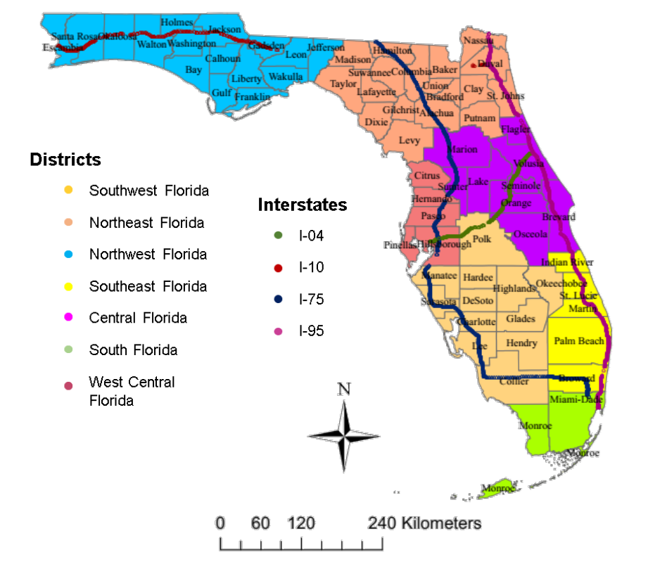
Figure 1: Locations of the traffic count detectors
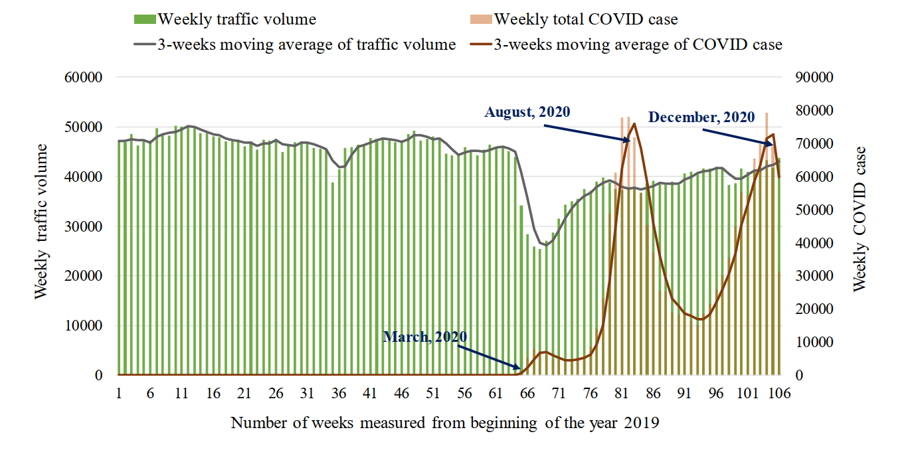
Figure 2: Weekly COVID-19 transmission rate and traffic volume in Florida 2019 and 2020

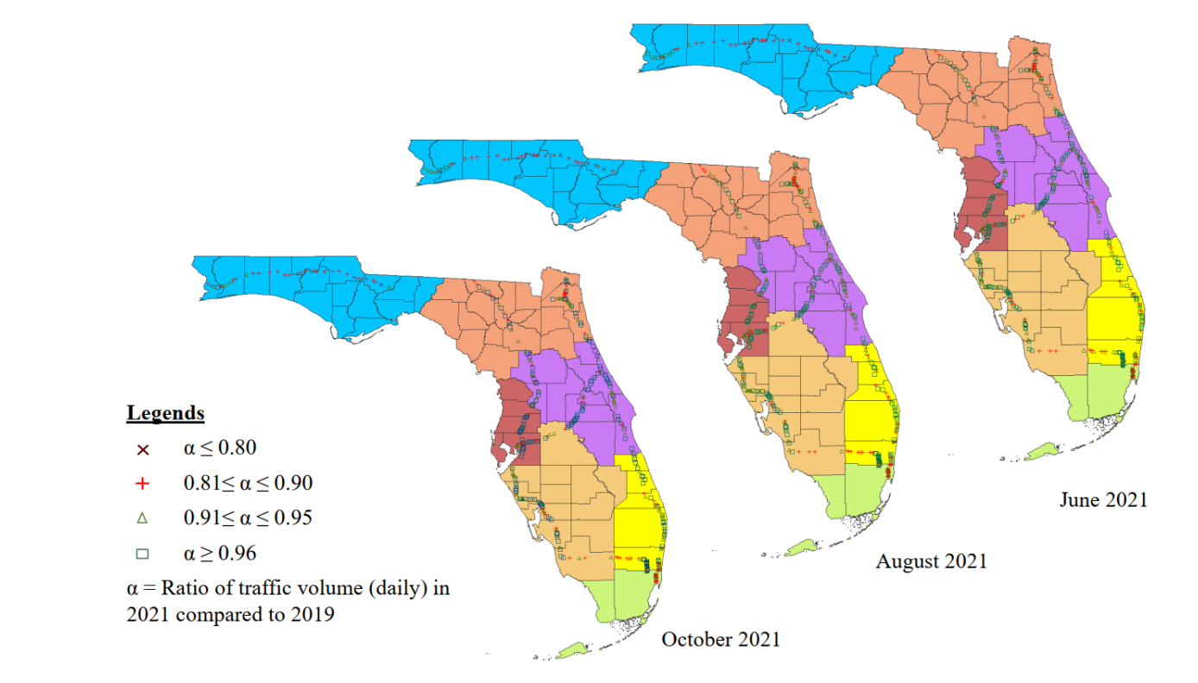
Figure 3: Spatial and temporal changes in weekday’s traffic volume
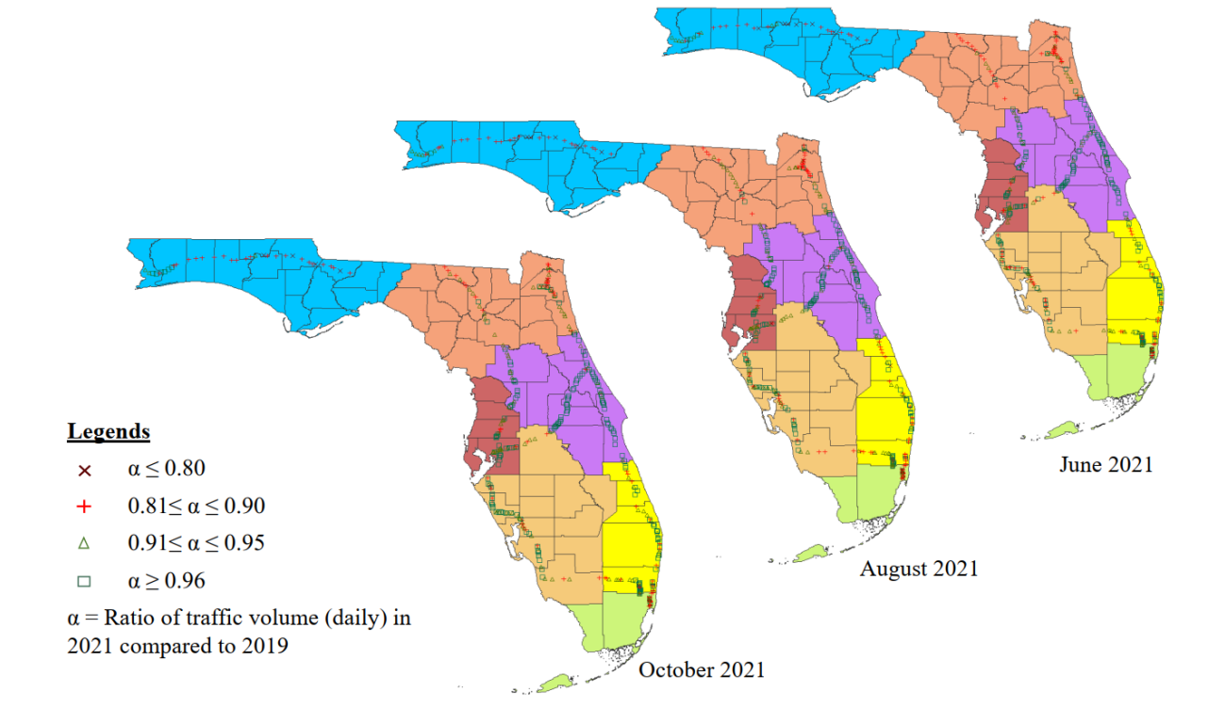
Figure 4: Spatial and temporal changes in holiday’s traffic volume
Table 1: Descriptive Summary of Variables with Same Values in Both Models (N = 3,957)

Variable | Variable Description | Min. | Max. | Mean
Socioeconomics
Low median income | Annual median income ≤ $35,200 | 0.00 | 1.00 | 0.04
Proportion of no vehicle household | Number of no vehicle household/ Total number of households in 1.61 km (1 mile) buffer | 0.00 | 0.33 | 0.07
Employment population ratio | Total number of employed population/ Total population in 1.61 km (1 mile) buffer | 0.00 | 85.60 | 58.92
Land use characteristics
Distance from the nearest CBD | Distance of the detectors from the nearest CBD in kilometers | 0.43 | 300.71 | 72.73
Proportion of commercial area | Commercial area/ Total land-use area in 1.61 km (1 mile) buffer zone | 0.00 | 1.00 | 0.14
Proportion of industrial areas | Industrial area/ Total land-use area in 1.61 km (1 mile) buffer zone | 0.00 | 0.88 | 0.05
Proportion of recreational area | Recreational area/ Total land-use area in 1.61 km (1 mile) buffer zone | 0.00 | 1.00 | 0.13
Proportion of institutional area | Institutional area/ Total land-use area in 1.61 km (1 mile) buffer zone | 0.00 | 0.79 | 0.07
Proportion of residential area | Residential area/ Total land-use area in 1.61 km (1 mile) buffer zone | 0.00 | 1.00 | 0.58
Built environment attributes
Number of shopping center | Total number of shopping centers in 1.61 km (1 mile) buffer zone | 0.00 | 279.00 | 18.30
Number of restaurants | Total number of restaurants in 1.61 km (1 mile) buffer zone | 0.00 | 321.00 | 13.13
Roadway characteristics
Number of Lanes | Average number of lanes in 1.61 km (1 mile) buffer zone | 2.00 | 7.00 | 3.53
Maximum speed limit | Maximum speed limit within 1.61 km (1 mile) buffer zone in kmph (mph) | 80.47 (50.00) | 112.65 (70.00) | 109.34 (67.94)
Spatial factors
Central region | Detectors in Central region | 0.00 | 1.00 | 0.22
South region | Detectors in South region | 0.00 | 1.00 | 0.08
Southeast region | Detectors in Southeast region | 0.00 | 1.00 | 0.19
Southwest region | Detectors in Southwest region | 0.00 | 1.00 | 0.16
Northeast region | Detectors in Northeast region | 0.00 | 1.00 | 0.16
Northwest region | Detectors in Northwest region | 0.00 | 1.00 | 0.08
West central region | Detectors in West central region | 0.00 | 1.00 | 0.09
Distance to nearest weather station | Distance of the detectors from the nearest weather station (km) | 0.69 | 68.35 | 27.60
Table 2: Descriptive Summary of Variables Varies in Weekday and Holiday Models
Variables | Variable Description | Weekday (N = 94,373) |  |  | Holiday (N = 94,197)
 |  | Min. | Max. | Mean | Min. | Max. | Mean
Covid-19 transmission Factors
2-weeks lag average COVID case per 1M population | Number of average COVID cases of 2-weeks lag per 1 million population | 0.00 | 19,235.00 | 511.98 | 0.00 | 19,235.00 |  | 518.68
Difference with the 3-weeks moving average | Moving average = (Sum of 1-, 2-, 3- weeks lag average COVID case)/3  Diff. with 3-week moving average = ((1 week lag case - moving average)/moving average) *100 | -1.00 | 2.00 | 0.07 | -1.00 | 2.00 |  | 0.08
Meteorological variables
Precipitation | Average precipitation ≥ 0.64cm (0.25 inch) during the PM peak period | 0.00 | 1.00 | 0.02 | 0.00 | 1.00 |  | 0.01
Average wind speed | Average wind speed of the corresponding date in PM peak period | 0.00 | 67.52 | 5.93 | 0.00 | 21.15 |  | 5.79
Temporal Factors
1 week lag traffic volume | Traffic volume of 1 week lag of the corresponding date in PM peak period | 0.00 | 20091.00 | 6255.80 | 0.00 | 20085.00 |  | 5795.80
Dependent variable
Traffic volume | Traffic volume of the corresponding date in PM peak period | 0.00 | 20091.00 | 6281.37 | 0.00 | 20089.00 |  | 5748.17

Table 3: Goodness of Fit Measures
Model | Weekday Model |  | Holiday Model
 | Log-likelihood (LL) | Bayesian Information Criterion (BIC) | Log-likelihood (LL) | Bayesian Information Criterion (BIC)
Ordinary Least Squares Linear Regression Model | -126,400 | 252,983 | -132,300 | 264,783
Spatial Autoregressive Model (SAR) | -88,145 | 176,485 | -92,552 | 185,299
Spatial Error Model (SEM) | -87,926 | 176,035 | -92,357 | 184,898

Table 4: Model Estimation Results
Variable | Weekdays |  | Holidays
 | Coefficient | T-value | Coefficient | T-value
Intercept | 7.312 | 132.11 | 6.721 | 105.11
Covid-19 transmission Factors
ln (2-week lagged COVID-19 cases per 1M population +1) x10⁻² | -0.741 | -8.78 | -0.572 | -5.86
% Difference with the preceding 3 weeks moving average | -0.068 | -10.32 | -0.118 | -19.09
x Effect in the South region | -0.053 | -2.19 | ---- | ----
Socioeconomics
Low median income | -0.461 | -7.79 | ---- | ----
x COVID effect after 1st March 2020 | -0.073 | -3.02
Proportion of Zero vehicle household | -3.172 | -11.84 | -3.401 | -12.31
Land use characteristics
Distance from the nearest CBD x10⁻² | -0.071 | -2.31 | 0.134 | 4.04
Proportion of commercial area | ---- | ---- | -0.279 | -3.75
Proportion of industrial areas | 0.334 | 3.04 | ---- | ----
Proportion of recreational area | ---- | ---- | 0.214 | 4.15
x COVID effect after 1st March 2020 | ---- | ---- | -0.053 | -2.89
Built environment attributes
Number of shopping centers x10⁻² | 0.182 | 3.69 | 0.192 | 3.56
x Covid effect after 1st March 2020 x10⁻² | -0.039 | -2.67 | -0.034 | -1.81
Roadway Characteristics
Number of Lanes | 0.162 | 11.64 | 0.213 | 14.65
Meteorological variables
Precipitation | -0.053 | -2.92 | -0.031 | -1.69
Average wind speed x10⁻² | -0.201 | -2.65 | -0.207 | -2.51
Spatial Factors
Base: Other regions in Florida
Central Region | ---- | ---- | 0.491 | 16.93
South Region | -0.570 | -8.52 | -0.483 | -6.67
Temporal Factors
1 week lag traffic volume/1000 | 0.121 | 125.48 | 0.142 | 135.95
Correlations
Spatial autocorrelation | 0.252 | 32.27 | 0.274 | 36.49

Table 5: Confusion matrix for weekday (holiday) model
 | Predicted traffic volume recovery rate
True traffic volume recovery rate |  | Less than 0.81 | 0.81 to 0.90 | 0.90 to 0.95 | More than 0.95 | Total
 | Less than 0.81 | ---  (---) | ---  (---) | ---  (---) | ---  (---) | ---  (---)
 | 0.81 to 0.90 | 0.11%  (0.10%) | 1.34%  (0.97%) | 0.20%  (0.24%) | 0.21%  (0.58%) | 1.86%  (1.89%)
 | 0.90 to 0.95 | 0.01%  (0.13%) | 2.15%  (3.72%) | 2.59%  (3.10%) | 0.56%  (1.68%) | 5.32%  (8.63%)
 | More than 0.95 | 0.07%  (0.18%) | 5.41%  (10.66%) | 23.31%  (28.16%) | 64.03%  (50.48%) | 92.82%  (89.49%)
 | Total | 0.20%  (0.41%) | 8.90%  (15.36%) | 26.10%  (31.50%) | 64.80%  (52.74%) | 100%  (100%)

